Modeling and Curve Fitting ⸱ Practice

Examples 1–3
Look for a pattern in each table of values to determine which kind of model best describes the data. Then write an equation for the function that models the data.
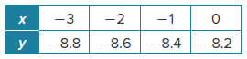
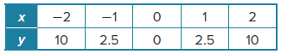
1. 2.

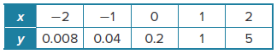
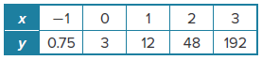
3. 4.

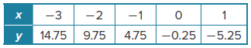
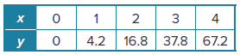
5. 6.

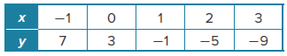
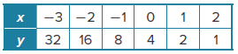
7. 8.

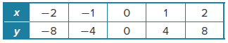
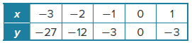
9. 10.

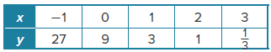
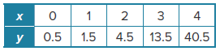
11. 12.

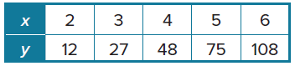
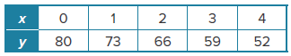
13. 14.

Example 4
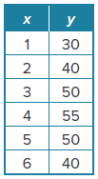
15. DRONES The table shows the time after a drone was launched (in seconds) x and the height of the drone, in feet, above ground y.

a. Make a scatter plot of the data.

b. Which regression equation has an R² value closest to 1?

c. Find an appropriate regression equation, and state the coefficient of determination. Based on the regression equation, what are the relevant domain and range?

d. Predict the height of the drone 7 seconds after it was launched. Round to the nearest foot.

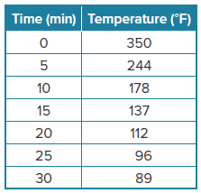
16. BAKING Alyssa baked a cake and is waiting for it to cool so she can ice it. The table shows the temperature of the cake every 5 minutes after Alyssa took it out of the oven.

a. Make a scatter plot of the data.

b. Which regression equation has an R² value closest to 1? Is this the equation that best fits the context of the problem? Explain
your reasoning.

c. Find an appropriate regression equation, and state the coefficient of determination. Based on the regression equation, what are the relevant domain and range?

d. Alyssa will ice the cake when it reaches room temperature (70$°$F). Use the regression equation to predict when she can ice her cake.

Mixed Exercises
USE TOOLS Use a graphing calculator to determine whether to use a linear, quadratic, or exponential regression equation. State the coefficient of determination.
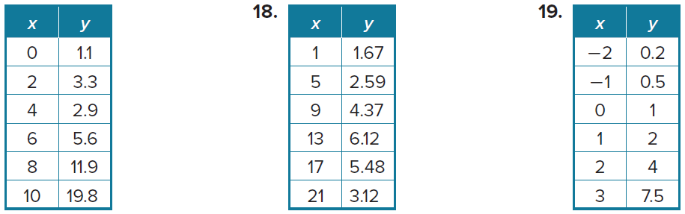


17. 18. 19.

20. WEATHER The San Mateo weather station records the amount of rainfall since the beginning of a thunderstorm. Data for a storm is recorded as a series of ordered pairs (2, 0.3), (4, 0.6),
(6, 0.9), (8, 1.2), (10, 1.5), where the x-value is the time in minutes since the start of the storm, and the y-value is the amount of rain in inches that has fallen since the start of the storm. Determine which kind of model best describes the data.

21. INVESTING The value of a certain parcel of land has been increasing in value ever since it was purchased. The table shows the value of the land parcel over time.
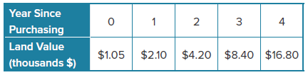

Look for a pattern in the table of values to determine which model best describes the data. Then write an equation for the function that models the data.

22. BOATS The value of a boat typically depreciates over time. The table shows the value of a boat over a period of time.

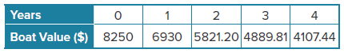

Write an equation for the function that models the data. Then use the equation to determine how much the boat is worth after 9 years.

23. NUCLEAR WASTE Radioactive material slowly decays over time. The amount of time needed for an amount of radioactive material to decay to half its initial quantity is known as its half-life. Consider a 20-gram sample of a radioactive isotope.

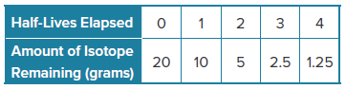

a. Is radioactive decay a linear decay, quadratic decay, or an exponential decay?

b. Write an equation to determine how many grams y of the radioactive isotope will be remaining after x half-lives.

c. How many grams of the isotope will remain after 11 half-lives?

d. Plutonium-238 is one of the most dangerous waste products of nuclear power plants. If the half-life of plutonium-238 is 87.7 years, how long would it take for a 20-gram sample of plutonium-238 to decay to 0.078 gram?

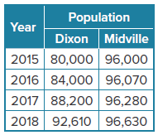
24. USE A MODEL The table shows the populations of two towns from 2015 to 2018.

a. For each town, write a function that models the town’s population x years after 2015.

b. Based on the function types you used in part a, what can you conclude about the populations of the towns as time goes on? Explain.

25. STRUCTURE The table shows the height of an elevator above ground level at various times.
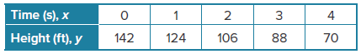
a. What type of function best models the data in the table? Why?
b. The average rate of change is the change in the value of the dependent variable divided by the change in the value of the independent variable. What is the average rate of change of the function over the interval x = 0 to x = 4? What does this tell you about the motion of the elevator?
c. Write a function that models the height of the elevator as a function of time. How is the coefficient of x related to your answers to parts a and b?

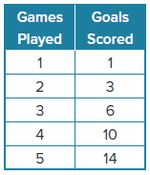
26. SOCCER The table shows the total number of games a soccer team played and the number of total goals scored in a season.
a. Make a scatter plot of the data.

b. Which regression equation has an R² value closest to 1? What is the value?

c. Find the appropriate regression equation. What are the domain and range?

d. The team’s goal is to score 25 goals for the season. Use the regression equation to predict in which game they will score their 25th goal.

27. USE A SOURCE Look up hourly temperature data for a starting time of 6:00 A.M. and every hour after that for 8 hours. Plot the points, with x representing the time in hours after 6:00 A.M. and
y representing the temperature. Then, identify what type of model best describes the data.
28. PRECISION Jase used a graphing calculator to find the predicted dollar value of a used vehicle after 7 years. The calculator reported the value as 5127.45928113. How should Jase decide how many digits to report?

29. CONSTRUCT ARGUMENTS Diego claims that no function can have equal non-zero first differences and equal non-zero second differences. Is Diego correct? Use examples or counterexamples to justify your argument.

30. PERSEVERE Write a function that has constant second differences, first differences that are not constant, a y-intercept of –5, and contains the point (2, 3).

31. ANALYZE What type of function will have constant third differences, but not constant second differences? Justify your argument.

32. CREATE Write a linear function that has a constant first difference of 4.

33. PERSEVERE Explain why linear functions grow by equal differences over equal intervals, and exponential functions grow by equal factors over equal intervals. (Hint: Let y = ax represent a linear function, and let y = a^{x} represent an exponential function.)

34. WRITE How can you determine whether a given set of data should be modeled by a linear function, a quadratic function, or an exponential function?

