Combining Functions ⸱ Practice

Examples 1 and 2
Given that f(x) = x – 9, g(x) = 3x² – 2x + 5, and h(x) = –6x, find each function.
1. (f + g)(x) 2. (f – g)(x)

3. (f + h)(x) 4. (g – f)(x)

5. (g – h)(x) 6. (g + h)(x)

7. (h – g)(x) 8. (f – h)(x)

Examples 3 and 4
Given that f(x) = 11x, g(x) = x² – 6x + 3, h(x) = –x + 4, and j(x) = 2^{x} + 3, find each function.
9. (f $∙$ g)(x) 10. (f $∙$ h)(x)

11. (g $∙$ h)(x) 12. (f $∙$ f)(x)

13. (f $∙$ j)(x) 14. (h $∙$ j)(x)

Examples 5 and 6
15. TRANSPORTATION Jan’s walking speed can be represented by the function f(t) = 4t + 3, where
t is the number of seconds. The moving walkway at an airport has a speed that can be represented by the function g(t) = 3t + 1.

a. Find f(t) + g(t) and explain what it represents.

b. Find f(t) – g(t) and explain what it represents.

16. CLUBS An improvisational acting club has 32 members. The manager of the club expects its membership to increase by 4 members per year. A photography club has 60 members and is expected to grow by 10% per year.

a. Write a function f(t) to represent the number of members in the acting club after t years.
b. Write a function g(t) to represent the number of members in the photography club
after t years.

c. Find (f + g)(t) and explain what this function represents.

17. MAGIC SHOW A magician currently sells tickets to his shows for $15 and averages 180 spectators per show. He estimates that he can sell 10 more tickets for each $0.75 decrease in price.

a. Let x represent the number of $0.75 price decreases. Write a function P(x) to represent the price of a ticket and a function T(x) to represent the number of tickets sold.
b. Write a function R(x) that can be used to find the revenue from ticket sales.
c. If the magician decides to sell the tickets for $12, find his revenue.

18. GOLF A golf course offers a membership plan where players pay an annual fee of $250 plus a fee for each round of golf played. The function C(x) = 15x + 250 represents the total cost for playing x rounds of golf. Explain how you can think of C(x) as the sum of two functions. What do each of these functions represent?

Mixed Exercises
Given that p(x) = –2x, q(x) = x² + 5, r(x) = x² – x + 2, and t(x) = ${\left(\frac{1}{4}\right)}^{x}$ – 5, find each function.
19. (q + t)(x) 20. (t – r)(x)

21. (p $∙$ q)(x) 22. (p $∙$ r)(x)

23. (q $∙$ r)(x) 24. (q $∙$ q)(x)

25. (p $∙$ t)(x) 26. (p + q + r)(x)

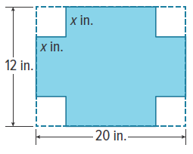
27. STORAGE Raul is making boxes out of sheets of cardboard to hold his video game collection. He begins with a rectangular sheet that is 20 inches long and 12 inches wide, as shown. Then he cuts identical squares from each corner and bends the sides to form a box.

a. If x represents the length of each side of the squares, write functions ℓ(x) and w(x) to represent the length and width, respectively, of the resulting box.
b. Find (ℓ $∙$ w)(x) and explain what it represents.
c. What is the domain of (ℓ $∙$ w)(x)? Explain.
d. Find (ℓ $∙$ w)(1.5) and interpret its meaning.

28. USE A MODEL Alba sells homemade granola at a farmers’ market. When Alba sets the price at $4 per bag, she can sell 185 bags. She finds that for every increase of $0.25 in the price of a bag of granola, she sells 10 fewer bags.
a. Let x represent the number of $0.25 increases in the price. Write a function P(x) that gives the price of the granola as a function of x. Write a function G(x) that gives the number of bags of granola Alba sells as a function of x.

b. Explain how to combine functions to write a function R(x) that gives Alba’s revenue from selling granola as a function of x.

c. Alba is considering raising the price of the granola to $4.75. Use your model to explain whether or not this is a good idea.

29. STRUCTURE Tyree makes a pattern, as shown, using shaded tiles and white tiles.

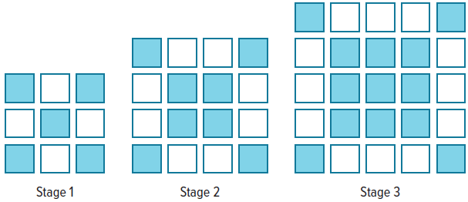

a. Write a function f(n) that gives the number of shaded tiles needed to make stage n of the pattern and a function g(n) that gives the number of white tiles needed to make stage n of the pattern.

b. Explain how to write a function h(n) that gives the total number of tiles needed to make stage n of the pattern. Use the function to the find the total number of tiles needed to make stage 10.

c. Explain how you know your answer to part b is correct.

30. USE TOOLS A chemist works in a lab that maintains a constant temperature of 22°C. She heats a saline solution and then lets the solution cool. As the solution cools, she records its temperature every 3 minutes. Her data is shown in the table.
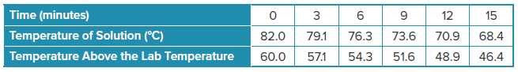

a. Write a function P(x) that models the temperature of the solution above the lab temperature in degrees Celsius x minutes after the chemist starts recording the data. Write a second function S(x) that models the temperature of the solution.
b. Explain how the function you wrote for S(x) in part a is a combination of two functions.
c. The chemist wants to know approximately how long it will take until the solution cools to a temperature of 45°C. Explain how to use your calculator to estimate this time to the nearest minute.

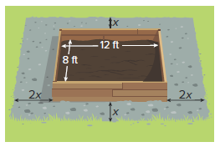
31. CONSTRUCT ARGUMENTS A rectangular flower bed in a garden is 12 feet long and 8 feet wide. Kazuo plans to add a gravel border around the flower bed so that the border is twice as wide along the 8-foot sides of the flower bed as it is along the 12-foot sides.
a. Let x be the width of the gravel border along the 12-foot sides of the flower bed, as shown. Write a function A(x) that gives the area of the gravel border in square feet. Explain how you can write this function as a combination of simpler functions.

b. Kazuo said that the function A(x) is a quadratic function. Therefore, as x increases, the area of the gravel border will increase up to a point, reach a maximum value, and then start to decrease. Do you agree? Justify your argument.

32. REGULARITY Describe the difference between the method for adding a linear and a quadratic function and the method for multiplying a linear and a quadratic function.

33. STRUCTURE Adding the linear function j(x) = 5 to the exponential function k(x) = 3^{x} – 7, gives a new exponential function m(x), which is a translation of k(x). What is the equation of the translated function, m(x)?

34. FRAME An 8 x 10 picture frame has a glass center that is 8 inches wide and 10 inches long. The frame that surrounds the glass can be a variety of different sizes. How much larger is the area
of a framed picture than its perimeter if the frame extends x inches outside the glass in
each direction?

35. CREATE Define f(x) and g(x) if (f – g)(x) = x² + 14x – 12, where f(x) is a quadratic function and
g(x) is a linear function.

36. CREATE Define f(x) and g(x) if (f $∙$ g)(x) = x³ – x² – 4x + 4, where f(x) is a quadratic function and g(x) is a linear function.

37. ANALYZE Determine whether the following statement is sometimes, always, or never true. Justify your argument.

Multiplying a linear equation with two terms by a quadratic equation with three terms will result in an equation that has three terms.

38. WRITE You learned that when a linear function and a quadratic function are multiplied, the product is a third-degree polynomial. What do you think would be the degree of the product of two quadratic functions? What about the degree of the sum of two quadratic functions? Explain your reasoning.

39. FIND THE ERROR Delfina multiplied the linear function f(x) = 6x – 8 by the quadratic function g(x) = 4x² + 7x – 19. She found that (f $∙$ g)(x) = 24x³ + 42x² + 152. Is Delfina’s solution correct? Explain your reasoning.

40. WHICH ONE DOESN’T BELONG? Consider the functions a(x), b(x), and c(x), below, and their products, (a $∙$ b)(x), (a $∙$ c)(x), and (b $∙$ c)(x). Determine which of the products does not belong. Justify your conclusion.

