Verifying Trigonometric Identities ⸱ Practice

Examples 1 and 2
Verify that each equation is an identity by transforming one side.
1. cos² $θ$ + tan² $θ$ cos² $θ$ = 1 2. cot $θ$(cot $θ$ + tan $θ$) = csc² $θ$

3. 1 + sec² $θ$ sin² $θ$ = sec² $θ$ 4. sin $θ$ sec $θ cot θ$ = 1

5. $\frac{1 - cos θ}{1 + cos θ}$ = (csc $θ$ – cot $θ$)² 6. $\frac{1 - 2\cos^{2} θ}{sin θ cos θ}$ = tan $θ$ – cot $θ$

7. (sin $θ$ – 1)(tan $θ$ + sec $θ$) = –cos $θ$ 8. cos $θ$ cos (–$θ$) – sin $θ$ sin (–$θ$) = 1

9. sec² $θ$ – tan² $θ$ = $\frac{1 - sin θ}{cos θ}$ 10. $\frac{1 + tan θ}{sin θ + cos θ}$ = sec $θ$

Example 3
Verify that each equation is an identity by transforming each side.
11. ${\left(\sin{θ}+\frac{\cot{θ}}{\csc{θ}}\right)}^{2}$ = $\frac{2 + sec θ csc θ}{sec θ csc θ}$ 12. $\frac{cos θ}{1 - sin θ}$ = $\frac{1 + sin θ}{cos θ}$

13. csc² $θ$ – 1 = $\frac{\cot^{2} θ}{csc θ sin θ}$ 14. cos $θ$ cot $θ$ = csc $θ$ – sin $θ$

15. csc² $θ$ = cot² $θ$ + sin $θ$ csc $θ$ 16. $\frac{sec θ - csc θ}{csc θ sec θ}$ = $\frac{\sin{θ }- \cos{θ}}{\sin^{2} θ + \cos^{2} θ}$

Mixed Exercises
Verify that each equation is an identity.
17. tan $θ$ cos $θ$ = sin $θ$ 18. cot $θ$ tan $θ$ = 1

19. (tan $θ$)(1 – $\sin^{2}$ $θ$) = sin $θ$ cos $θ$ 20. $\frac{csc θ}{sec θ}$ = cot $θ$

21. $\frac{\sin^{2} θ}{1 - \sin^{2} θ}$ = $\tan^{2}$ $θ$ 22. $\frac{\cos^{2} θ}{1 – sin θ}$ = 1 + sin $θ$

23. OPTICS The polarizing angle for any substance can be found using Brewster’s Law. It states that the relationship between the two indices of fractions n₁ and n₂ and the polarizing angle $θ$_{p} is tan $θ$_{p} = $\frac{n_{2}}{n_{1}}$. Use the law of refraction n₁ sin $θ$_{p} = n₂ sin θ_{r} to prove Brewster’s Law.
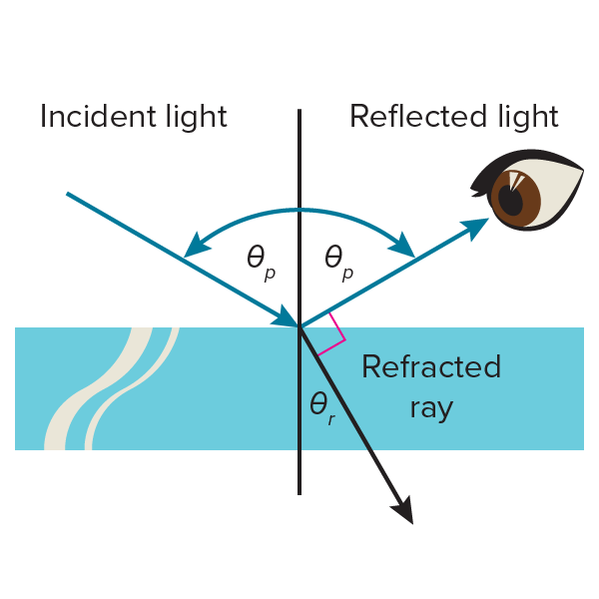

24. STRUCTURE The graph of y = $\frac{\cos^{2} x}{1 - sin x}$ is shown below on the left. The graph of y = sin x is shown below on the right. Use the graphs to write an identity involving $\frac{\cos^{2} x}{1 - sin x}$ and sin x. Then verify the identity.

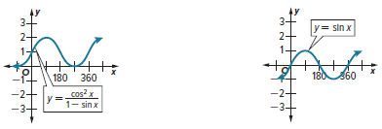

25. CONSTRUCT ARGUMENTS Show two different methods of verifying that $\frac{1}{1 - \sin^{2} θ}$ = $\tan^{2}$ $θ$ + 1 is a trigonometric identity.

Determine whether each equation is an identity. Justify your argument.
26. $\frac{tan\left(\frac{π}{2} - θ\right)csc θ}{\csc^{2} θ}$ = cos $θ$ 27. $\frac{1 + tan θ}{1 + cot θ}$ = tan $θ$ 28. sin $θ$ csc (–$θ$) = 1

29. $\frac{\sec^{2} θ - \tan^{2} θ}{\cos^{2} θ + \sin^{2} θ}$ = 1 30. tan $θ$ + cos $θ$ = sin $θ$ 31. cot (–$θ$) cot $\left(\frac{π}{2}-θ\right)$ = 1

32. sec $θ$ sin$\left(\frac{π}{2} - θ\right)$ = 1 33. $\frac{1 + \tan^{2} θ}{\csc^{2} θ}$ = $\sin^{2} θ$ 34. sec² (–$θ$) – tan² (–$θ$) = 1

35. REASONING Diego decides that if sin² A + cos² B = 1, and A and B both have measures between 0° and 180°, then A = B. Is he correct? Explain your reasoning.

36. USE TOOLS How can you use your calculator to show that the identity sin² $θ$ + csc² $θ$ = 1 is not an identity? Explain your reasoning.
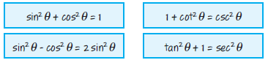
37. WHICH ONE DOESN’T BELONG? Identify the equation
that does not belong with the other three. Justify your conclusion.

38. PERSEVERE Transform the right side of tan² $θ$ = $\frac{\sin^{2} θ}{\cos^{2} θ}$ to show that tan² $θ$ = sec² $θ$ – 1.

39. ANALYZE Explain why sin² $θ$ + cos² $θ$ = 1 is an identity, but sin $θ$ = $\sqrt{1-\cos^{2} θ}$ is not.

40. WRITE A classmate is having trouble trying to verify a trigonometric identity. Write a question you could ask to help her work through the problem.

41. CREATE Let x = $\frac{1}{2}$ tan $θ$, where $-\frac{π}{2}$ < $θ$ < $\frac{π}{2}$. Write f(x) = $\frac{x}{\sqrt{1 + 4x^{2}}}$ in terms of a single trigonometric function of $θ$.

42. CREATE A statement such as cos $θ$ = 2 is a contradiction. Write two contradictions involving the sine or tangent function.

