Sum and Difference Identities ⸱ Practice

Examples 1 and 2
Find the exact value of each expression.
1. sin 135° 2. cos 165° 3. cos $\frac{7π}{12}$
4. sin $\frac{π}{12}$ 5. tan 195° 6. cos $\left(-\frac{π}{12}\right)$
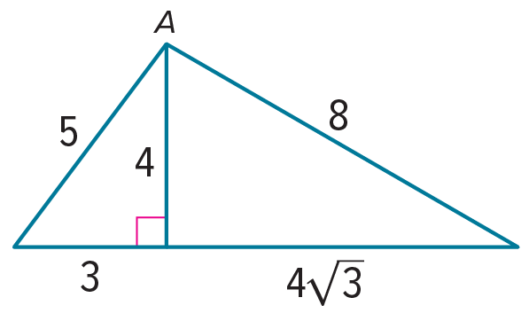
Example 3
7. ART As part of a mosaic that an artist is making, she places two right triangular tiles together to make a new triangular piece. One tile has lengths of 3 inches, 4 inches, and 5 inches. The other tile has lengths 4 inches, 4$\sqrt{3}$ inches, and 8 inches. The pieces are placed with the sides of 4 inches against each other as shown in the figure.
a. What is the exact values of sin A and cos A?
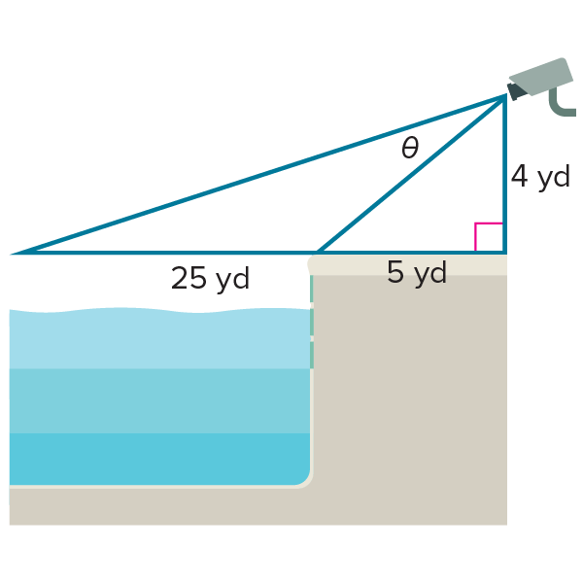
b. What is the measure of angle A?
c. Is the new triangle formed from the two triangular tiles also a right triangle? Explain.

8. CAMERAS Security cameras are being installed in the Community Center. One camera will be placed on the wall 4 yards above the pool deck. If the pool deck is 5 yards wide, through what angle $θ$ must the camera rotate to view the entire length of the pool? Round to the nearest tenth of a degree.

Examples 4 and 5
Verify that each equation is an identity.
9. cos $\left(\frac{π}{2}+θ\right)$ = –sin $θ$ 10. cos (60$°$ + $θ$) = sin (30$°$ – $θ$)

11. cos (180$°$ + $θ$) = –cos $θ$ 12. tan ($θ$ + 45$°$) = $\frac{1 + \tan{θ}}{1 -\tan{θ}}$

Mixed Exercises
Find the exact value of each expression.
13. sin 330° 14. cos (–165°)

15. sin (–225°) 16. cos 135°

17. sin (–45)° 18. cos 210°

19. cos (–135°) 20. tan 75°

21. sin (–195°) 22. sin 75°

23. cos (–225°) 24. tan 210°

25. sin $\frac{4π}{3}$ 26. sin $\frac{23π}{12}$

Verify that each equation is an identity.
27. sin (90° + $θ$) = cos $θ$ 28. sin (180° + $θ$) = –sin $θ$

29. cos (270° – $θ$) = –sin $θ$ 30. cos ($θ$ – 90°) = sin $θ$

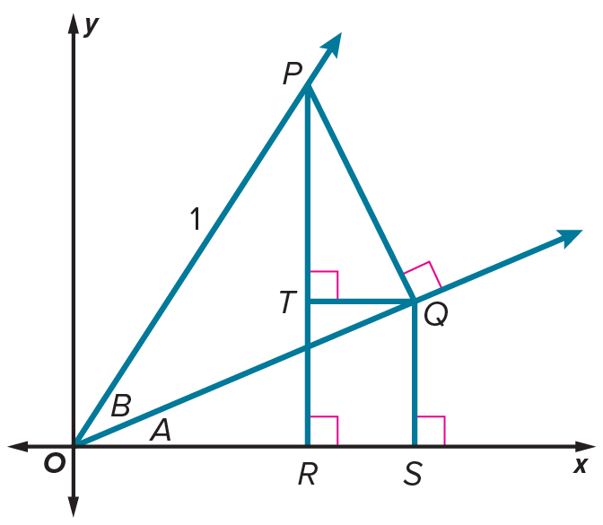
31. sin $\left(θ - \frac{π}{2}\right)$ = –cos $θ$ 32. cos ($π$ + $θ$) = –cos $θ$

33. CONSTRUCT ARGUMENTS You can use the figure to prove that cos (A + B) = cos A cos B – sin A sin B. Angle A was drawn in standard position and ∠B shares a side with the ∠A, as shown. P is a point on the side of the angle with measure A + B so that OP = 1. $\overline{PQ}$ is perpendicular to the terminal side of ∠A. $\overline{QS}$ is perpendicular to the x-axis. $\overline{QT}$ is perpendicular to $\overline{PR}$.
a. Find m∠TPQ. Justify your answer.
b. Explain how to write PQ and OQ in terms of sin B and/or
cos B. (Hint: Focus on △POQ.)
c. Use the side lengths of △QOS to write a ratio for cos A. Then use this, and the expressions for PQ and OQ from part b, to write an expression for OS that involves sines and/or cosines of A and/or B.
d. Use the side lengths of △TPQ to write a ratio for sin A. Then use this, and the expressions for PQ and OQ from part b, to write an expression for QT that involves sines and/or cosines of A and/or B.
e. Prove the sum formula for cosines by using your work in the previous steps.

Find the exact value of each expression.
34. tan 165° 35. sec 1275°

36. sin 735° 37. tan $\frac{23π}{12}$

38. csc $\frac{5π}{12}$ 39. cot $\frac{113π}{12}$

Verify that each equation is an identity.
40. sin (A + B) = $\frac{tan A + tan B}{sec A sec B}$ 41. cos (A + B) = $\frac{1 - tan A tan B}{sec A sec B}$

42. sec (A – B) = $\frac{sec A sec B}{1 + tan A tan B}$ 43. sin (A + B) sin (A – B) = sin² A – sin² B

44. CONSTRUCT ARGUMENTS Explain how to use the sum formula for cosines to prove the difference formula for cosines.

45. CONSTRUCT ARGUMENTS You can use the sum and difference formulas for sines and cosines to prove the sum and difference formulas for tangent.
a. Prove the sum formula for tangent.
b. Prove the difference formula for tangent.

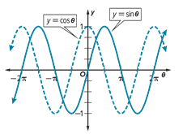
46. REASONING The figure shows the graphs of y = sin $θ$ and y = cos $θ$.
a. Explain how to use the graphs to find the value of h in the equation sin ($θ$ – h) = cos $θ$.
b. Use one or more sum or difference formulas to prove that you found the correct value of h.

47. STRUCTURE Show how to find the exact value of sin $\frac{13π}{12}$.
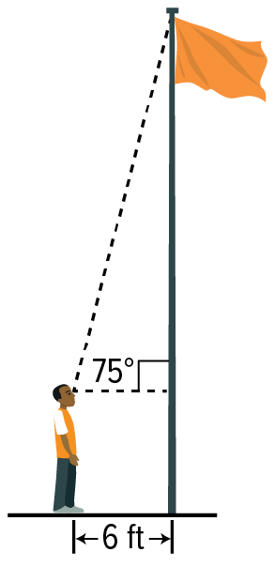
48. USE A MODEL Demetri stands 6 feet from the base of a flagpole and sights the top of the pole with an angle of elevation of 75$°$. His eyes are 5 feet above the ground. Find the exact height of the flagpole. Then find the height to the nearest tenth of a foot.

49. STRUCTURE Solve cos ($θ$ + $π$) = sin ($θ$ – $π$) algebraically, given that 0 ≤ $θ$ ≤ $π$. Explain your steps.
50. PRECISION Use sum or difference identities to prove that the equation cos $\left(\frac{π}{2}-θ\right)$ = sin $θ$ is an identity.

STRUCTURE Use sum or difference identities to write each expression as a single trigonometric expression. Then find the exact value of each expression.
51. sin 19° cos 11° + cos 19° sin 11° 52. $\frac{\tan{144°} –\tan{9°}}{1 + \tan{144°}\tan{9°}}$

53. cos 111° cos 21° + sin 111° sin 21° 54. sin 108° cos 18° – cos 108° sin 18°

55. $\frac{\tan{\frac{π}{16}} +\tan{\frac{3π}{16}}}{1 – \tan{\frac{π}{16}}\tan{\frac{3π}{16}}}$ 56. cos $\frac{π}{3}$ cos $\frac{2π}{3}$ – sin $\frac{π}{3}$ sin $\frac{2π}{3}$

57. ANALYZE Simplify the following expression without expanding any of the sums or differences.
sin $\left(\frac{π}{3}-θ\right)$ cos $\left(\frac{π}{3}+θ\right)$ – cos $\left(\frac{π}{3}-θ\right)$ sin $\left(\frac{π}{3}+θ\right)$
58. WRITE You may have experienced a wireless Internet provider temporarily losing the signal. Waves that pass through the same place at the same time cause interference. Interference occurs when two waves combine to have a greater, or smaller, amplitude than either of the component waves. Constructive interference occurs when two waves combine to have a greater amplitude than either of the component waves. Destructive interference occurs when the component waves combine to have a smaller amplitude. Explain how the sum and difference identities are used to describe wireless Internet interference. Include an explanation of the difference between constructive and destructive interference.
59. PERSEVERE Derive an identity for cot (A + B) in terms of cot A and cot B.

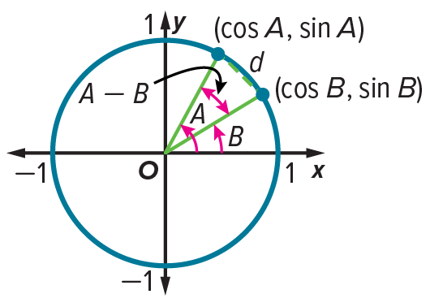
60. ANALYZE The top figure shows two angles A and B in standard position on the unit circle. In the bottom figure, an angle with measure A – B is in standard position.
a. Find d, where (x₁, y₁) = (cos B, sin B) and (x₂, y₂) = (cos A, sin A).
b. Find d when an angle with measure A – B is in standard position.
c. Find and simplify $d^{2}$ for each expression. Then equate the values of $d^{2}$ to
derive a formula for cos (A – B).

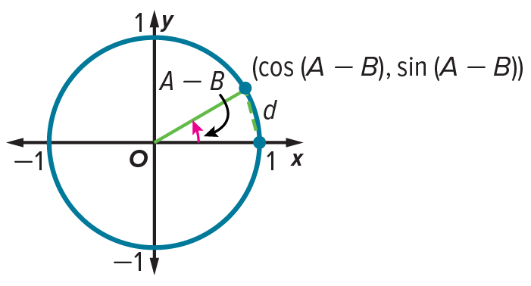

61. CREATE Consider the following theorem. If A, B, and C are the angles of an oblique triangle, then tan A + tan B + tan C = tan A tan B tan C. Choose values for A, B, and C. Verify that the conclusion is true for your specific values.
62. CREATE Write an expression that has an exact value of $\frac{\sqrt{6} - \sqrt{2}}{4}$.

63. PERSEVERE Verify that sin (90° – $θ$) = cos $θ$ is an identity using the Difference Identity.

