Double-Angle and Half-Angle Identities ⸱ Practice

Examples 1 and 3
Find the exact values of sin 2$θ$, cos 2$θ$, sin $\frac{θ}{2}$, and cos $\frac{θ}{2}$.
1. sin $θ$ = $\frac{2}{3}$; 90$°$ < $θ$ < 180$°$ 2. sin $θ$ = $-\frac{15}{17}$; $π$ < $θ$ < $\frac{3π}{2}$

3. cos $θ$ = $\frac{3}{5}$; $\frac{3π}{2}$ < $θ$ < 2$π$ 4. cos $θ$ = $\frac{1}{5}$; 270$°$ < $θ$ < 360$°$

5. tan $θ$ = $\frac{4}{3}$; 180$°$ < $θ$ < 270$°$ 6. tan $θ$ = $\frac{3}{5}$; $\frac{π}{2}$ < $θ$ < $π$

7. cos $θ$ = $\frac{7}{25}$, 0° < $θ$ < 90° 8. sin $θ$ = – $\frac{4}{5}$, 180° < $θ$ < 270°

9. sin $θ$ = $\frac{40}{41}$, 90° < $θ$ < 180° 10. cos $θ$ = $\frac{3}{7}$, 270° < $θ$ < 360°

Example 2
11. SOUND WAVES The sound waves produced by vibrating a tuning fork is represented by
S = 2 sin 2$θ$. Rewrite this formula in terms of S and $θ$.
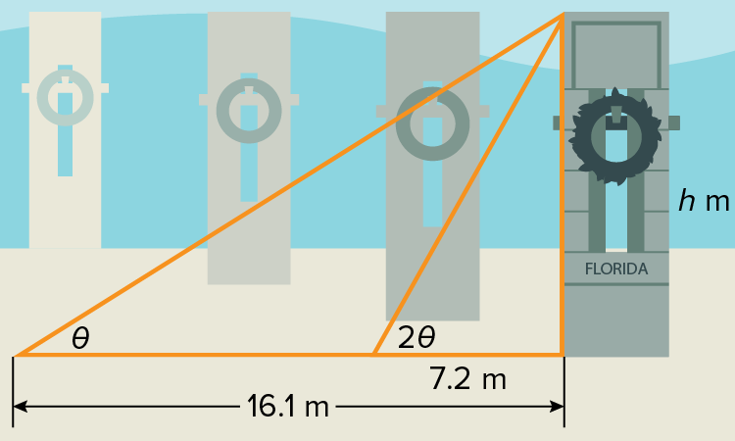
12. MONUMENTS The World War II Memorial consists of 56 granite pillars arranged around a plaza with two triumphal arches on opposite sides. When the shadow from one of the pillars is 16.1 meters long, the angle of elevation to the Sun is $θ$. When the shadow is 7.2 meters long, the angle of elevation is $2θ$. What is the height of the pillar?

Example 4
Find the exact value of each expression.
13. sin 75$°$ 14. sin $\frac{3π}{8}$ 15. sin $\frac{7π}{12}$

16. tan 165$°$ 17. tan $\frac{5π}{12}$ 18. tan 22.5$°$

19. cos 22.5° 20. sin 165° 21. cos 105°

22. sin $\frac{π}{8}$ 23. sin $\frac{15π }{8}$ 24. cos 75°

Mixed Exercises
Find the exact values of sin 2$θ$, cos 2$θ$, and tan 2$θ$.
25. cos $θ$ = $\frac{4}{5}$, 0° < $θ$ < 90° 26. sin $θ$ = $\frac{1}{3}$, 0 < $θ$ < $\frac{π}{2}$

27. tan $θ$ = –3, 90° < $θ$ < 180° 28. sec $θ$ = $-\frac{4}{3}$, 90° < $θ$ < 180°

29. csc $θ$ = – $\frac{5}{2}$, $\frac{3π}{2}$ < $θ$ < 2$π$ 30. cot $θ$ = $\frac{3}{2}$, 180° < $θ$ < 270°

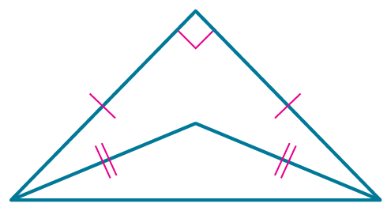
31. STRUCTURE The large triangle is an isosceles right triangle. The small triangle inside the large triangle was formed by bisecting each of the acute angles of the right triangle.
a. What are the exact values of sine and cosine for either of the congruent angles of the small triangle?
b. What are the exact values of sine and cosine for the obtuse angle of the small triangle?

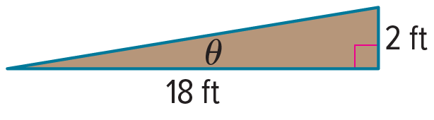
32. RAMPS A ramp for loading goods onto a truck was mistakenly built with the dimensions shown. The degree measure of the angle the ramp makes with the ground should have been twice the degree measure of the angle used.
a. Find the exact values of the sine and cosine of the angle the ramp should have made with the ground.
b. If the ramp had been built properly, what would the degree measures of the two acute angles have been?

33. Show how to find the exact value of sin 240° by each method indicated.
a. using a sum of angles formula b. using a difference of angles formula
c. using a double-angle formula d. using a half-angle formula

34. FIND THE ERROR Teresa and Armando are calculating the exact value of sin 15°. Is either of them correct? Explain your reasoning.
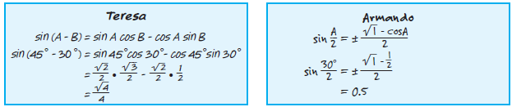
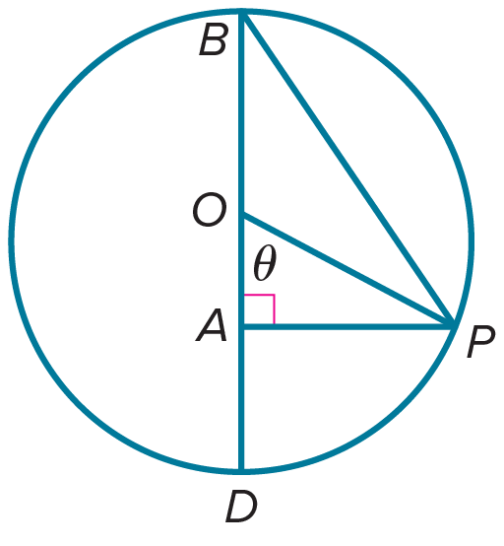
35. PERSEVERE Circle O is a unit circle. Use the figure to prove that tan $\frac{1}{2}θ$ = $\frac{sin θ}{1 + cos θ}$.

36. WRITE Write a short paragraph about the conditions under which you would use each of the three identities for cos 2$θ$.

37. PERSEVERE Use the sum identity for sin (A + B) to derive the double-angle identity for sin 2$θ$. Then use the sum identity for cos (A + B) to derive the double-angle identity for cos 2$θ$.

38. ANALYZE Derive the half-angle identities from the double-angle identities.

39. PERSEVERE Suppose a golfer consistently hits the ball so that it leaves the tee with an initial velocity of 115 feet per second. If d = $\frac{2v^{2} sin θ cos θ}{g},$ explain why the maximum distance is attained when $θ$ = 45°.

40. CREATE Choose an integer n greater than 2 and write an identity for a trigonometric ratio involving$nθ$.

