Solving Trigonometric Equations ⸱ Practice

Example 1
Solve each equation for the given interval.
1. cos² $θ$ = $\frac{1}{4}$; 0$°$ ≤ $θ$ ≤ 360$°$ 2. 2 sin² $θ$ = 1; 90$°$ ≤ $θ$ ≤ 270$°$

3. sin 2$θ$ – cos $θ$ = 0; 0 ≤ $θ$ ≤ 2$π$ 4. 3 sin² $θ$ = cos² $θ$; 0 ≤ $θ$ ≤ $\frac{π}{2}$

5. 2 sin $θ$ + $\sqrt{3}$ = 0; 180$°$ ≤ $θ$ ≤ 360$°$ 6. 4 sin² $θ$ – 1 = 0; 180$°$ ≤ $θ$ ≤ 360$°$

Example 2
Solve each equation for all values of $θ$ if $θ$ is measured in radians.
7. cos 2$θ$ + 3 cos $θ$ = 1 8. 2 sin² $θ$ = cos $θ$ + 1

9. cos² $θ$ – $\frac{3}{2}$ = $\frac{5}{2}$ cos $θ$ 10. 3 cos $θ$ – cos $θ$ = 2

Solve each equation for all values of $θ$ if $θ$ is measured in degrees.
11. sin $θ$ – cos $θ$ = 0 12. tan $θ$ – sin $θ$ = 0

13. sin² $θ$ = 2 sin $θ$ + 3 14. 4 sin² $θ$ = 4 sin $θ$ – 1

Example 3
15. SANDCASTLES The water level on Sunset Beach can be modeled by the function y = 7 + 7 sin $\frac{π}{6}t$, where y is the distance in feet of the waterline above the low tide mark and t is the number of hours past 6 A.M. At 2 P.M., Nashiko built her sandcastle 10 feet above the low tide mark. At what time will the waterline reach Nashiko’s sandcastle?

16. BATTERY The light of a battery indicator bulb pulses while the battery is charging. This can be modeled by the equation y = 60 + 60 sin $\frac{π}{4}t$, where y is the lumens emitted from the bulb and t is the number of seconds since the beginning of a pulse. At what time will the amount of light emitted be equal to 110 lumens?
Example 4
17. Solve 3 csc $θ$ ≤ 2 for 0° ≤ θ ≤ 360°. 18. Solve $\sqrt{3}$ sec $θ$ ≤ 2 for 0° ≤ θ ≤ 360°.

Example 5
Solve each equation over the given interval.
19. cos $θ$ + 1 = sin $θ$; [0, 2$π$) 20. cos $θ$ + sin $θ$ = 1; [0, 2$π$)

21. 1 – cos $θ$ = $\sqrt{3}$ sin $θ$; [0, 2$π$) 22. tan $\left(\frac{θ}{2}\right)$ – 1 = 0; [0, 2$π$)

Example 6
Solve each equation for $θ$ with $θ$ measured in degrees.
23. sin $θ$ + $\sqrt{2}$ = – sin $θ$ 24. tan 3$θ$ = 1

Mixed Exercises
Solve each equation for the given interval.
25. sin $θ$ = $\frac{\sqrt{2}}{2}$, 0° ≤ $θ$ ≤ 360° 26. 2 cos $θ$ = – $\sqrt{3}$, 90° < $θ$ < 180°

27. $\tan^{2}$ $θ$ = 1, 180° < $θ$ < 360° 28. 2 sin $θ$ = 1, 0 ≤ $θ$ < π

29. $\sin^{2}$ $θ$ + sin $θ$ = 0, π ≤ $θ$ < 2π 30. 2 $\cos^{2}$ $θ$ + cos $θ$ = 0, 0 ≤ $θ$ < π

Solve each equation for all values of $θ$ if $θ$ is measured in radians.
31. 2 $\cos^{2}$ $θ$ – cos $θ$ = 1 32. $\sin^{2}$ $θ$ – 2 sin $θ$ + 1 = 0

33. sin $θ$ + sin $θ$ cos $θ$ = 0 34. $\sin^{2}$ $θ$ = 1

35. 4 cos $θ$ = –1 + 2 cos $θ$ 36. tan $θ$ cos $θ$ = $\frac{1}{2}$

Solve each equation for all values of $θ$ if $θ$ is measured in degrees.
37. 2 sin $θ$ + 1 = 0 38. 2 cos $θ$ + $\sqrt{3}$ = 0

39. $\sqrt{2}$ sin $θ$ + 1 = 0 40. 4 $\sin^{2}$ $θ$ = 3

41. 2 $\cos^{2}$ $θ$ = 1 42. cos 2$θ$ = –1

Solve each equation.
43. 3 $\cos^{2}$ $θ$ – $\sin^{2}$ $θ$ = 0 44. sin $θ$ + sin 2$θ$ = 0

45. 2 $\sin^{2}$ $θ$ = sin $θ$ + 1 46. cos $θ$ + sec $θ$ = 2

47. Find all solutions for sin $θ$ = cos 2$θ$ if 0° ≤ $θ$ < 360°.

48. Find all solutions for 4 $\cos^{2}$ $θ$ = 1 if 0 ≤ $θ$ < 2π.

49. Solve cos 2$θ$ = cos $θ$ for all values of $θ$ if $θ$ is measured in degrees.

50. Solve cos 2$θ$ = 3 sin $θ$ – 1 for all values of $θ$ if $θ$ is measured in radians.

51. SOUND The sound from stringed instruments is generated by waves that travel along the strings. The wave traveling on a guitar string can be modeled by D = 0.5 sin (6.5x)° sin (2500t)°, where D is the displacement in millimeters at the position x millimeters from the bridge of the guitar at time t seconds. Find the first positive time when the point 50 centimeters from the bridge has a displacement of 0.01 millimeter.

52. RIDES The original Ferris wheel had a diameter of about 260 feet and would make a complete revolution in 9 minutes. The motion of the wheel can be modeled by h = 134 – 130 cos $\frac{2πt}{9}$, where h is the height of the rider in feet above the ground t minutes after they begin the ride. When is the rider about 175 feet above the ground?

53. USE A MODEL The table shows the number of hours of daylight on various days of the year in Seattle, Washington. The function f(x) = 3.725 sin (0.016x − 1.180) + 11.932 models the number of hours of daylight in Seattle on day x of the calendar year.
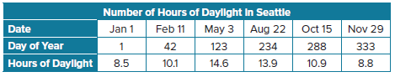
a. What is the maximum value of f(x)? What does this tell you?

b. During what period of the year does Seattle get more than 14 hours of daylight per day? Explain.

54. USE A SOURCE Research the outside temperature several times during the day. Make a table of the data, where x is the number of hours since midnight and y is the temperature in degrees Fahrenheit. Use the data and your calculator to write a sine function T(x) that models the temperature. Approximate the high temperature for the day. At approximately what time did the high temperature occur? Justify your reasoning.

55. BUSINESS Carissa has a small business installing and repairing air conditioners. She has kept track of her monthly profit since she started the business. The function
P(x) = 1808.831 sin (0.543x − 2.455) + 1942.476 models the monthly profit in dollars, x months since Carissa started the business.
a. Determine the approximate period of the function. What does this tell you about Carissa’s business?
b. Next month will mark the 6th anniversary of the day that Carissa started the business. What profit should she expect to make next month? Explain.

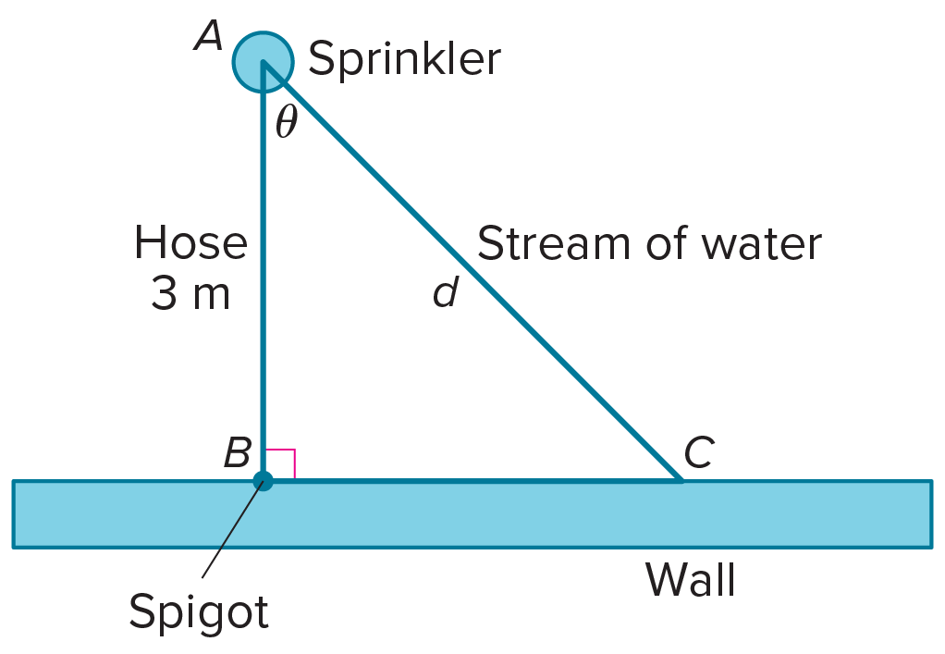
56. STRUCTURE A garden sprinkler is attached to a spigot by a straight hose that is 3 meters long. The sprinkler makes 6 complete rotations every minute. As it rotates, it sprays a stream of water that hits the wall, as shown. Let d be the length of the stream of water from the sprinkler to the wall, and assume the stream of water hits the spigot when the sprinkler is first turned on. The function d(x) = 3 sec $\frac{π}{5}$x models the length of the stream in meters as a function of the time x in seconds. After the sprinkler is turned on, what is the first time when the stream of water that strikes the wall is 5 meters long?

57. PERSEVERE Solve sin 2x < sin x for 0 ≤ x ≤ 2π without a calculator.

58. ANALYZE Compare and contrast solving trigonometric equations with solving linear and quadratic equations. What techniques are the same? What techniques are different? How many solutions do you expect?

59. WRITE Why do trigonometric equations often have infinitely many solutions?

60. CREATE Write an example of a trigonometric equation that has exactly two solutions if 0° ≤ $θ$ ≤ 360°.

61. PERSEVERE How many solutions in the interval 0° ≤ $θ$ < 360° should you expect for
a sin (b$θ$ + c) = d, if a ≠ 0 and b is a positive integer?

62. FIND THE ERROR Ms. Rollins divided her students into four groups, asking each to solve the equation sin $θ$ cot $θ$ = $\cos^{2}$ $θ$. Do any of the groups have the correct solution? Explain your reasoning.
