Graphing Quadratic Functions ⸱ Practice

Example 1
Graph each function. Then state the domain and range.
1. f(x) = x² + 6x + 8 2. f(x) = –x² – 2x + 2 3. f(x) = 2x² – 4x + 3

4. f(x) = –2x² 5. f(x) = x² – 4x + 4 6. f(x) = x² – 6x + 8

Example 2
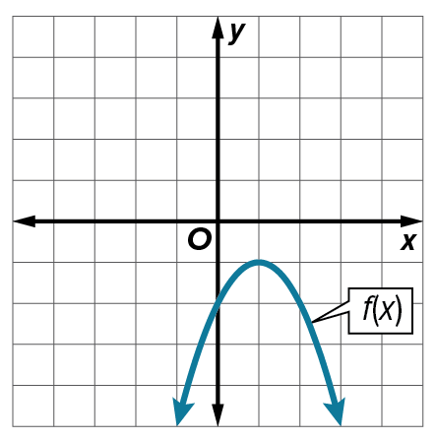
7. Compare the graph of f(x) to a quadratic function g(x) with a y-intercept of 1 and a vertex at (1, 3). Which function has a greater maximum? Explain.

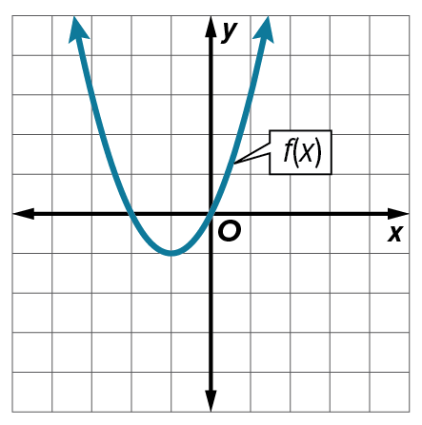
8. Compare the graph of f(x) to a quadratic function g(x) with a y-intercept of 0.5 and a vertex at (‒1, ‒5). Which function has a lesser minimum? Explain.

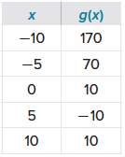
9. Compare f(x) = x² ‒ 10x + 5 to the quadratic function g(x) shown in the table. Which function has the lesser minimum? Explain.

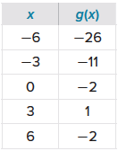
10. Compare f(x) = ‒x² + 6x ‒ 15 to the quadratic function g(x) shown in the table. Which function has the greater maximum? Explain.

Example 3
11. FISHING A county park sells annual permits to its fishing lake. Last year, the county sold 480 fishing permits at $80. This year, the park is considering a price increase. They estimate that for each $4 increase, they will sell 16 fewer
annual fishing permits.
a. Define variables and write a function to represent the situation.
b. How much would the park have to charge for each permit in order to maximize its revenue from fishing permits?
b. Find the domain and range in the context of this situation.

12. SALES Last month, a retailer sold 120 jar candles at $30 per candle. This month the retailer is considering putting the candles on sale. They estimate that for each $2 decrease in price, they will sell 10 additional candles.
a. How much should the retailer charge for each candle in order to maximize its profit?
b. Find the domain and the range in the context of this situation.
Example 4
Determine the average rate of change of f(x) over the specified interval.
13. f(x) = x² ‒ 10x + 5; interval ​​[–4, 4] 14. f(x) = 2x² + 4x ‒ 6; interval ​​[–3, 3]

15. f(x) = 3x² ‒ 3x + 1; interval ​​[–5, 5] 16. f(x) = 4x² + x + 3; interval ​​[–2, 2]

17. f(x) = 2x² ‒ 11; interval ​​[–3, 3] 18. f(x) = ‒2x² + 8x + 7; interval ​​[–4, 4]

Example 5
Determine the average rate of change of f(x) over the specified interval.
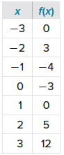
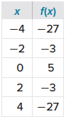
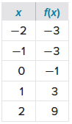
19. interval ​​[–3, 3] 20. interval ​​[–4, 4] 21. interval ​​[–2, 2]

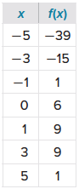
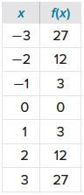
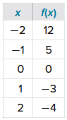
22. interval ​​[–5, 5] 23. interval ​​[–3, 3] 24. interval ​​[–2, 2]

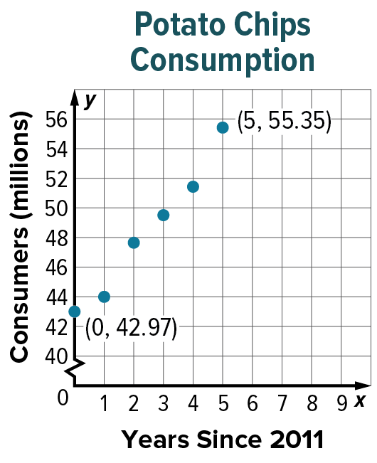
Example 6
25. FOOD The graph shows the number of people in the U.S. who consumed between 8 and 11 bags of potato chips in a year since 2011.
a. Use the graph to estimate the average rate of change of consumption from 2011 to 2016. Then check your results algebraically.

b. Interpret your results in the context of the situation.

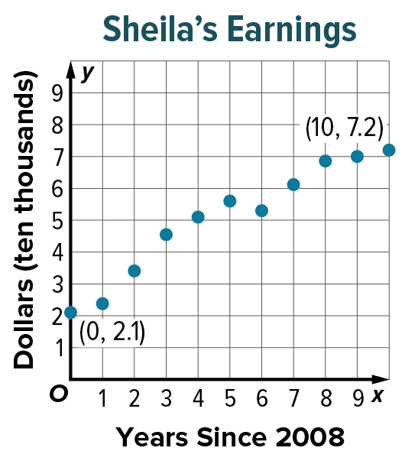
26. EARNINGS The graph shows the amount of money Sheila earned each year since 2008.
a. Use the graph to estimate the average rate of change of
Sheila’s earnings from 2008 to 2018. Then check your
results algebraically.
b. Interpret your results in the context of the situation.

Mixed Exercises
Complete parts a–c for each quadratic function.
a. Find the y-intercept, the equation of the axis of symmetry, and the
x-coordinate of the vertex.
b. Make a table of values that includes the vertex.
c. Use this information to graph the function.

27. f(x) = 2x² ‒ 6x ‒ 9 28. f(x) = ‒3x² ‒ 9x + 2 29. f(x) = ‒4x² + 5x

30. f(x) = 2x² + 11x 31. f(x) = 0.25x² + 3x + 4 32. f(x) = ‒0.75x² + 4x + 6

Determine whether each function has a maximum or a minimum value. Then find
and use the x-coordinate of the vertex to determine the maximum or minimum.
33. f(x) = ‒9x² ‒ 12x + 19 34. f(x) = 7x² ‒ 21x + 8

35. f(x) = ‒5x² + 14x ‒ 6 36. f(x) = 2x² ‒ 13x ‒ 9

37. f(x) = 9x ‒ 1 ‒ 18x² 38. f(x) = ‒16 ‒ 18x ‒ 12x²

39. HEALTH CLUBS Last year, the Sports Time Athletic Club charged $20 per month to participate in an aerobics class. Seventy people attended the classes. The club wants to increase the class price. They expect to lose one customer for each $1 increase in the price.
a. Define variables and write an equation for a function that represents the situation. Make a table and graph the function.
b. Find the vertex of the function and interpret it in the context of the situation. Does it seem reasonable? Explain.

40. TICKETS The manager of a community symphony estimates that the symphony will earn –40P² + 1100P dollars per concert if they charge P dollars for tickets. What ticket price should the symphony charge in order to maximize its profits?

41. REASONING On Friday nights, the local cinema typically sells 200 tickets at $6.00 each. The manager estimates that for each $0.50 increase in the ticket price, 10 fewer people will come to the cinema.
a. Define the variables x and y. Then write and graph a function to represent the expected revenue from ticket sales, and determine the domain of the function for the situation.
b. What price should the manager set for a ticket in order to maximize the revenue? Justify your reasoning.
c. Explain why the graph decreases from x = 4 to x = 20, and interpret the meaning of the
x-intercept of the graph.

42. USE A MODEL From 4 feet above a swimming pool, Tomas throws a ball upward with a velocity of
32 feet per second. The height h(t) of the ball t seconds after Tomas throws it is given by

h(t) = –16t² + 32t + 4. For t ≥ 0, find the maximum height reached by the ball and the time that this height is reached.

43. TRAJECTORIES At a special ceremonial reenactment, a cannonball is launched from a cannon on the wall of Fort Chambly, Quebec. If the path of the cannonball is traced on a graph so that the cannon is situated on the y-axis, the equation that describes the path is y = $-\frac{1}{1600}x^{2}+\frac{1}{2}x+20,$ where x is the horizontal distance from the cliff and y is the vertical distance above the ground in feet. How high above the ground is the cannon?
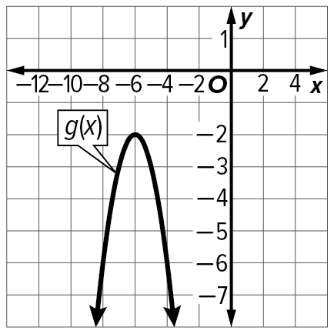
44. CONSTRUCT ARGUMENTS Which function has a greater maximum: f(x) = ‒2x² + 6x ‒ 7 or the function shown in the graph at the right? Explain your reasoning using a graph.

45. FIND THE ERROR Lucas thinks that the function f(x) and g(x) have the same maximum. Madison thinks that g(x) has a greater maximum. Is either of them correct? Explain your reasoning.
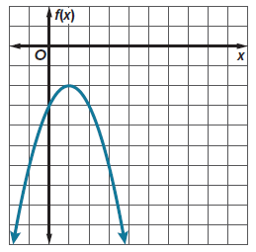
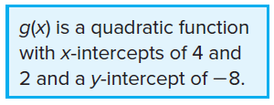

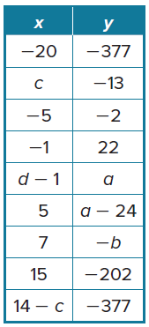
46. PERSEVERE The table at the right represents some points on the graph of a
quadratic function.
a. Find the values of a, b, c, and d.
b. What is the x-coordinate of the vertex of the function?
c. Does the function have a maximum or a minimum?

47. WRITE Describe how you determine whether a function is quadratic and if it
has a maximum or minimum value?

48. CREATE Give an example of a quadratic function with each characteristic.
a. maximum of 8 b. minimum of ‒4 c. vertex of (‒2, 6)

