Solving Quadratic Equations by Graphing ⸱ Practice

Example 1
Use the related graph of each equation to determine its solutions.
1. x² + 2x + 3 = 0 2. x² ‒ 3x ‒ 10 = 0 3. –x² ‒ 8x – 16 = 0
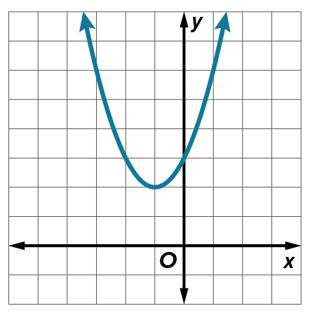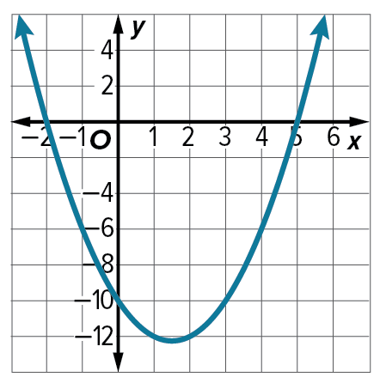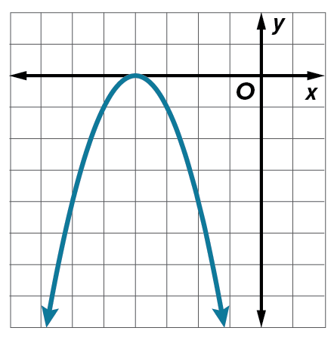

Solve each equation by graphing.
4. x² ‒ 10x + 21 = 0 5. 4x² + 4x + 1 = 0 6. x² + x ‒ 6 = 0

7. x² + 2x ‒ 3 = 0 8. ‒x² ‒ 6x ‒ 9 = 0 9. x² ‒ 6x + 5 = 0

10. x² + 2x + 3 = 0 11. x² ‒ 3x ‒ 10 = 0 12. ‒x² ‒ 8x ‒ 16 = 0

Example 2
13. Use a quadratic equation to find two real numbers with a sum of 2 and a product of ‒24.

14. Use a quadratic equation to find two real numbers with a sum of ‒15 and a product of ‒54.

Example 3
Solve each equation by graphing. If the exact roots cannot be found, state the consecutive integers between which the roots are located.
15. x² ‒ 4x + 2 = 0 16. x² + 6x + 6 = 0 17. x² + 4x + 2 = 0

18. ‒x² ‒ 4x = 0 19. ‒x² + 36 = 0 20. x² ‒ 6x + 4 = 0

21. x² + 5x + 3 = 0 22. x² ‒ 7 = 0 23. ‒x² ‒ 4x ‒ 6 = 0

Example 4
Use the tables to determine the location of the zeros of each quadratic function. State the

consecutive integers between which the roots are located.
24.

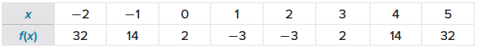
25.


26.

Use a table to solve each equation. If the exact roots cannot be found, approximate the roots to the nearest hundredth.
27. ‒3x² + 3 = 0 28. x² ‒ 3x + 2 = 0 29. $-\frac{1}{2}x^{2}+x+\frac{5}{2}$ = 0

30. x² ‒ 2x ‒ 2 = 0 31. ‒x² + 2x + 4 = 0 32. 2x² ‒ 12x + 17 = 0

Example 5
PHYSICS Use the formula h(t) = ${-{16t}^{2}+v}_{0}t+h_{0}$, where h(t) is the height of an object in feet, $v_{0}$ is the object’s initial velocity in feet per second, t is the time in seconds, and $h_{0}$ is the initial height in feet from which the object is launched. Round to the nearest tenth, if necessary.
33. Melah throws a baseball with an initial upward velocity of 32 feet per second. The baseball is released from Melah’s hand at a height of 4 feet. Use a graphing calculator to determine how long it will take the ball to hit the ground.

34. A punter kicks a football with an initial upward velocity of 60 feet per second. The ball is 2 feet above the ground when his foot meets the ball. Use a graphing calculator to determine how long will it take the ball to hit the ground.

Mixed Exercises
Solve each equation by graphing. If the exact roots cannot be found, state the consecutive integers between which the roots are located.
35. 4x² ‒ 15 = ‒4x 36. ‒35 = ‒3x ‒ 2x² 37. ‒3x² + 11x + 9 = 1

38. ‒4x² = 12x + 8 39. ‒0.5x² + 18 = ‒6x + 33 40. 0.5x² + 0.75 = 0.25x

41. 3x² + 8x = 0 42. 2x² + x = 11 43. ‒0.1x² + 0.5x + 10 = 0

Use a graph or table to solve each equation. If exact roots cannot be found, state the consecutive
integers between which the roots are located.
44. x² + 4x = 0 45. –2x² ‒ 4x ‒ 5 = 0 46. 0.5x² ‒ 2x + 2 = 0

47. –0.25x² – x – 1= 0 48. x² ‒ 6x + 11 = 0 49. –0.5x² + x + 6 = 0

REGULARITY Use a quadratic equation to find two real numbers that satisfy each situation, or show that no such numbers exist.
50. Their sum is 4, and their product is ‒117.

51. Their sum is 12, and their product is ‒85.

52. Their sum is ‒13, and their product is 42.

53. Their sum is ‒8, and their product is ‒209.

54. BRIDGES In 1895, a brick arch railway bridge was built on North Avenue in Baltimore, Maryland. The arch is described by the equation h = $9 –\frac{1}{50}x^{2}$, where h is the height in yards and x is the distance in yards from the center of the bridge. Graph this equation and describe, to the nearest yard, where the bridge touches the ground.

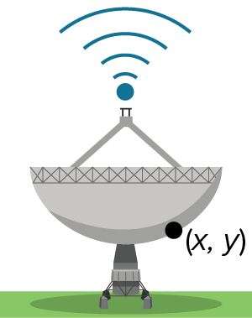
55. RADIO TELESCOPES The cross section of a large radio telescope is a parabola. The equation that describes the cross-section is y = $\frac{2}{75}x^{2}-\frac{4}{3}x-\frac{32}{3}$, where y is the depth of the dish in meters at a point x meters from the center of the dish.
If the dish does not extend above the ground level, what is the diameter of the
dish? Solve by graphing.

56. VOLCANOES A volcanic eruption blasts a boulder upward with an initial velocity of 240 feet per second. The height h(t) of the boulder in feet, t seconds after the eruption can be modeled by the function h(t) = ${-{16t}^{2}+v}_{0}t$. How long will it take the boulder to hit the ground if it lands at the same elevation from which it was ejected?

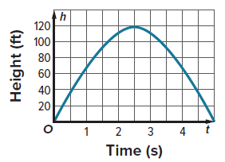
57. TRAJECTORIES Daniela hit a golf ball from ground level. The function
h = 80t – 16t² represents the height of the ball in feet, where t is the time in seconds after Daniela hit it. Use the graph of the function to determine how long it took for the ball to reach the ground.

58. HIKING Antonia is hiking and reaches a steep part of the trail that
runs along the edge of a cliff. In order to descend more safely, she drops her heavy backpack over the edge of the cliff so that it will land on a lower part of the trail, 38.75 feet below. The height h(t) of an object t seconds after it is dropped straight down can also be modeled by the function h(t) = ${-{16t}^{2}+v}_{0}t+h_{0}$, where
v₀ is the initial velocity of the object, and h₀ is the initial height.
a. Write a quadratic function that can be used to determine the amount of time t that it takes for the backpack to land on the trail below the cliff after Antonia drops it.

b. Use a graphing calculator to determine how long until the backpack hits the ground. Round to the nearest tenth.

59. FIND THE ERROR Hakeem and Nandi were asked to find the location of the roots of the quadratic function represented by the table. Is either of them correct? Explain.

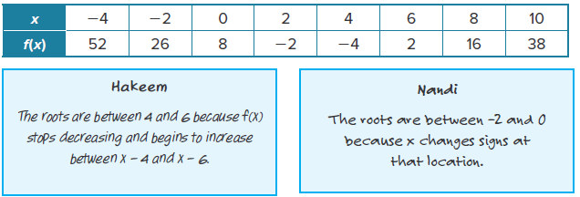

60. PERSEVERE Find the value of a positive integer k such that f(x) = x² ‒ 2kx + 55 has roots at k + 3 and k ‒ 3.

61. ANALYZE If a quadratic function has a minimum at (‒6, ‒14) and a root at x = ‒17, what is the other root? Explain your reasoning.

62. CREATE Write a quadratic function with a maximum at (3, 125) and roots at ‒2 and 8.

63. WRITE Explain how to solve a quadratic equation by graphing its related quadratic function.

