Solving Quadratic Equations by Completing the Square ⸱ Practice

Exampled 1-3
Solve each equation by using the Square Root Property.
1. x² – 18x + 81 = 49 2. x² + 20x + 100 = 64 3. 9x² – 12x + 4 = 4

4. 4x² + 4x + 1 = 16 5. 4x² – 28x + 49 = 64 6. 16x² + 24x + 9 = 81

7. 36x² + 12x + 1 = 18 8. 25x² + 40x + 16 = 28 9. 25x² + 20x + 4 = 75

10. 36x² + 48x + 16 = 12 11. 25x² – 30x + 9 = 96 12. 4x² – 20x + 25 = 32

13. 2x² – 20x + 50 = –128 14. 2x² –24x + 72 = –162 15. 2x² + 28x + 98 = –200

16. x² – 8x + 16 = –36 17. 3x² + 24x + 48 = –108 18. 3x² – 24x + 48 = –363

Example 4
Find the value of c that makes each trinomial a perfect square. Then write the trinomial as a perfect square trinomial.
19. x² + 10x + c 20. x² – 14x + c 21. x² + 24x + c

22. x² + 5x + c 23. x² – 9x + c 24. x² – x + c

Example 5 and 6
Solve each equation by completing the square.
25. x² – 13x + 36 = 0 26. x² + x – 6 = 0 27. x² – 4x – 13 = 0

28. x² + 3x – 6 = 0 29. x² – x – 3 = 0 30. x² – 8x – 65 = 0

31. When the dimensions of a cube are reduced by 4 inches on each side, the surface area of the new cube is 864 square inches. What were the dimensions of the original cube?

Example 7 and 8
Solve each equation by completing the square.
32. 2x² – 8x – 24 = 0 33. 2x² – 3x + 1 = 0 34. 2x² – 13x – 7 = 0

35. 25x² + 40x – 9 = 0 36. 2x² + 7x – 4 = 0 37. 3x² + 2x – 1 = 0

38. x² – 4x + 12 = 0 39. 2x² – 3x + 5 = 0 40. 2x² + 5x + 7 = 0

41. x² – 2x + 3 = 0 42. x² = –24 43. x² – 2x + 4 = 0

Examples 9 and 10
Write each function in vertex form. Find the axis of symmetry. Then find the vertex, and determine if it is a maximum or minimum.
44. y = x² + 2x – 5 45. y = x² + 6x + 1 46. y = –x² + 4x + 2

47. y = –x² – 8x – 5 48. y = 2x² + 4x + 3 49. y = 3x² + 6x – 1

Example 11
50. FIREWORKS The height of a firework at an amusement park celebration can be modeled by a quadratic function. Suppose the firework is launched from a platform 2 feet off the ground at a velocity of 96 feet per second. Hint: Use $h\left(t\right)=-\frac{1}{2}gt^{2}+vt+h_{0}$, where g = 32 $\frac{ft}{s^{2}}$.

a. Write a function to represent this situation.
b. Rewrite the function in vertex form.
c. Find the axis of symmetry and the vertex and interpret their meaning in the context of the situation.

51. DIVING Malik is participating in a diving championship. For each of his dives, his height above the water can be modeled by a quadratic function. The diving board is 7.5 meters above the water and Malik jumps with a velocity of 4.18 meters per second.
Use $h\left(t\right)=-\frac{1}{2}gt^{2}+vt+h_{0}$, where g = 9.8 $\frac{m}{s^{2}}$.
a. Write a function in vertex form to represent this situation.
b. Find the axis of symmetry and the vertex and interpret their meaning in the context of the situation.

Mixed Exercises
PRECISION Solve each equation. Round to the nearest hundredth, if necessary.

52. 4x² ‒ 28x + 49 = 5
55. x² + 1.2x + 0.56 = 0.91
58. x² ‒ 1.8x + 11.24 = 2.43
53. 9x² + 30x + 25 = 11
56. x² + 0.7x + 4.1225 = 0
59. –0.3x² – 0.78x – 5.514 = 0
54. x² + x + $\frac{1}{3}$ = $\frac{2}{3}$
57. x² ‒ 3.2x = –3.46
60. 1.1x² ‒ 8.8x + 22 = 2.2

61 . FREE FALL A rock falls from the top of a cliff that is 25.8 meters high. Use the formula
$h\left(t\right)=-\frac{1}{2}gt^{2}+vt+h_{0}$, where g = 9.8 $\frac{m}{s^{2}}$, to write a quadratic function that models the situation. Determine to the nearest tenth of a second the amount of time it takes the rock to strike the ground. Explain your reasoning.

62. REACTION TIME Tela was eating lunch when she saw her friend Jori approach. The room was crowded and Jori had to lift his tray to avoid obstacles. Suddenly, a glass on Jori's lunch tray tipped and fell off the tray. Tela lunged forward and managed to catch the glass just before it hit the ground. The height h, in feet, of the glass t seconds after it was dropped is given by
h = –16t² + 4.5. If Tela caught the glass when it was six inches off the ground, how long was the glass in the air before she caught it?

63. INVESTMENTS The amount of money A in an account in which P dollars are invested for 2 years is given by the formula A = P(1 + r)², where r is the interest rate compounded annually. If an investment of $800 in the account grows to $882 in two years, at what interest rate was it invested, to the nearest percent?

64. INVESTMENTS Niyati invested $1000 in a savings account with interest compounded annually. After two years the balance in the account is $1210. Use the compound interest formula
A = P(1 + r)^{t} to find the annual interest rate, to the nearest percent.

Write each function in vertex form. Then find the vertex.
65. y = x² – 10x + 28 66. y = x² + 16x + 65

67. y = x² – 20x + 104 68. y = x² – 8x + 17

69. AUDITORIUM SEATING The seats in an auditorium are arranged in a square grid pattern. There are 45 rows and 45 columns of chairs. For a special concert, organizers decide to increase seating by adding n rows and adding n columns to make a square pattern of seating 45 + n seats on a side.
a. How many seats are added in the expansion?

b. What is n if organizers wish to add 1000 seats?

70. DECK DESIGN The Rayburns current deck is 12 feet by 12 feet. They decide they would like to expand their deck and maintain its square shape. How much larger will each side need to be for the deck to have an area of 200 square feet?

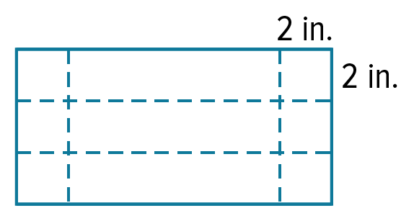
71. VOLUME A piece of sheet metal has a length that is three times its width. It is used to make a box with an open top by cutting out 2-inch by 2-inch squares from each corner, then folding up the sides.

a. Define variables and write a quadratic function that represents the volume of the box in cubic inches.

b. What are the dimensions of the metal sheet that results in a box with a volume of 1.125 cubic feet?

72. CONSTRUCT ARGUMENTS Explain why the equation for the axis of symmetry for
a quadratic function y = ax² + bx + c is x = $-\frac{b}{2a}$.

73. FIND THE ERROR Alonso and Aika are solving x² + 8x – 20 = 0 by completing the square. Is either of them correct? Explain your reasoning.

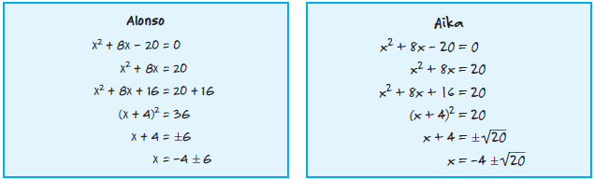

74. PERSEVERE Solve x² + bx + c = 0 by completing the square. Your answer will be an expression for x in terms of b and c.

75. ANALYZE Without solving, determine how many unique solutions there are for each equation. Are they rational, real, or complex? Justify your reasoning.
a. (x + 2)² = 16 b. (x ‒ 2)² = 16 c. ‒(x ‒ 2)² = 16

d. 36 ‒ (x ‒ 2)² = 16 e. 16(x + 2)² = 0 f. (x + 4)² = (x + 6)²

76. CREATE Write a perfect square trinomial equation in which the linear coefficient is negative and the constant term is a fraction. Then solve the equation.

77. WRITE Explain what is means to complete the square. Describe each step.

