Using the Quadratic Formula and the Discriminant ⸱ Practice

Example 1
Solve each equation by using the Quadratic Formula.
1. x² + 8x + 15 = 0 2. x² – 18x + 72 = 0

3. 12x² – 22x + 6 = 0 4. 4x² – 6x = –2

5. x² + 8x + 5 = 0 6. –8x² + 4x = –5

7. FOOTBALL A quarterback throws a football to a receiver. The path of a football can be modeled by the quadratic function h = –16t² + 45t + 4, where h is the height in feet and t is the number of seconds after the football is thrown. If the ball is overthrown and the receiver does not touch the ball, how long will it take the football to hit the ground?

Example 2 and 3
Solve each equation by using the Quadratic Formula.
8. x² + 2x – 35 = 0 9. 4x² + 19x – 5 = 0

10. 2x² – x – 15 = 0 11. 3x² + 5x = 2

12. x² + x – 8 = 0 13. 8x² + 5x – 1 = 0

14. x² – x – 5 = 0 15. 16x² – 24x – 25 = 0

16. x² – 6x + 21 = 0 17. x² + 25 = 0

18. 3x² + 36 = 0 19. 8x² – 4x + 1 = 0

20. 2x² + 2x + 3 = 0 21. x² – 14x + 53 = 0

22. 4x² + 2x + 9 = 0 23. 3x² – 6x + 11 = 0

Examples 4 and 5
Find the value of the discriminant for each quadratic equation. Then describe the number and type of roots for the equation.

24. x² – 8x + 16 = 0 25. x² – 11x – 26 = 0

26. 3x² – 2x = 0 27. 20x² + 7x – 3 = 0

28. 5x² – 6 = 0 29. x² – 6 = 0

30. x² + 8x + 13 = 0 31. 5x² – x – 1 = 0

32. x² – 2x – 17 = 0 33. x² + 49 = 0

34. x² – x + 1 = 0 35. 2x² – 3x = –2

Mixed Exercises
REGULARITY Describe the discriminant of the related equation of each graph. Then determine the type and number of roots.

36. 37. 38.
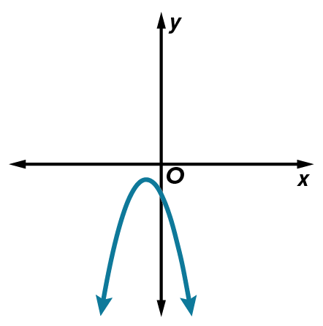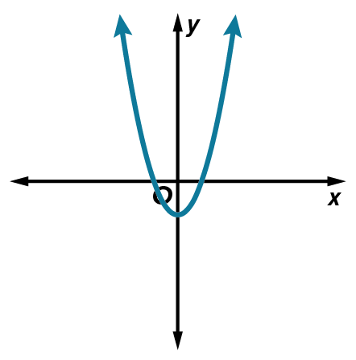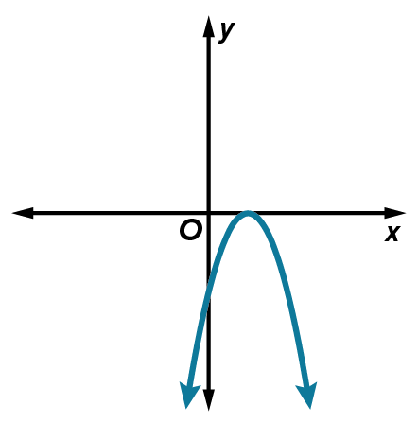

Use the discriminant to describe the number and type of roots for each equation. Then solve each
equation by using the Quadratic Formula.

39. 4x² ‒ 4x + 17 = 0 40. 8x ‒ 1 = 4x² 41. 7x² ‒ 5x = 0

42. x² + 10x + 24 = 0 43. x² – 11x + 24 = 0 44. 12x² + 9x + 1 = 0

45. 3x² – 16x + 16 = 0 46. r² – $\frac{3r}{5}$ + $\frac{2}{25}$ = 0 47. 2x² + 10x + 11 = 0

48. USE A MODEL The height h(t) in feet of an object t seconds after it is propelled up from the ground with an initial velocity of 60 feet per second is modeled by the equation h(t) = –16t² + 60t. When will the object be at a height of 56 feet?

49. SPORTS Natalya Lisovskaya set the women's shot put world record of 22.63 meters. Her throw can be modeled by h = –4.9t² + 13.7t + 1.6, where t is time in seconds and h is the height in meters. About how long was the shot in the air?

50. STOPPING DISTANCE A car’s stopping distance d is the sum of the distance traveled during the time it takes the driver to react and the distance traveled while braking. This is represented as $d=vt+\frac{v^{2}}{2μg}$, where v is the initial velocity in feet per second, t is the driver’s reaction time in seconds, μ is the coefficient of friction, and g is acceleration due to gravity. Use g = 32 ft/s².
a. Assume μ = 0.8 for rubber tires on dry pavement and the average reaction time of 1.5 seconds to complete the table. Round to the nearest tenth.
b. Make different assumptions to complete the table. Round to the nearest tenth.
coefficient of friction μ = ________________________________________________
reaction time t = ______________________________________________________
c. How did your different assumptions affect the data you found? Interpret the information in the context of the situation.

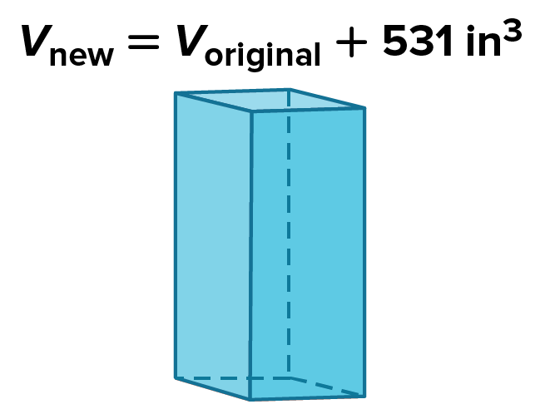
51. GEOMETRY A rectangular box has a square base and a height that is one more than 3 times the length of a side of the base.
If the sides of the base are each increased by 2 inches and
the height is increased by 3 inches, the volume of the box increases by 531 cubic inches. Define a variable and write an equation to represent the situation. Then find the dimensions of the original box.

52. GAMES A carnival game has players hit a pad with a large rubber mallet. This fires a ball up a 20-foot vertical chute toward a target at the top. A prize is awarded if the ball hits the target. Explain how to find the initial velocities in feet per second for which the ball will fail to hit the target. Assume the height of the ball can be modeled by the function h(t) = –16t² + vt, where v is the initial velocity.

53. WHICH ONE DOESN’T BELONG? Use the discriminant to determine which of these equations is different from the others. Explain your reasoning.

54. FIND THE ERROR Tama and Jonathan are determining the number of solutions of 3x² – 5x = 7. Is either of them correct? Explain your reasoning.
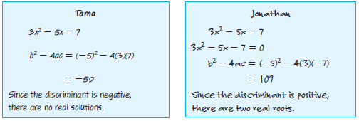

55. ANALYZE Determine whether each statement is sometimes, always, or never true. Explain
your reasoning.
a. In a quadratic equation written in standard form, if a and c have different signs, then the solutions will be real.

b. If the discriminant of a quadratic equation is greater than 1, the two roots are real irrational numbers.

56. CREATE Sketch the corresponding graph and state the number and type of roots for each of
the following.
a. b² ‒ 4ac = 0
b. A quadratic function in which f(x) never equals zero.
c. A quadratic function in which f(a) = 0 and f(b) = 0; a ≠ b.
d. The discriminant is less than zero.
e. a and b are both solutions and can be represented as fractions.

57. PERSEVERE Find the value(s) of m in the quadratic equation x² + x + m + 1 = 0 such that it has one solution.

58. WRITE Describe three different ways to solve x² ‒ 2x ‒ 15 = 0. Which method do you prefer,
and why?

