Quadratic Inequalities ⸱ Practice

Example 1
Graph each inequality.
1. y ≤ x² + 6x + 4 2. y < –x² + 4x – 6 3. y ≤ x² – 4

4. y ≤ x² + 4 5. y < 2x² – 4x – 2 6. –x² + 12x – 36 > y

7. y > x² + 6x + 7 8. y > x² – 8x + 17 9. y ≥ x² + 2x + 2

10. y ≥ 2x² + 4x 11. y > –2x² – 4x + 2 12. y ≥ x² – 4x + 4

Examples 3 and 4
Solve each inequality by graphing.
13. x² – 6x + 9 ≤ 0 14. – x² – 4x + 32 ≥ 0 15. $\frac{3}{4}$x² + $\frac{3}{4}$x – 10 > 5

16. x² – x ‒ 6 ≤ 0 17. x² + 8x + 16 ≥ 0 18. x² ‒ 2x ‒ 24 ≤ 0

Example 5
19. FENCING Vanessa has 180 feet of fencing that she intends to use to build a rectangular play area for her dog. She wants the play area to enclose at least 1800 square feet. What are the possible widths of the play area?

20. BUSINESS A bicycle maker sold 300 bicycles last year at a profit of $300 each. The maker wants to increase the profit margin this year, but predicts that each $20 increase in profit will reduce the number of bicycles sold by 10. How many $20 price increases can the maker add and still expect to make a total profit of at least $100,000?

Mixed Exercises
Solve each quadratic inequality by using a graph.
21. ‒2x² + 12x < ‒15 22. 5x² + x + 3 ≥ 0 23. 11 ≤ 4x² + 7x

24. x² ‒ 4x ≤ ‒7 25. ‒3x² + 10x < 5 26. ‒1 ≥ ‒x² ‒ 5x

27. x² + 2x + 1 > 0 28. x² – 3x + 2 ≤ 0 29. x² + 10x + 7 ≥ 0

30. x² – 5x > 14 31. –x² – 15 ≤ 8x 32. 9x ≤ 12x²

33. 4x² + 4x + 1 > 0 34. 5x² + 10 ≥ 27x 35. 9x² + 31x + 12 ≤ 0

36. REASONING Consider the equation ax² + bx + c = 0. Assume that the discriminant is zero and that a is positive. What are the solutions of the inequality ax² + bx + c ≤ 0?

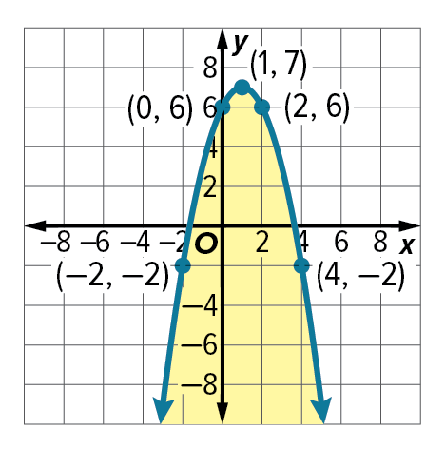
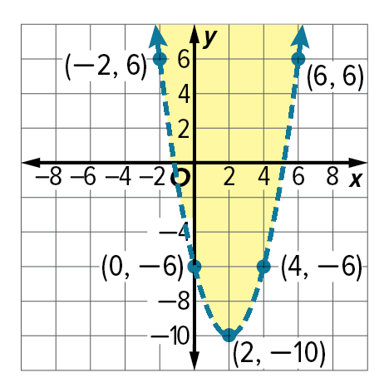
Write a quadratic inequality for each graph.
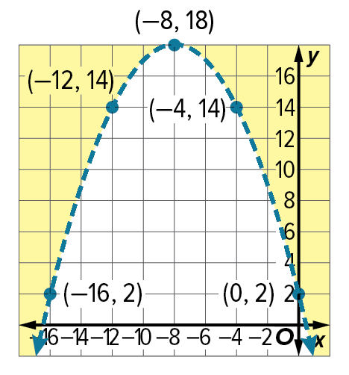
37. 38. 39.

40. BASEBALL A baseball player hits a high pop-up with an initial velocity of 32 meters per second, 1.3 meters above the ground. The height h(t) of the ball in meters t seconds after being hit is modeled by h(t) = –4.9t² + 32t +1.3.
a. During what time interval is the ball higher than the camera located in the press box 43.4 meters above the ground?
b. When is the ball within 2.4 meters of the ground where the catcher can attempt to catch it?

41. CONSTRUCT ARGUMENTS Are the boundaries of the solution set of x² + 4x ‒ 12 ≤ 0 twice the value of the boundaries of $\frac{1}{2}$x² + 2x – 6 ≤ 0? Explain.

42. FIND THE ERROR Don and Diego used a graph to solve the quadratic inequality x² – 2x – 8 > 0.
Is either of them correct? Explain your reasoning.
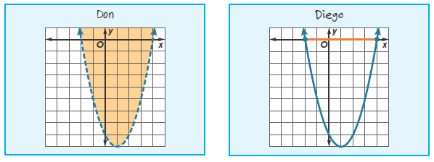

43. CREATE Write a quadratic inequality for each condition.
a. The solution set is all real numbers.
b. The solution set is the empty set.

44. ANALYZE Determine if the following statement is sometimes, always, or never true.
Justify your reasoning.
The intersection of y ≤ ‒ax² + c and y ≥ ax² ‒ c is the empty set.

45. PERSEVERE Graph the intersection of the graphs of y ≤ ‒x² + 4 and y ≥ x² ‒ 4.

46. WRITE How are the techniques used when solving quadratic inequalities and linear inequalities similar? How are they different?

