Solving Linear-Nonlinear Systems ⸱ Practice

Examples 1 and 2
Solve each system of equations by using substitution or elimination.
1. y = x² – 5 2. y = x – 2 3. y = x + 3
y = x – 3 y = x² – 2 y = 2x²

4. y = 3x 5. y = –2x + 2 6. y = 2 – x
x = y² y² = 2x y = x² – 4x + 2

7. x – y + 1 = 0 8. y = x – 1 9. y = x
y² = 4x y = x² y = –2x² + 4

Example 3
Use a system of equations to solve each quadratic equation.
10. x² + 3x + 3 = ‒2x ‒ 3 11. x² + 3x + 5 = 2x + 7 12. 2x² + 4x ‒ 3 = 9x

13. 4x² ‒ 6x ‒ 3 = ‒3x ‒ 2 14. 3x² ‒ 4x + 2 = 2 ‒ 2x 15. x² ‒ 4x + 5 = 2x +12

Example 4
16. CIVIL ENGINEERING For safety, roads are designed to ensure that rainwater runs off to the sides. Many roads are highest in the center so that a cross section of the road is a parabola. Suppose the surface of a road can be modeled by $y = -\frac{1}{300}x^{2}+\frac{3}{4}$, where x is the distance in feet from the center of the road and y is the height in feet of the road above the shoulder.
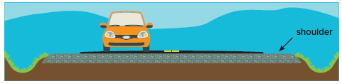
a. How wide is the road?
b. If the water level during a flash flood is 6 inches above the shoulder, about how wide is the portion of the road that is not under water?

17. SMALL BUSINESS A small business owner determines that the profit P in dollars from sales of a specific item can be modeled by P = 2x² + 30x, where x is the selling price of the items in dollars.
a. Create a linear-quadratic system to determine the price for which the business will earn $50,000.
b. Solve the system in part a graphically to determine the price for which the business will earn $50,000. Round to the nearest hundredth, if necessary.
c. What does the solution set of the system mean in the context of the situation?

Example 5
Solve each system of equations by graphing.
18. y = x² 19. y = $\frac{1}{2}$x² 20. y = ‒2x²
x = y² x = y² + 2y + 1 y = 6x²

21. x = (y ‒ 2)² 22. x = $\frac{1}{2}$y² + 1 23. x = $\frac{1}{4}$(y ‒ 1)² + 1
y = x² + 2 y = $\frac{1}{2}$(x – 1)² y = $\frac{1}{4}$(x ‒ 1)² + 1

Example 6
Solve each system of equations algebraically.
24. 2x² ‒ y = 8 25. x² ‒ y = 4 26. x = $\frac{1}{4}$y²
y = x² + 8 y = 2x² y² = ‒4x + 18

27. x = $\frac{1}{2}$y² 28. 2y = x² 29. y = x² + 3x ‒ 5
y² = ‒4x + 12 y = x² ‒ 8 2y = x² + 9x – 6

Example 7
Use a system of equations to solve each quadratic equation.
30. 2x² + 5x + 3 = 2 ‒ 2x² 31. 3x² ‒ x + 2 = x² + 8 32. ‒3x² + 3x + 5 = 9 ‒ 4x²

33. 2x² + 4x = 10 = x² + 6 34. 4x² + 2x + 7 = 3x² + 6 35. 5x² ‒ 5x ‒ 7 = 3x² ‒ 4

Mixed Exercises
Use the related graphs of each system of equations to determine the solutions.
36. y = $\frac{1}{4}x^{2}$ + $\frac{1}{2}$x – 2 37. y = $x^{2}$ + 4x – 1 38. y = 2x² – 4x + 6
y = $-\frac{1}{4}$x² – $\frac{1}{2}$x + 2 y = –2x² – 8x – 13 y = ${-\frac{1}{2}x}^{2}$ – 2x + 1

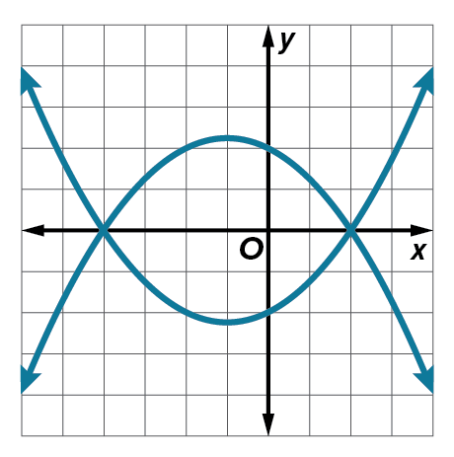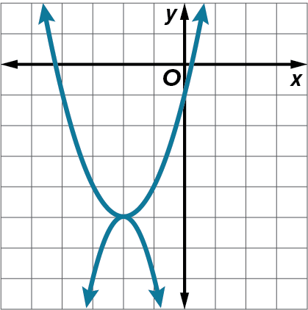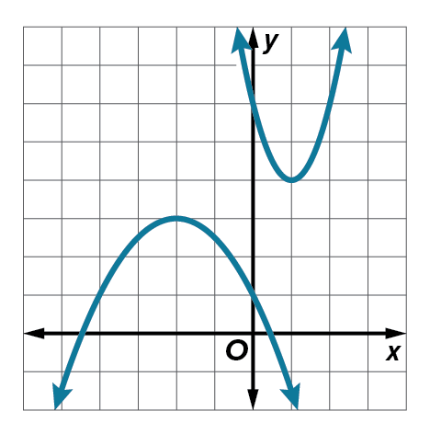

Solve each system of equations by graphing, substitution, or elimination.
39. y = x² + 9x + 8 40. y = 2x² + 7x + 12 41. y = x + 3
y = 7x + 8 y = x + 7 y = 2x² – x – 1

42. y = ${\left(\frac{1}{2}x\right)}^{2}$ 43. y = 2x² 44. y = ‒8x²
4x = y² x = y² – 2y + 1 y = 4x² + 1

45. 2x² ‒ y = 2 46. x² ‒ y = –4 47. y = x²
y = –x² + 4 y = 4x² – 2 y² = ‒3x + 5

48. y = –x – 3 49. y = –x 50. y = 3x – 4
y = x² – 5 y² = 2x y = x² + 9x + 20

51. x – 2= (y ‒ 2)² 52. 3x – 1 = $\frac{1}{8}$y² 53. x = (y + 2)²
y = x² + 5 y = x² + 5x – 4 y = (x + 2)²

54. x = $\frac{1}{4}$y² 55. 4y + 3 = x² 56. y = x² + x + 5
y² = ‒8x + 6 y = x² ‒ 24 y = 2x² + 3x + 2

Use a system of equations to solve each quadratic equation.
57. 2x² + x ‒ 1 = ‒10x + 12 58. 3x² ‒ 5x – 2 = –16 ‒ 8x 59. x² + 3x + 2 = x + 5

60. x² – 2x – 3 = ‒ $\frac{1}{3}x^{2}$ + $\frac{2}{3}$x + $\frac{23}{3}$ 61. 3x² + 4x + 1 = –x² – 2x – 1 62. 2x² – 6x + 4 = –x² + 3x – 2

63. 2x² + 6x + 5 = x² – 4 64. 4x² + 2x + 7 = 3x² + 6 65. 5x² ‒ 5x ‒ 7 = 3x² ‒ 4

66. x² + 4x + 4 = x + 4 67. x² + 5x + 12 = –4x – 6 68. 2x² – x ‒ 6 = –3x – 2

69. ROCKETS Two model rockets are launched at the same time from different heights. The height in meters for one rocket after t seconds is modeled by y = –4.9t² + 48.8t. The height for the other rocket is modeled by y = –4.9t² + 46.7t + 1.5.
a. After how many seconds are the rockets at the same height? Round to the nearest tenth.

b. From what height would the slower rocket have to be launched so that the rockets land at the same time? Justify your reasoning.

70. PACKAGING A manufacturer is making two different packages, measured in
inches, as shown in the figure. The manufacturer wants the surface area of the
packages to be the same.
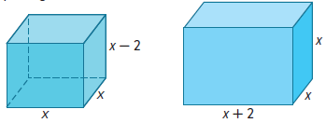
a. Create a quadratic equation that can be used to find the value of x, when the surface area of the packages is the same.
b. Solve the quadratic equation using any method.
c. Find and interpret the solution in the context of the situation.

71. VOLLEYBALL The function h(t) = –16t² + vt + h₀ models the height in feet of a volleyball, where v represents the initial
velocity, h₀ represents the initial height, and t represents the time in seconds since the ball was hit. Suppose a player bumps a volleyball when it is 3 feet from the ground with an initial velocity of 25 feet per second.
a. If the net is approximately 7 feet 4 inches, could the volleyball clear the net? Justify your reasoning.
b. The player on the other side of the net jumps 1 second after the ball is hit so that the path of her hands can be described by h(t) = –16(t – 1)² + 12(t – 1) + 7. If the ball clears the net, is it possible that she blocks the ball? Justify your reasoning.
c. What assumptions did you make?

72. PERSEVERE Describe three linear-quadratic systems of equations‒one with no solution, one with 1 solution, and one with 2 solutions.

73. CREATE Write a system of two quadratics in which there is one solution.
74. WRITE Describe a real-life situation that can be modeled by a system with a quadratic function and a linear function.

75. FIND THE ERROR Danny and Carol are solving the system y = x² + 3x – 9 and –4x + y = 3.
Is either of them correct? Explain your reasoning.
