Polynomial Functions ⸱ Practice

Example 1
Describe the end behavior of each function using the leading coefficient and degree, and state the domain and range.

1. f(x) = 3x⁴ 2. f(x) = –2x³

3. f(x) = $-\frac{1}{2}$x⁵ 4. f(x) = $\frac{3}{4}$x⁶

Example 2
5. USE A MODEL The shape of a parabolic reflector inside a flashlight can be modeled by the function f(x) = $\frac{4}{3}$x². Graph the function f(x), and state the domain and range.

6. MACHINE EFFICIENCY A company uses the function f($x$) = $x^{3}$+ 3$x^{2}$ – 18$x$ – 40 to model the change in efficiency of a machine based on its position x. Graph the function and state the domain and range.

Example 3
State the degree and leading coefficient of each polynomial in one variable. If it is not a polynomial in one variable, explain why.
7. n + 8 8. (2x – 1)(4$x^{2}$ + 3)

9. –${5x}^{5}$ + ${3x}^{3}$ – 8 10. 18 – 3y + 5$y^{2}$ – $y^{5}$ + 7$y^{6}$

11. $u^{3}$ + 4$u^{2}t^{2}$ + $t^{4}$ 12. 2r –$r^{2}$ + $\frac{1}{r^{2}}$


Example 4
13. TRIANGLES Dylan drew n dots on a piece of paper making sure that no set of 3 points were collinear. The number of triangles that can be made using the dots as vertices is equal to f(n) = $\frac{1}{6}$ ($n^{3}$ – 3$n^{2}$ + 2n), when n ≥ 0.
a. If Dylan drew 15 dots, how many triangles can be made?
b. Sketch a graph of the function.

14. DRILLING The volume of a drill bit can be estimated by the formula for a cone, V = $\frac{1}{3}$ ${πhr}^{2}$, where h is the height of the bit and r is its radius. Substituting $\frac{\sqrt{3}}{3}$r for h, the volume of the drill bit can be estimated by V = $\frac{\sqrt{3}}{9}$ ${πr}^{3}$.
a. What is the volume of a drill bit with a radius of 3 centimeters?
b. Sketch a graph of the function.

Example 5
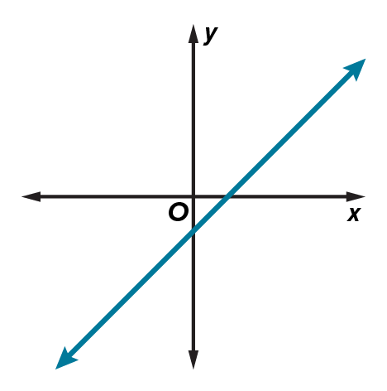
Use the graph to state the number of real zeros of the function.
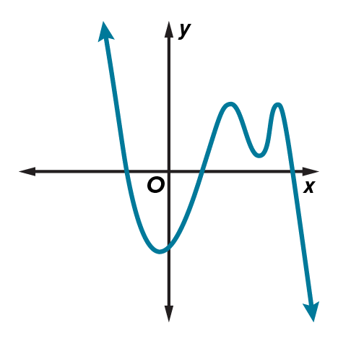
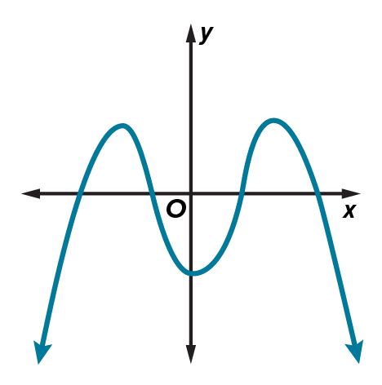
15. 16. 17.

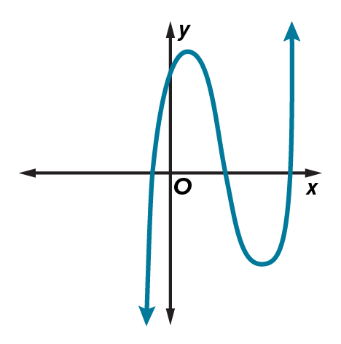
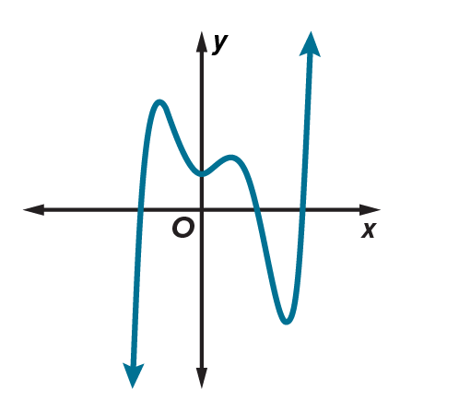
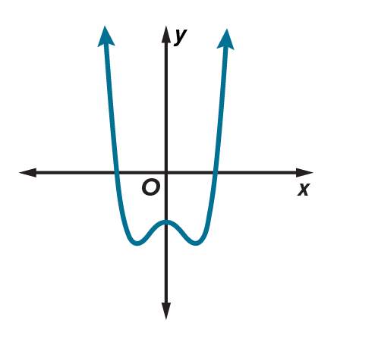
18. 19. 20.

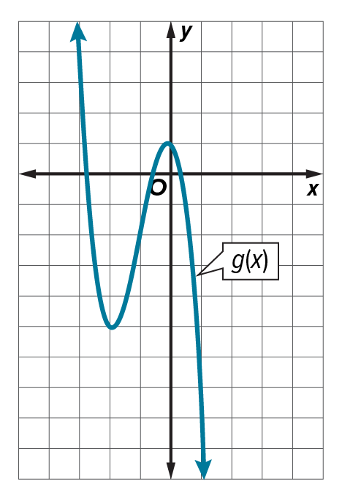
Example 6
21. Examine f(x) = x³ – 2x² – 4x + 1 and g(x) shown in the graph.

- Which function has the greater relative maximum?
- Compare the zeros, x- and y-intercepts, and end behavior of f(x) and g(x).

22. Examine the graph of f(x) and g(x) shown in the table.
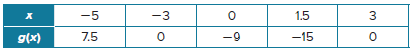
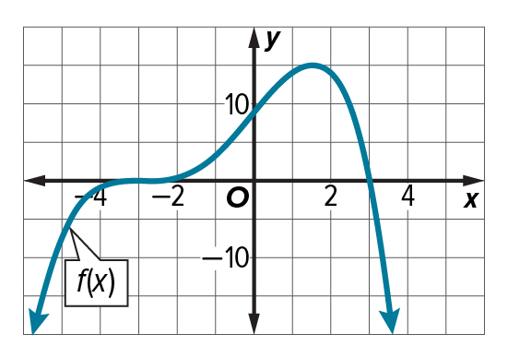
a. Which function has the greater relative maximum?
b. Compare the zeros, x- and y-intercepts, and end behavior of f(x) and g(x).

Mixed Exercises
Describe the end behavior, state the degree and leading coefficient of each polynomial. If the
function is not a polynomial, explain why.
23. f(x) = –5x⁴ + 3x² 24. g(x) = 2x⁵ + 6x⁴

25. g(x) = 8x⁴ + 5x⁵ 26. h(x) = 9x⁶ – 5x⁷ + 3x²

27. f(x) = –6x⁶ – 4x⁵ + 13x ⁻² 28. f(x) = (5 – 2x)(4 + 3x)

29. h(x) = (x + 5)(3x – 4) 30. g(x) = 3x⁷ – 4x⁴ + $\frac{3}{x}$

2.1 Polynomial Functions ⸱ Practice

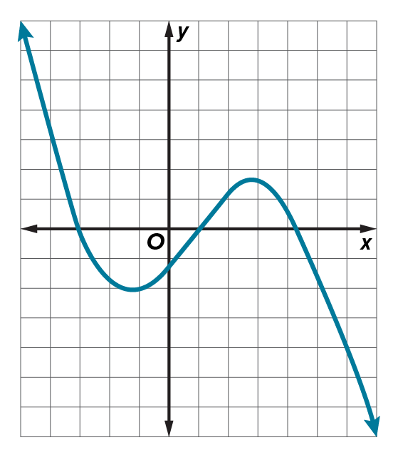
31. REASONING Describe the end behavior, and the possible degree and sign of the leading coefficient of the graph shown.

32. CONSTRUCT ARGUMENTS Explain why a polynomial function with an odd degree must have at least one real zero.

33. STRUCTURE If f(x) = ax³ – bx² + x, determine f(1 – x). Express the result in standard form. How does the end behavior of f(1 – x) compare to f(x)?

34. COMPARING Compare the end behavior of the functions g(x) = –3x⁴ + 15x³ – 12x² + 3x + 20 and h(x) = –3x⁴ – 16x – 1. Explain your reasoning.

35. USE A MODEL A box has a square base with sides of 10 centimeters and a height of 4
centimeters. For a new box, the height is increased by twice a number x and the lengths of the sides of the base are decreased by x. Write and graph a function to represent the volume of the new box. What new dimensions will produce a box with the greatest volume? Describe your solution process.

36. FIND THE ERROR Shenequa and Virginia are determining the number of real zeros of the graph. Is either of them correct? Explain your reasoning.
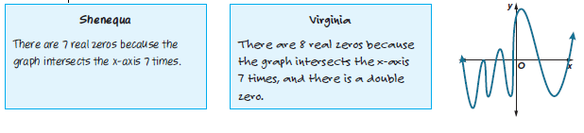

37. ANALYZE Compare the functions g(x) and f(x). Determine which function has the potential for more zeros and the degree of each function.
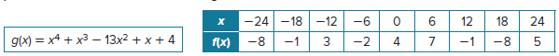

38. PERSEVERE If f(x) has a degree of 5 and a positive leading coefficient and g(x) has a degree of 3 and a positive leading coefficient, determine the end behavior of $\frac{f(x)}{ g(x)}$. Explain your reasoning.

39. CREATE Sketch the graph of an even-degree polynomial with 7 real zeros, one of which is a double zero, and the leading coefficient is negative.

