Analyzing Graphs of Polynomial Functions ⸱ Practice
Examples 1
Determine the consecutive integer values of x between which each real zero of each function is
located by using a table. Then sketch the graph.

1. f(x) = x² + 3x – 1 2. f(x) = –x³ + 2x² – 4

3. f(x) = x³ + 4x² – 5x + 5 4. f(x) = –x⁴ – x³ + 4

Examples 2
Use a table to graph each function. Then estimate the x-coordinates at which relative maxima and
relative minima occur.

5. f(x) = –2x³ + 12x² – 8x 6. f(x) = 2x³ – 4x² – 3x + 4

7. f(x) = x⁴ + 2x – 1 8. f(x) = x⁴ + 8x² – 12

Example 3
9. BUSINESS A banker models the expected value v of a company in millions of dollars by using the formula v = $n^{3}- 3n^{2}$, where n is the number of years in business. Graph the function and describe its key features over the relevant domain.

10. HEIGHT A plant’s height is modeled by the function f(x) = 1.5x³ – 20x² + 85x – 84, where x is the number of weeks since the seed was planted and f(x) is the height of the plant. Graph the function and describe its key features over its relevant domain.

Example 4
11. USE ESTIMATION The table shows U.S. car sales in millions of cars. Use a graphing calculator to make a scatter plot and a curve of best fit to show the trend over time. Then use the equation to estimate the car sales in 2017. Let 2008 be represented by year 0. Round the coefficients of the regression equation to the thousandths place.
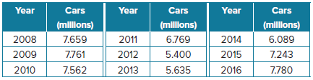

12. POPULATION The table shows the population in Cincinnati, Ohio, since 1960. Make a scatter plot and a curve of best fit to show the trend over the given time period. Then use the equation to estimate the population of Cincinnati in 2020.
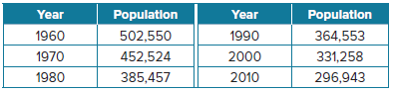

13. VOLUNTEERS The table shows average volunteer hours per month for a local non-profit. Make a
scatter plot and a curve of best fit to show the trend over the given time period. Then use the
equation to estimate the volunteer hours for September. Let January be represented by month 1.
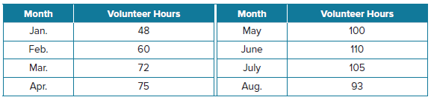

Example 5
14. FARMS The table shows the number of farms in the U.S. at various years, according to the USDA
Census of Agriculture. Find the average rate of change from 1982 to 2012. Interpret the results in the context of the situation.
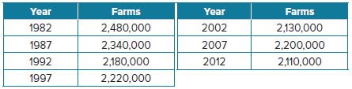

15. SALARY The table shows the annual salary of a salesperson over time. Find the average rate of
change over the given time interval. Interpret the results in context of this situation.
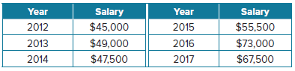

Mixed Exercises
Graph each function by using a table of values. Then, estimate the x-coordinates at which each zero and relative extrema occur, and state the domain and range.
16. f(x) = x³ – 3x² + 1 17. f(x) = 2x³ + 9x² + 12x + 2

18. f(x) = 2x³ – 3x² + 2 19. f(x) = x⁴ – 2x² + 2

20. Determine the key features for y = $\left\{\begin{aligned}x^{2} if x ≤ –4 \\ 5 if-4<x≤0 \\ x^{3} if x>0 \end{aligned}\right.$

USE TOOLS Use a graphing calculator to estimate the x-coordinates at which the maxima and minima of each function occur. Round to the nearest hundredth.
21. f(x) = x³ + 3x² – 6x – 6 22. f(x) = –2x³ + 4x² – 5x + 8

23. f(x) = –2x⁴ + 5x³ – 4x² + 3x – 7 24. f(x) = x⁵ – 4x³ + 3x² – 8x – 6

25. PRECISION Sketch the graph of a third-degree polynomial function that has a relative minimum at x = –3, passes through the origin, and has a relative maximum at x = 2. Describe the end behavior of the graph. Based on the sketch, determine whether the leading coefficient is negative or positive.

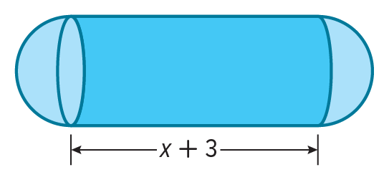
26. USE TOOLS A canister has the shape of a cylinder with spherical caps on either end. The volume of the canister in cubic millimeters is modeled by the function V(x) = π(x³ + 3x²) + $\frac{4}{3}$πx³ where x represents the radius in millimeters of a canister that is x + 3 millimeters wide.
a. Use a graphing calculator to sketch the model that represents the volume of the canister. Include axes labels.
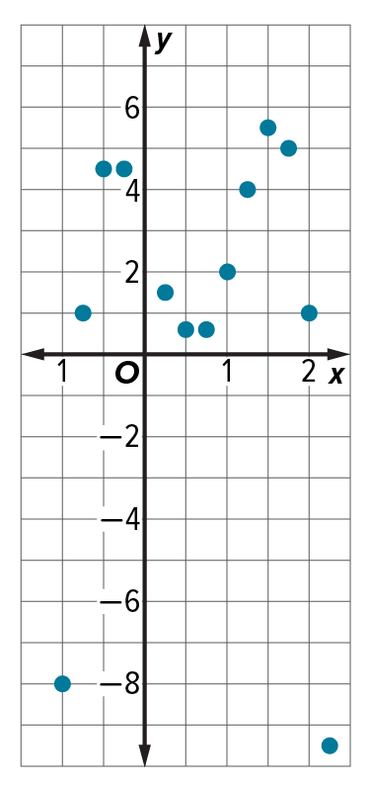
b. What is the domain of the model? Explain any restrictions that apply.
27. CONSTRUCT ARGUMENTS What type of polynomial function best models the data in the graph? Explain your reasoning.

28. FORECASTING The table shows the number of deliveries a grocery store has made since they began to offer the service. Use a scatter plot and a curve of best fit to determine the number of deliveries the grocery store can expect to deliver 10 years after they begin the service.
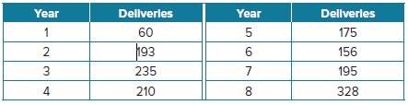

29. ANALYZE Explain why the leading coefficient and the degree are the only determining factors in the end behavior of a polynomial function.

30. ANALYZE The table below shows the values of a cubic function. Could there be a zero between
x = 2 and x = 3? Justify your argument.
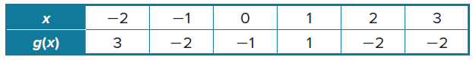

31. CREATE Sketch the graph of an odd degree polynomial function with 6 extrema and a relative extreme at y = 0.

32. ANALYZE Determine whether the following statement is sometimes, always, or never true. Justify your argument.

For any continuous polynomial function, the y-coordinate of a point where a function changes
from increasing to decreasing or from decreasing to increasing is either a relative maximum or relative minimum.

33. PERSEVERE A function is even if for every x in the domain of f, f(x) = f(–x). Is every even-degree polynomial function also an even function? Explain.

34. PERSEVERE A function is odd if for every x in the domain, –f(x) = f(–x). Is every odd-degree polynomial function also an odd function? Explain.

