Operations with Polynomials ⸱ Practice

Example 1
Determine whether each expression is a polynomial. If it is a polynomial, state the degree of
the polynomial.
1. 2x² – 3x + 5 2. a³ – 11

3. $\frac{5np}{n^{2}}$ – $\frac{2g}{h}$ 4. $\sqrt{m-7}$

Examples 2 and 3
Add or subtract.
5. (6a² + 5a + 10) – (4a² + 6a + 12) 6. (7b² + 6b – 7) – (4b² – 2)

7. (g + 5) + (2g + 7) 8. (5d + 5) – (d + 1)

9. (x² – 3x – 3) + (2$x^{2}$+ 7x – 2) 10. (–2f² – 3f – 5) + (–2f² – 3f + 8)

11. (2x – 3) – (5x – 6) 12. (x² + 2x – 5) – (3x² – 4x + 7)

Examples 4, 5, and 6
Multiply.
13. 3p(np – z) 14. 4x(2x² + y)

15. –5(2c²– d²) 16. x²(2x + 9)

17. (a – 5)² 18. (2x – 3)(3x – 5)

19. (x – y)(x² + 2xy + y²) 20. (a + b)(a³ – 3ab – b²)

21. (x – y)(x + y)(2x + y) 22. (a + b)(2a + 3b)(2x – y)

23. (r – 2t)(r + 2t) 24. (3y + 4)(2y – 3)

25. (x³ – 3x² + 1)(2x² – x + 2) 26. (4$x^{5}$ + $x^{3}$ – 7$x^{2}$ + 2)(3x – 1)

Example 7
27. CONSTRUCTION A rectangular deck is built around a square pool. The pool has side length s. The length of the deck is 5 units longer than twice the side length of the pool. The width of the deck is 3 units longer than the side length of the pool. What is the area of the deck in terms of s?
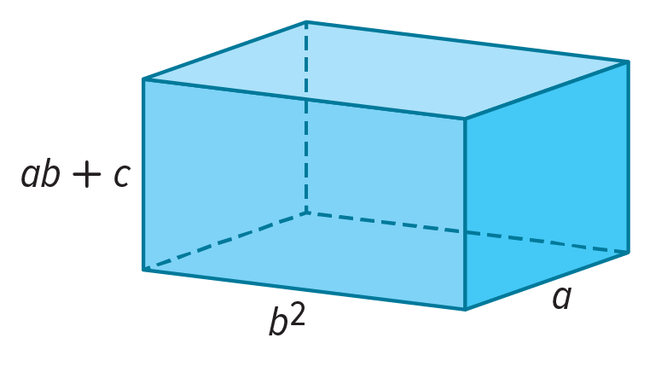
28. VOLUME The volume of a rectangular prism is given by the product of its length, width, and height. A rectangular prism has a length of b² units, a width of a units, and a height of ab + c units. What is the volume of the rectangular prism? Express your answer in simplified form.

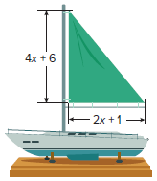
29. SAIL BOATS Tamara is making a sail for her sailboat.
a. Refer to the diagram to find the area of the sail.
b. If Tamara wants fabric on each side of her sail, write a polynomial to represent the total amount of fabric she will need to make the sail.

Mixed Exercises
Simplify.
30. 5xy(2x – y) + 6y²(x² + 6) 31. 3ab(4a – 5b) + 4b²(2a² + 1)

32. $\frac{1}{4}$g²(8g + 12h – 16gh²) 33. $\frac{1}{3}$n³(6n – 9p + 18np⁴)

34. (g³ – h)(g³ + h) 35. (n² – 7)(2n³ + 4)

36. (2x – 2y)³ 37. (4n – 5)³

38. (3z – 2)³ 39. $\frac{1}{4}$(16x – 12y) + $\frac{1}{3}$(9x + 3y)

40. STRUCTURE Use the polynomials f(x) = –6x³ + 2x² + 4 and g(x) = x⁴ – 6x³ – 2x to evaluate
and simplify the given expression. Determine the degree of the resulting polynomial.
Show your work.
a. f(x) + g(x)
b. g(x) – f(x)

41. STRUCTURE Use the polynomials f(x) = 3x² – 1, g(x) = x + 2, and h(x) = –x² – x to evaluate and simplify the given expressions. Determine the degree of the resulting polynomial.
a. f(x)g(x)
b. h(x)f(x)
c. [f(x)]²

42. USE A MODEL Inez wants to increase the size of her rectangular garden. The original garden is 8 feet longer than it is wide. For the new garden, she will increase the length by 25% and increase the width by 5 feet.

a. Draw and label a diagram that represents the original garden and the new garden. Define a variable and label each dimension with appropriate expressions.

b. Write and simplify an expression for the increase in area of the garden. If the original width of the garden was 10 feet, find how many square feet the garden’s area increased.

43. CONSTRUCT ARGUMENTS Complete the table to show which sets are closed under the operations. Write yes if the set is closed under the operation. Write no and provide a counterexample if the set is not closed under the operation. Assume that since division by zero is undefined, it does not affect closure.
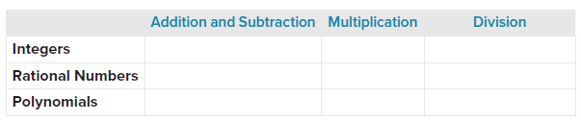

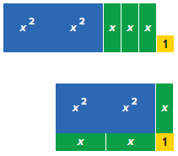
44. STRUCTURE The polynomial 2x² + 3x + 1 can be represented by the tiles shown in the figure at the right. These tiles can be arranged to form the rectangle shown. Notice that the area of the rectangle is 2x² + 3x + 1 units².
a. Find the length and width of the rectangle.
b. Find the perimeter of the rectangle. Then explain your process for finding the perimeter.
c. Select a value for x and substitute that value into each of the expressions above. For your value of x, state the length, width, perimeter, and area of the rectangle. Discuss any restrictions on the value of x.

45. BANKING Terry invests $1500 in two mutual funds. The first year, one fund grows 3.8% and the other grows 6%. Write a polynomial to represent the value of Terryl’s investment after the first year if he invested x dollars in the fund with the lesser growth rate.

46. GEOMETRY Consider a trapezoid that has one base that measures five feet greater than its height. The other base is one foot less than twice its height. Let x represent the height.
a. Write an expression for the area of the trapezoid.
b. Write an expression for the area of the trapezoid if its height is increased by 4 feet.

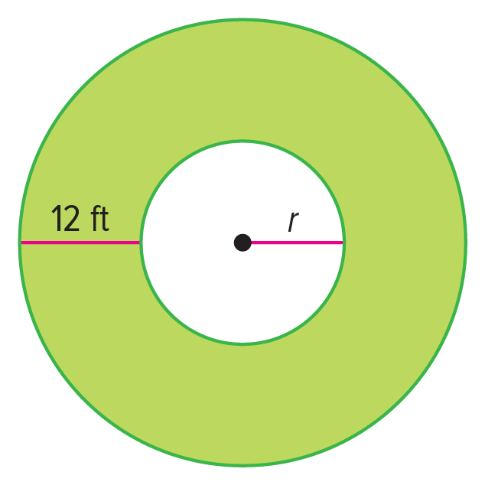
47. URBAN DEVELOPMENT The diagram represents an aerial view of a memorial in a town center. A sidewalk that is 12 feet wide with an area of 384π square feet surrounds a statue with a circular base of radius r.
a. Find the radius of the smaller and larger circles. Show your work.
b. A nearby town wants to use the same design concept, but use two squares rather than two circles. Draw and label a diagram with two squares to represent a sidewalk with the same uniform width and area as the circular sidewalk.
c. If s represents the side length of the smaller square, write a polynomial expression for the area of the sidewalk that surrounds the smaller square.

48. ANALYZE Given f(x) and g(x) are polynomials, is the product always a polynomial? Justify your argument.

49. PERSEVERE Use your result from Exercise 48 to make conjectures about the product of a polynomial with m terms and a polynomial with n terms. Justify your conjecture.
a. How many times are two terms multiplied?
b. What is the least number of terms in the simplified product?
50. FIND THE ERROR Isabella found the product of 3x² – 4x + 1 and x² + 5x + 6 using vertical alignment. Is her answer correct? Explain your reasoning.
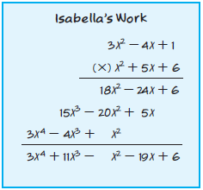

51. CREATE Write an expression where two binomials are multiplied and have a product of 9 – 4b².

