Dividing Polynomials ⸱ Practice

Examples 1
Simplify each expression.
1. $\frac{15y^{3} + 6y^{2} + 3y}{3y}$ 2. ${(4f^{5}-6f^{4}+12f^{3}-8f^{2})(4f^{2})}^{–1}$

3. (6j²k – 9jk²) ÷ (3jk) 4. (4$a^{2}h^{2}$– 8$a^{3}$h + 3$a^{4}$) ÷ (2$a^{2}$)

Examples 2 and 3
Simplify by using long division.
5. (n² + 7n + 10) ÷ (n + 5) 6. (d² + 4d + 3)(d + 1) ^{–1}

7. (2t² + 13t + 15) ÷ (t + 6) 8. (6y² + y – 2)(2y – 1)^{–1}

9. (4g² – 9) ÷ (2g + 3) 10. (2x² – 5x – 4) ÷ (x – 3)

Examples 4 and 5
Simplify using synthetic division.
11. (3$v^{2}$– 7v – 10)(v – 4)^{–1} 12. (3$t^{4}$ + 4$t^{3}$– 32$t^{2}$– 5t – 20)(t + 4)^{–1}

13. $\frac{y^{3 }+ 6}{y + 2}$ 14. $\frac{2x^{3}- x^{2}- 18x+ 32 }{2x – 6}$

15. (4p³– p² + 2p) ÷ (3p – 1) 16. (3c⁴ + 6c³ – 2c + 4)(c + 2)^{–1}

Mixed Exercises
Simplify.
17. (m² + m – 6) ÷ (m + 4) 18. (a³ – 6a² + 10a – 3) ÷ (a – 3)

19. (2x³ – 7x² + 7x – 2) ÷ (x – 2) 20. (x³ + 2x² – 34x + 9) ÷ (x + 7)

21. (x³ + 8) ÷ (x + 2) 22. (6x³ + x² + x) ÷ (2x + 1)

23. (28c³d² – 21cd²) ÷ (14cd) 24. (x⁴ – y⁴) ÷ (x – y)

25. $\frac{n^{3} + 3n^{2} - 5n - 4}{n + 4}$ 26. (a³b² – a²b + 2b)( –ab) ^{–1}

27. $\frac{{3z}^{5} + 5z^{4} + z + 5}{z + 2}$ 28. $\frac{p^{3} + 2p^{2} - 7p - 21}{p + 3}$

29. STRUCTURE Jada used long division to divide x⁴ + x³ + x² + x + 1 by x + 2. Her work is shown below with three numbers missing. What are A, B, and C?

30. AVERAGES Bena has a list of n + 1 numbers and she needs to find their average. Two of the numbers are n³ and 2. Each of the other n – 1 numbers are all equal to 1. Find the average of these numbers.

31. VOLUME The volume of a cylinder is π(x³– 32x²– 304x + 640). If the height of the cylinder is x + 40 feet, find the area of its base of the column in terms of x and π.

32. REASONING Rewrite $\frac{6x^{4} - 2x^{3} - 16x^{2} + 24x + 32}{2x + 4}$ as q(x) + $\frac{r(x)}{d(x)}$ using long division. What does the remainder indicate in this problem?

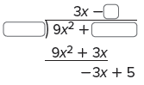
33. CONSTRUCT ARGUMENTS Determine whether you have enough information
to fill in the missing pieces of the long division exercise shown. Justify your response.

34. REGULARITY Rewrite $\frac{{2x}^{5}-7x⁴-15x³+ 2x^{2} + 3x + 6}{2x + 3}$ as q(x) + $\frac{r(x)}{d(x)}$ using long division.
a. Identify q(x), r(x), and g(x).
b. How can you check your work using the expressions of q(x), g(x), and r(x)?

35. STRUCTURE When a polynomial is divided by 4x – 6, the quotient is 2x² + x + 1 and the remainder is –4. What is the dividend, f(x)? Explain.

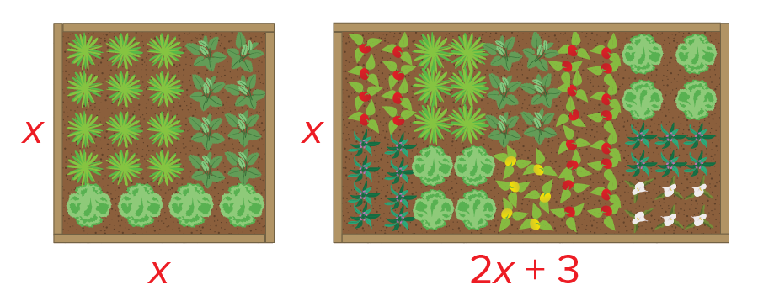
36. USE A MODEL Luciano has a square garden. A new
garden will have the same width and a length that is
3 feet more than twice the width of the original
garden.

a. Define a variable and label each side of the diagrams with an expression for its length.

b. Write a ratio to represent the percent increase in the area of the garden. Use polynomial division to simplify the expression.

c. Use your expression from part b to determine the percent of increase in area if the original garden was a 12-foot square. Check your answer.

37. REGULARITY Mariella makes the following claims about the degrees of the polynomials
in $\frac{f(x)}{d(x)}$ = q(x) + $\frac{r(x)}{d(x)}$. Do you agree with each claim? Justify your answers and provide examples.

a. The degree of d(x) must be less than the degree of f(x).

b. The degree of r(x) must be at least 1 less than the degree of d(x).

c. The degree of q(x) must be the degree of f(x) minus the degree of d(x).

38. FIND THE ERROR Tomo and Jamal are dividing 2x³ – 4x² + 3x – 1 by x – 3. Tomo claims that the reminder is –100. Jamal claims that the remainder is 26. Is either of them correct? Explain your reasoning.

39. PERSEVERE If a polynomial is divided by a binomial and the remainder is 0, what does this tell you about the relationship between the binomial and the polynomial?

40. ANALYZE What is the relationship between the degrees of the dividend, the divisor, and the quotient in any polynomial division exercise?

41. CREATE Write a quotient of two polynomials for which the remainder is 3.
42. WRITE Compare and contrast dividing polynomials using long division and using synthetic division.

43. PERSEVERE Mr. Collins has his class working with bases and polynomials. He wrote on the board that the number 1111 in base B has the value B³ + B² + B + 1. The class was then given the following questions to answer.
a. The number 11 in base B has the value B + 1. What is 1111 (in base B) divided by
11 (in base B)?
b. The number 111 in base B has the value B² + B + 1. What is 1111 (in base B) divided by
111 (in base B)?

