Solving Polynomial Equations Algebraically ⸱ Practice

Examples 1-3
Factor completely. If the polynomial is not factorable, write prime.
1. 8c³ – 27d³ 2. 64x⁴ + xy³

3. a⁸ – a²b⁶ 4. x⁶y³ + y⁹

5. 18x⁶ + 5y⁶ 6. w³ – 2y³

7. gx² – 3hx² – 6fy² – gy² + 6fx² + 3hy² 8. 12ax² – 20cy² – 18bx² – 10ay² + 15by² + 24cx²

9. a³x² – 16 a³x + 64a³ – b³x² + 16b³x – 64b³

10. 8x⁵ – 25y³ + 80x⁴ – x²y³ + 200x³ – 10xy³

Example 4
Solve each equation.
11. a³ – 9a² + 14a = 0 12. x³ = 3x²

13. t⁴ – 3t³ – 40t² = 0 14. b³ – 8b² + 16b = 0

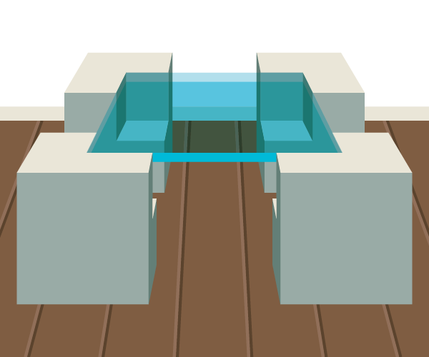
Example 5
15. FURNITURE A modern table is constructed with four legs made of concrete cubes with cube-shaped notches.
a. Define one or more variables and write an expression that represents the volume of one table leg.
b. Marisol determined that she will use 12,636 cubic inches of concrete to construct the four table legs. If the sides of the notches are 40% of the sides of the legs, how long are the sides of the legs?

Example 6
Write each expression in quadratic form, if possible.
16. x⁴ + 12x² – 8 17. –15x⁴ + 18x² – 4

18. 8x⁶ + 6x³ + 7 19. 5x⁶ – 2x² + 8

20. 9x⁸ – 21x⁴ + 12 21. 16x¹⁰ + 2x⁵ + 6

Example 7
Solve each equation.
22. x⁴ + 6x² + 5 = 0 23. x⁴ – 3x² – 10 = 0

24. 4x⁴ – 14x² + 12 = 0 25. 9x⁴ – 27x² + 20 = 0

26. 4x⁴ – 5x² – 6 = 0 27. 24x⁴ + 14x² – 3 = 0

Mixed Exercise
Factor completely. If the polynomial is not factorable, write prime.
28. x⁴ – 625 29. x⁶ – 64

30. x⁵ – 16x 31. 8x⁵y² – 27x²y⁵

32. x⁶ – 4x⁴ – 8x⁴ + 32x² + 16x² – 64 33. y⁹ – y⁶ – 2y⁶ + 2y³ + y³ – 1


34. DECOR Each box in a set of decorative storage boxes is a cube.
a. The sides of the smallest box are 30% of the length of the sides of the largest box. The volume of the largest box is 7784 cubic inches more than the volume of the smallest box. Define one or more variables, and write an equation that represents the situation.
b. What are the lengths of the sides of the largest and smallest boxes?
c. Two of the other boxes have a total volume of 2457 cubic inches. The length of the sides of the smaller of these boxes is 75% of those of the larger box. Write and solve an equation to find the lengths of the sides of the boxes.

Solve each equation.
35. x⁴ + x² – 90 = 0 36. x⁴ – 16x² – 720 = 0

37. x⁴ – 7x² – 44 = 0 38. x⁴ + 6x² – 91 = 0

39. x³ + 216 = 0 40. 64x³ + 1 = 0

41. 8x⁴ + 10x² – 3 = 0 42. 6x⁴ – 5x² – 4 = 0

43. 20x⁴ – 53x² + 18 = 0 44. 18x⁴ + 43x² – 5 = 0

45. 8x⁴ – 18x² + 4 = 0 46. 3x⁴ – 22x² – 45 = 0

47. x⁶ + 7x³ – 8 = 0 48. x⁶ – 26x³ – 27 = 0

49. 8x⁶ + 999x³ = 125 50. 4x⁴ – 4x² – x² + 1 = 0

51. x⁶ – 9x⁴ – x² + 9 = 0 52. x⁴ + 8x² + 15 = 0

53. STRUCTURE Consider the equation .
a. How are the exponents in the equation related?
b. How could you define u so that you could rewrite the equation as a quadratic equation in terms of u? Write the quadratic equation.
c. Solve the original equation.

Factor completely. If the polynomial is not factorable, write prime.
54. 21x³ – 18x²y + 24xy² 55. 8j³k – 4jk³ – 7

56. a² + 7a – 18 57. 2ak – 6a + k – 3

58. b² + 8b + 7 59. z² – 8z – 10

60. 4f² – 64 61. d² – 12d + 36

62. 9x² + 25 63. y² + 18y + 81

64. 7x² – 14x 65. 19x³ – 38x²

66. n³ – 125 67. m⁴ – 1

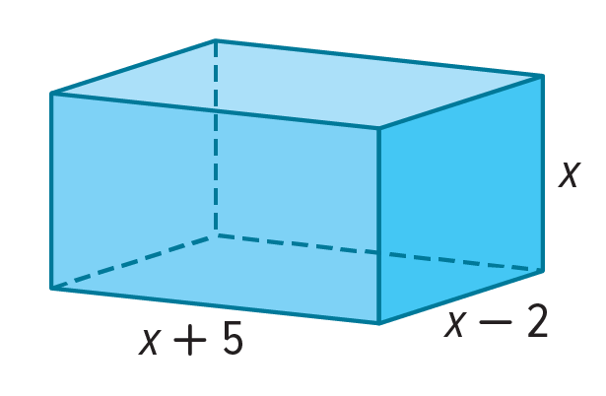
68. REASONING A rectangular box has dimensions of x inches, (x + 5) inches, and (x – 2) inches. If the volume of the box is 30x cubic inches. Find the dimensions of the box. Explain your reasoning.

69. GEOMETRY The combined volume of a cube and a cylinder is 1000 cubic inches. If the height of the cylinder is twice the radius and the side of the cube is four times the radius, find the radius of the cylinder to the nearest tenth of an inch.

70. ANALYZE Find the solutions of (a + 3)⁴ – 2(a + 3)² – 8 = 0. Show your work.

71. WRITE If the equation ax² + bx + c = 0 has solutions x = m and x = n, what are the solutions to ax⁴ + bx² + c = 0. Explain your reasoning.

72. PERSEVERE Factor 36x^{2n} + 12x^{n} + 1.

73. CREATE The cubic form of an equation is ax³ + bx² + cx + d = 0. Write an equation with degree 6 that can be written in cubic form.

