Proving Polynomial Identities ⸱ Practice

Example 1
Prove each polynomial identity.
1. (x – y)² = x² – 2xy + y² 2. (x + 5)² = x² + 10x + 25

3. 4(x – 7)² = 4x² – 56x + 196 4. (2x² + y²)² = (2x² – y²)² + (2xy)²

5. a² – b² = (a + b)(a – b) 6. x³ + y³ = (x + y)(x² – xy + y²)

7. p⁴ – q⁴ = (p – q)(p + q)(p² + q²) 8. a⁵ – b⁵= (a – b)(a⁴ + a³b + a²b² + ab³ + b⁴)

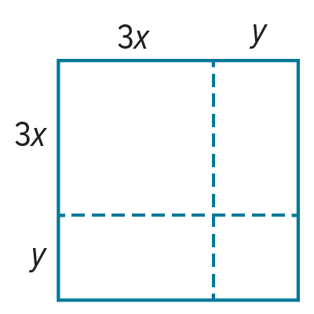
Example 2
9. SQUARES Aponi claims that you can find the area of a square using the following method: take two positive integers x and y. The side length of the square is defined by the expression 3x + y. The area of the square is defined by the expression 9x² + 6xy + y². Is Aponi correct? Explain your reasoning in the context of polynomial identities.

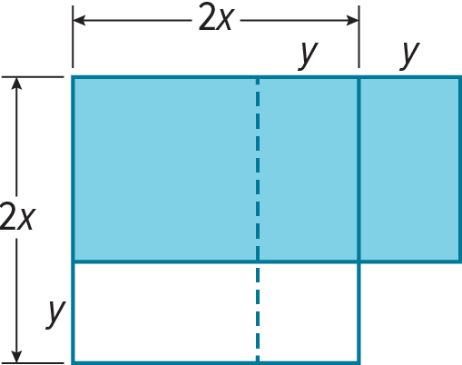
10. USE A MODEL Julio claims that you can find the area of a rectangle using the following method: take two positive integers x and y, where x > y. The side lengths of the rectangle are defined by the expression 2x + y and 2x – y. The area of the rectangle is defined by the expression 4x² – y². Is Julio correct? Explain your reasoning in the context of polynomial identities.

Mixed Exercises
Determine whether each equation is an identity.
11. (x + 3)²(x³ + 3x² + 3x + 1) = (x² + 6x + 9)(x + 1)³

12. (x + 2)(x + 1)² = (x² + 3x + 2)(x + 1)

13. (x + 3)(x – 1)² = (x² – 2x – 3)(x – 1)

14. (x + 2)²(x³ – 3x² + 3x – 1) = (x² + 4x + 4)(x – 1)³

15. (a + b)² = a² – 2ab + b²

16. USE TOOLS Consider the following equation.
(x – 2)²(x³ + 9x² + 27x + 27) = (x² – 4x + 4)(x + 3)³
a. Evaluate the expressions for each value to complete the table.
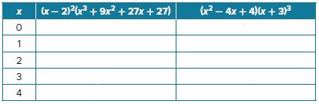
b. What conclusion can you make about the equation, based on the results in your table? Explain.
c. How can you prove your conclusion from part b?

USE TOOLS Use a computer algebra system (CAS) to prove each identity.
17. g⁶ + h⁶ = (g² + h²)(g⁴ – g²h² + h⁴)

18. a⁵ + b⁵ = (a + b)(a⁴ – a³b + a²b² – ab³ + b⁴)

19. u⁶ – w⁶ = (u + w)(u – w)(u² + uw + w²)(u² – uw + w²)

20. (x + 1)²(x – 4)³ = (x² – 3x – 4)(x³ – 7x² + 8x + 16)

21. WRITE Explain the meaning of polynomial identity and summarize the method for proving an equation is a polynomial identity.

22. CREATE Write and solve a system of equations using the identity, (x² – y²)² + (2xy)² = (x² + y²)² to find the values of x and y that make a 3, 4, 5 Pythagorean triple.

23. ANALYZE Refer to Example 2. Notice that Pedro says x and y must be positive integers and
x must be greater than y. Explain why these restrictions are necessary.

24. PERSEVERE Rebecca has a square garden with side length a that she wants to transform into a rectangle. Rebecca speculates that if she subtracts the same length b from one dimension of the garden and adds it to the other dimension the new rectangle’s area will be smaller than the original garden in the amount of b². Draw a diagram and show algebraically that Rebecca is correct.

25. FIND THE ERROR George is proving the identity a³ + b³ = (a + b)(a² – ab + b²) by simplifying the right side. His work is shown. Is George correct? If not, identify and correct his error.
