Roots and Zeros ⸱ Practice

Example 1
Solve each equation. State the number and type of roots.
1. 5x + 12 = 0 2. $x^{2}$ – 4x + 40 = 0

3. $x^{5}$ + 4$x^{3}$ = 0 4. $x^{4}$ – 625 = 0

5. 4$x^{2}$ – 4x – 1 = 0 6. $x^{5}$ – 81x = 0

7. 2x² + x – 6 = 0 8. 4x² + 1 = 0

9. x³ + 1 = 0 10. 2x² – 5x + 14 = 0

11. –3x² – 5x + 8 = 0 12. 8x³ – 27 = 0

13. 16x⁴ – 625 = 0 14. x³ – 6x² + 7x = 0

15. x⁵ – 8x³ + 16x = 0 16. x⁵ + 2x³ + x = 0

Example 2
State the possible number of positive real zeros, negative real zeros, and imaginary zeros of
each function.
17. g(x) = 3$x^{3}$ – 4$x^{2}$ – 17x + 6 18. h(x) = 4$x^{3}$ – 12$x^{2}$ – x + 3

19. f(x) = $x^{3}$ – 8$x^{2}$ + 2x – 4 20. p(x) = $x^{3}$ – $x^{2}$ + 4x – 6

21. q(x) = $x^{4}$ + 7x² + 3x – 9 22. f(x) = $x^{4}$ – $x^{3}$ – 5$x^{2}$ + 6x + 1

23. f(x) = x⁴ – 5x³ + 2x² + 5x + 7 24. f(x) = 2x³ – 7x² – 2x + 12

25. f(x) = –3x⁵ + 5x⁴ + 4x² – 8 26. f(x) = x⁴ – 2x² – 5x + 19

27. f(x) = 4x⁶ – 5x⁴ – x² + 24 28. f(x) = –x⁵ + 14x³ + 18x – 36

Example 3
Find all of the zeros of each function and use them to sketch a rough graph.
29. h(x) = $x^{3}$ – 5$x^{2}$ + 5x + 3 30. g(x) = $x^{3}$ – 6$x^{2}$ + 13x – 10

31. h(x) = $x^{3}$ + 4$x^{2}$ + x – 6 32. q(x) = $x^{3}$ + 3$x^{2}$ – 6x – 8

33. g(x) = $x^{4}$ – 3$x^{3}$ – 5$x^{2}$ + 3x + 4 34. f(x) = $x^{4}$ – 21$x^{2}$ + 80

35. f(x) = x³ + 7x² + 4x – 12 36. f(x) = x³ + x² – 17x + 15

37. f(x) = x⁴ – 3x³ – 3x² – 75x – 700 38. f(x) = x⁴ + 6x³ + 73x² + 384x + 576

39. f(x) = x⁴ – 8x³ + 20x² – 32x + 64 40. f(x) = x⁵ – 8x³ – 9x

Example 4
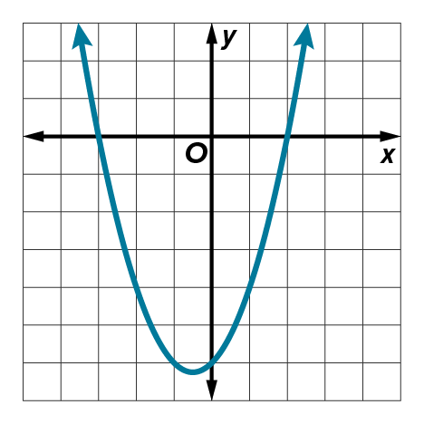
Write a polynomial that could be represented by each graph.
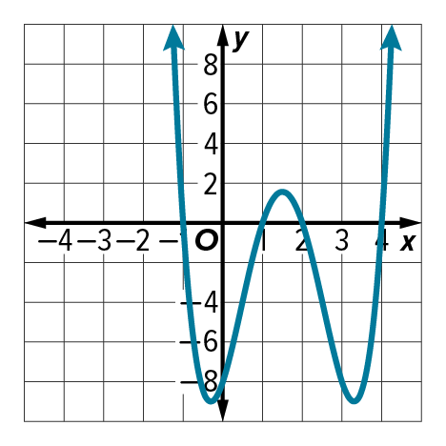
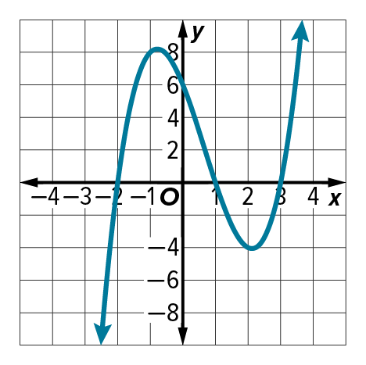
41. 42. 43.

Example 5
44. FISH Some fish jump out of the water. When a fish is out of the water, it’s location is above sea level. When a fish dives back into the water, its location is below sea level. A biologist can use polynomial functions to model the location of fish compared to see level. A biologist noticed that a fish is at sea level at –3, –2, –1, 1, 2, and 3 minutes from noon. Graph a polynomial function that could represent the location of the fish compared to sea level y, in centimeters, x seconds from noon.

45. BUSINESS After introducing a new product, a company’s profit is modeled by a polynomial function. In 2012 and 2017, the company’s profit on the product was $0. Graph a polynomial function that could represent the amount of profit, p(x), in thousands of dollars, x years
since 2010.

Mixed Exercises
Write a polynomial function of least degree with integral coefficients that has the given zeros.
46. 5, –2, –1 47. –4, –3, 5

48. –1, –1, 2i 49. –3, 1, –3i

50. 0, –5, 3 + i 51. –2, –3, 4 – 3i

Sketch the graph of each function using its zeros.
52. f(x) = x³ – 5x² – 2x + 24 53. f(x) = 4x³ + 2x² – 4x – 2
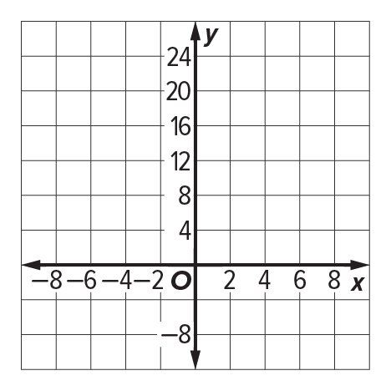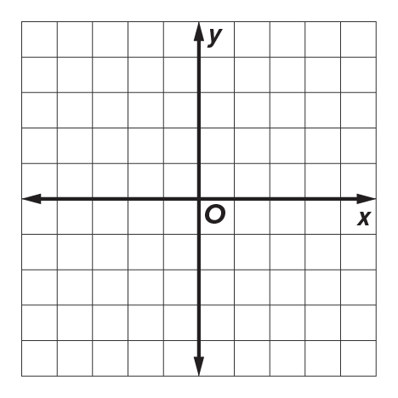

54. f(x) = x⁴ – 6x³ + 7x² + 6x – 8 55. f(x) = x⁴ – 6x³ + 9x² + 4x – 12
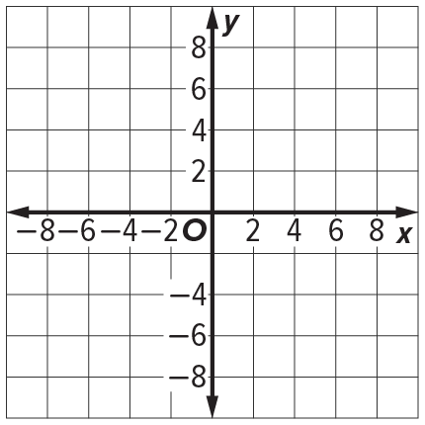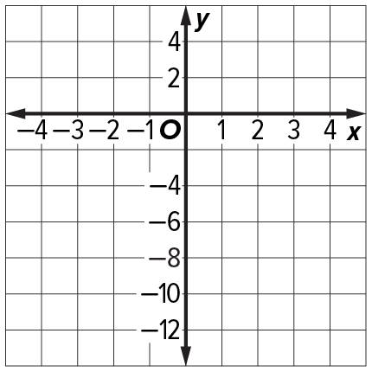

56. USE A SOURCE Linear algebra is the study of linear equations. In linear algebra, the coefficients of linear equations are often organized into rectangular arrays called matrices. Research the eigenvalues of a matrix and how they relate to the roots of a polynomial function. What fields use linear algebra, matrices, and eigenvalues?.

57. SPACE The technology for a rocket that will safely return to Earth for refueling and reuse is currently being developed. The three sections of the booster that will power the flight of the payload are cylindrical with a total volume of about 234π cubic meters. If the second stage section of the booster is x meters tall, then the interstage section x + 3 meters tall, and the first stage section is 5x + 6.5 meters tall. The radius of the booster is x – 5 meters.

a. Write and solve an equation to represent the total volume of the booster.
b. What are the dimensions of the first stage section of the booster? Explain your reasoning.

58. CREATE Consider two polynomial functions, f(x) and g(x).
a. Write a polynomial function f(x) of least degree with integral coefficients and zeros that include –1 – 4i and $\frac{2}{3}$ + $\frac{1}{3}$i. Explain how you found the function.
b. Write another polynomial function g(x) with integral coefficients that has the same degree and zeros. How did you find this function?
c. Are you able to sketch the graphs of f(x) and g(x) based on the zeros? Explain your reasoning. Then sketch the graphs of f(x) and g(x).

59. ANALYZE Use the zeros to draw the graph of P(x) = x³ – 7x² + 7x + 15 by hand. Discuss the accuracy of your graph, and what could be done to improve the accuracy.

60. PRESEVERE Let the polynomial function f(x) have real coefficients, be of degree 5, and have zeros 4 + 3i, 2 − 7i, and 6 + bi where b is a real number.
a. What can be determined about b? Explain your reasoning.
b. Write a possible equation for f(x).

61. CREATE Sketch the graph of a polynomial function with:
a. 3 real, 2 imaginary zeros b. 4 real zeros c. 2 imaginary zeros

62. PERSEVERE Write an equation in factored form of a polynomial function of degree 5 with 2 imaginary zeros, 1 nonintegral zero, and 2 irrational zeros. Explain.

63. WHICH ONE DOESN’T BELONG? Determine which equation is not like the others. Justify your conclusion.

64. ANALYZE Provide a counterexample for each statement.
a. All polynomial functions of degree greater than 2 have at least 1 negative real root.
b. All polynomial functions of degree greater than 2 have at least 1 positive real root.
65. WRITE Explain to a friend how you would use Descartes’ Rule of Signs to determine the number of possible positive real roots and the number of possible negative real roots of the polynomial function f(x) = x⁴ – 2x³ + 6x² + 5x – 12.
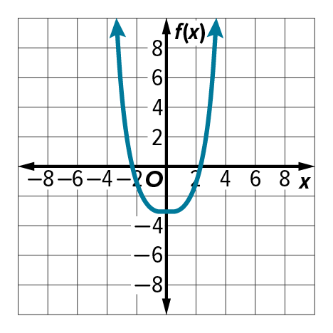
66. FIND THE ERROR The graph shows a polynomial function. Brianne says the function is a 4th degree polynomial. Amrita says the function is a 2nd degree polynomial. Is either of them correct? Explain your reasoning.

