Operations on Functions ⸱ Practice

Examples 1 and 2
Find (f + g)(x), (f – g)(x), (f □ g)(x), and $\left(\frac{f}{g}\right)$(x) for each f(x) and g(x).
1. f(x) = 2x 2. f(x) = x – 1
g(x) = –4x + 5 g(x) = 5x – 2

3. f(x) = x – 2 4. f(x) = x²
g(x) = 2x – 7 g(x) = x – 5

5. f(x) = –x² + 6 6. f(x) = 3x² – 4
g(x) = 2x² + 3x – 5 g(x) = x² – 8x + 4

Example 3
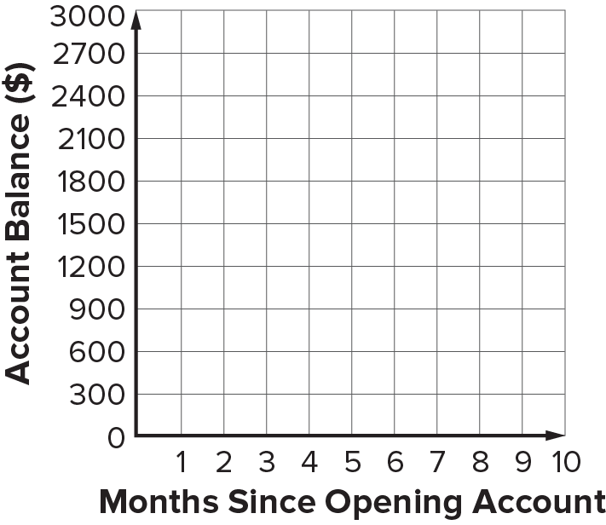
7. FINANCE Trevon opens a checking account that he only uses to pay fixed bills, which are expenses that are the same each month, such as car loans or rent. The checking account has an initial balance of $1750 and Trevon deposits $925 each month. The balance of the account can be modeled by a(x) = 1750 + 925x, where x is the number of months since the account was opened. The total of Trevon’s fixed bills is modeled by b(x) = 840x. Define and graph the function that represents the account balance after he pays his bills.
a. Identify and write a new function to represent the account balance.
b. Graph the combined function.

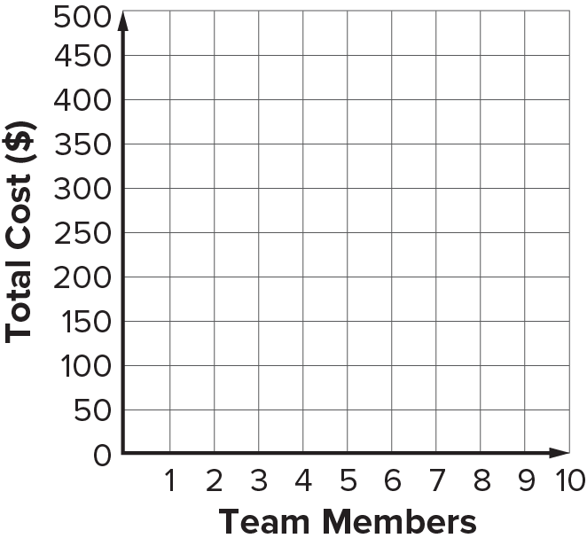
8. BASEBALL A coach is ordering custom practice T-shirts and game jerseys for each of the team members. The coach orders T-shirts from a local shop that charges $7.50 for each, plus a $35 initial printer fee. The cost of the T-shirts is modeled by t(x) = 7.5x + 35, where x is the number of team members. He orders jerseys online, which cost $18 each with $20 shipping. The cost of the jerseys is modeled by j(x) = 18x + 20. Define and graph the function that represents the total cost of the T-shirts and jerseys.
a. Identify and write a new function to represent total cost.
b. Graph the combined function.

Examples 4
For each pair of functions, find f ◦ g and g ◦ f, if they exist. State the domain and range for each.
9. f = {(–8, –4), (0, 4), (2, 6), (–6, –2)} 10. f = {(–7, 0), (4, 5), (8, 12), (–3, 6)}
g = {(4, –4), (–2, –1), (–4, 0), (6, –5)} g = {(6, 8), (–12, –5), (0, 5), (5, 1)}

11. f = {(5, 13), (–4, –2), (–8, –11), (3, 1)} 12. f = {(–4, –14), (0, –6), (–6, –18), (2, –2)}
g = {(–8, 2), (–4, 1), (3, –3), (5, 7)} g = {(–6, 1), (–18, 13), (–14, 9), (–2, –3)}

Examples 5
Find [f ◦ g](x) and [g ◦ f](x), if they exist. State the domain and range for each.
13. f(x) = 2x 14. f(x) = –3x
g(x) = x + 5 g(x) = –x + 8

15. f(x) = x² + 6x – 2 16. f(x) = 2x² – x + 1
g(x) = x – 6 g(x) = 4x + 3

Example 6
17. USE A MODEL Mr. Rivera wants to purchase a riding lawn mower, which is on sale for 15% off the original price. The sales tax in his area is 6.5%. Let x represent the original cost of the lawn mower. Write two functions representing the price of the lawn mower p(x) after the discount and the price of the lawn mower t(x) after sales tax. Write a composition of functions that represents the price of the riding lawn mower. How much will Mr. Rivera pay for a riding lawn mower that originally cost $1350?

18. REASONING A sporting goods store is offering a 20% discount on shoes. Mariana also has a $5 off coupon that can be applied to her purchase. She is planning to buy a pair of shoes that originally costs $89. Will the final price be lower if the discount is applied before the coupon or if the coupon is applied before the discount? Justify your response.

Mixed Exercises
19. REASONING A bookstore that offers a 12% membership discount is currently offering 20% off each customer’s total purchase when they spend more than $50. If Keshawn has $78 of books, should he request that the membership discount or the 20% off discount be applied first? Justify your response.

20. CONSTRUCT ARGUMENTS Is [f ◦ g](x) always equal to [g ◦ f](x) for two functions f(x) and g(x)?
Justify your conclusions. Provide a counterexample if needed.

If f(x) = 3x, g(x) = x + 4, and h(x) = x² – 1, find each value.
21. f[g(1)] 22. g[h(0)] 23. g[f(–1)]

24. h[f(5)] 25. g[h(–3)] 26. h[f(10)]

27. f[h(8)] 28. [f ◦ (h ◦ g)](1) 29. [f ◦ (g ◦ h)](–2)

30. h[f(–6)] 31. f[h(0)] 32. f[g(7)]

33. f[h(–2)] 34. [g ◦ (f ◦ h)](–1) 35. [h ◦ (f ◦ g)](3)


36. AREA Valeria wants to know the area of a figure made by joining an equilateral triangle and square along an edge. The function f(s) = $\frac{\sqrt{3}}{4}$ s² gives the area of an equilateral triangle with side s. The function g(s) = s² gives the area of a square with side s. Write a function h(s) that gives the area of the figure as a function of its side length s.

37. USE A MODEL The volume V of a weather balloon with radius r is given by V(r) = $\frac{4}{3}$ πr³. The balloon is being inflated so that the radius increases at a constant rate r(t) = $\frac{1}{2}$ t + 2, where r is in meters and t is the number of seconds since inflation began.
a. Determine the function that represents the volume of the weather balloon in terms of time.
b. Find the volume of the balloon 12 seconds after inflation begins. Round your answer to the nearest cubic meter.

38. REASONING The National Center for Education Statistics reports data showing that since 2006, college enrollment for men in thousands can be modeled by f(x) = 389x + 7500, where x represents the number of years since 2006. Similarly, enrollment for women can be modeled by g(x) = 480x + 10,075. Write a function for (f + g)(x) and interpret what it represents.

39. STRUCTURE The table shows various values of functions f(x), g(x), and h(x).
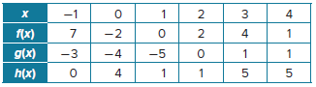
Use the table to find the following values:
- (f + g)(–1) b. (h – g)(0) c. (f • h)(4)

d. $\left(\frac{f}{g}\right)$(3) e. $\left(\frac{g}{h}\right)$(2) f. $\left(\frac{g}{f}\right)$(1)

40. PRESEVERE If (f + g)(3) = 5 and (f • g)(3) = 6, find f(3) and g(3). Explain.

41. CREATE Write two functions f(x) and g(x) such that (f ◦ g)(4) = 0.

42. FIND THE ERROR Chris and Tobias are finding (f ◦ g)(x), where f(x) = x² + 2x – 8 and g(x) = x² + 8. Is either of them correct? Explain your reasoning.
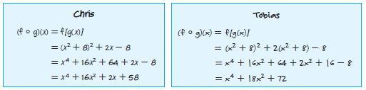

43. PERSEVERE Given f(x) = $\sqrt{x^{3}}$ and g(x) = $\sqrt{x^{6}}$, determine each domain.
a. g(x) • g(x) b. f(x) • f(x)

44. ANALYZE State whether the following statement is sometimes, always, or never true. Justify your argument.

The domain of two functions f(x) and g(x) that are composed g[f(x)] is restricted by the domain of g(x).


1.FINANCE Trevon opens a checking account that he only uses to pay fixed bills, which are expenses that are the same each month, such as car loans or rent. The checking account has an initial balance of $1750 and Trevon deposits $925 each month. The balance of the account can be modeled by a(x) = 1750 + 925x, where x is the number of months since the account was opened. The total of Trevon’s fixed bills is modeled by b(x) = 840x. Define and graph the function that represents the account balance after he pays his bills.
a. Identify and write a new function to represent the account balance.
b. Graph the combined function.


2. BASEBALL A coach is ordering custom practice T-shirts and game jerseys for each of the team members. The coach orders T-shirts from a local shop that charges $7.50 for each, plus a $35 initial printer fee. The cost of the T-shirts is modeled by t(x) = 7.5x + 35, where x is the number of team members. He orders jerseys online, which cost $18 each with $20 shipping. The cost of the jerseys is modeled by j(x) = 18x + 20. Define and graph the function that represents the total cost of the T-shirts and jerseys.
a. Identify and write a new function to represent total cost.
b. Graph the combined function.

3. USE A MODEL Mr. Rivera wants to purchase a riding lawn mower, which is on sale for 15% off the original price. The sales tax in his area is 6.5%. Let x represent the original cost of the lawn mower. Write two functions representing the price of the lawn mower p(x) after the discount and the price of the lawn mower t(x) after sales tax. Write a composition of functions that represents the price of the riding lawn mower. How much will Mr. Rivera pay for a riding lawn mower that originally cost $1350?

4. REASONING A sporting goods store is offering a 20% discount on shoes. Mariana also has a $5 off coupon that can be applied to her purchase. She is planning to buy a pair of shoes that originally costs $89. Will the final price be lower if the discount is applied before the coupon or if the coupon is applied before the discount? Justify your response.

5. REASONING A bookstore that offers a 12% membership discount is currently offering 20% off each customer’s total purchase when they spend more than $50. If Keshawn has $78 of books, should he request that the membership discount or the 20% off discount be applied first? Justify your response.

6. CONSTRUCT ARGUMENTS Is [f ◦ g](x) always equal to [g ◦ f](x) for two functions f(x) and g(x)?
Justify your conclusions. Provide a counterexample if needed.

