Inverse Relations and Functions ⸱ Practice

Example 1
For each polygon, find the inverse of the relation. Then, graph both the original relation and its inverse.
1. $△MNP$ with vertices at {(−8, 6), (6, −2), (4, −6)}

2. $△XYZ$ with vertices at {(7, 7), (4, 9), (3, −7)}

3. trapezoid QRST with vertices {(8, −1), (−8, −1), (−2, −8), (2, –8)}

4. quadrilateral FGHJ with vertices at {(4, 3), (−4, −4), (−3, −5), (5, 2)}

Examples 2 and 3
Find the inverse of each function. Then graph the function and its inverse. If necessary, restrict the domain of the inverse so that it is a function.
5. f(x) = x + 2 6. g(x) = 5x

7. f(x) = –2x + 1 8. h(x) = $\frac{x – 4}{3}$

9. f(x) = $-\frac{5}{3}$x – 8 10. g(x) = x + 4

11. f(x) = 4x 12. f(x) = –8x + 9

13. f(x) = 5x² 14. h(x) = x² + 4

Example 4
15. WEIGHT The formula to convert weight in pounds to stones is p(x) = $\frac{x}{14}$, where x is the weight in pounds.
a. Find the inverse of p(x), and describe its meaning.
b. Graph p(x) and p⁻¹(x). Use the graph to find the weight in pounds of a dog that weighs about
2.5 stones.

16. CRYPTOGRAPHY DeAndre is designing a code to send secret messages. He assigns each letter of the alphabet to a number, where A = 1, B = 2, C = 3, and so on. Then he uses c(x) = 4x – 9 to create the secret code.
a. Find the inverse of c(x), and describe its meaning.
b. Make tables of c(x) and c⁻¹(x). Use the table to decipher the message: 15, 75, 47, 3, 71, 27, 51, 47, 67.

Examples 5
Determine whether each pair of functions are inverse functions. Write yes or no.
17. f(x) = x – 1 18. f(x) = 2x + 3
g(x) = 1 – x g(x) = $\frac{1}{2}$(x – 3)

19. f(x) = 5x – 5 20. f(x) = 2x
g(x) = $\frac{1}{5}$x + 1 g(x) = $\frac{1}{2}$x

21. h(x) = 6x – 2 22. f(x) = 8x – 10
g(x) = $\frac{1}{6}$x + 3 g(x) = $\frac{1}{8}$x + $\frac{5}{4}$

Examples 6
23. GEOMETRY The formula for the volume of a right circular cone with a height of 2 feet is V = $\frac{2}{3}$πr². Determine whether r = $\sqrt{\frac{3V}{2π}}$ is the inverse of the original function.

24. GEOMETRY The formula for the area of a trapezoid is A = $\frac{h}{2}$(a + b). Determine whether h = 2A – (a + b) is the inverse of the original function.

Mixed Exercises
Find the inverse of each function. Then graph the function and its inverse. If necessary, restrict the domain of the inverse so that it is a function.
25. y = 4 26. f(x) = 3x

27. f(x) = x + 2 28. g(x) = 2x – 1

29. f(x) = $\frac{1}{2}$x² – 1 30. f(x) = (x + 1)² + 3

Determine whether each pair of functions are inverse functions. Write yes or no.
31. f(x) = 4x² 32. f(x) = $\frac{1}{3}$x² + 1
g(x) = $\frac{1}{2}\sqrt{x}$ g(x) = $\sqrt{3x-3}$

33. f(x) = x² – 9 34. f(x) = $\frac{2}{3}$x³
g(x) = x + 3 g(x) =

35. f(x) = (x + 6)² 36. f(x) = 2$\sqrt{x-5}$
g(x) = $\sqrt{x}$ – 6 g(x) = $\frac{1}{4}$x² – 5

Restrict the domain of f(x) so that its inverse is also a function. State the restricted domain of f(x) and the domain of f^{–1}(x).
37. f(x) = x² + 5 38. f(x) = 3x²

39. f(x) = $\sqrt{x+6}$ 40. f(x) = $\sqrt{x+ 3}$

Sketch a graph of the inverse of each function. Then state whether the inverse is a function.
41. 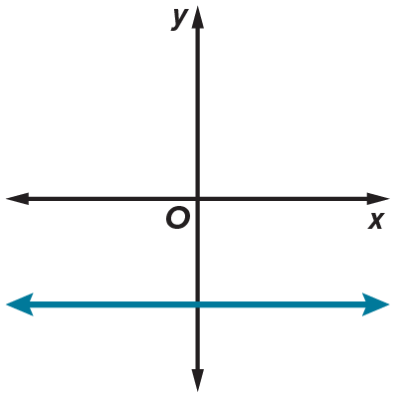 42.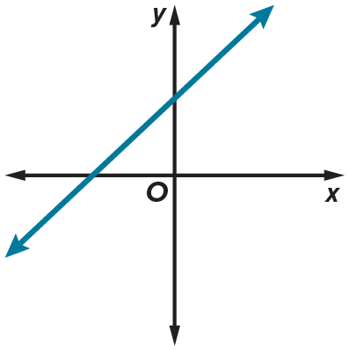

43. 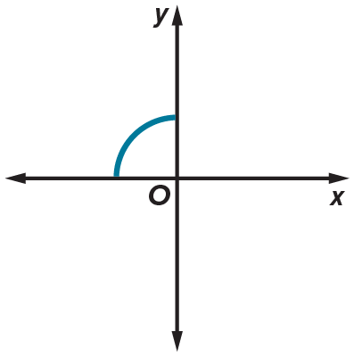 44. 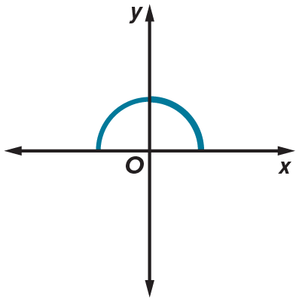

45. FITNESS Alejandro is a personal trainer. For his clients to gain the maximum benefit from their exercise, Alejandro calculates their maximum target heart rate using the function f(x) = 0.85(220 − x), where x represents the age of the client. Find the inverse of this function and interpret its meaning in the context of the situation.
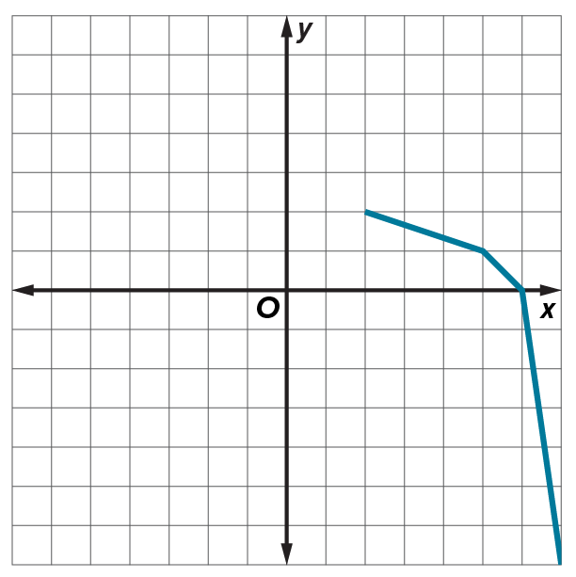
46. Graph the inverse of the piecewise function shown.

47. USE A MODEL The diagram shows a sheet of metal with squares of side
length x removed from each corner which can be used to form an open box.
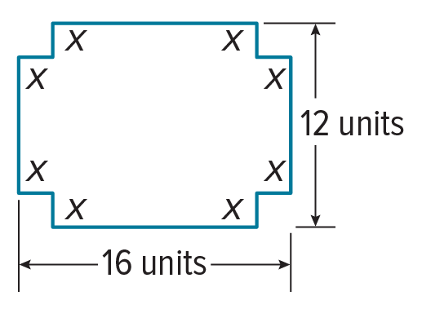
a. Write and graph the function V(x) which gives the volume of the open
box. Explain how the domain of this function must be restricted within
the context of this scenario.
b. Does restricting the domain in part a allow for the inverse to also
be a function? Explain your reasoning.

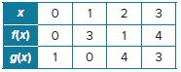
48. ANALYZE Use the table to find the relationship between
(f + g)^{–1}(x) and f^{–1}(x) + g^{–1}(x).
a. Suppose that functions f(x), g(x), and (f + g)(x) all have inverse functions defined on the domain [0, 3]. Calculate the following values.
i. f^{–1}(3) + g^{–1}(3) ii. f^{–1}(1) + g^{–1}(1)
b. Use the value of (f + g)(1) to find (f + g)^{–1}(3). Use the value of (f + g)(0) to find (f + g)^{–1}(1).
c. Joyce claims that (f + g)^{–1}(x) = f^{–1}(x) + g^{–1}(x). Determine whether she is correct. Explain your reasoning.
d. Consider the functions f(x) = 2x + 1 and g(x) = 2x – 1. Compare (f + g)^{–1}(x) and
f^{–1}(x) + g^{–1}(x).

49. ANALYZE If a relation is not a function, then its inverse is sometimes, always, or never a function. Justify your argument.

50. CREATE Give an example of a function and its inverse. Verify that the two functions are inverses.

51. PERSEVERE Give an example of a function that is its own inverse.

52. ANALYZE Can the graphs of a linear function with a slope ≠ 0 and its inverse ever be perpendicular? Justify your answer.

53. WRITE Suppose you have a composition of two functions that are inverses. When you put in a value of 5 for x, why is the result always 5?

