Graphing Radical Functions ⸱ Practice

Example 1
Identify the domain and range of each function.
1. y = $\sqrt{x-9}$ 2. y = $\sqrt{x+7}$

3. y = –$\sqrt{6x}$ 4. y = 5 $\sqrt{x+2}-1$

5. y = $\sqrt{3x-4}$ 6. y = –$\sqrt{x-2}+2$

Example 2
Graph each function. State the domain and range of each function. Then describe how it is related to the graph of the parent function.
7. y = $-\frac{1}{3}\sqrt{x+1}$ 8. y = –$\sqrt{x-2}$ + 3

9. y = $2\sqrt{x}$ 10. y = $\sqrt{x+3}$

11. y = 3$\sqrt{x}-5$ 12. y = $\sqrt{x+4}$ – 2

Example 3
13. REFLEXES Rachel and Ashley are testing one another’s reflexes. Rachel drops a ruler from a given height so that it falls between Ashley’s thumb and index finger. Ashley tries to catch the ruler before it falls through her hand. The time, in seconds, required to catch the ruler is given by the product of $\frac{1}{4}$ and the square root of the distance the ruler falls in inches.
a. Write and graph a function, where d is the distance in inches, and t is the time, in seconds.
b. Describe the key features of the function.
c. Graph the parent function on the same coordinate grid. How does the function you wrote in part a compare to the parent function?
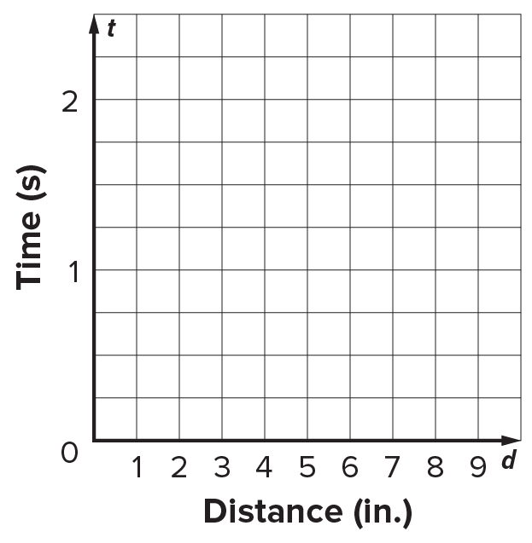

Example 4
Graph each inequality.
14. y < $\sqrt{x-5}$ 15. y > $\sqrt{x+6}$

16. y ≥ –4$\sqrt{x+3}$ 17. y ≤ –2$\sqrt{x-6}$

18. y > 2$\sqrt{x+7}$ – 5 19. y ≥ 4$\sqrt{x-2}$ – 12

Example 5
Graph each function. State the domain and range of each function.
20. f(x) = $\sqrt[3]{x+1}$ 21. f(x) = 3$\sqrt[3]{x-2}$

22. f(x) = $\sqrt[3]{x+7}$ – 1 23. f(x) = –$\sqrt[3]{x-2}$ + 9

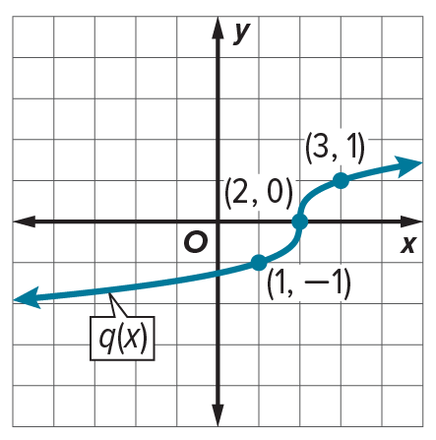
Example 6
24. Examine p(x) = –3$\sqrt{x-2}$ and q(x) shown in the graph.
a. Graph p(x).
b. Compare the key features of the functions.

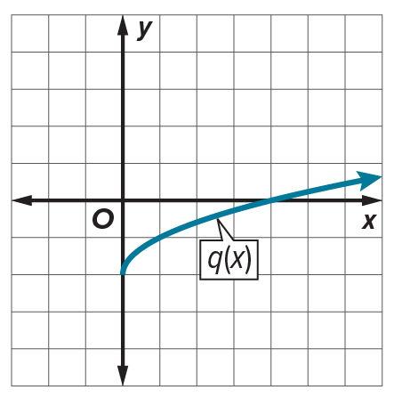
25. Examine p(x), which is 2 less than the cube root of x, and q(x) shown in the graph.
a. Graph p(x).
b. Compare the key features of the functions.

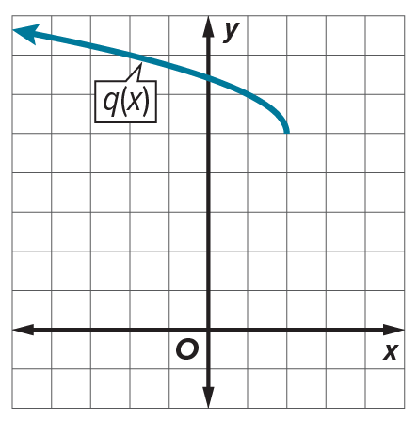
26. Examine p(x) = $\sqrt{x-2}+5$ and q(x) shown in the graph.
a. Graph p(x).
b. Compare the key features of the functions.

Example 7
Write a radical function for each graph.
27. 28.
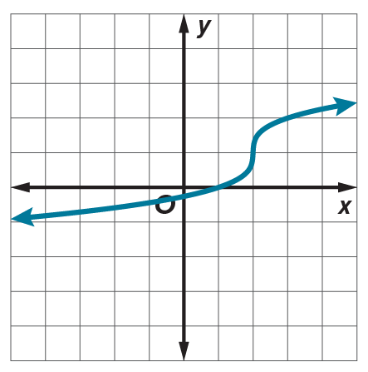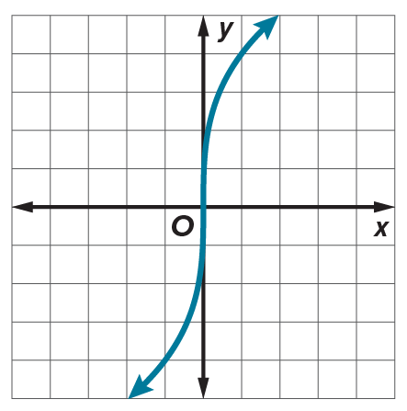

Mixed Exercises
Graph each function and state the domain and range. Then describe how it is related to the graph of the parent function.
29. f(x) = 2$\sqrt{x-5}$ – 6 30. f(x) = $\frac{3}{4}\sqrt{x+12}$ + 3

31. f(x) = $-\frac{1}{5}\sqrt{x-1}$ – 4 32. f(x) = –3$\sqrt{x+7}$ + 9

33. f(x) = $-\frac{1}{3}\sqrt[3]{x+2}$ – 3 34. f(x) = $-\frac{1}{2}\sqrt[3]{2x-1}$ + 3

Graph each inequality.
35. y ≤ 6 – 3$\sqrt{x-4}$ 36. y < $\sqrt{4x-12}$ + 8

1. Write a radical function for the graph
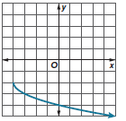

2. Write a radical function for the graph
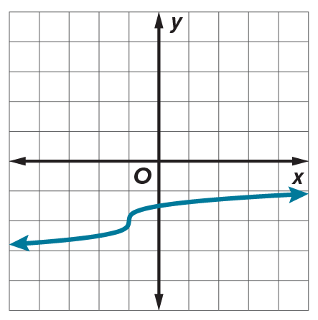

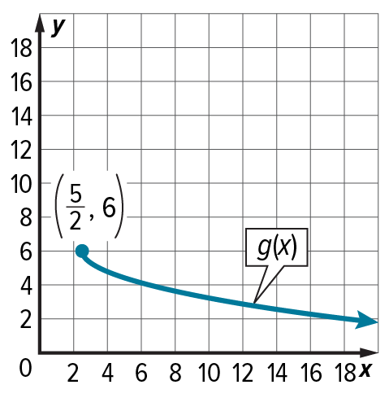
3. STRUCTURE Consider the function f(x) = −$\sqrt{x+3}$ + $\frac{13}{2}$ and the function g(x) whose graph is shown.
a. Determine which function has the greater maximum value. Explain your reasoning.

b. Compare the domains of the two functions.

c. Compare the rates of change of the two functions over the interval [6,13].

4. DISTANCE LaRez is standing at the side of a road watching a cyclist. The distance, in feet, between LaRez and the cyclist as a function of time is given by the square root of the sum of 9 and the product of 36 and the time squared.

a. Write and graph a function, where t is the time, in seconds, and d is the distance, in feet.

b. Describe the key features of the function.

5. GEOMETRY The length of the radius of a hemisphere can be found using the formula
r = $\sqrt[3]{\frac{3V}{2π}}$, given the volume V of the hemisphere. Graph the function. State the key features of the graph.

6. STRUCTURE Graph f(x) > $\sqrt{-x+2}$ − 3 and its inverse on the same coordinate plane as well as y = x. Write the inequality that defines the graph of the inverse. Determine any restrictions that must be placed on the domain of the inverse.

43. PERSEVERE Write an equation for a square root function with a domain of {x | x ≥ –4}, a range of {y | y ≤ 6}, and that passes through (5, 3).

44. ANALYZE For what positive values of a are the domain and range of f(x) = $\sqrt[a]{x}$ the set of real numbers? Justify your argument.

45. WRITE Explain why there are limitations on the domain and range of square root functions.

46. WRITE Explain why y = $±\sqrt{x}$ is not a function.

47. CREATE Write an equation of a relation that contains a radical and its inverse such that:
a. the original relation is a function, and its inverse is not a function.
b. the original relation is not a function, and its inverse is a function.

