Operations with Radical Expressions ⸱ Practice

Examples 1 and 2
Simplify.
1. $\sqrt{72a^{8}b^{5}}$ 2. $\sqrt{9a^{15}b^{3}}$

3. $\sqrt{24a^{16}b^{8}c}$ 4. $\sqrt{18a^{6}b^{3}c^{5}}$

5. $\sqrt[4]{{64a}^{4}b^{4}}$ 6. $\sqrt[3]{{-8d}^{2}f^{5}}$

7. $\sqrt{\frac{25}{36}r^{2}t}$ 8. $\sqrt{\frac{192k^{4}}{64}}$

9. $\sqrt[5]{\frac{3072h^{8}}{243f^{5}}}$ 10. $\sqrt[3]{\frac{432n^{12}}{64q^{6}}}$

Example 3
Simplify.
11. $\sqrt{2}$ + $\sqrt{8}$ + $\sqrt{50}$ 12. $\sqrt{12}$ – 2$\sqrt{3}$ + $\sqrt{108}$

13. $8\sqrt{5}$ – $\sqrt{45}$ – $\sqrt{80}$ 14. $2\sqrt{48}$ – $\sqrt{75}$ – $\sqrt{12}$

15. $\sqrt{28x}-\sqrt{14}+\sqrt{63x}$ 16. $\sqrt{135}+5\sqrt{10d}-3\sqrt{60}$

Examples 4
Simplify.
17. 3$\sqrt{5y}$ • 8$\sqrt{10yz}$ 18. 2$\sqrt{32a^{3}b^{5}}$ • $\sqrt{8a^{7}b^{2}}$

19. 6$\sqrt{3ab}$ • $4\sqrt{24ab^{3}}$ 20. 5$\sqrt{x^{8}y^{3}}$ • $5\sqrt{2x^{5}y^{4}}$

21. 5$\sqrt{2x}$ • 3$\sqrt{7x^{2}y^{3}}$ 22. 3$\sqrt{a^{5}b^{7}}$ • $2\sqrt{5a^{7}b^{3}}$

Examples 5
23. TRAMPOLINE There are two trampoline runways at a gymnastics practice facility. Both runways are $\sqrt{3}$ meters wide. One is 6$\sqrt{3}$ meters long and the other is 5$\sqrt{2}$ meters long. What is the total area of the trampoline runways?

24. DISTANCE Jayla walks 5 blocks north, then 8 blocks east to get to the library. Each block is
5$\sqrt{10}$ yards long. If Jaime could walk in a straight line to the library instead, how far would
the walk be, in yards?

Simplify.
25. $\left(7\sqrt{2}-3\sqrt{3}\right)\left(4\sqrt{6}+3\sqrt{12}\right)$ 26. $\left(8\sqrt{5}-6\sqrt{3}\right)\left(8\sqrt{5}+6\sqrt{3}\right)$

27. $\left(12\sqrt{10}-6\sqrt{5}\right)\left(12\sqrt{10}+6\sqrt{5}\right)$ 28. $\left(6\sqrt{3}+5\sqrt{2}\right)\left(2\sqrt{6}+3\sqrt{8}\right)$

Examples 6 and 7
Simplify.
29. $\frac{\sqrt{5a^{5}}}{\sqrt{b^{13}}}$ 30. $\frac{\sqrt{7x}}{\sqrt{{10x}^{3}}}$

31. $\frac{3\sqrt[3]{6x^{2}}}{3\sqrt[3]{5y}}$ 32. $\sqrt[4]{\frac{7x^{3}}{4b^{2}}}$

33. $\frac{6}{\sqrt{3} - \sqrt{2}}$ 34. $\frac{\sqrt{2}}{\sqrt{5} - \sqrt{3}}$

35. $\frac{9 - 2\sqrt{3}}{\sqrt{3} + 6}$ 36. $\frac{2\sqrt{2} + 2\sqrt{5}}{\sqrt{5} + \sqrt{2}}$

37. $\frac{3\sqrt{7}}{\sqrt{5}- 1}$ 38. $\frac{7x}{3 - \sqrt{2}}$

Mixed Exercises
Simplify.
39. $\sqrt[3]{16y^{4}z^{12}}$ 40. $\sqrt[3]{-54x^{6}y^{11}}$

41. $\frac{x + 1}{\sqrt{x} - 1}$ 42. $\frac{x - 2}{\sqrt{x^{2} - 4} }$

43. 3$\sqrt{24x}$ – 2$\sqrt{54x}$ + $\sqrt{48}$ 44. 5$\sqrt{18c}$ + 3$\sqrt{72c}$ + 6 $\sqrt{76}$

45. 10$\sqrt{175a}$ – 4$\sqrt{112a}$ – 2$\sqrt{63a}$ 46. 7$\sqrt{204y}$ + 4$\sqrt{459y}$ – 8 $\sqrt{140y}$

47. VOLUME McKenzie has a rectangular prism with dimensions 20 inches by 35 inches by 40 inches. She would like to replace it with a cube with the same volume. What should the length of a side of the cube be? Express your answer as a radical expression in simplest form.

48. MUSIC Traditionally, musical instruments are tuned so that the note A has a frequency of 440 Hertz. With each note higher on the instrument, the frequency of the pitch is multiplied by a factor of $\sqrt[12]{2}$. What is the ratio of the frequencies of two notes that are 6 steps apart on the instrument? What is the ratio of the frequencies of two notes that are 9 steps apart on the instrument? Express your answers in simplest form.

49. PHYSICS The speed of a wave traveling over a string is given by $\frac{\sqrt{t}}{\sqrt{u}}$, where t is the tension
of the string and u is the density. Simplify the expression.

50. LIGHT Suppose a light has a brightness intensity of $I_{1}$when it is at a distance of $d_{1}$and a brightness intensity of $I_{2}$ when it is at a distance of $d_{2}$. These quantities are related by the equation $\frac{d_{2}}{d_{1}}$ = $\sqrt{\frac{I_{1}}{I_{2}}}$. Suppose $I_{1}$ = 50 units and $I_{2}$ = 24 units, find $\frac{d_{2}}{d_{1}}$ . Express your answer in simplest form.

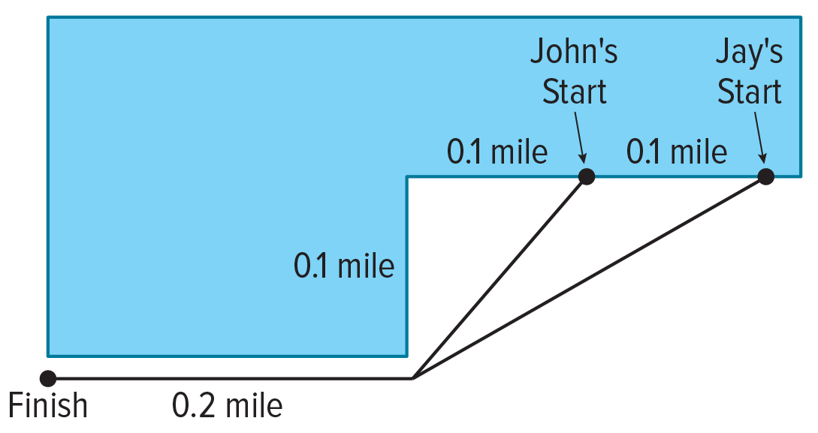
51. RACING Jay likes to race his younger brother while running. To make the race fair, John and Jay start at different locations, but finish at the same point. The diagram shows their running paths. Both of them finished the race in exactly 4 minutes.

a. If John and Jay continued at their average paces during the race, exactly how many minutes would it take them each to run a mile? Express your answer as a radical expression in simplest form.
b. Exactly how many times faster is Jay compared to John? Express your answer as a radical expression in simplest form.

52. STRUCTURE Write the ratio of the side lengths of the two cubes described in simplest form.
a. The volumes of the two cubes are 270x cubic inches and 32x² cubic inches.
b. The surface areas of the two cubes are 6x⁴ square feet and 6(x + 1) square feet.

53. REGULARITY Rewrite each of the following expressions as a single expression in the form ax^{m} for appropriate choices of a and m. Show your work.
a. $\sqrt{x}\left(\sqrt{x}+\sqrt{4x}\right)$
b. $\sqrt{x}\left(\sqrt{x}+\sqrt{4x}+\sqrt{9x}\right)$
c. $\sqrt{x}\left(\sqrt{x}+\sqrt{4x}+\sqrt{9x}+\sqrt{16x}\right)$
d. More generally, simplify $\sqrt{x}\left(\sqrt{x}+\sqrt{4x}+…+\sqrt{n^{2}x}\right)$ for any positive integer n. Use the fact that 1 + 2 + … + n = $\frac{n(n + 1)}{2}$.
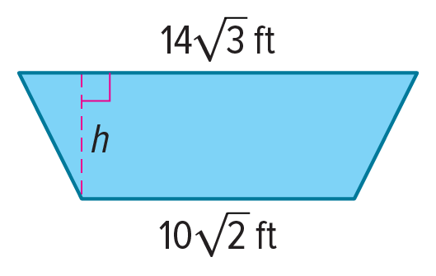
54. MODELING If the area of the trapezoid shown is 200 square feet, what is the height h of the trapezoid?

55. CONSTRUCT ARGUMENTS A spherical paperweight with a volume of 72π cubic centimeters is to be packaged in a gift box that is a cube. There must be at least 2 centimeters of packing material around the paperweight to protect it during shipping. The formula for the volume of a sphere is V = $\frac{4}{3}$πr³.
a. Write an expression for the minimum length of a side of the gift box. Show your work.
b. The shipper wants to use a box with a volume of 384 cubic centimeters that they already have in inventory. Is this box suitable? Justify your arguments.

56. FIND THE ERROR Twyla and Brandon are simplifying 4$\sqrt{32}$ + 6$\sqrt{18}$. Is either of them correct? Explain your reasoning.
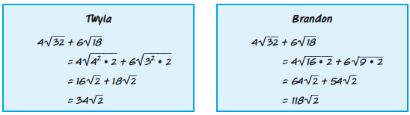

57. PERSEVERE Find four combinations of whole numbers that satisfy $\sqrt[a]{256}$ = b.

58. PERSEVERE Show that $\frac{-1 - i\sqrt{3}}{2}$ is a cube root of 1.

59. WRITE Explain why absolute values may be unnecessary when an nth root of an even power results in an odd power.

60. WHICH ONE DOESN’T BELONG? Determine which of the radical expressions doesn’t belong. Justify your conclusion.

