Solving Radical Equations ⸱ Practice

Example 1
Solve each equation.
1. 5$\sqrt{j}$ = 1 2. $\sqrt{b-5}$ = 4

3. $\sqrt{3n+1}$ = 5 4. 2 + $\sqrt{3p+7}$ = 6

5. $\sqrt{k-4}$ – 1 = 5 6. 5 = $\sqrt{2g-7}$

Example 2
Solve each equation.
7. $\sqrt[3]{3r-6}$ = 3 8. ${\left(2d+3\right)}^{\frac{1}{3}}$ = 2

9. ${(t - 3)}^{\frac{1}{3}}$ = 2 10. 4 – ${(1-7u)}^{\frac{1}{3}}$ = 0

11. $\sqrt[3]{2v-7}$ = –2 12. ${4(5n-1)}^{\frac{1}{3}}$ – 1 = 0

Examples 3 and 4
Solve each equation. Identify any extraneous solutions.
13. $\sqrt{x-15}$ = 3 – $\sqrt{x}$ 14. ${\left(5q+1\right)}^{\frac{1}{4}}$ + 7 = 5

15. ${\left(3x+7\right)}^{\frac{1}{4}}$ – 3 = 1 16. ${\left(3y-2\right)}^{\frac{1}{5}}$ + 5 = 6

17. ${\left(4z-1\right)}^{\frac{1}{5}}$ – 1 = 2 18 $\sqrt{x-10}$ = 1 – $\sqrt{x}$

19. $\sqrt[6]{y+2}$ + 9 = 14 20. ${\left(2x-1\right)}^{\frac{1}{4}}$ – 2 = 1

Example 5
Use a graphing calculator to solve each equation by graphing.
21. $\sqrt{x-7}$ + 2 = 8 22. 5 + $\sqrt{3m+9}$ = 10

23. $\sqrt[3]{5b-4}$ = 2 24. $\sqrt[3]{2v+3}$ = –2

Example 6
Use a graphing calculator to solve each equation by using a system of equations.
25.$2\left(\sqrt[3]{2k-3}\right)$ = $\left(\sqrt[4]{k+14}\right)$ 26. $3\left(\sqrt[3]{d-5}\right)$ = $\left(\sqrt[4]{3d+2}\right)$

27. $\sqrt{2x+7}$ = 5 – $\sqrt{3x}$ 28. $\sqrt{n+8}$ = $\sqrt{4n-9}$

Example 7
29. GEOMETRY Heron’s formula states that the area of a triangle whose sides have lengths a, b, and c is A = $\sqrt{s(s-a)(s-b)(s-c)}$ where $s=\frac{1}{2}\left(a+b+c\right)$. If the area of the triangle is 270 cm², s = 45 cm, a = 15 cm, and c = 39 cm, what is the length of side b?

30. TWINE The largest ball of twine was started in 1953 by Frank Stroeber. In 4 years the ball had a volume of approximately 268 ft³. What was the radius of the ball of twine at that time? Round your answer to the nearest tenth.

Mixed Exercises
Solve each equation. Identify any extraneous solutions.
31. 6 + $\sqrt{4x+8}$ = 9 32. $\sqrt{7a-2}$ = $\sqrt{a+3}$

33. $\sqrt{x-5}$ – $\sqrt{x}$ = –2 34. $\sqrt{b-6}$ + $\sqrt{b}$ = 3

35. ${2\left(x-10\right)}^{\frac{1}{3}}$ + 4 = 0 36. ${3\left(x+5\right)}^{\frac{1}{3}}$ – 6 = 0

37. ${\frac{1}{7}\left(14a\right)}^{\frac{1}{3}}$ = 1 38. ${\frac{1}{4}\left(32b\right)}^{\frac{1}{3}}$ = 1

39. $\sqrt{x-3}$ = 3 – x 40. $\sqrt{x-2}$ = 22 – x
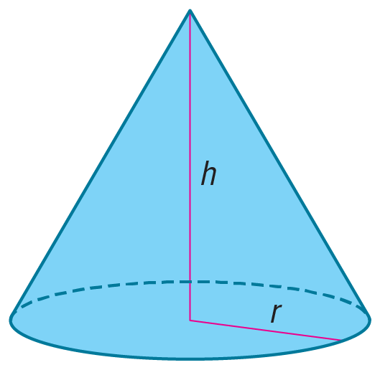
41. $\sqrt{x+30}$ = x 42. $\sqrt{x+22}$ = x + 2

43. GEOMETRY The lateral area of a cone with base radius r and height h is given by the formula L = πr$\sqrt{r^{2}+h^{2}}$. A cone has a lateral area of 65π square units and a base radius of 5 units. What is the height of the cone?

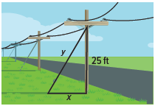
44. TETHERS A tether of length y secures a telephone pole at 25 feet off the ground. The distance from the tether to the pole along the ground is represented by x. By the Pythagorean Theorem, the length of the tether is given by y = $\sqrt{x^{2}+{25}^{2}}$. If x + y = 50 feet, what is the measure of x?

45. SPACE NASA’s Near-Earth Asteroid Tracking project tracked more than 300 asteroids. An asteroid is passing near Earth. If Earth is located at the origin of a coordinate plane, the path that the asteroid will trace out is given by y = $\frac{17}{x}$, x > 0, where unit corresponds to one million miles. One asteroid will be visible by telescope when it is within $\frac{145}{12}$ million miles of Earth.

a. Write an expression that gives the distance of the asteroid from Earth as a function of x.

b. For what values of x will the asteroid be in range of a telescope?

46. DRIVING To determine the speed of a car when it begins to skid to a stop, the formula s = $\sqrt{30fd}$ can be used, where s is the speed of the car, f is the coefficient of friction, and d is the length of the skid marks in feet. If the speed limit is 25 mph and the coefficient of friction is 0.6, what is the length of the skid marks if the driver is driving the speed limit?

47. CHEMISTRY The nuclear radius of an element can be approximated by r = (1.2 × 10^{–15}) where r is the length of the radius in meters and A is the molecular mass of the element.
a. The nuclear radius of neon is about 3.267 × 10^{–15} meter. Find its molecular mass.
b. Which element has a molecular radius of approximately 5.713 × 10^{–15} meter? Justify your
conclusion.
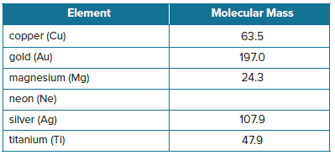

48. USE A MODEL Explain how to find the solutions to $\sqrt[4]{10x+11}$ – $\sqrt{x+2}$ = 0 graphically and confirm your results algebraically. What are the solutions?

1. USE TOOLS The surface area of a sphere is 20 cm² greater than the surface area of a cube. Find functions to represent the radius of the sphere and the side length of the cube, in terms of the surface area of the cube. If the radius of the sphere equals the side length of the cube, describe how to use a graphing calculator to find the surface area of the cube and sphere. Sketch the graph. Find the surface area of the cube and the sphere.

2. CONSTRUCT ARGUMENTS Explain how we know that the equation $\sqrt{x-5}$ + 1 = $\sqrt{(2-x)}$ has no solutions without having to actually solve it. Confirm this by graphing the two sides of the equation.

3. WHICH ONE DOESN’T BELONG? Determine which of the expressions doesn’t belong. Justify your conclusion.

4. PERSEVERE Haruko is working to solve ${\left(x+5\right)}^{\frac{1}{4}}$ = –4. He said that he could tell there was no real solution without even working the problem. Is Haruko correct? Explain your reasoning.

5. ANALYZE Determine whether $\frac{\sqrt{{\left(x^{2}\right)}^{2}}}{-x}$ = x is sometimes, always, or never true when x is a real number. Justify your argument.

6. CREATE Write an equation that can be solved by raising each side of the equation to the given power.
a. $\frac{3}{2}$ power b. $\frac{5}{4}$ power c. $\frac{7}{8}$ power

ANALYZE Determine whether the following statements are sometimes, always, or never true for
$x^{\frac{1}{n}}$ = a. Explain your reasoning.
55. If n is odd, there will be extraneous solutions.

56. If n is even, there will be extraneous solutions.

