Graphing Exponential Functions ⸱ Practice

Example 1
Graph each function. Find the domain, range, y-intercept, asymptote, and end behavior.
1. f(x) = 3^{x} 2. f(x) = 5^{x}

3. f(x) = 1.5^{x} 4. f(x) = ${\left(\frac{5}{2}\right)}^{x}$

Example 2
Graph each function.
5. f(x) = 2(3)^{x} 6. f(x) = –2(4)^{x} 7. f(x) = 4^{x + 1} – 5

8. f(x) = 3^{2x} + 1 9. f(x) = –0.4(3)^{x + 2} + 4 10. f(x) = 1.5(2)^{x} + 6

Example 3
Identify the value of k and write a function g(x) for each graph as it relates to f(x).
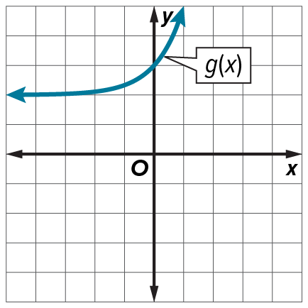
11. f(x) = 2^{x}; g(x) = f(x) + k 12. f(x) = 3^{x}; g(x) = f(x) + k 13. f(x) = ${\left(\frac{3}{2}\right)}^{x}$; g(x) = k □ f(x)
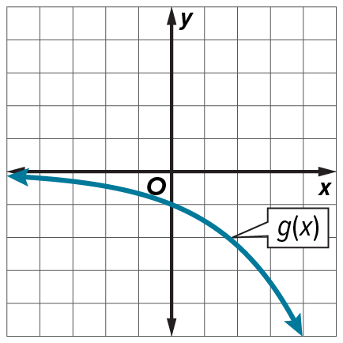
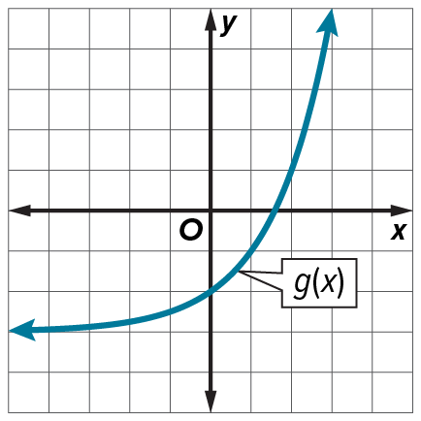

Example 4
14. SUBSCRIPTIONS Subscriptions to an online arts and crafts club have been increasing by 20% every year. The club began with 40 members. Make a graph of the number of subscribers over the first 5 years of the club’s existence. About how many subscriptions are there after Year 4?

15. SHOES The cost of a pair of athletic shoes increases about 5.1% every year. In 2018 the average price for a pair of athletic shoes was $58.17. Graph a function that models the cost of an average pair of athletic shoes. Then estimate the cost of an average pair of shoes in 25 years.

16. MONEY Sunil opened a savings account that compounds interest at a rate of 3% annually. Let P be the initial amount Sunil deposited, and let t be the number of years the account has been open.
a. Write an equation to find A, the amount of money in the account after t years. Assume that Sam made no more deposits and no withdrawals.
b. If Sunil opened the account with $500 and made no deposits or withdrawals, graph a function to represent the money in his savings account. Then estimate the amount of money in the account 10 years after opening the account.
c. Estimate the number of years it would take for such an account to double in value.

Example 5
Determine whether each function represents exponential growth or exponential decay.
17. f(x) = 7^{x} 18. g(x) = 0.99^{x} 19. h(x) = ${\left(\frac{2}{3}\right)}^{x}$

20. j(x) = ${\left(\frac{5}{4}\right)}^{x}$ 21. k(x) = 0.75^{x} 22. m(x) = 1.02^{x}

Example 6
Graph each function. Find the domain, range, y-intercept, asymptote, and end behavior.
23. f(x) = 0.25^{x} 24. f(x) = 0.8^{x}

25. f(x) = ${\left(\frac{1}{2}\right)}^{x}$ 26. f(x) = ${\left(\frac{2}{3}\right)}^{x}$

Example 7
Graph each function.
27. f(x) = –4${\left(\frac{3}{5}\right)}^{x + 4}$ + 3 28. f(x) = 3${\left(\frac{2}{5}\right)}^{x - 3}$ – 6 29. f(x) = $\frac{1}{2}{\left(\frac{1}{5}\right)}^{x + 5}$ + 8

30. f(x) = $\frac{3}{4}{\left(\frac{2}{3}\right)}^{x + 4}$ – 2 31. f(x) = $-\frac{1}{2}{\left(\frac{3}{8}\right)}^{x + 2}$ + 9 32. f(x) = $-\frac{5}{4}{\left(\frac{4}{5}\right)}^{x + 4}$ + 2

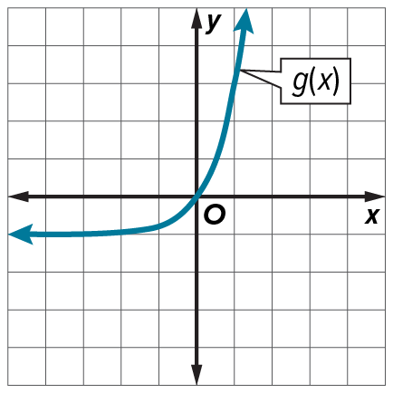
Example 8
33. Consider $f\left(x\right)=\left\{\begin{matrix}{\left(\frac{3}{4}\right)}^{x}\text{for} x<0 \\ 3x+1 \text{for} x≥0\end{matrix}\right.$ and g(x) shown in the graph.
a. Graph f(x).
b. How do the key features, such as domain and range, intercepts, increasing and decreasing, positive and negative, minimum and maximum, symmetry, and end behavior of f(x) and g(x) compare?

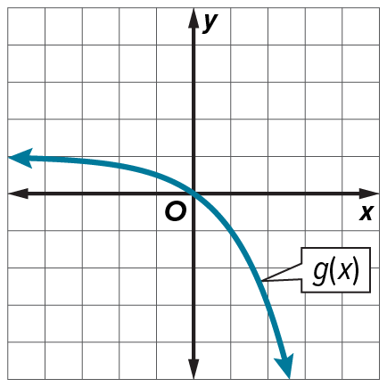
34. Consider $f\left(x\right)=\left\{\begin{matrix}{-\left(\frac{1}{2}\right)}^{x}\text{+} \text{3 for} x<-1 \\ -\frac{1}{4}x+\frac{3}{4} \text{for} x≥-1\end{matrix}\right.$ and g(x) shown in the graph.
a. Graph f(x).
b. How do the key features, such as domain and range, intercepts, increasing and decreasing, positive and negative, minimum and maximum, symmetry, and end behavior of f(x) and g(x) compare?

Mixed Exercises
Graph each function. State the function’s domain and range. Then use the graph to determine whether the function represents an exponential growth or exponential decay function.
35. y = 3(2)^{x} 36. y = 2${\left(\frac{1}{2}\right)}^{x}$
37. y = $-\frac{3}{2}$(1.5)^{x} 38. y = 3${\left(\frac{1}{3}\right)}^{x}$

f(x) is the parent function and g(x) is a transformation of f(x). Use the graph to determine g(x).
1. f(x) = $4^{x}$ 2. f(x) = ${\left(\frac{1}{5}\right)}^{x}$
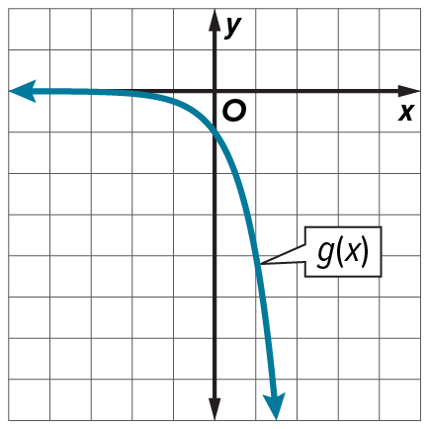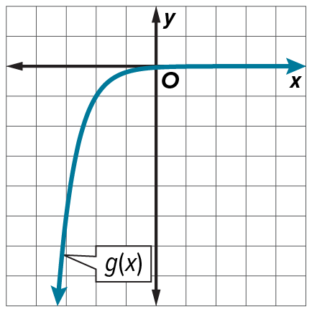

3. REASONING For y = ${ab}^{x}$, where a > 0, if b > 1, the function represents exponential growth. It represents exponential decay if 0 < b < 1.
a. Choose a positive value for a and let b = 1. Complete the table for these values of a and b.
Is y = ${ab}^{x}$ an exponential function? Explain your reasoning.
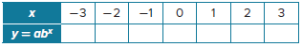

b. Choose a positive value for a and a negative value for b. Complete the table for these values. Is y = ${ab}^{x}$ an exponential function? Explain your reasoning.
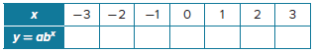

4. INVESTMENTS At age 28, Cataline makes a single $22,000 investment that earns 5% interest each year.
a. If Catalina leaves the investment untouched until she turns 65, how much will the investment be worth at that time?
b. Catalina’s twin brother, Rodrigo, waits 2 years and then makes the same investment as Catalina. If the function that describes Catalina’s investment is C(t), what function describes Rodrigo’s investment? What will his investment be worth when he turns 65?

5. PERSEVERE A substance decays 35% each day. After 8 days, there are 8 milligrams of the substance remaining. How many milligrams were there initially?

6. WRITE Write the procedure for transforming the graph of g(x) = b^{x} to the graph of f(x) = ab^{x – h} + k. Justify each step.

43. CARS The value of an automobile depreciates by approximately 15% each year after purchase. Jayden paid $28,000 when he bought his car 15 years ago.
a. Write and graph a function that models how the value of the car depreciates.
b. How does the average decrease in value during the first five years of ownership compare to the last five years of ownership?

44. STRUCTURE Let f(x) = 6^{x}; g(x) = $-\frac{1}{2}$(6)^{x + 3} – 1 and h(x) = $\frac{3}{2}$(6)^{x – 5}.
a. What is the asymptote of each function?
a. How could you transform f(x) to create the graphs of g(x) and h(x)?
b. How could you directly transform g(x) to create the graph of h(x)?

45. Let f(x) = (4)^{x} and g(x) = (4)^{–x} + 1. What transformations of f(x) will result in the graph of g(x)? Graph both functions. For g(x), identify how the y-intercept, intervals where the function is increasing, decreasing, positive, or negative, the asymptote, and the end behavior of f(x) are transformed?

46. If the graph of f(x) = (0.5)^{x} is reflected in the y-axis, stretched vertically by a factor of 2, and translated 1 unit down to create g(x), find the equation for g(x). What are the domain, range, y-intercept, and zeros of g(x)? Graph g(x) and label any intercepts.

47. CHEMISTRY A compound undergoes exponential decay with initial amount 27.3 grams.
a. If the amount of the compound decreases by ten percent each year, define variables and write a function modeling the amount of the compound remaining at a given time.
b. Find the average rate of change for the function over [0, 2] and [3, 5]. Explain the rates of change in terms of the situation.

48. USE TOOLS A population of bacteria grows exponentially with initial population 20,000. After one day the bacteria population grows to 30,000.
a. Write a function P(t) to model the bacteria population after t days.
b. Use a graphing calculator to graph P(t) and sketch the graph. Identify the intercepts, zeros, and the end behavior as t → +∞ and explain these features in the context of the problem.
c. What is an appropriate domain for P(t)? Explain your reasoning.

49. ANALYZE Determine whether each statement is sometimes, always, or never true. Explain your reasoning.
a. An exponential function of the form y = ab^{x – h} + k has a y-intercept.
b. An exponential function of the form y = ab^{x – h} + k has an x-intercept.
c. The function f(x) = |b|^{x} is an exponential growth function if b is an integer.

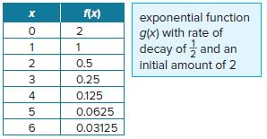
50. FIND THE ERROR Vince and Grady were asked to graph f(x) and g(x) given the table for f(x) and the description of g(x). Vince thinks they are the same, but Grady disagrees. Who is correct? Explain your reasoning.

51. PERSEVERE A substance decays 35% each day. After 8 days, there are 8 milligrams of the substance remaining. How many milligrams were there initially?

52. CREATE Give an example of a value of b for which f(x) = ${\left(\frac{8}{b}\right)}^{x}$ represents exponential decay.

53. WRITE Write the procedure for transforming the graph of g(x) = b^{x} to the graph of f(x) = ab^{x – h} + k. Justify each step.

