Geometric Sequences and Series ⸱ Practice

Example 1
Determine whether each sequence is geometric.
1. 5, 7, 9, 11, 13, … 2. 3, 6, 12, 24, 48, …

3. 2, –4, 8, –16, 32, … 4. 400, 200, 100, 50, 25, …

5. 60, 48, 36, 24, 12, … 6. 8000; –2000; 500; –125; …

Example 2
Find and graph the first six terms of each geometric sequence.
7. 1, 2, 4, … 8. 2, 6, 18, …

9. –1, –3, –9, … 10. 800, –400, 200, …

11. 512, –128, 32, … 12. 160, 80, 40, …

Example 3
13. FAMILY Amanda is researching her ancestry. She records names and birth dates for her parents, their parents, and so on, in an online research tool. If she can locate all of the information, how many names will Amanda record in the generation that is 5 generations before her?

14. MOORE’S LAW Gordon Moore, co-founder of Intel, suggested that the number of transistors on a square inch of integrated circuit in a computer chip would double every 18 months. Assuming Moore’s law is true, how many times as many transistors would you expect on a square inch of integrated circuit in year 6?

Example 4
Write an equation for the nth term of each geometric sequence.
15. 3, 9, 27, … 16. –1, –3, –9, …

17. 2, –6, 18, … 18. 5, 10, 20, …

19. a₄ = 324 and r = 3 20. a₃ = 512 and r = $\frac{1}{8}$

Example 5
Given a formula for a geometric sequence in recursive or explicit form, translate it to the other form.
21. a₁ = 3, a_{n} = 0.6a_{n – 1}, n ≥ 2 22. a_{n} = 0.8(2)^{n – 1}

23. a₁ = –1, a_{n} = $\frac{1}{2}$a_{n – 1}, n ≥ 2 24. a_{n} = $-\frac{2}{3}$(6)^{n – 1}

Example 6
Find the geometric means of each sequence.
25. 4, ? , ? , ? , 64 26. 1, ? , ? , ? , 81

27. 38; 228; ? ; 8208; 49,248; … 28. 51; ? ; 4131; ? ; 334,611; …

Example 7
29. SCIENTIFIC RESEARCH Scientific balloons carry equipment to observe or conduct experiments. The NASA Balloon Program generally tries to fly balloons above 80,000 to 90,000 feet. Suppose a balloon rises 1000 feet in the first minute after it is launched. For the next hour, each minute it rises 1% more than it rose in the previous minute.
a. Complete the table to show the height of the balloon at various times after launch.
b. After an hour will the balloon have reached its target height of 80,000 – 90,000 feet? Explain.

Example 8
Find a₁ for each geometric series described.
30. S_{n} = 1295, r = 6, n = 4 31. S_{n} = 1640, r = 3, n = 8
32. S_{n} = 218$\frac{2}{5}$, $a_{n}$ = 1$\frac{2}{5}$, r = $\frac{1}{5}$ 33. S_{n} = –342, $a_{n}$= –512, r = –2

Example 9
Find the sum of each geometric series.
34. $\sum_{k=1}^{7}{4}{\left(-3\right)}^{k - 1}$ 35. $\sum_{k=1}^{8}{\left(-3\right)}{\left(-2\right)}^{k - 1}$

36. $\sum_{k=1}^{9}{\left(-1\right)}{\left(4\right)}^{k - 1}$ 37. $\sum_{k=1}^{10}{5}{\left(-1\right)}^{k - 1}$

Mixed Exercises
Find a_{n} for each geometric sequence.
38. a₁ = 5, r = 2, n = 6 39. a₁ = 18, r = 3, n = 6

40. a₁ = –3, r = –2, n = 5 41. a₁ = –20, r = –2, n = 9

42. a₁ = 65,536, r = $\frac{1}{4}$, n = 6 43. a₁ = –78,125, r = $\frac{1}{5}$, n = 9

Determine whether each sequence is geometric. If a sequence is geometric, write an equation for the nth term.
44. 4, 7, 13, 25, … 45. 25, 175, 1225, 8575, …

46. –16,384; –8192; –4096; –2048; … 47. –15, 30, –60, 120, –240, …

Find the sum of each geometric series to the nearest ten-thousandth.
48. a₁ = 36, r = $\frac{1}{3}$, n = 8 49. a₁ = 16, r = $\frac{1}{2}$, n = 9

50. a₁ = 240, r = $\frac{3}{4}$, n = 7 51. a₁ = 360, r = $\frac{4}{3}$, n = 8

52. Find the missing term in the geometric sequence 64, 96, 144, 216, ? .

53. Find the first five terms of the geometric sequence for which a₁ = 3 and r = –2.

54. Find the sum of a geometric series for which a₁ = 3125, a_{n} = 1, and r = $\frac{1}{5}$.

55. Find a₁ in a geometric series for which S_{n} = 3045, r = $\frac{2}{5}$ and a_{n} = 120.

56. Find a₁ in a geometric series for which S_{n} = –728, r = 3, and n = 6.

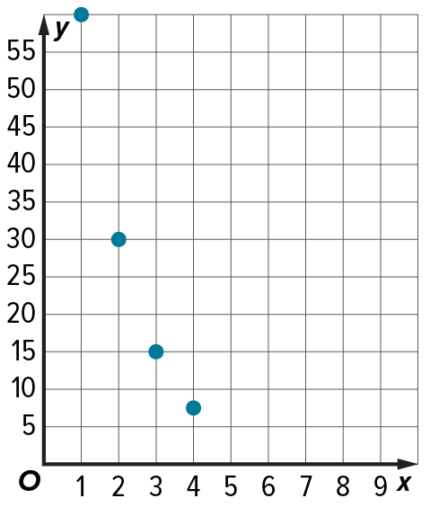
57. Write an equation to find the nth term of the sequence shown in the graph.

58. Write an equation to find the nth term of the geometric sequence $\frac{1}{3}$,$\frac{2}{9}$ ,$\frac{4}{27}$, ... .

59. Find the missing terms in the geometric sequence $\frac{729}{64}$, ? , ? , ? , $\frac{324}{9}$.

60. Find two geometric means between 3 and 375.

61. Find two geometric means between 16 and –2.

62. BIOLOGY Mitosis is a process of cell division that results in two identical daughter cells from a single parent cell. The table illustrates the number of cells produced after each of the first 5 cell divisions.
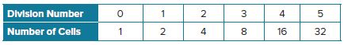

a. Do the entries in the “Number of Cells” row form a geometric series? If so, find r.
b. Write formulas in explicit and recursive form to find the nth term of the sequence.
c. Find the number of cells after 100 divisions.

63. CONSTRUCT ARGUMENTS A grand prize winner has two choices for receiving their winnings. They can choose an $80 million immediate payout, or 20 annual payments that begin at $4 million and increase 2% each year. Which option would you advise the winner to take? Explain your reasoning.

64. STRUCTURE An athlete makes a running plan using the formula a_{n} = 20(1.1)^{n-1}, where a_{n} is the
target number of miles for the nth week of training.

a. Interpret the formula in terms of the situation.
b. How many total miles will the athlete have run after training for 10 weeks?
c. The athlete hopes to run a total of 1000 miles in preparation for a race at the end of 20 weeks
of training. Will she reach this goal? Explain your reasoning.
d. Another athlete increased running mileage by the same ratio each week but reached 1000
miles in 15 weeks. Approximately how many miles did he run for the first week of training?
Explain your reasoning.

65. USE A MODEL A geometric series can be combined with compound interest to find a formula for payments on a loan or mortgage. For a mortgage with a principal P, a monthly interest rate r, and consisting of n monthly payments, each monthly payment is $\frac{Pr}{1- {(1 + r)}^{-n}}$.
a. For a 30-year $300,000 mortgage with a 6% annual interest rate, how much interest is collected over the life of the loan? Hint: Use r = annual interest rate ÷ 12.
b. Suppose a family can afford to make monthly payments of up to $1250. If annual interest rate is 4%, what is the greatest 20-year mortgage they can afford? Round your answer to the nearest $1000.

66. PROOF Derive the explicit formula for a geometric sequence using the recursive formula.
67. CREATE Write a geometric series for which r = $\frac{3}{4}$ and n = 6.

68. ANALYZE Explain how $\sum_{k=1}^{10}{3}{\left(2\right)}^{k - 1}$ needs to be altered to refer to the same series if k = 1 changes to k = 0. Explain your reasoning.

69. PROOF Prove the formula for the nth term of a geometric sequence.

70. PERSEVERE The fifth term of a geometric sequence is $\frac{1}{27}$th of the eighth term. If the ninth term is 702, what is the eighth term?

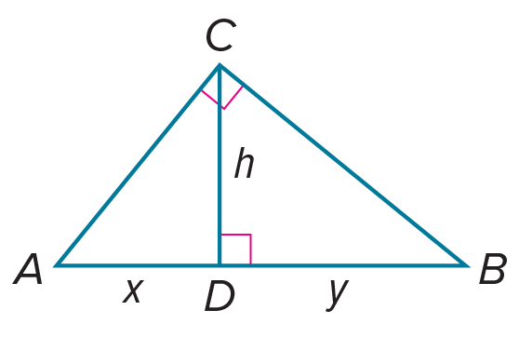
71. PERSEVERE Use the fact that h is the geometric mean between x and y in the figure at the right to find h⁴ in terms of x and y.

72. CREATE Write a geometric series with 6 terms and a sum of 252.

73. WRITE How can you classify a sequence as arithmetic, geometric, or neither? Explain your reasoning.

