Modeling Data ⸱ Practice

Example 1
Use a graphing calculator to make a scatter plot of the data in the table. Then determine whether the data are best modeled by a linear, quadratic, or exponential function.
1.
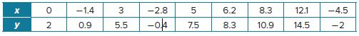

2.
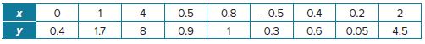

3.
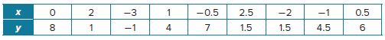

Example 2
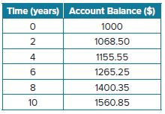
4. SAVINGS Brittany deposited $1000 into an account. She made no further deposits or withdrawal. The table shows the account balance for a period of 10 years.
a. Use the graphing calculator to draw a scatterplot of
the data.
b. Use the regression feature of the graphing calculator to determine the best model. Round coefficients and constants to the nearest hundredth.
c. About how much will be in the account after 15 years?

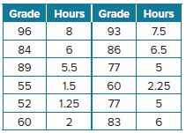
5. TEST GRADES A professor conducted a survey by asking 12 students how many hours they spent preparing for the final exam. The professor then matched the students’ responses with their final exam grades.
a. Graph and analyze the data set. State if it is linear or exponential. Write an equation for the best-fit model.
b. Based on your graph, what is the minimum number of hours that you should spend studying if you want to get a
passing grade of 60% or better on the final exam?

6. SCIENCE EXPERIMENTS Shawnte devised an experiment for measuring the average time before a soap bubble pops. She creates 64 identical bubbles and documents the number that have not popped at various times.
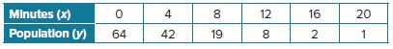

a. Graph the data.
b. What is the best model? What is the regression function?
c. When would you expect there to be 32 unpopped bubbles?
Mixed Exercises
USE TOOLS Use a graphing calculator to make a scatter plot of the data. Then determine whether the data are best modeled by a linear, quadratic, or exponential function.
7. (0, 1), (−1, −3), (10, 41), (2, 9), (7, 29), (−9, −35), (5, 21)
8. (0, 1), (6, 64), (2, 4), (4, 16), (3, 8), (5, 32), (1, 2)

Describe the correlation for each value of r.
9. r = 0.965 10. r = −1
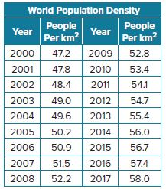
11. r = 0.22 12. r = −0.39

13. POPULATION The World Bank and the Food and Agriculture Organization track world population trends. The table shows the number of people per square kilometer for several years. Use a graphing calculator to graph the scatter plot that models the data. Then use the scatter plot to describe the relationship between the variables.

14. CREATE Make a table of values where the data in the table is best modeled by an exponential function.
15. WRITE Explain how to use a graphing calculator to determine whether data in a table are best modeled by a linear, quadratic, or exponential function.

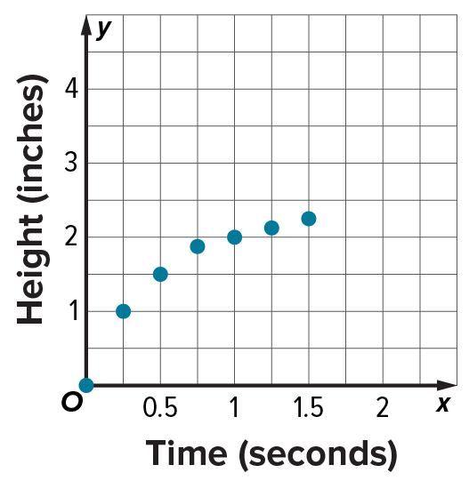
16. ANALYZE The path of a stream of water in a fountain is shown in the graph. Should you select an exponential function or quadratic function to model this data? Explain.

17. PERSEVERE The surface areas SA of hemispheres with radius r are shown in the table. What is the best model? What is the equation of the regression function?

