Logarithms and Logarithmic Functions ⸱ Practice

Example 1
Write each equation in exponential form.
1. $\log_{15}$ 225 = 2 2. $\log_{3}$ $\frac{1}{27}$ = –3 3. $\log_{5}$ $\frac{1}{25}$ = –2

4. $\log_{3}$ 243 = 5 5. $\log_{4}$ 64 = 3 6. $\log_{4}$ 32 = $\frac{5}{2}$

Example 2
Write each equation in logarithmic form.
7. 2⁷ = 128 8. 3^{–4} = $\frac{1}{81}$ 9. 7^{–2} = $\frac{1}{49}$

10. ${\left(\frac{1}{7}\right)}^{3}$ = $\frac{1}{343}$ 11. 2⁹ = 512 12. ${64}^{\frac{2}{3}}$ = 16

Example 3
Evaluate each expression.
13. $\log_{2}$ 64 14. $\log_{100}$ 100,000 15. $\log_{5}$ 625

16. $\log_{27}$ 81 17. $\log_{4}$ $\frac{1}{32}$ 18. $\log_{10}$ 0.00001

19. $\log_{8}$ 512 20. $\log_{9}$ 1 21. $\log_{8}$ 4

Example 4
22. STRUCTURE The electric current I in amperes in a particular circuit can be represented by
log₂I = –t, where t is given in seconds. Write an equation to find the current when time is known.

23. STRUCTURE The value of a guitar in dollars after x years can be modeled by the equation y = g(1.0065)^{x}, where g is the initial cost of the guitar. If a guitar costs $400, write an equation to find the number of years it takes for a guitar to reach a certain value.

Example 5
Graph each function. Then find the intercepts, domain, range, and end behavior.
24. f(x) = $\log_{\frac{1}{9}}x$ 25. f(x) = $\log_{\frac{1}{5}}x$

26. f(x) = $\log_{2}$ x 27. f(x) = $\log_{8}$ x

Example 6
Graph each function.
28. f(x) = 2 $\log_{4}$ (x + 3) – 2 29. f(x) = –3 $\log_{10}$ (x – 2) + 1

30. f(x) = $\log_{3}$ (x + 1) – 4 31. f(x) = –$\log_{5}$ x + 2.5

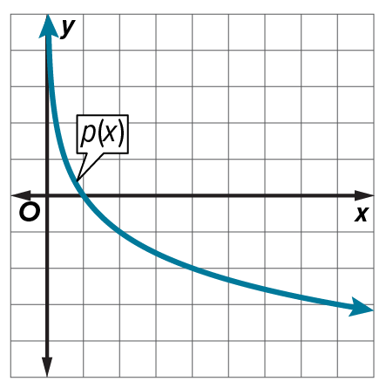
Example 7
32. Consider g(x) = log₁₀ (x ‒ 4) and p(x) shown in the graph.
Part A Graph g(x).
Part B Compare the end behavior of g(x) and p(x).

33. Consider f(x) = log₁₀ (x + 2) and the logarithmic function g(x) shown in the table.
Part A Graph f(x) and g(x).
Part B Compare the end behavior of f(x) and g(x).
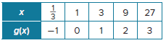

Example 8
Identify the value of k, and write a function for each graph as it relates to f(x) = log₅ x.
34. g(x) = f(x) + k 35. h(x) = k ∙ f(x) 36. j(x) = f(x) + k

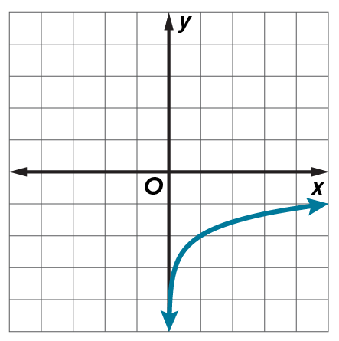
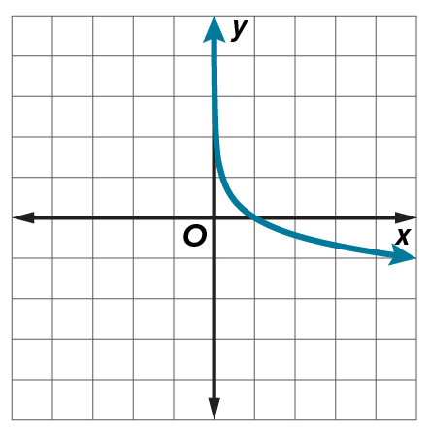
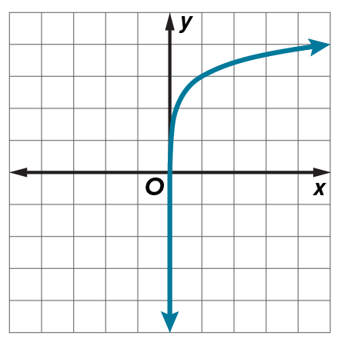

Mixed Exercises
Write each equation in exponential form and each exponential equation in logarithmic form.
37. $\log_{6}$ 216 = 3 38. $\log_{2}$ 64 = 6

39. $\log_{3}$ $\frac{1}{81}$ = –4 40. 3^{–5} = $\frac{1}{243}$

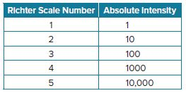
41. ${\left(\frac{1}{4}\right)}^{3}$ = $\frac{1}{64}$ 42. ${7776}^{\frac{1}{5}}$ = 6

43. EARTHQUAKES The intensity of an earthquake can be measured on the
Richter scale using the formula y = 10^{R–1}, where y is the absolute intensity of the earthquake and R is its Richter scale measurement. In 1906, an earthquake in San Francisco had an absolute intensity of 6,000,000. What is the Richter scale measurement of the earthquake?

44. INVESTING Maria invests $1000 in a savings account that pays 4% interest compounded annually. The value of the account A at the end of x years can be determined by the
equation A = 1000(1.04^{x}). Solve the equation for x.

45. CONSTRUCT ARGUMENTS Julio and Natalia are competing in a math competition. They each selected a logarithmic function and compar their functions to see which has a greater value. Julio selected the function f(x) = 10 log₂ x and Natalia selected g(x) = 2 log₁₀ x.
a. Which function has a greater value when x = 7? Explain your reasoning.
b. Which function has a greater value when x = 1? Explain your reasoning.

46. BIOLOGY An amoeba divides into two amoebas every hour. The number N of amoebas after t hours can be represented by t = log₂ N. How many hours will it take for a single amoeba to divide into 2048 amoebas?

47. STRUCTURE Graph f(x) = 3^{X} and g(x) = log₃ x on the same coordinate plane. Define the domain, range, intercepts, and asymptotes of each. Compare the two graphs.

48. WRITE What should you consider when using exponential and logarithmic models to
make decisions?

49. ANALYZE Let f(x) = log₁₀ x and g(x) = 10^{x}. Find f(g(x)) and g(f(x)) and justify your conclusion.

50. FIND THE ERROR Betsy says that the graphs of all logarithmic functions cross the y-axis at (0, 1) because any number to the zero power equals 1. Tyrone disagrees because he says log 0 is undefined. Is either of them correct? Explain your reasoning.

51. PERSEVERE Without using a calculator, compare log₇ 51, log₈ 61, and log₉ 71. Which of these is the greatest? Explain your reasoning.

52. CREATE Write a logarithmic equation of the form y = log_{b} x for each of the following conditions.
a. y is equal to 25. b. y is negative.
c. y is between 0 and 1. d. x is 1.
e. x is 0.

53. FIND THE ERROR Elisa and Matthew are evaluating $\log_{\frac{1}{7}} 49$. Is either of them correct? Explain your reasoning.
