Common Logarithms ⸱ Practice

Example 1
Use a calculator to evaluate each expression to the nearest ten-thousandth.
1. log 18 2. log 39 3. log 120

4. log 5.8 5. log 42.3 6. log 0.003

Example 2
7. BIOLOGY There are initially 1000 bacteria in a culture. The number of bacteria doubles each hour. The number of bacteria N present after t hours is N = 1000(2)^{t}. How long will it take the culture to increase to 50,000 bacteria?

8. SOUND An equation for loudness L in decibels is given by L = 10 log R, where R is the relative intensity of the sound compared to the minimum threshold of human hearing. One city’s emergency weather siren is 138 decibels loud. How many times greater than the minimum threshold of hearing is the siren?

Example 3
Solve each equation. Round to the nearest ten-thousandth.
9. $4^{5k}$ = 37 10. $8^{p}$ = 50 11. $7^{y}$ = 15

12. $5^{4x - 2}$ = 120 13. $6^{x + 2}$ = 18 14. ${2.4}^{x + 4}$ = 30

Example 4
Solve each inequality. Round to the nearest ten-thousandth.
15. $7^{3x - 1}$ ≥ 21 16. ${6.5}^{2x}$ ≥ 200 17. $3^{x}$ > 243

18. ${16}^{v}$ ≤ $\frac{1}{4}$ 19. $8^{y + 4 }$> 15 20. $2^{x}$ < 25

Example 5
Express each logarithm in terms of common logarithms. Then approximate its value to the
nearest ten-thousandth.
21. log₄ 22 22. log₁₂ 200 23. log₂ 50

24. log₈ 15 25. log₃ 2 26. log₅ 0.4

Example 6
27. USE ESTIMATION The revenue of a restaurant is r = 180 + 35 log₄ x, where r is the annual revenue in thousands of dollars and x is the amount spent on advertising in thousands of dollars. Use a graphing calculator to determine the amount spent on advertising if the annual revenue for the restaurant is $250,000. Round to the nearest dollar.

28. USE ESTIMATION The function f(x) = 2 + 10log₉ (x + 2) gives the estimated number of deer in a county, where x is the number of years since 2012 and f(x) is the deer population in hundreds. A natural resources officer wants to estimate when the population will reach 1500. Write the equation in terms of common logarithms. Then, use a graphing calculator to determine the year.

Mixed Exercises
Solve each equation or inequality. Round to the nearest ten-thousandth.
29. $5^{x^{2} - 3}$ = 72 30. $4^{2x}$ = $9^{x + 1}$ 31. $2^{n + 1}$ = $5^{2n - 1}$

32. $7^{2n}>{52}^{4n + 3}$ 33. $6^{p}≤{13}^{5-p}$ 34. $2^{y + 3}≥8^{3y}$

Express each logarithm in terms of common logarithms. Then approximate its value to the nearest ten-thousandth.
35. log₃ (20)² 36. log₆ (5)⁴ 37. log₈ (4)⁵

38. log₅ (8)³ 39. log₂ (3.6)⁶ 40. log₁₂ (10.5)⁴

41. log₃ $\sqrt{150}$ 42. log₄ $\sqrt[3]{39}$ 43. log₅ $\sqrt[4]{1600}$

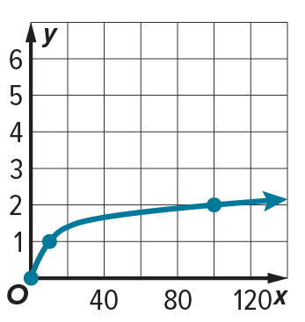
44. STRUCTURE Give that log₁₀ 2 ≈ 0.3010 and log₁₀ 3 ≈ 0.4771, explain how to find l${og}_{2}$ 3?

45. REASONING The graph of y = log₁₀ x is shown. Given that $\frac{1}{l{og}_{10}2}$ ≈ 3.32, sketch a graph of y = log₂ x on the same coordinate plane.

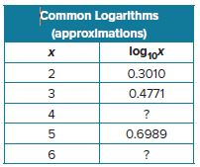
46. CONSTRUCT ARGUMENTS When a number n is written in scientific notation, it has the form n = s × ${10}^{p}$, where 1 $≤$ s < 10. Prove that p ≤ log₁₀ n < p + 1.

47. STRUCTURE Use the table shown and the properties of logarithms to determine the following.
a. Determine the missing entries in the table. Justify your reasoning.

b. How can you use this table to determine log₁₀ 1.5?

48. USE TOOLS The equation t = $\frac{1}{\log{(1+r)}}$ gives the number of years t it takes $1000 to grow to $10,000 in a savings account earning annual interest rate r, compounded annually. If Jo wants to grow her $1000 investment to $10,000 in 45 years, use a graphing calculator to determine the interest rate needed for the investment.

49. STRUCTURE Rewrite each equation using common logarithms and solve. Show your work.
a. 3 log₂ (2x) ‒ log₄ (3x) = 1
b. log₆(x²) + log₃(x) = 3
c. 2 log₂(3x) = ‒8 log₃ (x)

50. STRUCTURE Rewrite each inequality using common logarithms and solve. Show your work.
a. log₇ (2x) < 2 log₆ (x)
b. 3 log₂(4x) ≤ log(8x)

51. FIND THE ERROR Sam and Rosamaria are solving 4^{3p} = 10. Is either of them correct? Explain
your reasoning.

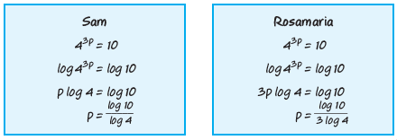

52. PERSEVERE Solve $\log_{\sqrt{a}} 3=\log_{a} x$ for x and explain each step.

53. CONSTRUCT ARGUMENTS Find the values of log₃ 27 and log₂₇ 3. Make a conjecture about the relationship between log_{a} b and log_{b} a. Justify your argument.

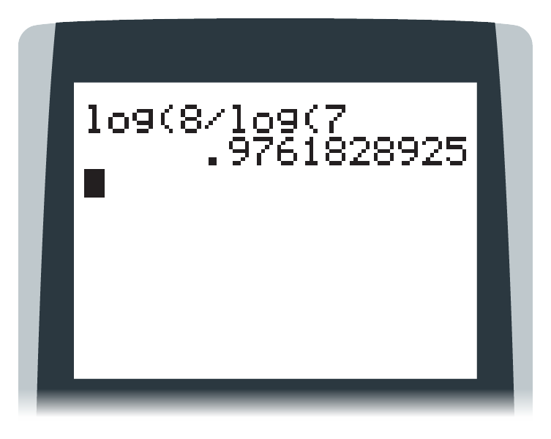
54. FIND THE ERROR Claudia wants to find the value of log₇ 8 to the nearest thousandth. She uses the Change of Base Formula and a calculator to Find the approximation. The screen at right shows what she entered, and the result.

a. Explain the error Claudia made and how she can correct it.

b. Consider the relationship between log 8 and log 7. Explain why the result displayed on the calculator should alert Claudia that an error has occurred.

