Multiplying and Dividing Rational Expressions ⸱ Practice

Example 1
Simplify each expression and state when the original expression is undefined.
1. $\frac{x\left(x - 3\right)\left(x + 6\right)}{x^{2} + x - 12}$ 2. $\frac{y^{2}\left(y^{2} + 3y + 2\right)}{2y\left(y - 4\right)\left(y + 2\right)}$

3. $\frac{\left(x^{2} - 9\right)\left(x^{2} - z^{2}\right)}{4\left(x + z\right)\left(x - 3\right)}$ 4. $\frac{\left(x^{2} - 16x + 64\right)\left(x + 2\right)}{\left(x^{2} - 64\right)\left(x^{2} - 6x - 16\right)}$

5. $\frac{x^{2}\left(x + 2\right)\left(x - 4\right)}{6x\left(x^{2} + x - 20\right)}$ 6. $\frac{3y\left(y - 8\right)\left(y^{2} + 2y - 24\right)}{15y^{2}\left(y^{2} - 12y + 32\right)}$

Example 2
Simplify each expression.

7. $\frac{x^{2} - 5x - 14}{28 + 3x - x^{2}}$ 8. $\frac{9x^{2}-{ x}^{3}}{x^{2} - 3x - 54}$

9. $\frac{\left(x - 4\right)\left(x^{2} + 2x - 48\right)}{\left(36 - x^{2}\right)\left(x^{2} + 4x - 32\right)}$ 10. $\frac{16 -{ c}^{2}}{c^{2} + c - 20}$

Example 3
Simplify each expression.
11. $\frac{3ac^{3}f^{3}}{8a^{2}bcf^{4}}$ ∙ $\frac{12ab^{2}c}{18ab^{3}c^{2}f}$ 12. $\frac{14xy^{2}z^{3}}{21w^{4}x^{2}z}$ · $\frac{7wxyz}{12w^{2}y^{3}z}$

13. $\frac{64a^{2}b^{5}}{35b^{2}c^{3}f^{4}}$ ÷ $\frac{12a^{4}b^{3}c}{70abcf^{2}}$ 14. $\frac{9x^{2}yz}{5z^{4}}$ ÷ $\frac{12x^{4}y^{2}}{50xy^{4}z^{2}}$

15. $\frac{15a^{2}b^{2}}{21ac}$ ∙ $\frac{14a^{4}c^{2}}{6ab^{3}}$ 16. $\frac{14c^{2}f^{5}}{9a^{2}}$ ÷ $\frac{35cf^{4}}{18ab^{3}}$

Example 4
17. BEAUTY A producer of beauty care products wants to compare the areas of two face cream containers. For some measure a the area for the first container is represented by $\frac{16a^{2} + 40a + 25}{3a^{2} - 10a – 8}$. The area of the second container is represented by $\frac{4a + 5}{a^{2} - 8a + 16}$ . Write and simplify an expression that represents the ratio of the area of the first container to the area of the second container.

18. PACKAGING A packaging plant quality assurance agent compares the surface area and volume of packages to ensure the packages will be transported economically. The most popular package size is a cylinder with a height of 18 inches. Define a variable, then write and simplify an expression that represents the ratio of the surface area to the volume of the cylinder.

19. LANDSCAPING Rashard is building a rectangular patio. If $\frac{t^{2} + 19t + 84}{4t – 4}$ represents the length of the patio and $\frac{2t - 2}{t^{2} + 9t + 14}$ represents the width, write and simplify an expression that represents the area of the patio.

Example 5
Simplify each expression.
20. $\frac{\frac{x^{2} - 9}{6x - 12}}{\frac{x^{2} + 10x + 21}{x^{2} - x - 2}}$ 21. $\frac{\frac{y - x}{z^{3}}}{\frac{x - y}{{6z}^{2}}}$

22. $\frac{\frac{a^{2} - b^{2}}{b^{3}}}{\frac{b^{2} - ab}{a^{2}}}$ 23. $\frac{\frac{x - y}{a + b}}{\frac{x^{2} - y^{2}}{b^{2} - a^{2}}}$

Mixed Exercises
Simplify each expression.
24. $\frac{y^{2} + 8y + 15}{y - 6}$ ∙ $\frac{y^{2} - 9y + 18}{y^{2} - 9}$ 25. $\frac{c^{2} - 6c - 16}{c^{2} - d^{2}}$ ÷ $\frac{c^{2} - 8c}{c + d}$

26. $\frac{x^{2} + 9x + 20}{8x + 16}$ ∙ $\frac{{4x}^{2} + 16x + 16}{x^{2} - 25}$ 27. $\frac{{3a}^{2} + 6a + 3}{a^{2} - 3a - 10}$ ÷ $\frac{{12a}^{2} - 12}{a^{2} - 4}$

28. $\frac{{9 - x}^{2}}{x^{2} - 4x - 21}$ ∙ ${\left(\frac{{2x}^{2} + 7x + 3}{2x^{2} - 15x + 7}\right)}^{-1}$ 29. ${\left(\frac{{2x}^{2} + 2x - 12}{x^{2} + 4x - 5}\right)}^{-1}$ ∙ $\frac{{2x}^{3} - 8x}{x^{2} - 2x - 35}$

30. ${\left(\frac{3{xy}^{3}z}{2a^{2}bc^{2}}\right)}^{3}$ ∙ $\frac{16a^{4}b^{3}c^{5}}{15x^{7}yz^{3}}$ 31. $\frac{20x^{2}y^{6}z^{-2}}{3a^{3}c^{2}}$ ∙ ${\left(\frac{16x^{3}y^{3}}{9acz}\right)}^{-1}$

32. $\frac{\frac{8x^{2} - 10x - 3}{10x^{2} + 35x - 20}}{\frac{{2x}^{2} + x - 6}{4x^{2} + 18x + 8}}$ 33. $\frac{\frac{2x^{2} + 7x - 30}{-6x^{2} + 13x + 5}}{\frac{{4x}^{2} + 12x - 72}{3x^{2} - 11x - 4}}$

34. $\frac{x^{2} + 4x - 32}{{2x}^{2} +9x - 5}$ ∙ $\frac{{3x}^{2} - 75}{{3x}^{2} - 11x - 4}÷\frac{{6x}^{2} - 18x - 60}{x^{3} - 4x}$ 35. $\frac{{8x}^{2} + 10x - 3}{{3x}^{2} - 12x - 36}$ ÷ $\frac{{2x}^{2} - 5x - 12}{3x^{2} - 17x - 6}$ ∙ $\frac{{4x}^{2} + 3x - 1}{{4x}^{2} - 40x + 24}$

36. JELLY BEANS A large jar contains B blue jelly beans and R red jelly beans. A bag of 100 red and
100 blue jelly beans is added to the jar. What is the ratio of red to blue jelly beans in the jar?

37. MILEAGE Martina drives a hybrid car that gets 45 miles per gallon when driving in the city and 48 miles per gallon when driving on the highway. If Martina uses C gallons of gas in the city and H gallons of gas on the highway, write an expression for the average number of miles per gallon that Martina gets with her car in terms of C and H.
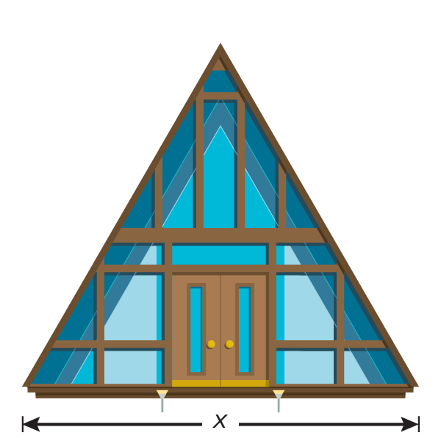
38. HEIGHT The front face of a Nordic house is triangular. The area of the face is $x^{2}$ + 3x + 10, where x is the base of the triangle. What is the height of the triangle in terms of x?

39. CONTAINERS David is designing a cylindrical container. He wants the height of the container to be twice the length of the radius. Write an expression for the ratio of the volume of the container to the surface area of the container, where h is the height and r is the radius.

40. ARCHERY Harold and Hinto are on the archery team. So far at practice, Harold has hit the target 7 out of 10 times for an average of 70%, and Hinto has hit the target 9 out of 10 times for an average of 90%. Harold and Hinto each hit the target on their next x consecutive attempts.
a. Write an expression for Harold and for Hinto that shows their average of hitting the target after hitting the target on x consecutive attempts.
b. Write a simplified expression for the ratio of the percentage Harold hit the target to the percentage Hinto hit the target if they both hit the target on their next x consecutive attempts.

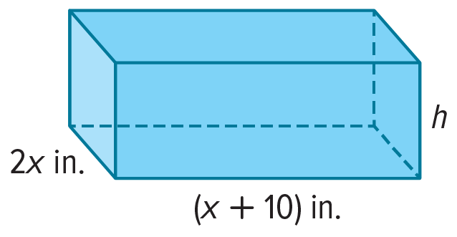
41. GEOMETRY The volume of the rectangular box shown is given by V = (2$x^{3}$ + 26$x^{2}$ + 60x) cubic inches.
a. Explain how to find an expression in terms of x for the height h of the box.
b. In terms of x, what is h in simplest form?
c. Explain how you could check the expression you found in
part b. Then check your expression.

42. ROWING The time it takes Irfan to row 9 miles upstream is $\frac{9}{5 - c}$. The time it takes him to row 9 miles downstream is $\frac{9}{5 + c}$, where c is the speed of the current in miles per hour and 0 ≤ c < 5.
a. Which way does Irfan travel faster, downstream or upstream? Give two reasons for
your answer.
b. Determine how much faster Irfan travels in the faster direction than in the slower direction. Explain your method.

43. REASONING During her first week of running, Rafaela takes t minutes to run a mile. In miles per hour, her average speed is given by $\frac{60}{t}$. Rafaela hopes to get her average time to t − 2 minutes to run a mile during her second week of running. On average, how many times faster does Rafaela hope to run a mile during her second week than during her first week of running? Explain how you know.
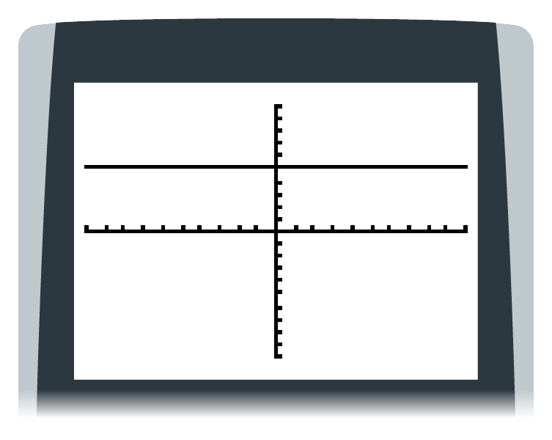
44. CONSTRUCTING ARGUMENTS Saquita graphs the function y = $\frac{5(x + 1)(x + 2)(x + 3)}{(x + 1)(x + 2)(x + 3)}$
on a graphing calculator and claims that the result is a horizontal
line because of the following display. Is Saquita correct? Justify your argument.

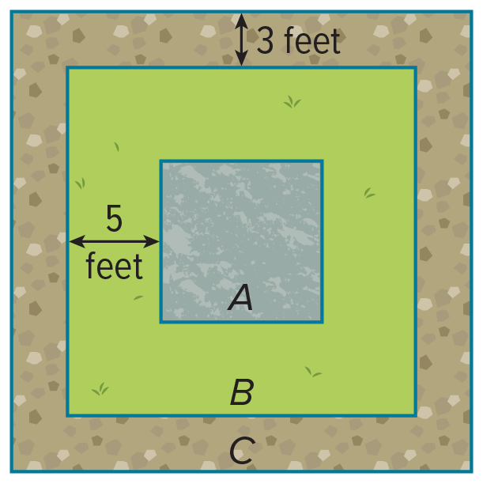
45. USE A MODEL Anita’s yard is being professionally landscaped. The final design will consist of a circular fountain x feet in diameter in square A surrounded by a grassy area in square B and a gravel pathway in square C that borders the grassy area. The square areas will be centered on each other as shown in the diagram. Square A will have a side length of 2x feet.
a. Anita would like the lengths of the sides to be proportional. For what values of x will the ratio of the lengths of a side of square C to a side of square B equal the ratio of the lengths of a side of square B to a side of square A? Explain your reasoning. What diameter could the fountain have?
b. If the landscape architect changed the width of the gravel pathway to 4 feet and the width of the grassy area to 2 feet, is there a value for x that would make the ratios equal? Explain your reasoning. What diameter could the fountain have?

46. ANALYZE Compare and contrast $\frac{(x - 6)(x + 2)(x + 3)}{x + 3}$ and (x – 6)(x + 2).

47. FIND THE ERROR Troy and Beverly are simplifying $\frac{x + y}{x - y}$ ÷ $\frac{4}{y - x}$. Is either of them correct? Explain your reasoning.
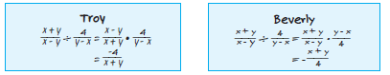

48. PERSEVERE Find the expression that makes the following statement true for all values of x within the domain.
$\frac{x - 6}{x + 3}$ $∙$ $\frac{?}{x – 6}$ = x – 2

49. WHICH ONE DOESN’T BELONG? Identify the expression that does not belong with the other three. Justify your conclusion.

50. ANALYZE Determine whether the following statement is sometimes, always, or never true. Justify your argument.
A rational function that has a variable in the denominator is defined for all real values of x.

51. CREATE Write a rational expression that simplifies to $\frac{x - 1}{x + 4}$.

52. WRITE The rational expression $\frac{x^{2} + 3x}{4x}$ is simplified to $\frac{x + 3}{4}$. Explain why this new expression is not defined for all values of x.

53. CREATE Write three different rational expressions that are equivalent to the expression $\frac{a}{a - 5}, a≠5$.

