Adding and Subtracting Rational Expressions ⸱ Practice

Examples 1 and 2
Simplify each expression.
1. $\frac{3}{x}$ + $\frac{5}{y}$ 2. $\frac{3}{8p^{2}r}$ + $\frac{5}{4p^{2}r}$

3. $\frac{2c - 7}{3}$ + 4 4. $\frac{2}{m^{2}p}$ + $\frac{5}{p}$

5. $\frac{12}{5y^{2}}$ – $\frac{2}{5yz}$ 6. $\frac{7}{4gh}$ + $\frac{3}{4h^{2}}$

7. $\frac{3}{w – 3}$ – $\frac{2}{w^{2} – 9}$ 8. $\frac{3t}{2 – x}$ + $\frac{5}{x – 2}$

9. $\frac{k}{k – n}$ – $\frac{k}{n – k}$ 10. $\frac{4z}{z – 4}$ + $\frac{z + 4}{z + 1}$

11. $\frac{n}{n – 3}$ + $\frac{2n + 2}{n^{2} - 2n – 3}$ 12. $\frac{3}{y^{2} + y – 12}$ – $\frac{2}{y^{2} + 6y + 8}$

Example 3
13. ELECTRIC POTENTIAL The electrical potential between two electrons is given by a formula that has the form $\frac{1}{r}$ + $\frac{1}{1 - r}$. Simplify this expression.
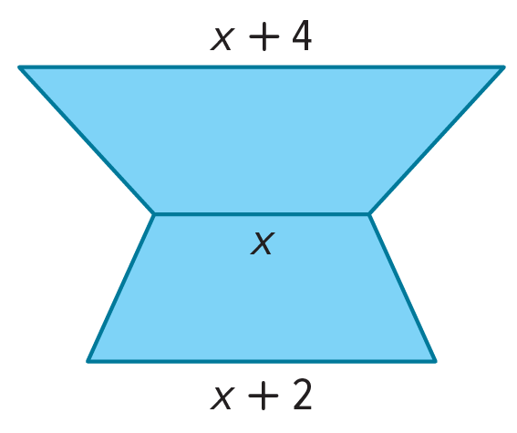
14. GEOMETRY The cross section of a solid consists of two trapezoids stacked one on top of the other. The total area of the cross section is $x^{2}$ square units. Assuming the trapezoids have the same height, write an expression for the height of the solid in terms of x. Write your answer in simplest form. Recall that the area of a trapezoid with height h and bases $b_{1}$ and $b_{2}$ is given by $\frac{1}{2}$ h($b_{1}$ + $b_{2}$)).

15. TRACK Morgan, Connell, Zack, and Moses run the 400-meter relay together. Each of them runs 100 meters. Their average speeds were r, r + 0.5, r – 0.5, and r – 1 meters per second, respectively.
a. Write an expression for each individual’s time for their leg of the race.
b. Write an expression for their time as a team. Write your answer as a ratio of two polynomials.
c. The world record for the 100-meter relay is 37.4 seconds. What will r equal if the team ties
the world record?

Examples 4 and 5
Simplify each expression.
16. $\frac{\frac{2}{x - 3} + \frac{3x}{x^{2} - 9}}{\frac{3}{x + 3} - \frac{4x}{x^{2} - 9}}$ 17. $\frac{\frac{4}{x + 5} + \frac{9}{x - 6}}{\frac{5}{x - 6} - \frac{8}{x + 5}}$

18. $\frac{\frac{5}{x + 6} - \frac{2x}{2x - 1}}{\frac{x}{2x - 1} + \frac{4}{x + 6}}$ 19. $\frac{\frac{8}{x - 9} - \frac{x}{3x + 2}}{\frac{3}{3x + 2} + \frac{4x}{x - 9}}$

Mixed Exercises
Simplify each expression.
20. $\frac{2}{a + 2}$ – $\frac{3}{2a}$ 21. $\frac{5}{3b + d}$ – $\frac{2}{3bd}$

22. $\frac{1}{x^{2} + 2x + 1}$ + $\frac{x}{x + 1}$ 23. $\frac{2x + 1}{x – 5}$ – $\frac{4}{x^{2} - 3x – 10}$

24. $\frac{5a}{24cf^{4}}$ + $\frac{a}{36bc^{4}f^{3}}$ 25. $\frac{4b}{15x^{3}y^{2}}$ – $\frac{3b}{35x^{2}y^{4}z}$

26. $\frac{5b}{6a}$ + $\frac{3b}{10a^{2}}$ + $\frac{2}{ab^{2}}$ 27. $\frac{4}{3x}$ + $\frac{8}{x^{3}}$ + $\frac{2}{5xy}$

28. $\frac{8}{3y}$ + $\frac{2}{9}$ – $\frac{3}{10y^{2}}$ 29. $\frac{1}{16a}$ + $\frac{5}{12b}$ – $\frac{9}{10b^{3}}$

30. $\frac{8}{x^{2} - 6x - 16}$ + $\frac{9}{x^{2} - 3x - 40}$ 31. $\frac{6}{y^{2} - 2y - 35}$ + $\frac{4}{y^{2} + 9y + 20}$

32. $\frac{12}{3y^{2} - 10y - 8}$ – $\frac{3}{y^{2} - 6y + 8}$ 33. $\frac{6}{2x^{2} + 11x - 6}$ – $\frac{8}{x^{2} + 3x - 18}$

34. $\frac{2x}{4x^{2} + 9x + 2}$ + $\frac{3}{2x^{2} - 8x - 24}$ 35. $\frac{4x}{3x^{2} + 3x - 18}$ – $\frac{2x}{2x^{2} + 11x + 15}$

36. LENSES The focal length of a lens f is related to the distance from the subject to the lens p and the distance from the lens to the image on the sensor q by the formula $\frac{1}{p}$ + $\frac{1}{q}$ = $\frac{1}{f}$. Express $\frac{1}{p}$ + $\frac{1}{q}$ as a single fraction.

37. USE A SOURCE In the seventeenth century, Lord William Brouncker conducted research in mathematics and music and served as the first president of the Royal Society in London, England. Research Lord Brouncker’s work in the area of continued fractions. Describe the discovery for which he is best known.

Simplify each expression.
38. $\frac{1}{12a}$ + 6 – $\frac{3}{5a^{2}}$ 39. $\frac{5}{16y^{2}}$ – 4 – $\frac{8}{3x^{2}y}$

40. $\frac{5}{6x^{2} + 46x - 16}$ + $\frac{2}{6x^{2} + 57x + 72}$ 41. $\frac{1}{8x^{2} - 20x – 12}$ + $\frac{4}{{6x}^{2} + 27x + 12}$

42. $\frac{x^{2} + y^{2}}{x^{2} - y^{2}}$ + $\frac{y}{x + y}$ – $\frac{x}{x - y}$ 43. $\frac{x^{2} + x}{x^{2} - 9x + 8}$ + $\frac{4}{x - 1}$ – $\frac{3}{x - 8}$

44. $\frac{\frac{2}{a - 1} + \frac{3}{a - 4}}{\frac{6}{a^{2} - 5a + 4}}$ 45. $\frac{\frac{1}{x} + \frac{1}{y}}{\left(\frac{1}{x} - \frac{1}{y}\right)\left(x + y\right)}$

Find the slope of the line that passes through each pair of points.
46. $A\left(\frac{2}{p},\frac{1}{2}\right)$ and $B\left(\frac{1}{3},\frac{3}{p}\right)$ 47. $C\left(\frac{1}{4},\frac{4}{q}\right)$ and $D\left(\frac{5}{q},\frac{1}{5}\right)$

48. USE A MODEL Hachi needs to buy fencing for her rectangular garden.
a. Write an expression, in simplest form, that represents the number of feet of fencing Hachi needs. Are there any restrictions on the variables? Explain.

b. Hachi wants to remove a square corner from her garden. The square section removed will have sides the length of half the width of the original garden. What expression represents the perimeter of the new garden? Explain.
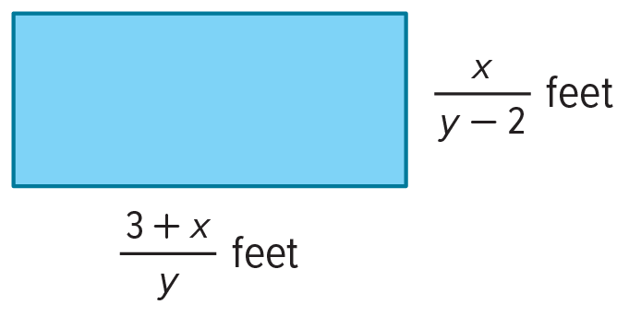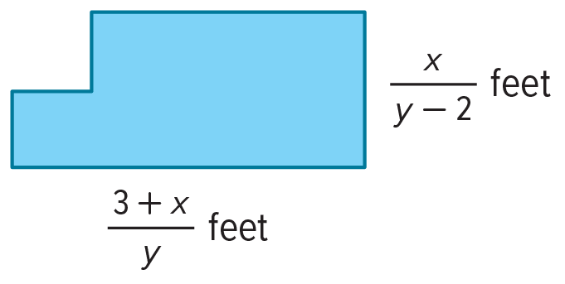

49. STRUCTURE Determine the average of three rational numbers represented by these rational expressions: $\frac{1}{x}$, $\frac{1}{x - 3}$, and $\frac{1}{2x}$ for x ≠ 3, and x ≠ 0. Explain how you found the average.

50. ELECTRONICS A resistor is an electrical component that reduces the flow of electrical current through a circuit. A resistor is connected in parallel when both of its terminals are connected to both terminals of an adjacent resistor. When three resistors are connected in parallel, the total resistance, R_{T}, is given by R_{T} = $\frac{1}{\frac{1}{R_{1}} + \frac{1}{R_{2}} + \frac{1}{R_{3}}}$.
a. Simplify the complex fraction. Explain how you know your result is simplified as much as possible.

b. Timothy found this formula for total resistance, $\frac{1}{R_{T}}$ = $\frac{1}{R_{1}}+\frac{1}{R_{2}}+\frac{1}{R_{3}}$. He said that this formula is equivalent to the original formula. Is Timothy correct? Explain.

Find and simplify the sum or difference.
51. $\frac{2(x + 5)}{2x^{2} - 1}$ + $\frac{4x}{x + 1}$ 52. $\frac{x - 1}{x^{2} + x - 12}$ – 2

53. WORK The ecology club is landscaping a local park. Dell can plant a flower bed in 3 hours. Max can plant a flower bed of the same size in 4 hours. Using t, time in hours, write an expression representing how many flower beds they will complete in t hours working together. Explain your reasoning.

54. REASONING Determine three real numbers that divide the real number line between
$\frac{x}{6}$ and $\frac{x}{2}$ into four equal parts. Assume that x ≠ 0. Explain your reasoning.

55. STRUCTURE The Fibonacci numbers are a famous sequence in which each term is the sum of the previous two. So, the Fibonacci sequence is 1, 1, 2, 3, 5, 8, 13, 21,34, … The sequence is related to a sequence of continued fractions. Simplify each continued fraction.
a. $\frac{1}{1 + \frac{1}{x}}$ b. $\frac{1}{1 + \frac{1}{1 + \frac{1}{x}}}$
c. $\frac{1}{1 + \frac{1}{1 + \frac{1}{1 + \frac{1}{x}}}}$ d. $\frac{1}{1 + \frac{1}{1 + \frac{1}{1 + \frac{1}{1 + \frac{1}{x}}}}}$
e. Find the values of the expressions in parts a–d for x = 1.
f. How are the terms of the Fibonacci sequence related to the values you found in part e? Make a conjecture about the next value in the pattern.
56. PERSEVERE Simplify $\frac{5x^{-2} - \frac{x + 1}{x}}{\frac{4}{3 - x^{-1}} + 6x^{-1}}$.

57. ANALYZE The sum of any two rational numbers is always a rational number. So, the set of rational numbers is said to be closed under addition. Determine whether the set of rational expressions is closed under addition, subtraction, multiplication, and division by a nonzero rational expression. Justify your argument.

58. CREATE Write three monomials with an LCM of 180a⁴b⁶c.

59. WRITE Explain how to add rational expressions that have unlike denominators. How does this compare to adding rational numbers?

60. CREATE Write a rational expression by adding and subtracting three terms that each have a monomial denominator and a sum of $\frac{4w - 9}{20w}$.

