Graphing Reciprocal Functions ⸱ Practice

Example 1
Determine the excluded value of x for each function.
1. f(x) = $\frac{5}{x}$ 2. g(x) = $\frac{-2}{x + 2}$ 3. f(x) = $\frac{10}{x - 3}$

4. g(x) = $\frac{5}{-6x}$ 5. f(x) = $\frac{5}{2x + 3}$ 6. g(x) = $\frac{5}{7x - 9}$

Example 2
Identify the asymptotes, domain, and range of each function. Then graph the function and identify its intercepts.
7. f(x) = $\frac{1}{x - 1}$ 8. f(x) = – $\frac{1}{x}+4$

9. f(x) = $\frac{5}{x + 4}$ 10. f(x) = $\frac{6}{x}-3$.

Example 3
11. PLANES A plane is scheduled to leave Dallas for an 800-mile flight to Chicago’s O’Hare airport. However, the departure is delayed for two hours.
a. If t = 0 represents the scheduled departure time, write a function that represents the plane’s average speed r on the vertical axis as a function of travel time t, which is based on the travel from the scheduled departure time to the destination. Graph the function.
b. Analyze the key features of the graph in the context of the situation.

12. COMPUTERS To manufacture a specific model of computer, a company pays $5000 for rent and overhead and $435 per computer for parts.
a. Write the function relating average cost to make a computer C to how many computers n are being made. Graph the function.
b. Analyze the key features of the function.

Example 4
Graph each function. State the domain and range.
13. f(x) = $\frac{1}{x + 3}$ – 3 14. f(x) = $\frac{-1}{x + 5}$ – 6

15. f(x) = $\frac{-1}{x + 1}$ + 3 16. f(x) = $\frac{1}{x + 4}$ – 2

Example 5
Identify the values of a, h, and k. Then write a function for the graph g(x) = $\frac{a}{x - h}+k.$
17. 18.
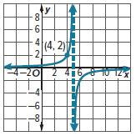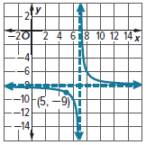

19. 20.
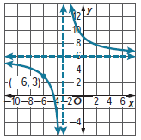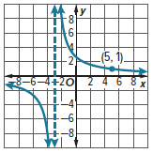

21. 22.
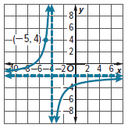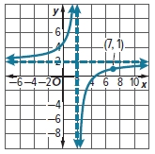

Mixed Exercises
Determine the values for x for which f(x) is undefined.
23. f(x) = $\frac{2}{-2x + 5}$ 24. f(x) = $\frac{-12 }{-3x - 7}$

25. f(x) = $\frac{4}{x^{2} - 2x - 3}$ 26. f(x) = $\frac{6 }{ x^{2} + 4x - 12}$

27. f(x) = $\frac{-3 }{ x^{2} - 2x - 15}$ 28. f(x) = $\frac{-2}{(x + 4)(x^{2} - 9)}$

29. What are the domain and range for the function f(x) = $\frac{3}{x + 1}$?
30. Determine the equations of any asymptotes of the graph of f(x) = $\frac{3}{x^{2} - x - 12}$.

Graph each function. State the domain and range, and identify the asymptotes.
31. f(x) = $\frac{3}{2x - 4}$ 32. f(x) = $\frac{5}{3x}$

33. f(x) = $\frac{2}{4x + 1}$ 34. f(x) = $\frac{1}{2x + 3}$

35. f(x) = $\frac{-3}{x + 7}-1$ 36. f(x) = $\frac{-4}{x + 2}-5$

37. f(x) = $\frac{6}{x - 1}+2$ 38. f(x) = $\frac{2}{x - 4}+3$

39. f(x) = $\frac{-7}{x - 8}-9$ 40. f(x) = $\frac{-6}{x - 7}-8$

Write a function for each graph f(x) = $\frac{a}{x - h}+k.$
41. 42.
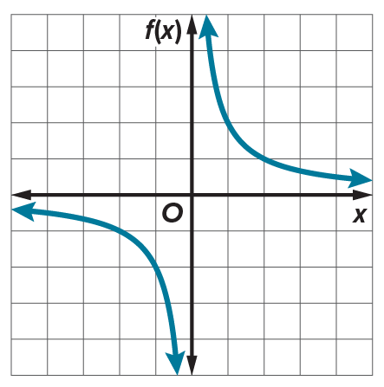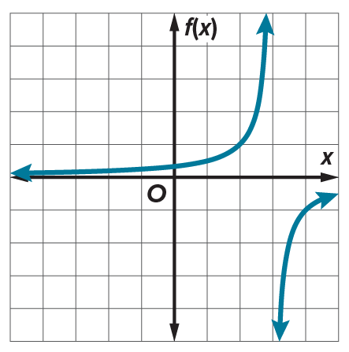

43. 44.
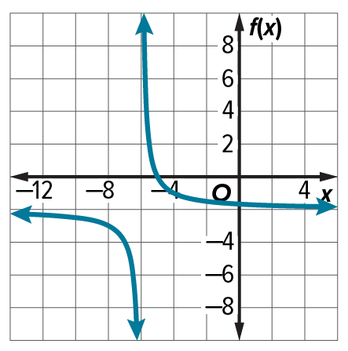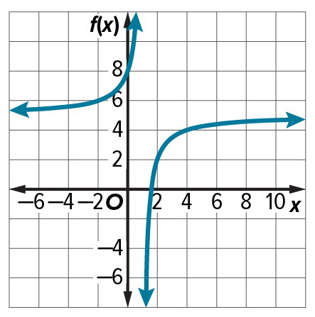

45. VACATION The Castellanos family is planning to rent a car for a trip. The rental costs $125 plus $0.30 per mile.
a. Write the equation that relates the cost per mile, C, to the number of miles traveled, m.
b. Explain any limitations to the range or domain in this situation.

46. BIOLOGY The population of a certain bacteria can be approximated by the function
P(t) = $\frac{40}{t + 2}$ + 10, where P(t) is equal to the number of bacteria after t minutes. Eventually,
what will happen to the bacteria population?

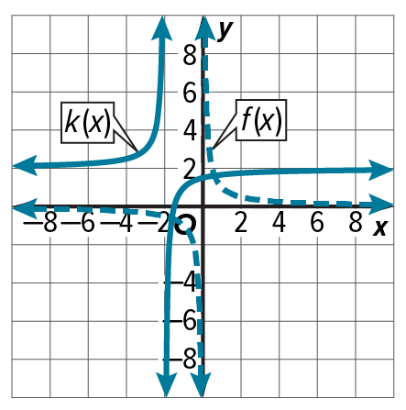
STRUCTURE Graph each reciprocal function and identify any transformations from the graph of the parent function f(x) = $\frac{1}{x}$.
47. g(x) = $\frac{-1}{x + 2}$ + 1 48. h(x) = $\frac{2}{x - 4}$ – 5

49. PRECISION The figure shows the graph of the parent reciprocal function, f(x), and the graph of a reciprocal function, k(x). Explain how to use transformations to write the equation for k(x).

50. MONEY Some students are renting a bus for a trip to an aquarium. The bus costs $200 and the aquarium tickets are $25 per person.
a. Write a function that gives the total cost per student y, assuming that there
are x students and they share the cost of the bus equally. Then graph the function on a coordinate plane.
b. What is an appropriate domain for the function? Explain.
c. Find the average rate of change on the interval x = 10 to x = 20. Interpret the result.

51. CREATE Write a reciprocal function for which the graph has a vertical asymptote at x = –4 and a horizontal asymptote at f(x) = 6.

52. ANALYZE Consider the functions f(x) = $\frac{1}{x}$ and g(x) = .
a. Make a table of values comparing the two functions. Then graph both functions.
b. Compare and contrast the two graphs.
c. Make a conjecture about the difference between the graphs of reciprocal functions with an
even exponent in the denominator and those with an odd exponent in the denominator.

53. WHICH ONE DOESN’T BELONG? Find the function that does not belong. Justify your conclusion.

54. PERSEVERE Write two different reciprocal functions with graphs having the same vertical and horizontal asymptotes. Then graph the functions.

55. PERSEVERE Graph f(x) = $\frac{4}{{(x + 2)}^{2}}$. What are the asymptotes of the graph?

56. WRITE Explain why only part of the graph of a rational function may be meaningful in a real-world situation in the context of the problem.

