Graphing Rational Functions ⸱ Practice

Example 1
Graph each function.
1. f(x) = $\frac{x^{4}}{6x + 12}$ 2. f(x) = $\frac{x^{3}}{8x - 4}$

3. f(x) = $\frac{x^{4} - 16}{x^{2} - 1}$ 4. f(x) = $\frac{x^{3} + 64}{16x - 24}$

Example 2
5. INTERNET An Internet service provider charges customers a $60 installation fee plus $30 per month for Internet service. A function that models the average monthly cost is f(x) = $\frac{60 + 30x}{x}$, where x is the number of months.
a. Graph the function.
b. Find the x- and y-intercepts and end behavior of the graph.
c. Find the average monthly cost of a customer that has Internet service for 8 months.

6. SALES The quantity of a certain product sold in week x is approximated by the function f(x) = $\frac{80x}{x^{2}+40}$.
a. Graph the function.
b. Find the x- and y-intercepts and end behavior of the graph.
c. During which week(s) did 5 of the products sell?

7. FACTORY The cost to create a part of a small engine is modeled by f(x) = $\frac{18x-12}{6x}$, where x is the number of parts made.
a. Graph the function.
b. Find the x- and y-intercepts and end behavior of the graph.
c. About how much does the 6th part cost to make?

Example 3
For Exercises 8-10, consider the given function and the function shown in the graph.
a. Graph the given function.
b. Which function has the greater y-intercept?
c. Compare the asymptotes of the two functions.

8. f(x) = $\frac{x-5}{3x+5}$ and g(x) 9. h(x) = $\frac{x+1}{4x-4}$ and j(x) 10. f(x) = $\frac{x-3}{2x+7}$ and g(x)
shown in the graph. shown in the graph. shown in the graph.
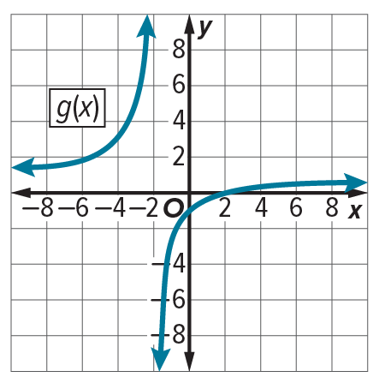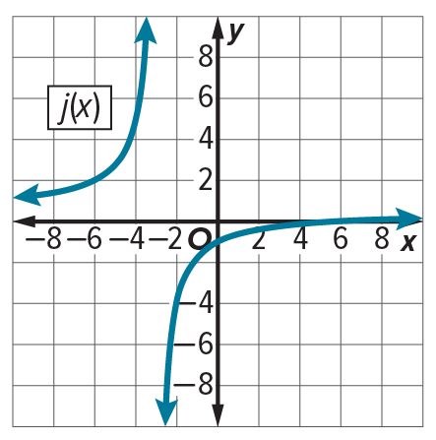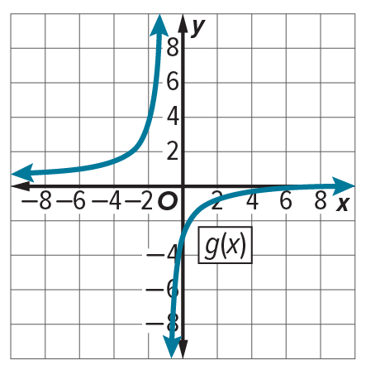

Example 4
Find the zeros and asymptotes of each function. Then graph each function.
11. f(x) = $\frac{{\left(x - 4\right)}^{2}}{x + 2}$ 12. f(x) = $\frac{{\left(x + 3\right)}^{2}}{x - 5}$

13. f(x) = $\frac{{6x}^{2} + 4x + 2}{x + 2}$ 14. f(x) = $\frac{{2x}^{2}+7x}{x - 2}$

15. f(x) = $\frac{3x^{2} + 8}{2x - 1}$ 16. f(x) = $\frac{{2x}^{2} + 5}{3x + 4}$

Example 5
Graph each function. Find the point discontinuity.
17. f(x) = $\frac{x^{2} - 2x - 8}{x - 4}$ 18. f(x) = $\frac{x^{2} + 4x - 12}{x - 2}$

19. f(x) = $\frac{x^{2} - 25}{x + 5}$ 20. f(x) = $\frac{x^{2} - 64}{x - 8}$

21. f(x) = $\frac{(x - 4)(x^{2} - 4)}{x^{2} - 6x + 8}$ 22. f(x) = $\frac{(x + 5)(x^{2} + 2x – 3)}{x^{2} + 8x + 15}$

Mixed Exercises
Graph each function.
23. f(x) = $\frac{x}{x + 2}$ 24. f(x) = $\frac{x^{2} - 4}{x - 2}$

25. f(x) = $\frac{x^{2} + x - 12}{x - 3}$ 26. f(x) = $\frac{x - 1}{x^{2} - 4x + 3}$

27. f(x) = $\frac{3}{x^{2} - 2x - 8}$ 28. f(x) = $\frac{x^{3}}{2x + 2}$

29. f(x) = $\frac{2x^{3} + 4x^{2} - 10x - 12}{2x^{2} + 8x + 6}$ 30. f(x) = $\frac{{(x + 1)}^{2}}{2x - 1}$

31. Consider f(x) = $\frac{(x + 2)(x - 3)}{x + 2}$ and g(x) = $\frac{(x + 2)(x - 3)}{x(x + 2)}$ .
a. Graph f(x) and g(x).
b. Which function has a y-intercept of −3?
c. Compare the asymptotes and point discontinuity of f(x) and g(x).
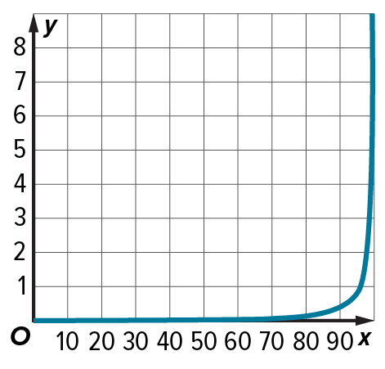
32. BACTERIA The graph shows the cost in millions of dollars y to remove x percent of the bacteria from drinking water.
a. What does the x-coordinate of the vertical asymptote represent?

b. What happens to the cost of removing bacteria from drinking water as p approaches 100?

33. Sir Isaac Newton studied the rational function f(x) = $\frac{ax^{3} + bx^{2} + cx + d}{x}$. Assuming
that d ≠ 0, where will the graph of this function have a vertical asymptote?

Graph each function.
34. f(x) = $\frac{5}{(x - 1)(x + 4)}$ 35. f(x) = $\frac{4}{{\left(x - 2\right)}^{2}}$

36. f(x) = $\frac{x - 3}{x + 1}$ 37. f(x) = $\frac{1}{{\left(x + 4\right)}^{2}}$

38. f(x) = $\frac{2x}{(x + 2)(x - 5)}$ 39. f(x) = $\frac{x^{4} - 2x^{2} + 1}{x^{3} + 2}$

40. f(x) = $\frac{x^{4} - x^{2} - 12}{x^{3} - 6}$ 41. f(x) = $\frac{{3x}^{4} + 6x^{3} + 3x^{2}}{x^{2} + 2x + 1}$

42. f(x) = $\frac{{2x}^{4} + 10x^{3} + 12x^{2}}{x^{2} + 5x + 6}$ 43. f(x) = $\frac{x + 1}{x^{2} + 6x + 5}$
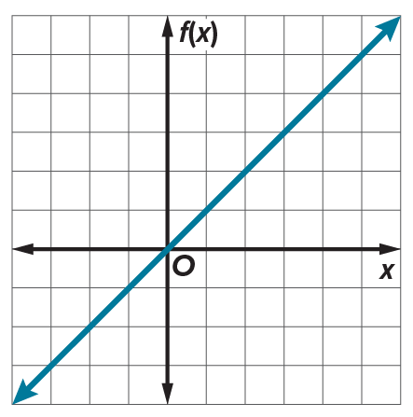
44. f(x) = $\frac{x^{2} - 10x - 24}{x + 2}$ 45. f(x) = $\frac{x^{3} + 1}{x^{2} - 4}$

46. CONSTRUCT ARGUMENTS Alina graphed the function f(x) = $\frac{x^{2} - 4x}{x – 4}$, as shown. Did she correctly graph the function? If so, justify your argument. If not, explain how to correct the graph.

47. BATTING AVERAGES A major league baseball player had a lifetime batting average of 0.305 at the beginning of the 2017 season. The baseball player had 2067 hits out of 6767 at bats. During the 2017 season, the baseball player had 183 hits.
a. Write an equation describing the baseball player’s batting average y at the end of the 2017 season using x to represent the number of at bats the player had during the season.
b. Determine the location of the horizontal and vertical asymptotes for the graph of
the equation.
c. What is the meaning of the horizontal asymptote for the graph of this equation?

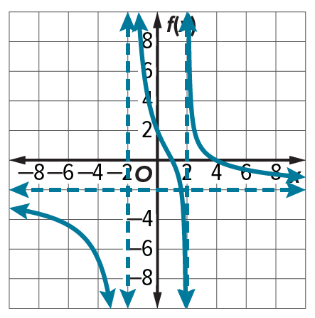
48. REASONING A music studio uses the function f(x) = $\frac{300x}{x^{2} + 4}$ to estimate the number of downloads per hour in thousands in the hours after the release of a new song. Graph the function. Then restrict the domain of the function as required by the context, and graph the function with the restricted domain. Explain the shape of the graph in the context of the situation.

49. STRUCTURE Identify the domain, zeros, intercepts, and asymptotes of the graph, and determine a function that corresponds to the graph.

50. STRUCTURE Consider the functions y = x + 1, y = $\frac{(x + 1)(x - 1)}{x - 1}$, y = $\frac{(x + 1){(x - 1)}^{2}}{x - 1}$, and y = $\frac{(x + 1){(x - 1)}^{2}}{{(x - 1)}^{2}}$. Which, if any, are equivalent?

51. SKETCH A GRAPH Graph a rational function that has a y-intercept at 5, a vertical asymptote at x = 3, and a horizontal asymptote at y = 6.5.

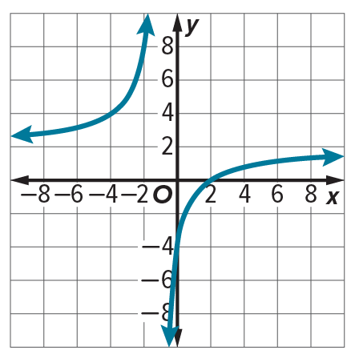
52. PRECISION Analyze the graph of the function shown. Over what intervals of x is the function positive? Over what intervals of x is the function negative? Over what intervals is the function increasing? Over what intervals is the function decreasing?

53. REGULARITY Describe how you use the degrees of the numerator and denominator to learn about a function’s asymptotes.

54. PERSEVERE On the drive to visit a nearby college, the Marshall family averages 40 miles per hour.
a. Define variables and write a function for the average speed for the entire trip, in terms of the average speed for the drive home. (Hint: Write an expression for the average speed in terms of distance and times for the outgoing trip and return trip. Then express time in terms of speed and distance.)
b. If the family averages 60 miles per hour driving home, is the average speed for the entire trip equal to 50 miles per hour? Explain. What is the horizontal asymptote, and what does it represent?

55. CREATE Sketch the graph of a rational function with a horizontal asymptote y = 1 and a vertical asymptote x = –2.

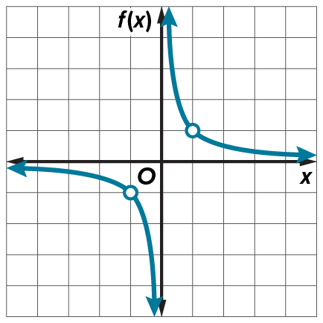
56. PERSEVERE Compare and contrast g(x) = $\frac{x^{2} - 1}{x\left(x^{2} - 2\right)}$ and f(x) shown in the graph.

57. ANALYZE Describe the difference between the graphs of f(x) = x – 2 and
g(x) = $\frac{(x + 3)(x - 2)}{x + 3}$.

58. PERSEVERE A rational function has an equation of the form f(x) = $\frac{a(x)}{b(x)}$, where a(x) and b(x) are polynomial functions and b(x) ≠ 0. Show that f(x) = $\frac{x}{a - b}$ + c is a rational function.

59. WRITE How can factoring be used to determine the vertical asymptotes or point discontinuity of a rational function?

