Variation ⸱ Practice

Example 1
If x varies directly as y, find x when y = 8.
1. x = 6 when y = 32 2. x = 11 when y = –3

3. x = 14 when y = –2 4. x = –4 when y = 10

5. If y varies directly as x, and y = 35 when x = 7, find y when x = 11.

6. If y varies directly as x, and y = 360 when x = 180, find y when x = 270.

Example 2
If a varies jointly as b and c, find a when b = 4 and c = –3.
7. a = –96 when b = 3 and c = –8 8. a = –60 when b = –5 and c = 4

9. a = –108 when b = 2 and c = 9 10. a = 24 when b = 8 and c = 12

11. If y varies jointly as x and z, and y = 18 when x = 2 and z = 3, find y when x is 5 and z is 6.

12. If y varies jointly as x and z, and y = −16 when x = 4 and z = 2, find y when x is −1 and z is 7.

Example 3
If f varies inversely as g, find f when g = –6.
13. f = 15 when g = 9 14. f = 4 when g = 28

15. f = –12 when g = 19 16. f = 0.6 when g = –21

17. If y varies inversely as x, and y = 2 when x = 2, find y when x = 1.

18. If y varies inversely as x, and y = 6 when x = 5, find y when x = 10.

Example 4
19. Suppose a varies directly as b, and a varies inversely as c. Find b when a = 5 and c = –4, if b = 12 when c = 3 and a = 8.

20. Suppose x varies directly as y, and x varies inversely as z. Find z when x = 10 and y = –7, if z = 20 when x = 6 and y = 14.

2 1. Suppose a varies directly as b, and a varies inversely as c. Find b when a = 2.5 and c = 18, if b = 6 when c = 4 and a = 96.

22. Suppose x varies directly as y, and x varies inversely as z. Find z when x = 32 and y = 9, if z = 16 when x = 12 and y = 4.

Example 5
23. ELECTRICITY The resistance R of a piece of wire varies directly as its length L and inversely as its cross-sectional area A. A piece of copper wire 3 meters long and 2 millimeters in diameter has a resistance of 0.0107 ohms (Ω). Find the resistance of a second piece of copper wire 2 meters long and 6 millimeters in diameter. (Hint: The cross-sectional area is πr².)

24. PLANTS The size of plant cells before cell division is directly related to the water available for nutrition and inversely proportional to the bacteria present in the soil. If a given plant’s cells grow to 1.5 mm when 0.25 liter of water is available and the bacteria level is restricted to 500 parts per million, what would the bacteria level be for the same plant whose cells grow to 2 mm with 0.4 liter of water available?

25. PRESSURE The volume of a gas varies directly with the temperature and inversely with the pressure. A certain gas has a volume of 15 L, a temperature of 290 K, and a pressure of 1 atm. If the gas is compressed to a volume of 12 L and is heated to 310 K, what will the new pressure be? Round your answer to the nearest thousandth.

Mixed Exercises
State whether each equation represents a direct, joint, inverse, or combined variation for the given variable. Then name the constant of variation.
26. c = 12m; c 27. p = $\frac{4}{q}$; p

28. A = $\frac{1}{2}$bh; A 29. rw = 15; r

30. y = 2rgt; y 31. f = 5280m; f

32. y = 0.2d; y 33. vz = –25; z

34. t = 16rh; t 35. R = $\frac{8}{w}$ ; R

36. b = $\frac{1}{3}$a; b 37. C = 2πr; C

38. $\frac{x}{y}$ = 2.75; x 39. fg = –2; f

40. a = 3bc; a 41. 10 = $\frac{xy^{2}}{z}$; x

42. y = –11x; y 43. $\frac{n}{p}$ = 4; n

44. 9n = pr; p 45. –2y = z; z

46. a = 27b; a 47. c = $\frac{7}{d}$; c

48. –10 = gh; g 49. m = 20cd; m

50. If y varies directly as x and y = 540 when x = 10, find x when y = 1080.

51. If y varies directly as x and y = 12 when x = 72, find x when y = 9.

52. If y varies jointly as x and z and y = 120 when x = 4 and z = 6, find y when x is 3 and z is 2.

53. If y varies inversely as x, and y = 3 when x = 14, find x when y = 6.

54. STRUCTURE Bulan works at a car wash. The amount Bulan earns varies directly with the number of hours she works. Bulan earns $144 for working 12 hours. Write the direct variation equation for the amount Bulan earns y for working x hours. How much will Bulan earn for working 18 hours?

55. DESIGN As a general rule, the number of parking spaces in a parking lot for a movie theater complex varies directly with the number of theaters in the complex. A typical complex has 30 parking spaces for each theater. A developer wants to build a new cinema complex on a lot that has enough space for 210 parking spaces. Write the direct variation equation for the number of parking spaces y for x theaters. How many theaters should the developer build in his complex?

Determine whether each relation shows direct or inverse variation, or neither.
5 6. 57. 58.
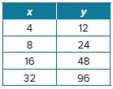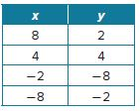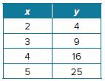

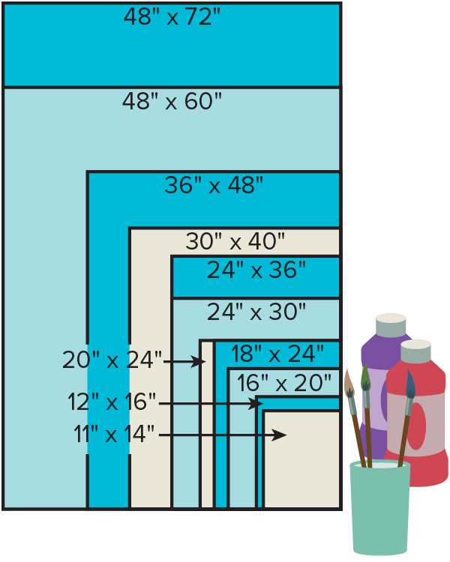
59. ART Premade art canvas is available in the standard sizes shown.

a. Analyze the relationship between the width and length of each canvas size. For each size, write a function that relates the length ℓ to the width w.
b. For which sizes is the relationship between the width and the length the same? Explain your reasoning.
c. Explain what it means in the context of the situation if the relationship between the width and length is the same for two canvas sizes.

60. PRECISION The cost of painting a wall varies directly with the area of the wall. Write a formula for the cost of painting a rectangular wall with dimensions ℓ by w. With respect to ℓ and w, does the cost vary directly, jointly, or inversely? Explain your reasoning.

61. RENT An apartment rents for m dollars per month.
a. If n students share the rent equally, how much would each student have to pay?
b. How does the cost per student vary with the number of students?
c. If 2 students have to pay $700 each, how much money would each student have to pay if there were 5 students sharing the rent?

69. COMMUNICATIONS On average, the number of calls c each day between two cities is directly proportional to the product of the populations P₁ and P₂ of the cities and inversely proportional to the square of the distance between them. That is, c = $\frac{kP_{1}P_{2}}{d^{2}}$. Use the function and the population and distance information in the table below.
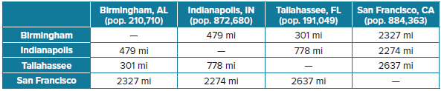
a. The average number of daily calls between Indianapolis and Birmingham is about 16,000. Find the value of k. Round to the nearest hundredth.
b. Find the average number of daily calls between Tallahassee and each other city listed.
c. Could you use this formula to find the average number of phone calls made within a city? Explain.

63. INVESTING You decide to invest 10% of your before-tax income in a retirement fund, so your employer deducts this money from your weekly paycheck.
a. Write an equation to represent the amount deducted from your paycheck d for investment in your retirement fund for a week during which you worked h hours and are paid r dollars per hour.
b. Is your equation a direct, joint, or inverse variation? Explain your reasoning.
c. If you earn $19.50 per hour and worked 36 hours last week, explain how to determine the amount deducted last week for your retirement fund.

64. FIND THE ERROR Jamil and Savannah are setting up a proportion to begin solving the combined variation in which z varies directly as x, and z varies inversely as y. Who has set up the correct proportion? Explain your reasoning.
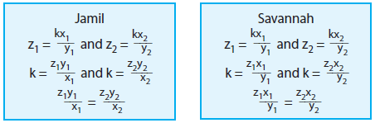
65. PERSEVERE If a varies inversely as b, c varies jointly as b and f, and f varies directly as g, how are a and g related?

66. ANALYZE Explain why some mathematicians consider every joint variation a combined variation, but not every combined variation a joint variation.

67. CREATE Describe three real-life quantities that vary jointly with each other.

68. WRITE Determine the type(s) of variation(s) for which 0 cannot be one of the values. Explain your reasoning.

