Solving Rational Equations and Inequalities ⸱ Practice

Example 1
Solve each equation. Check your solutions.
1. $\frac{2x + 3 }{x + 1}$ = $\frac{3}{2}$ 2. $\frac{-12}{y}$ = y – 7

3. $\frac{9}{x - 7}$ – $\frac{7}{x - 6}$ = $\frac{13}{x^{2} - 13x + 42}$ 4. $\frac{13}{y + 3}$ – $\frac{12}{y + 4}$ = $\frac{18}{y^{2} + 7y + 12}$

5. $\frac{14}{x - 2}$ – $\frac{18}{x + 1}$ = $\frac{22}{x^{2} – x - 2}$ 6. $\frac{2}{a + 2}$ – $\frac{10}{a + 5}$ = $\frac{36}{a^{2} + 7a + 10}$

Example 2
7. $\frac{x}{2x - 1}$ + $\frac{3}{x + 4}$ = $\frac{21}{2x^{2} + 7x - 4}$ 8. $\frac{2}{y - 5}$ + $\frac{y - 1}{2y + 1}$ = $\frac{2}{2y^{2} - 9y - 5}$

9. $\frac{x - 8}{2x + 2}$ + $\frac{x}{2x + 2}$ = $\frac{2x - 3 }{x + 1}$ 10. $\frac{12p + 19 }{p^{2} + 7p + 12}$ – $\frac{3}{p + 3}$ = $\frac{5}{p + 4}$

11. $\frac{2f}{{f }^{2}- 4}$ + $\frac{1}{f - 2}$ = $\frac{2}{f + 2}$ 12. $\frac{8}{t^{2} - 9}$ + $\frac{4}{t + 3}$ = 1

Examples 3–5
13. SOLUTION Evita adds a 75% acid solution to 8 milliliters of solution that is 15% acid.
a. Write a function that represents the percent of acid in the resulting solution, where x is the amount of 75% acid solution added.
b. How much 75% acid solution should be added to create a solution that is 50% acid?

14. FLIGHT TIME The distance between John F. Kennedy International Airport and Los Angeles International Airport is about 2500 miles. Let S be the airspeed of a jet, which is the speed at which the jet would be traveling in still air. The ground speed, which indicates how fast the jet is traveling over the land surface, is affected by the airspeed and the wind. Traveling in the same direction as the wind increases the ground speed; and traveling in the opposite direction decreases ground speed.
a. Suppose the current wind speed is 100 miles per hour at the altitude at which the jet will fly. Write an equation for S if it takes 2 hours and 5 minutes longer to fly between New York and Los Angeles against the wind versus flying with the wind.
b. Solve the equation in part a for S.
c. Write and solve an equation and find how much longer it would take to fly against the wind between New York and Los Angeles if the wind speed increases to 150 miles per hour and the airspeed of the jet is 525 miles per hour.

15. CONSTRUCTION It takes Rosita 32 hours to drywall a basement by herself and 18 hours if Paola helps her. How long would it take Paola to drywall the basement by herself? Round your answer to the nearest hour.

16. BASEBALL A major league baseball team plays 162 games a season. Halfway through the season, one team has won 60% of their games. What percent of their remaining games would the team need to win to end the season winning 75% of their games?

17. CURRENT The distance for the Valleyview River Cruise trip is 14 miles round trip. The boat travels 10 miles per hour in still water. Because of the current, it takes longer to cruise upstream than downstream.
a. Define a variable and write an equation to represent the situation if it takes 30 minutes longer to cruise upstream versus downstream.

b. What is the speed of the current?

18. YARDWORK Each week Imani and Demond must mow their 4-acre yard. When they use both their 36-inch mower and 42-inch mower it takes them 2 hours. When the 36-inch mower is out for repairs, it takes them $3\frac{1}{4}$ hours. How long would the job take if the 42-inch mower were broken?

Example 6
Solve each inequality. Check your solutions.
19. 3 – $\frac{4}{x}$ > $\frac{5}{4x}$ 20. $\frac{5}{3a}$ – $\frac{3}{4a}$ > $\frac{5}{6}$

21. $\frac{x - 2}{x + 2}$ + $\frac{1}{x - 2}$ > $\frac{x - 4}{x - 2}$ 22. $\frac{3}{4}$ – $\frac{1}{x - 3}$ > $\frac{x}{x + 4}$

23. $\frac{x}{5}$ + $\frac{2}{3}$ < $\frac{3}{x - 4}$ 24. $\frac{x}{x + 2}$ + $\frac{1}{x - 1}$ < $\frac{3}{2}$

Example 7
25. ORIGAMI For prom, Muna wants to fold 1000 origami cranes. She is asking volunteers to help and does not want to make anyone fold more than 15 cranes.
a. Write an inequality to represent this situation, if N is the number of people enlisted to fold cranes.

b. What is the minimum number of people that will satisfy the inequality in part a?

26. PROM Caleb manages the budget for his school's junior prom. His class has spent $1250 for the prom venue, $625 for a DJ, and $1470 for decorations. They will also serve dinner before the dance, which costs $12 per student. If he wants to keep the cost of prom tickets less than $20, how many students will need to buy tickets?

Mixed Exercises
27. HEIGHT Fabiana is 8 inches shorter than her sister Pilar, or 12.5% shorter than Pilar. How tall is Fabiana?

Solve each inequality. Check your solutions.
28. $\frac{x - 2}{x + 4}$ > $\frac{x + 1}{x + 10}$ 29. $\frac{3}{k}$ – $\frac{4}{3k}$ = 0

30. 2 – $\frac{3}{v}$ = $\frac{5}{v}$ 31. n + $\frac{3}{n}$ < $\frac{12}{n}$

32. $\frac{1}{2m}$ – $\frac{3}{m}$ < – $\frac{5}{2}$ 33. $\frac{1}{2x}$ < $\frac{2}{x}$ – 1

34. $\frac{6}{x + 2}$ = $\frac{x - 7}{x + 2}$ + $\frac{1}{4}$ 35. $\frac{t - 5}{t - 3}$ = $\frac{t - 3}{t + 3}$ + $\frac{1}{t - 3}$

36. 3 + $\frac{2}{t}$ > $\frac{8}{t}$ 37. $\frac{6}{m + 5}$ > 2

38. NUMBER THEORY The ratio of two less than a number to six more than that number is 2 to 3. What is the number?

39. BUSINESS The Franklin Electronics Company has determined that, after its first 50 wireless speakers are produced, the average cost of producing one speaker can be approximated by C(x) = $\frac{60x + 17,000}{x - 50}$, where x represents the number of speakers produced. Consumer research has indicated that the company should charge $80 per speaker in order to maximize its profit.
a. The company wants to determine how many speakers must be produced and sold in order to ensure that the revenue from each one is greater than the average cost of producing each one. Write an inequality whose solution represents this information.
b. Solve your inequality and interpret your solution in the context of the situation.

40. ANALYZE Let f(x) = –x – 2 and g(x) = $-\frac{3}{x}$.
a. Find any x values for which f(x) or g(x) is undefined and any solutions to f(x) = g(x).
b. Write the solution set to the inequality f(x) ≤ g(x). Graph your results on a number line.
c. Explain why each value from part a should be included in or excluded from the solution set of the inequality.

41. USE TOOLS Graph f(x) = $\frac{2}{x^{2} - x}$ and g(x) = $\frac{1}{x - 1}$ on your graphing calculator. Then use the graph to solve $\frac{2}{x^{2} - x}$ = $\frac{1}{x - 1}$. Explain why this method works.

42. USE A MODEL It takes one fuel line 3 hours to fill an oil tanker. How fast must a second fuel line be able to fill the oil tanker so that, when used together, the two lines will fill the tanker in 45 minutes?

43. The prom committee is spending $1000 for the venue and DJ plus $35 per person for the catered meal. How many students must attend the prom to keep the ticket price at or below $60?

44. STATISTICS The harmonic mean is often the most accurate average of numbers in situations involving rates or ratios. The number x is the harmonic mean of y and z if $\frac{1}{x}$ is the average of$\frac{1}{y}$ and $\frac{1}{z}$.
a. Write an equation for the harmonic mean of 50 and 75.

b. What is the harmonic mean of 50 and 75?

45. CONSTRUCT ARGUMENTS Hideki used the rational function f(x) = $\frac{x^{2} + x - 12}{x^{2} - 2x - 3}$ to determine the solutions of f(x) = 0. He found that x could be 3 or –4. Do you agree? Justify your argument.

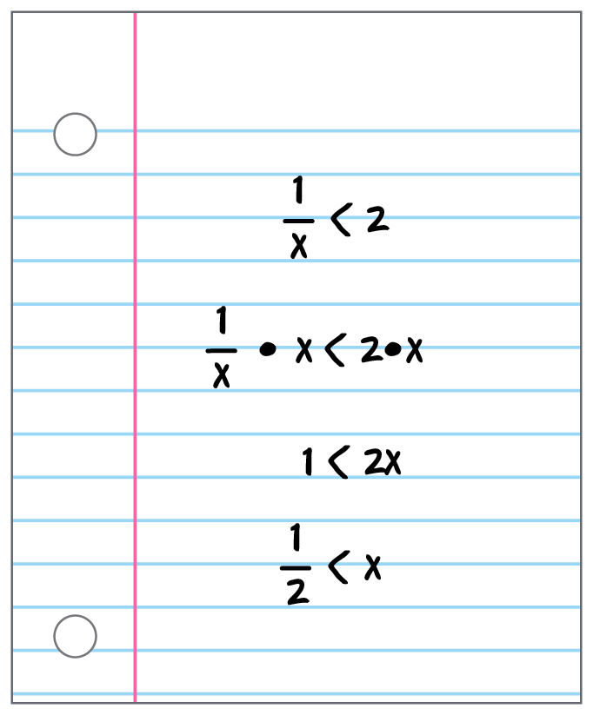
46. ANALYZE Given $\frac{5x}{x - 2}$ = 7 + $\frac{10}{x - 2}$.
a. Solve the equation for x. Is your solution extraneous? Explain how you know.
b. How can you use a graphical method to check your answer for part a?

47. FIND THE ERROR A student is trying to solve the inequality $\frac{1}{x}$ < 2. Refer to the work shown at the right. Do you agree? Explain your reasoning. What is one method this student could have used to check their work?

48. CREATE Give an example of a rational equation that can be solved by multiplying each side of the equation by 4(x + 3)(x – 4).

49. PERSEVERE Solve $\frac{1 + \frac{9}{x} + \frac{20}{x^{2}}}{ \frac{x^{2} - 25}{x^{2}}}$ = $\frac{x + 4}{x - 5}$.

50. ANALYZE While using the table feature on the graphing calculator to explore f(x) = $\frac{1}{x^{2} - x - 6}$, the values –2 and 3 say “ERROR.” Explain its meaning.

51. WRITE Why should you check solutions of rational equations and inequalities?

