Using Statistical Experiments ⸱ Practice

Example 1
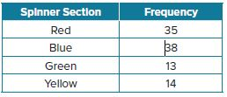
1. A student spun a spinner with 4 equal sections 100 times and recorded the results.
a. Find the theoretical probability of spinning Blue. Write your answer as a percentage rounded to the nearest tenth, if necessary.
b. Find the experimental probability of spinning Blue. Write your answer as a percentage rounded to the nearest tenth, if necessary.

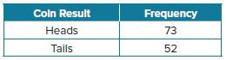
2. A student flipped a coin 125 times and recorded the results.
- Find the theoretical probability of the coin landing on heads. Write your answer as a percentage rounded to the nearest tenth, if necessary.
- Find the experimental probability of the coin landing on heads. Write your answer as a percentage rounded to the nearest tenth, if necessary.
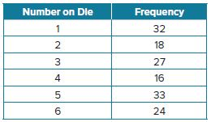
3. A fair 6-sided die is rolled 150 times.
a. Find the theoretical probability of rolling a 3. Write your answer as a percentage rounded to the nearest tenth, if necessary.
b. Find the experimental probability of rolling a 3. Write your answer as a percentage rounded to the nearest tenth, if necessary.

Examples 2 and 3
4. INTERNET Tiana sells handmade earrings online. Last month she sold 60% of her inventory. Design and run a simulation that can be used to estimate the probability of selling inventory.

5. PROGRAMMING Lamar designed a soccer computer game. He coded the program such that a player will make a goal on 35% of the attempts. Paola is testing the game and thinks there may be an error in the game’s programming. She attempted to make 30 goals and only 4 were successful. Run and evaluate a simulation and decide whether Paola is correct.

Mixed Exercises
6. Describe a way to simulate the test results for someone who guesses on a multiple choice test with 4 choices for each question.

7. Describe a spinner that could be used to simulate an event with 2 possible outcomes, one with a probability of 60%.

8. How should numbers be assigned to use a random number generator for the following situation?
Probability of choosing blue: 40%
Probability of choosing green: 20%
Probability of choosing red: 30%
Probability of choosing purple: 10%

9. HAIR COLOR A survey of Hartford High School students found that 50% of the students had brown hair, 40% had blonde hair, and 10% had red hair. Design a simulation that can be used to estimate the probability that a randomly selected student will have one of these hair colors. Assume that each student’s hair color will fall into one of these categories.
10. DESIGN Marta designed a simulation using a fair coin and a spinner with six equal sections. Describe a situation that Marta may be simulating.

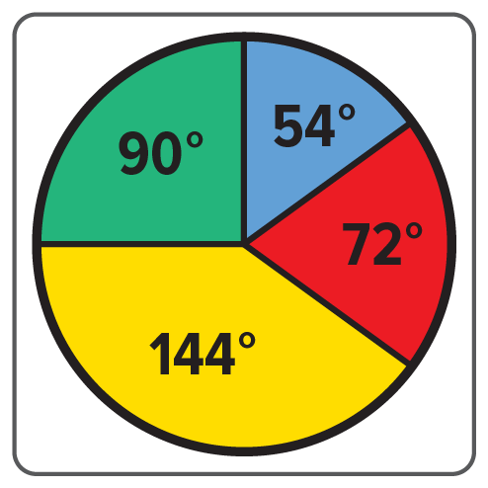
11. TRAVEL According to a survey done by a travel agency, 40% of their cruise clients went to the Bahamas, 25% went to Mexico, 20% went to Alaska, and 15% went to Greece. When Jinhai and Jayme were asked to design a simulation that could be used to estimate the probability of a client going to each of these places, Jinhai designed the spinner with central angles shown. Jayme wants to assign integers to each destination and use the random number generator on her graphing calculator. Which model would allow more trials to be conducted in a shorter period of time?

12. EARTHQUAKES Geologists conclude that there is a 62% probability of a magnitude 6.7 or greater quake striking the San Francisco Bay region before 2032. Design a simulation that can be used to estimate the probability that such an earthquake occurs.

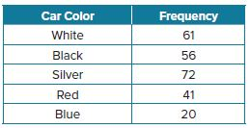
13. STATE YOUR ASSUMPTION Sarah kept track of the color of each car that passed her house. She recorded the car color for 250 cars.
a. Find the theoretical probability of a blue car passing by Sarah’s house. Write your answer as a percentage rounded to the nearest tenth, if necessary.
b. Find the experimental probability of a blue car passing by Sarah’s house. Write your answer as a percentage rounded to the nearest tenth, if necessary.
c. What assumption did you make to find the theoretical probability?

14. USE TOOLS Describe an event that can be simulated using each method.
a. A coin is tossed.
b. A four-sided die is rolled.

15. USE A MODEL Forty-two students participated in a raffle with three prizes. Fifteen of the participants were members of the basketball team. All three winners were members of the basketball team. The other students claim the raffle was unfair.
a. Describe a simulation you could use to test the results of the raffle.
b. Run a simulation and record your results in a table.
c. Based on your results, do you think the raffle was fair? Explain your reasoning.

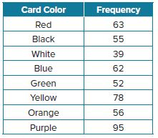
16. CARDS A package of cards has an equal number of red, black, white, blue, green, yellow, orange, and purple cards. Judy kept track of the color card she randomly drew after shuffling the cards. She recorded the card color results for 500 trials.
a. Find the theoretical probability of Judy drawing any color card. Write your answer as a percentage rounded to the nearest tenth, if necessary.
b. Find the experimental probability of Judy drawing a green card. Write your answer as a percentage rounded to the nearest tenth, if necessary.
c. Find the experimental probability of Judy drawing a yellow card. Write your answer as a percentage rounded to the nearest tenth, if necessary.

17. USE A MODEL A volleyball player serves an ace 66% of the time in a set.
a. Design a model or simulation you could use to estimate the probability that the volleyball player will serve an ace on the next serve.
b. Run your simulation and record your results in a table.
c. Examine the data. Is the data from your simulation consistent with the probability model?

18. CONSTRUCT ARGUMENTS There are 2 candidates running for class president. Of the six models discussed in this lesson—cards, coin toss, marbles, dice, random number generator, or spinner—which model would be most appropriate for a simulation to determine how students will vote? Justify your conclusion.

19. ANALYZE Jevon tosses a coin several times and finds that the experimental probability for the coin landing heads up is 25%. Should Jevon be concerned about the fairness of the coin? Explain your reasoning.

20. ANALYZE Is the experimental probability of heads when a coin is tossed 15 times sometimes, never, or always equal to the theoretical probability? Justify your argument.

21. PERSEVERE True or false: If the theoretical probability of an event is 1, the experimental probability of the event cannot be 0. Explain your reasoning.

22. WRITE What should you consider when using the results of a simulation to make a prediction?

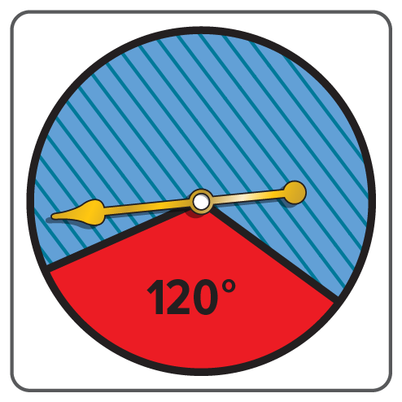
23. ANALYZE An experiment has three equally likely outcomes, A, B, and C. Is it possible to use the spinner shown in a simulation to predict the probability of outcome C? Explain your reasoning.

24. WRITE Can tossing a coin sometimes, always, or never be used to simulate an experiment with two possible outcomes? Explain your reasoning.

