Analyzing Population Data ⸱ Practice

Example 1
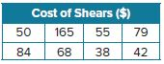
1. BARBER A barber wants to purchase new professional shears from a Web site. The prices of all of the shears are shown in the table. Use the standard deviation formula to find and interpret the standard deviation of the data. Round your answers to the nearest cent.

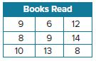
2. READING Ms. Sanchez keeps track of the total number of books each student in the book club reads during the school year. Use the standard deviation formula to find and interpret the standard deviation of the data. Round your answers to the nearest tenth.

Example 2
Use a graphing calculator to find the mean and standard deviation of each set of data. Round to the nearest tenth.
3. 20, 23, 24, 23, 22, 25, 21, 23, 24, 22, 21, 23, 22, 24

4. 150, 153, 125, 136, 143, 150, 166, 148, 150, 173, 150, 153, 143, 142, 153

5. 9.0, 3.8, 6.2, 7.1, 5.3, 6.2, 7.1, 8.2, 7.1, 4.5, 9.9, 8.2

6. 3350, 2800, 4525, 2150, 2800, 2150, 3350, 1800, 5250, 3975, 580, 2800

Example 3
7. TRACK Twenty track members were timed on a one-mile run before their season began and again after their season was completed. Use the mean and standard deviation to compare the distributions.
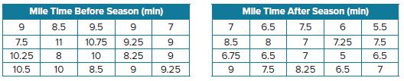

8. GRADES Mr. Williams recorded students' test scores of his two Geometry classes. Use the mean and standard deviation to compare the distributions.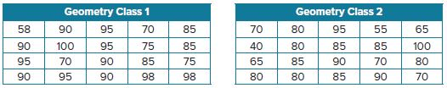

Mixed Exercises

Use technology to calculate the mean and standard deviation of each set of data. Round to the nearest thousandth.
9. 0.2, 0.4, 0.35, 0.25, 0.3, 0.45, 0.3, 0.4, 0.65, 0.35, 0.15, 0.35, 0.4, 0.45, 0.35, 0.5, 0.6, 0.3
10. $\frac{1}{4}$, $\frac{5}{8}$,$\frac{1}{2}$, $\frac{3}{8}$,$\frac{5}{8}$, $\frac{3}{8}$, $\frac{1}{2}$, 1, $\frac{1}{2}$, $\frac{1}{8}$, $\frac{5}{8}$, $\frac{3}{4}, \frac{1}{2}$, $\frac{3}{4}$, $\frac{7}{8}$, $\frac{1}{4}$
11. TESTING A community college offers 10 dates for taking the entrance exam. An administrator records the number of attendees at each session. Find and interpret the standard deviation of the data. Round your answers to the nearest tenth.
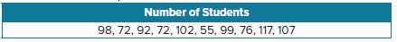
12. USE A MODEL Juan Carlos is researching the effect of tank size on the development of guppies. He measures each fish in both tanks. How can Juan Carlos use the mean and standard deviation to develop a conclusion in his research?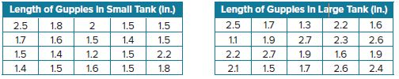
13. CONSTRUCT ARGUMENTS The manager of a fast food restaurant is analyzing the hourly wages of the employees. To make the wages more even, she wants to reduce the spread of the data that represent the wages by adding $1 to each employee’s hourly wage. Is this an effective method to reduce the spread? Justify your response.
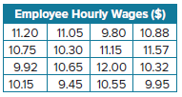
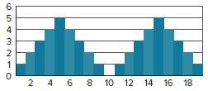
14. WRITE How can the center and spread of a bimodal distribution, like the one shown, be described?
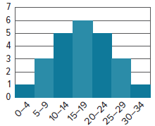
15. ANALYZE Approximate the mean and standard deviation of the distribution of data shown. Explain your reasoning.
16. CREATE Create a symmetric set of data with 12 data values. Then calculate the mean and standard deviation of your set of data.
17. WRITE Explain how to find the standard deviation of a set of data without using technology.

