Normal Distributions ⸱ Practice

Example 1
Identify the random variable in each distribution, and classify it as discrete or continuous. Explain your reasoning.
1. the number of texts received per week
2. the number of “likes” for a Web page
3. the height of a plant after a specific amount of time

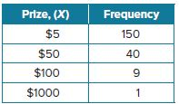
Examples 2-4
4. FUNDRAISING At a fundraising dinner, the underside of 200 plates were randomly tagged with a sticker to indicate winning a cash prize. The frequency table shows the number of winning plates for each prize. Construct a relative frequency table, and graph the probability distribution.

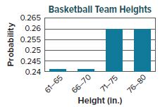
5. BASKETBALL An athletic director made a probability distribution of the heights of her team’s basketball players, and distributed a flyer that claimed that the majority of the players on the basketball team are 71 inches or taller. Identify any flaws in the representation of the probability distribution.

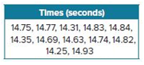
6. TRACK The preliminary times for a 110-meter hurdles race are shown. Create a histogram of the set of data. Determine whether the data can be approximated with a normal distribution.

Example 5
7. A normal distribution has a mean of 186.4 and a standard deviation of 48.9.
a. What range of values represents the middle 99.7% of the data?
b. What percent of data will be greater than 235.3?
c. What range of values represents the upper 2.5% of the data?

Example 6
Find the z-value for each standard normal distribution.
8. σ = 9.8, X = 55.4, and μ = 68.34
9. σ = 11.6, X = 42.80, and μ = 68.2
10. σ = 11.6, X = 119.2, and μ = 112.4

Example 7
Use a table to find the area under the normal curve for each interval.
11. z > 0.58 12. z < –1.56 13. –2.29 < z < 2.76

Example 8
14. TESTING The scores on a test administered to prospective employees are normally distributed with a mean of 100 and a standard deviation of 12.3.
a. What percent of the scores are between 70 and 80?
b. What percent of the scores are over 115?
c. If 75 people take the test, how many would you expect to score lower than 75?

Mixed Exercises
15. USE A MODEL Shawndra conducted a study to find how far people park from parking blocks by measuring the distance from the end of the parking block to the front fender of the parked car. The distribution of the data closely approximated a normal distribution with a mean of 8.5 inches. About 2.5% of cars parked more than 11.5 inches from the parking block. What percentage of cars would you expect to have parked less than 5.5 inches from the parking block?
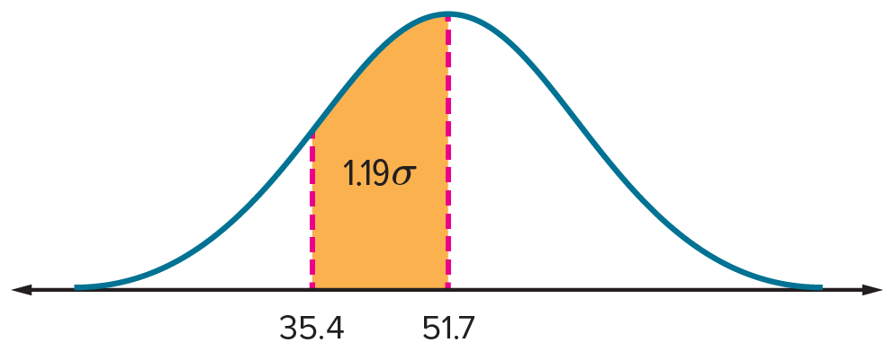
16. PRECISION Use the normal distribution of data.
a. What is the standard deviation of the data set?
b. What percent of the data will be greater than 60?

17. LIGHT BULBS The time that a certain brand of light bulb will last is normally distributed. About 2.5% of the bulbs last longer than 6800 hours, and about 16% last longer than 6500 hours. How long does the average bulb last?

18. STRUCTURE Each day, Roberto takes a 20-question practice college entrance exam and records his score. Find the probability distribution for this situation.
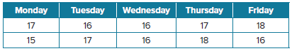

19. FIND THE ERROR A data set of tree diameters is normally distributed with mean 11.5 centimeters, standard deviation 2.5, and range from 3.6 to 19.8. Monica and Hiroko want to find the range that represents the middle 68% of the data. Is either of them correct? Explain your reasoning.
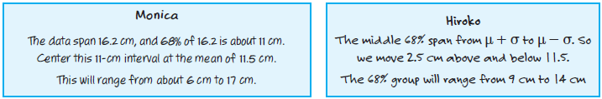

20. PERSEVERE A shipment of cell phones has an average battery life of 8.2 hours with a standard deviation of 0.7 hour. Eight of the phones have a battery life greater than 9.3 hours. If the sample is normally distributed, how many phones are in the shipment?
21. WRITE Describe the relationship between the z-value, the position of an interval of X in the normal distribution, the area under the normal curve, and the probability of the interval occurring.

