Angles and Angle Measure ⸱ Practice
Examples 1 and 2
Draw an angle with the given measure in standard position.
1. 160° 2. 280° 3. 400°

4. 185° 5. 810° 6. 390°

7. 495° 8. ‒50° 9. ‒420°

10. 210° 11. 305° 12. 580°

13. 135° 14. ‒450° 15. ‒560°

Example 3
Find an angle with a positive measure and an angle with a negative measure that are coterminal with each angle.
16. 65° 17. ‒75° 18. 230°

19. 45° 20. 60° 21. 370°

22. ‒90° 23. 420° 24. 30°

25. 55° 26. 80° 27. 110°

28. $\frac{2π}{5}$ 29. $\frac{5π}{6}$ 30. $-\frac{3π}{2}$

31. $\frac{2π}{3}$ 32. $\frac{5π}{2}$ 33. $-\frac{3π}{4}$

Example 4
Rewrite each degree measure in radians.
34. 140° 35. ‒260° 36. ‒75°

37. 380° 38. 130° 39. 720°

40. 210° 41. 90° 42. ‒30°

Example 5
Rewrite each radian measure in degrees.
43. – $\frac{3π}{5}$ 44. $\frac{7π}{6}$ 45. $\frac{π}{3}$

46. $\frac{5π}{6}$ 47. $\frac{2π}{3}$ 48. $\frac{5π}{4}$

49. – $\frac{3π}{4}$ 50. – $\frac{7π}{6}$ 51. $\frac{π}{4}$

Example 6
52. TRANSPORTATION A traffic roundabout has a diameter of 200 meters. How far does an automobile travel in the roundabout if it goes one-fourth of the way around?

53. ANALOG CLOCKS The length of the minute hand of an analog clock is 5 inches. If the minute hand rotates from 12 noon to 12:40 P.M., then how far does its point move?

Mixed Exercises
REGULARITY Rewrite each degree measure in radians and each radian measure in degrees.
54. 18° 55. 6° 56. ‒72°

57. ‒820° 58. 4π 59. $\frac{5π}{2}$

60. – $\frac{9π}{2}$ 61. – $\frac{7π}{12}$ 62. ‒270°

Find the length of each arc. Round to the nearest tenth.
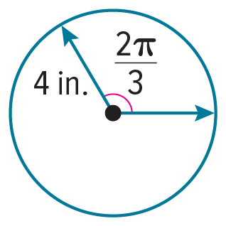
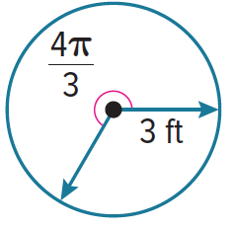
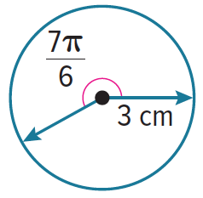
63. 64. 65.

66. TIME Find both the degree and radian measures of the angle through which the hour hand on a clock rotates from 5 A.M. to 10 P.M.

67. ROTATION A truck with 16-inch radius wheels is driven at 77 feet per second (52.5 miles per hour). Find the measure of the angle through which a point on the outside of the wheel travels each second. Round to the nearest degree and nearest radian.

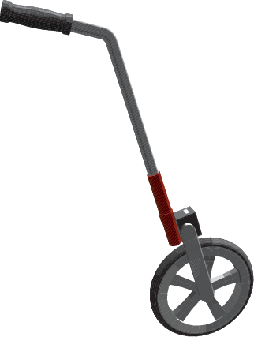
68. PLANETS Earth makes one full rotation on its axis every 24 hours. How long does it take Earth to rotate through 150°? Neptune makes one full rotation on its axis every 16 hours. How long does it take Neptune to rotate through 150°?

69. SURVEYING If a surveyor’s wheel with a diameter of 19 inches completes $\frac{5}{6}$ of a rotation, what is the total distance traveled in inches? Round to the nearest hundredth if necessary.

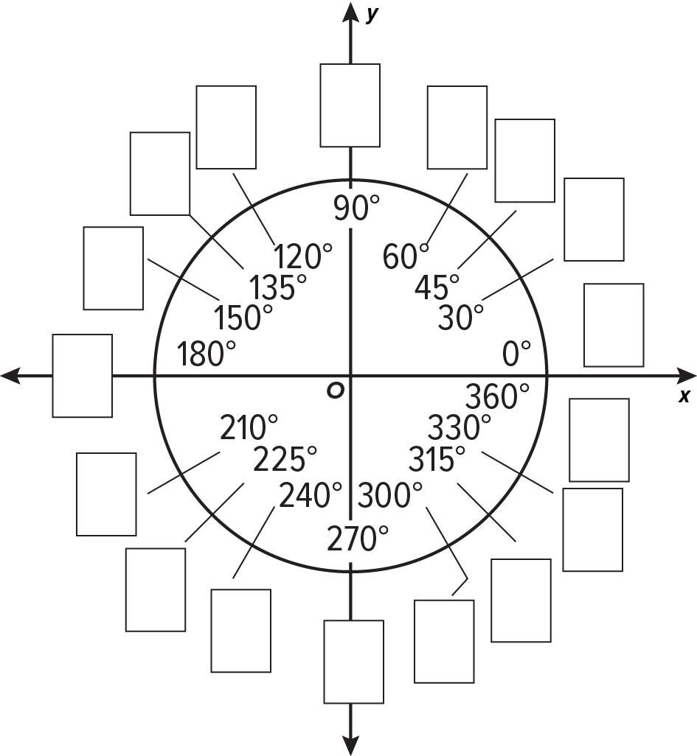
70. STRUCTURE It is convenient to know the measures of some specific angles in both degree and radian measures.
a. Complete the figure at the right by writing the radian measure for each angle.
b. Describe at least one pattern or symmetry that you notice in the
completed figure.

71. CLOCKS Through what angle, in degrees and radians, does the hour hand on a clock rotate between 4 p.m. and 7 p.m.? Assuming the length of the hour hand is 6 inches, find the arc length of the circle made by the hour hand during that time.

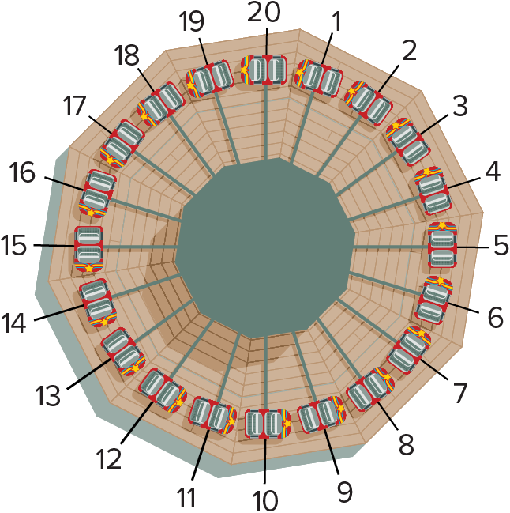
72. AMUSEMENT PARKS The carousel at an amusement park has 20 horses spaced evenly around its circumference. The horses are numbered consecutively from 1 to 20. The carousel completes one rotation about its axis every 40 seconds.
a. What is the central angle, in degrees, formed by horse #1 and horse #8?
b. What is the speed of the carousel in rotations per minute?
c. What is the speed of the carousel in radians per minute?
d. A child rides the carousel for 6 minutes. Through how many radians will the child pass in the course of the carousel ride?

73. FERRIS WHEELS The London Eye is one of the world’s largest Ferris wheels. The diameter of the wheel is 135 meters, and it makes a complete rotation in 30 minutes. A passenger gets on the ride and travels for 5 minutes before the ride stops. The passenger wants to know how far she traveled during this time.
a. During the 5-minute interval, what is the measure of the central angle of the wheel’s rotation in radians? Explain.
b. Explain how to find the distance the passenger traveled to the nearest meter.
c. Explain how you know your answer is reasonable.

74. PIZZA A circular pizza with a diameter of 18 inches is cut into 8 congruent slices. What is the radian measure of the central angle of each slice? Explain.

75. CONSTRUCT ARGUMENTS A lawn sprinkler produces a stream of water that reaches 15 feet from the sprinkler head. The sprinkler rotates to sweep out part of a circle. The area of the lawn that gets watered as the sprinkler moves back and forth is 75π square feet. Melinda says it is possible to determine the radian measure of the angle that is swept out by the sprinkler. Seiji says there is not enough information to determine this. Who is correct? Justify your argument.
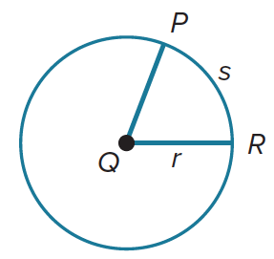
76. REASONING Consider the figure at the right.
a. Suppose s = r. What is m∠PQR in radians? What is the measure of the angle to the nearest tenth of a degree?
b. Suppose 2s = r. What is m∠PQR in radians? What is the measure of the angle to the nearest tenth of a degree?

77. STRUCTURE Circle C has a radius of 5 centimeters. The function f(x) gives the length in centimeters of an arc of circle C that is subtended by a central angle of x radians. Describe the graph of f(x) as precisely as possible, and justify your answer.

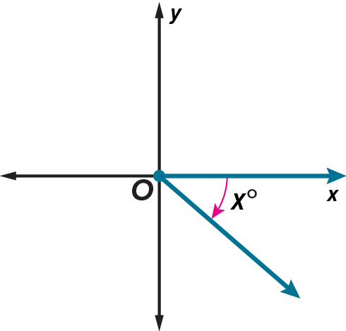
78. FIND THE ERROR Tarshia and Alan are writing an expression for the measure of an angle coterminal with the angle shown at the right. Is either of them correct? Explain your reasoning.
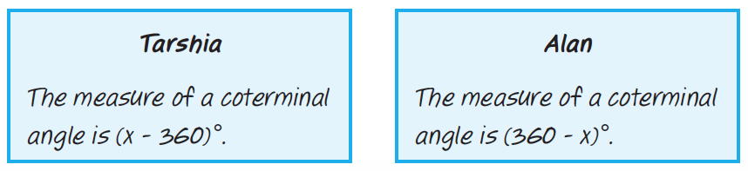

79. PERSEVERE A line makes an angle of $\frac{π}{2}$ radians with the positive x-axis at the point (2, 0). Find the equation of the line.

80. ANALYZE Express $\frac{1}{8}$ of a revolution in degrees and in radians. Justify your argument.

81. CREATE Draw and label an acute angle in standard position. Find two angles, one positive and one negative, that are coterminal with the angle.

82. ANALYZE Justify the formula for the length of an arc.

83. WRITE Use a circle with radius r to describe what one degree and one radian represent. Then explain how to convert between the measures.

