Trigonometric Functions of General Angles ⸱ Practice

Example 1
Find the exact values of the six trigonometric functions for angle $θ$.

1. 2. 3.
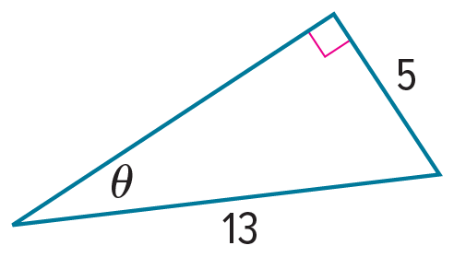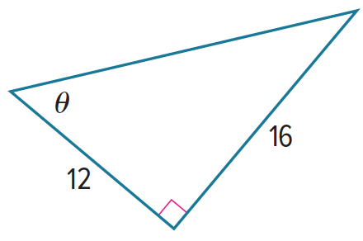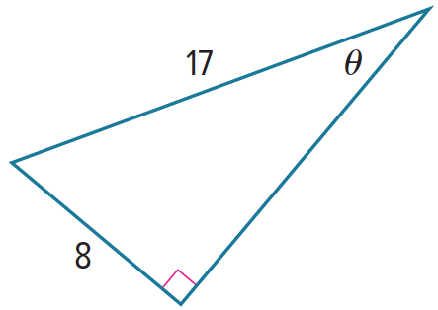

4. 5. 6.
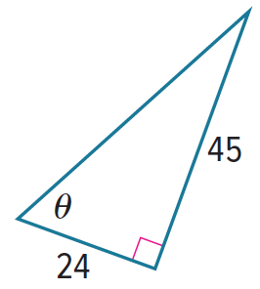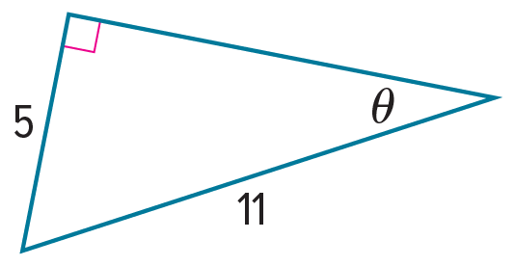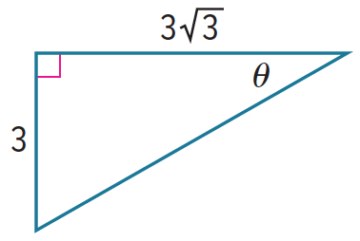

Example 2
In a right triangle, ∠A and ∠B are acute. Find the values of the five remaining trigonometric functions.
7. tan A =$\frac{\text{8}}{\text{15}}$ 8. cos A =$\frac{\text{3}}{\text{10}}$ 9. tan B = $3$

10. sin B =$\frac{\text{4}}{\text{9}}$ 11. cos A =$\frac{\text{1}}{\text{2}}$ 12. sin A =$\frac{\text{15}}{\text{17}}$

Examples 3 and 4
The terminal side of $θ$ in standard position contains each point. Find the exact values of the six trigonometric functions of $θ$.
13. (5, 12) 14. (3, 4) 15. (8, ‒15)

16. (‒4, 3) 17. (‒9, ‒40) 18. (1, 2)

19. (8, 4) 20. (4, 4) 21. (6, 2)

22. (–5, 5$\sqrt{2}$) 23. (3, ‒9) 24. (‒8, 12)

25. (3, 0) 26. (0, ‒7) 27. (0, 4)

Example 5
Sketch each angle. Then find the measure of each reference angle.
28. $\frac{31π}{36}$ 29. 230° 30. 205°

31. $\frac{4π}{3}$ 32. – $\frac{π}{6}$ 33. $\frac{7π}{4}$

34. 135° 35. 200° 36. $\frac{5π}{3}$

37. $\frac{13π}{8}$ 38. ‒210° 39. $-\frac{7π}{4}$

Example 6
PRECISION Find the exact value of each trigonometric function.
40. tan 330° 41. cos $\left(-\frac{11π}{4}\right)$ 42. cot 30°

43. csc $\frac{π}{4}$ 44. sin (‒150°) 45. tan $\left(-\frac{π}{4}\right)$
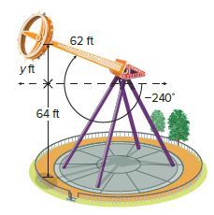
Example 7
46. AMUSEMENT RIDES An amusement park thrill ride swings its riders back and forth on a pendulum that spins. Suppose the swing arm of the ride is 62 feet in length, and the axis from which the arm swings is about 64 feet above the ground. What is the height of the riders above the ground at the peak of the arc? Round to the nearest foot if necessary.

47. ROOFING A roofer rests a ladder at a height of 12 feet against a building so that the base of the ladder is x feet from the bottom of the side of the building, forming a 71.6° angle with the ladder and ground. Find the distance from the bottom of the ladder to the side of the building.
a. Write an equation that can be used to find the distance from the bottom of the ladder to the side of the building.
b. How far is the bottom of the ladder from the side of the building? Round to the nearest tenth if necessary.

Mixed Exercises
In a right triangle, ∠A is acute.
48. If tan A = 3, what is sin A? 49. If sin A = $\frac{1}{16}$, what is cos A?

50. If tan A = $\frac{7}{12}$, what is cos A? 51. If sin B = $\frac{3}{8}$, what is tan B?

Find the exact value of each trigonometric function.
52. sin 150° 53. cos 270° 54. cot 135°

55. tan (‒30°) 56. tan $\frac{π}{4}$ 57. cot (‒π)

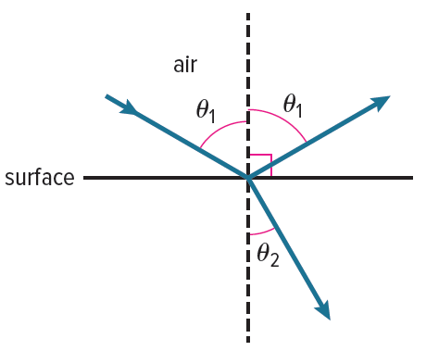

58. LIGHT Light rays are reflected by a surface. If the surface is partially transparent, some of the light rays are bent or refracted as they pass from the air through the material. The angles of reflection $θ_{1}$ and of refraction $θ_{2}$ in the diagram at the right are related by the equation sin $θ_{1}$ = n sin $θ_{2}$. If $θ$₁ = 60° and n = $\sqrt{3}$, find the measure of $θ_{2}$.

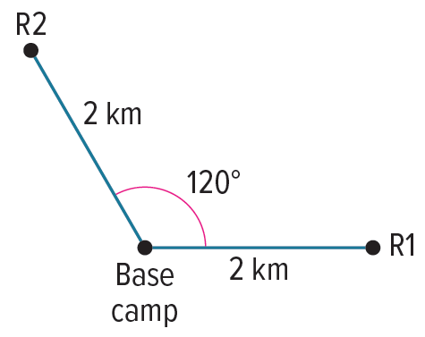
59. RADIOS Two correspondence radios are located 2 kilometers away from a base
camp. The angle formed between the first radio, the base camp, and the second radio is 120°. If the first radio has coordinates (2, 0) relative to the base camp, what is the position of the second radio relative to the base camp?

60. PAPER AIRPLANES The formula R = $\frac{{V_{0}}^{2} sin 2θ}{32}$ + 15 cos $θ$ gives the distance traveled by a paper airplane that is thrown with an initial velocity of $V_{0}$ feet per second at an angle of $θ$ with the ground.
a. If the airplane is thrown with an initial velocity of 15 feet per second at an angle of 25°, how far will the airplane travel?
b. Two airplanes are thrown with an initial velocity of 10 feet per second. One airplane is thrown at an angle of 15° to the ground, and the other airplane is thrown at an angle of 45° to the ground. Which will travel farther?


61. CLOCK The hands on the clock form an acute angle, $θ$. The minute hand is about 5 inches long, and the angle formed by the hands at the center of the clock is 75°. If the tips of the hands were connected, it would form a right triangle, with the minute hand being the hypotenuse. Use a trigonometric ratio to find the length of the hour hand to the nearest tenth of an inch.

62. FERRIS WHEELS Luis rides a Ferris wheel in Japan called the Sky Dream Fukuoka, which has a radius of about 60 m and is 5 m off the ground. After he enters the bottom car, the wheel rotates 210.5° counterclockwise before stopping. How high above the ground is Luis when the car has stopped?

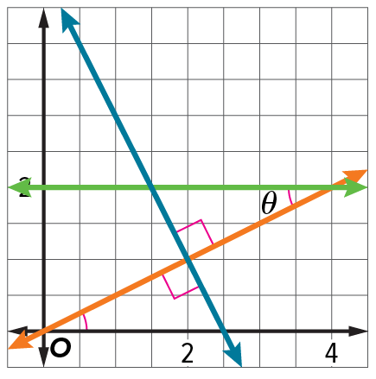
REASONING Use the congruent triangles in the figure for Exercises 63–66.

63. What is the cosecant of $θ$?

64. What is the cosine of $θ$?

65. What is the cotangent of $θ$?

66. What is the secant of $θ$?

67. STRUCTURE There are many angles that share the same reference angle. Give 3 angles that have a reference angle of 60°, including at least one angle with a measure greater than 360°. Explain your method.

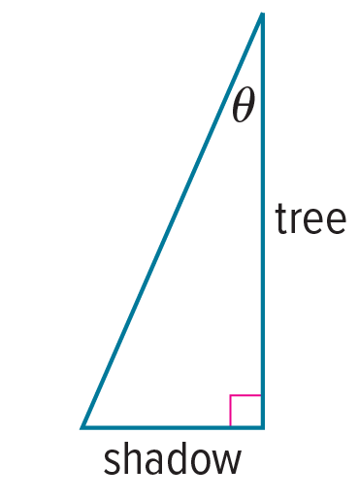
68. SHADOW A tree is $15\frac{1}{3}$ feet tall and casts a shadow at a right angle from the base of the tree. The length of the shadow depends on the angle at which the sunlight hits the tree, $θ$.
a. Find the distance from the top of the tree to the end of the tree’s shadow, in feet, when the Sun is at an angle of 13°. Round your answer to the nearest tenth.
b. How long is the tree’s shadow, in feet, when the Sun is at an angle of 58°? Round your answer to the nearest tenth.

69. ANALYZE Determine whether the following statement is true or false. Explain your reasoning.
For any acute angle, the sine function will never have a negative value.

70. CREATE In right triangle ABC, sin A = sin C. What can you conclude about $△$ABC? Justify your reasoning.

71. PERSEVERE For an angle $θ$ in standard position, sin $θ$ = $\frac{\sqrt{2}}{2}$ and tan $θ$ = ‒1. Can the value of $θ$ be 225°? Justify your reasoning.

72. ANALYZE Determine whether 3 sin 60° = sin 180° is true or false. Justify your argument.

73. WRITE Use the sine and cosine functions to explain why cot 180° is undefined.

74. CREATE Give an example of a negative angle $θ$ for which sin $θ$ > 0 and cos $θ$ < 0.

75. WRITE Describe the steps for evaluating a trigonometric function for an angle $θ$ that is greater than 90°. Include a description of a reference angle.

76. PERSEVERE When will all six trigonometric functions have a rational value? Justify your argument.

