Circular and Periodic Functions ⸱ Practice

Example 1
The terminal side of angle $θ$ in standard position intersects the unit circle at each point P.
Find cos $θ$ and sin $θ$.
1. $P\left(-\frac{\sqrt{3}}{2}, \frac{1}{2}\right)$ 2. P(0, –1) 3. $P\left(-\frac{2}{3}, \frac{\sqrt{5}}{3}\right)$

4. $P\left(-\frac{4}{5}, -\frac{3}{5}\right)$ 5. $P\left(\frac{1}{6}, -\frac{\sqrt{35}}{6}\right)$ 6. $P\left(\frac{\sqrt{7}}{4}, \frac{3}{4}\right)$

Example 2
Find the exact values of the six trigonometric functions for each given angle measure.
7. $\frac{π}{6}$ radians 8. $\frac{3π}{4}$ radians 9. $\frac{π}{2}$ radians

10. $\frac{5π}{3}$ radians 11. π radians 12. $\frac{7π}{6}$ radians

Example 3
Determine the period of the function.
13. 14.
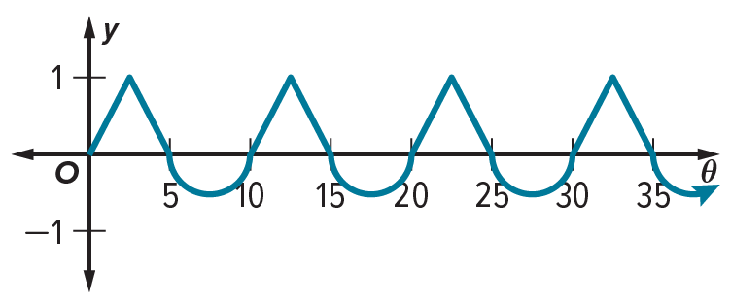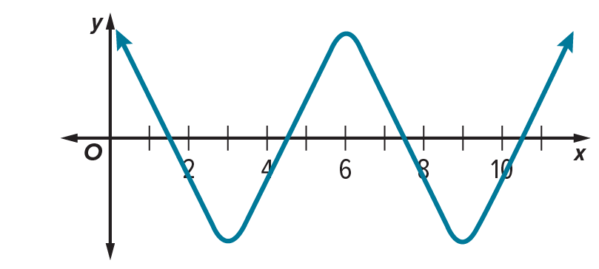

15. 16.
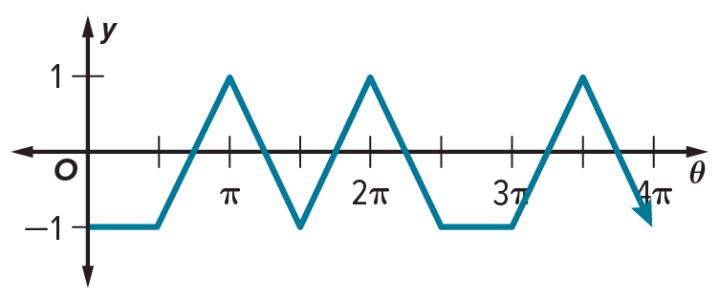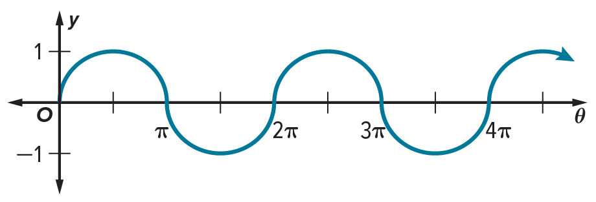

17. 18.
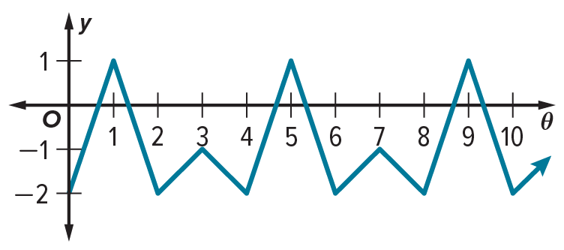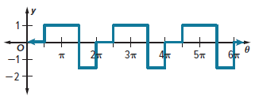

Example 4
19. GEARS A gear at a factory has a diameter of 24 inches and can complete about 15 rotations per minute. One spot on the gear has a specific notch. The distance of the notch d from the edge of the machine to which the gear is attached varies periodically as a function of time t. Identify the period of the function. Then graph the function. Assume that the notch begins at the point closest to the edge of the machine, 10 inches from the edge.

20. PENDULUM The height of a pendulum varies periodically as a function of time. The pendulum swings in one direction and reaches its high point of 3 feet. It then swings the opposite direction and reaches 3 feet again. Its lowest point is 1.5 feet. The time it takes for the pendulum to swing from its low point to one of its high points is 3 seconds. Identify the period of the function. Then graph the function. Assume that the pendulum begins at the low point, 1.5 feet above the ground.

Example 5
Find the exact value of each expression.
21. sin (–510°) 22. sin 495° 23. cos $\left(-\frac{5π}{2}\right)$

24. sin $\left(\frac{5π}{3}\right)$ 25. cos $\left(\frac{11π}{4}\right)$ 26. sin $\left(-\frac{3π}{4}\right)$

Mixed Exercises
Find the exact value of each expression.
27. cos 45° ‒ cos 30° 28. 6(sin 30°)(sin 60°)

29. 2 sin $\frac{4π}{3}$ ‒ 3 cos $\frac{11π}{6}$ 30. cos$\left(-\frac{2π}{3}\right)+\frac{1}{3}$ sin 3π

31. (sin 45°)² + (cos 45°)² 32. $\frac{\left(\cos{30°}\right)\left(\cos{150°}\right)}{\sin{315°}}$

33. FERRIS WHEELS A Ferris wheel with a diameter of 100 feet completes 2.5 revolutions per minute. What is the period of the function that describes the height of a seat on the outside edge of the Ferris wheel as a function of time?
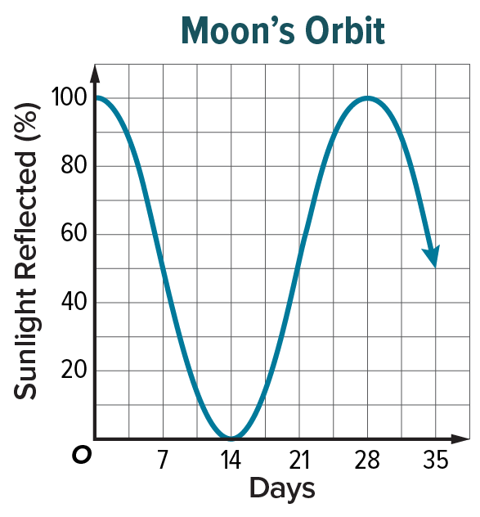
34. MOON The Moon’s period of revolution is the number of days it takes for the Moon to revolve around Earth. The period can be determined by graphing the percentage of sunlight reflected by the Moon each day, as seen by an observer on Earth. Use the graph to determine the Moon’s period of revolution.

35. ARGUMENTS Determine whether each statement is always, sometimes, or never true. Justify your argument.
a. If k is a real number, then there is a value of $θ$ such that cos $θ$ = k.
b. sin $θ$ = sin ($θ$ + 2$π$)
c. If $θ$ = nπ, where n is a whole number, then cos $θ$ = 1.
d. If $θ$ is an angle in standard position in which the terminal side lies in Quadrant IV, then sin $θ$ is positive.

36. REASONING Point P lies on the unit circle and on the line y = x. If $θ$ is an angle in standard position in which the terminal side contains P, what can you conclude about sin $θ$ and cos $θ$? Explain.

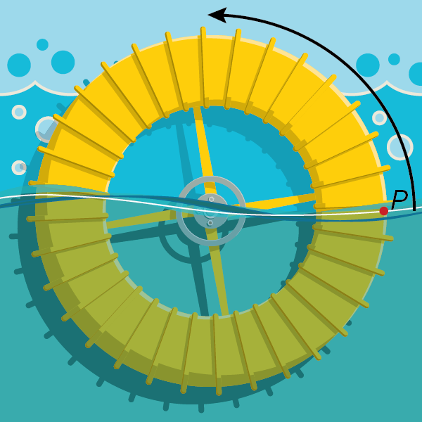
37. USE A MODEL The wheel at a water park has a radius of 1 meter. As the water flows, the wheel turns counterclockwise, as shown. A point P on the edge of the wheel begins at the surface of the water. The function f(x) = sin x represents the height of P above or below the surface of the water as the wheel rotates through an angle of x radians.
a. How far does point P travel as the wheel rotates through an angle of
$\frac{3π}{4}$ radians? Explain.
b. Graph f(x) = sin x on the coordinate plane.
c. What is the period of the function? Explain how you know and explain how the period is shown in the graph. What does the period tell you about point P?
d. What are the x-intercepts? What do these represent?
e. Identify an interval where the function is decreasing. What does this represent?

38. TIRES A point on the edge of a car tire is marked with paint. As the car moves slowly, the marked point on the tire varies in distance from the surface of the road. The height in inches of the point is given by the function h = –8 cos t + 8, where t is the time in seconds.
a. What is the maximum height above ground that the point on the tire reaches?
b. What is the minimum height above ground that the point on the tire reaches?
c. How many rotations does the tire make per second?
d. How far does the marked point travel in 30 seconds? How far does the marked point travel in one hour?

39. TEMPERATURES The temperature T in degrees Fahrenheit of a city t months into the year is approximated by the formula T = 42 + 30 sin $\left(\frac{π}{6}t\right)$.
a. What is the highest monthly temperature for the city?
b. In what month does the highest temperature occur?
c. What is the lowest monthly temperature for the city?
d. In what month does the lowest temperature occur?
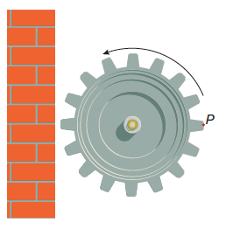
40. FACTORIES A machine in a factory has a gear with a radius of 1 foot. A point P on the edge of the gear begins at the furthest point from a wall, and then the gear begins to rotate counterclockwise. The function f(x) = cos x + 2 represents the distance of P from the wall as the gear rotates through an angle of x radians.
a. What is f$\left(\frac{π}{2}\right)$? What does it represent?
b. Graph f(x) on a coordinate plane.
c. What is the period of the function? What does this tell you about P?
d. What are the maximum and minimum values of the function?

41. FIND THE ERROR Francis and Benita are finding the exact value of cos ($–\frac{π}{3})$. Is either of them correct? Explain your reasoning.
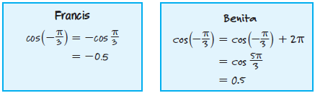
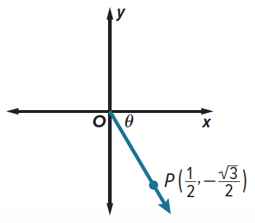
42. PERSEVERE A ray has its endpoint at the origin of the coordinate plane, and point P$\left(\frac{1}{2},-\frac{\sqrt{3}}{2}\right)$ lies on the ray. Find the angle $θ$ formed by the positive x-axis and the ray.

43. ANALYZE Is the period of a sine curve sometimes, always, or never an integer multiple of π? Justify your reasoning.

44. CREATE Draw the graph of a periodic function that has a maximum value of 10 and a minimum value of ‒10. Describe the period of the function.

45 . WRITE Explain how to determine the period of a periodic function from its graph. Include a description of a cycle.

