Graphing Sine and Cosine Functions ⸱ Practice

Example 1
Find the amplitude, midline, and period of each function.
1. 2.
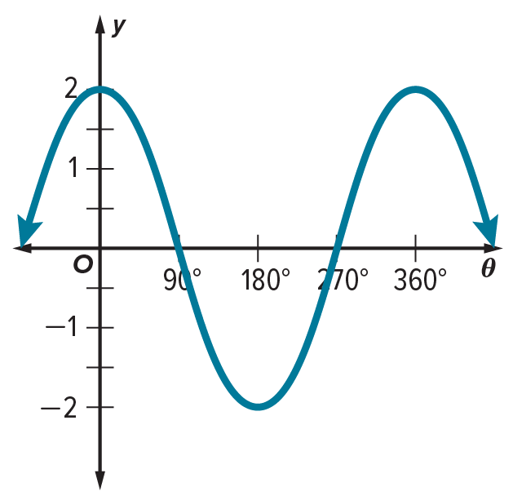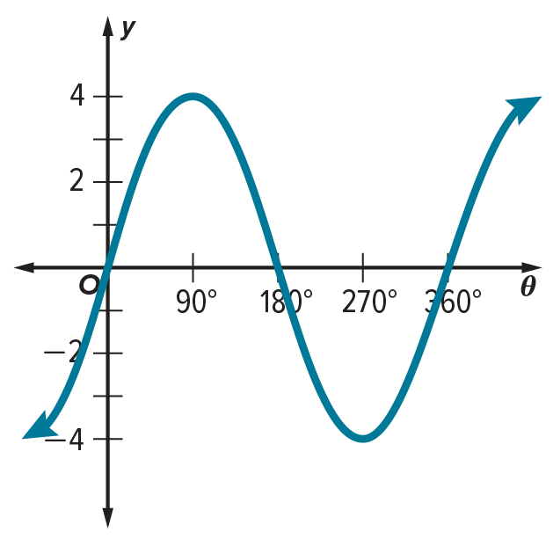

3. 4.
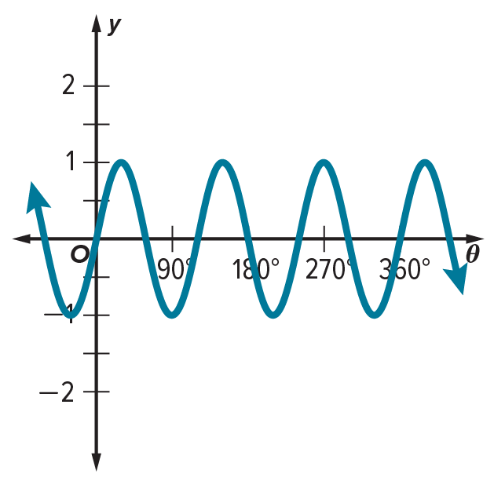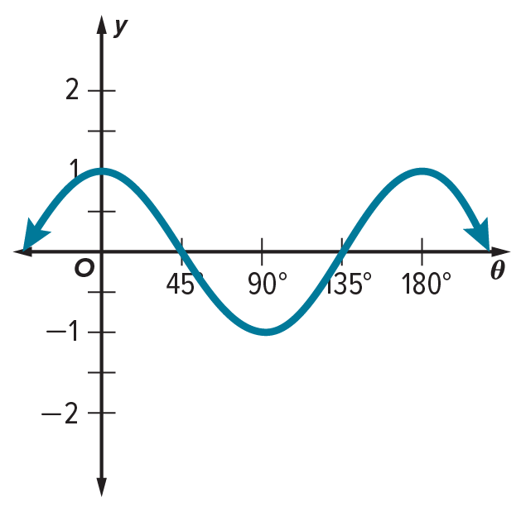

Example 2
Find the amplitude and period of each function.
5. y = 2 cos 𝜃 6. y = 2 sin 𝜃 7. y = cos $\frac{1}{2}θ$

8. y = $\frac{3}{4}$ cos $θ$ 9. y = $\frac{1}{2}$ sin 2𝜃 10. y = 3 cos $2θ$

Examples 3 and 4
Find the amplitude and period of each function. Then graph the function.
11. y = 3 sin 𝜃 12. y = cos 3𝜃 13. y = sin 4𝜃

14. y = $\frac{3}{2}$ sin $θ$ 15. y = 4 cos 2𝜃 16. y = 5 sin $\frac{2}{3}θ$

Example 5
17. USE A MODEL An object on a spring oscillates according to the function y = 25 cos πt, where y is the distance in inches from its equilibrium position in t seconds.
a. Find and describe the period and frequency.
b. Identify the domain and range in the context of the situation.

18. SWINGS Suppose a tire swing is rotated $\frac{π}{5}$ radians and released. The function $y=\frac{π}{5}cos 2t$ represents the displacement of the swing at time t for a frequency of radians per second.
a. Find the period and frequency, and describe them in the context of the situation.
b. Identify the domain and range in the context of the situation.

Example 6
19. REASONING A boat that is tied to a dock moves vertically up and down with the waves. Delray watches the boat for 30 seconds and notes that the boat moves up and down a total of 6 times. The difference between the boat’s highest point and lowest point is 3 feet. Write and graph a trigonometric function that models the boat’s vertical position x seconds after she began watching. Assume that when Delray began watching the boat, it was at its highest point and that its average vertical position was 0 feet.

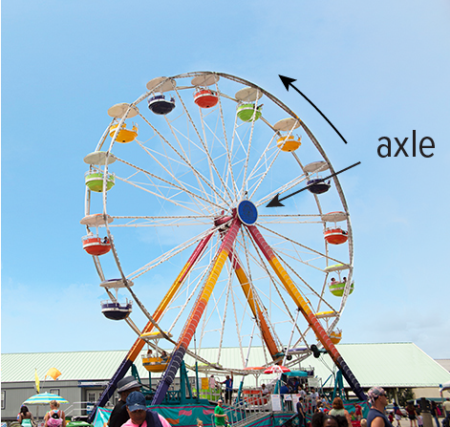
20. FERRIS WHEELS A Ferris wheel at a state fair has a diameter of 65 feet and makes 4 complete revolutions each minute. Santiago boards a car of the Ferris wheel at the car’s lowest point, and he rides for 2 minutes. Write and graph a trigonometric function that models his height above or below the axle of the Ferris wheel 𝜃 minutes after the ride starts.

Mixed Exercises
Find the amplitude and period of each function. Then graph the function.
21. y = 3 sin $\frac{2}{3}θ$ 22. y = $\frac{1}{2}$ cos $\frac{3}{4}θ$ 23. y = 4 cos $\frac{θ}{3}$

REGULARITY For each graph, identify the period and write an equation.
24. 25. 26.
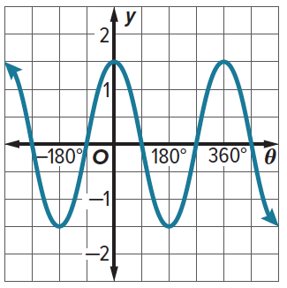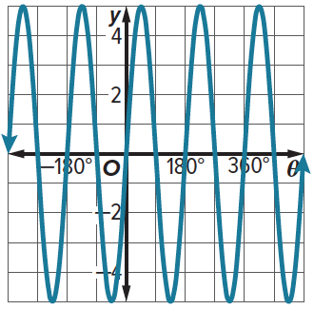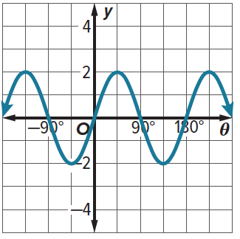

27. USE A SOURCE Research how the sine function can be used to model ocean waves. Explain.

28. PHYSICS An anchoring cable exerts a force of 500 Newtons on a pole. The force has the horizontal and vertical components $F_{x}$ and $F_{y}$.
a. The function $F_{x}$ = 500 cos $θ$ describes the relationship between the angle $θ$ and the horizontal force. What are the amplitude and period of this function?
b. The function $F_{y}$ = 500 sin $θ$ describes the relationship between the angle $θ$ and the vertical force. What are the amplitude and period of this function?

29. WEATHER The function y = 60 + 25 sin $\frac{π}{6}t$, where t is in months and t = 0 corresponds to April 15, models the average high temperature in degrees Fahrenheit.
a. Determine the period of this function. What does this period represent?
b. What is the maximum high temperature and when does this occur?

30. MODELING A cyclist pedals at a rate of 6 rotations every 5 seconds. The motion of the pedals is circular with a radius of 7 inches. The closest the pedals get to the ground is four inches away. Write a function h(t) that models the height of a pedal in inches as a function of the time t in seconds. Assume the pedal starts at its highest point.

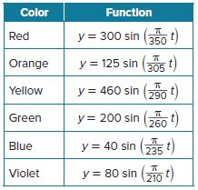
31. STRUCTURE Functions can be used to model the wave patterns of different colors of light emitted from a particular source, where y is the height of the wave in nanometers and t is the length from the start of the wave in nanometers.
a. What are the amplitude and period of the function describing green light waves?
b. The intensity of a light wave corresponds directly to its amplitude. Which color emitted from the source is the most intense?
c. The color of light depends on the period of the wave. Which color has the shortest period? The longest period?

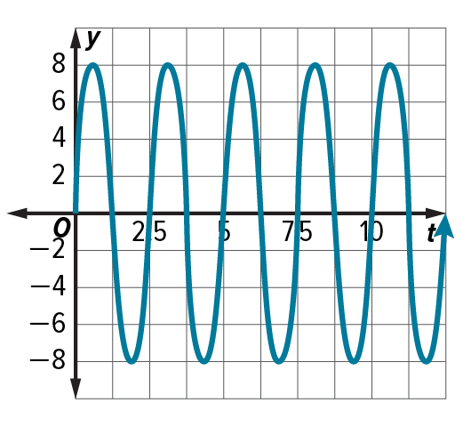

32. SWIMMING As Kazuo swims a 25-meter sprint, the position of his right hand relative to the water surface can be modeled by the graph shown, where y is the height of the hand in inches from the water level and t is the time in seconds past the start of the sprint. What function describes this graph?

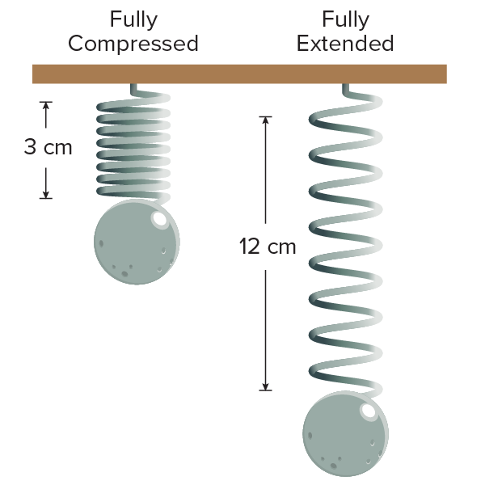
33. REASONING Maribel sets up an experiment with a spring at a physics lab. She hangs the spring from a hook and attaches a weight to the bottom of the spring. She records the length of the spring when is it fully compressed and fully extended, as shown. When she releases the spring from the fully-compressed position, she finds that it takes 2 seconds to come back to this position. Maribel wants to write a function f(t) that models the length of the spring, in centimeters, t seconds after it has been released.
a. What is the amplitude of f(t)? What is the period?
b. Write and graph a function f(t) that models the length of the spring.


34. AMUSEMENT RIDES An amusement park ride consists of two 16-foot arms that each have a car on one end of the arm and a counterweight on the other end. The arms rotate in opposite directions. Each car has a minimum height of 3 feet above the ground. It takes each car 3 seconds to make a complete rotation. The function f(x) models the height of one car above the ground x seconds after the ride starts. (Assume the cars make complete rotations as soon as the ride begins.)
a. Write and graph a function f(x) that models the motion of a car.
b. What is the first interval of your graph in which the function is increasing? What does it represent?
c. Explain how your graph shows the period of the ride.

35. CREATE Write a sine function in which the amplitude is 2 and its graph has 3 complete cycles on the interval 0 ≤ 𝜃 ≤ π. Justify your answer.

36. ARGUMENTS The function h(x) = 6 sin 30πx + 10 models the height above ground in inches of a point P at the tip of a blade of a floor fan x seconds after the fan is turned on. What is the speed of the fan in rotations per minute? Explain.

37. ANALYZE Compare and contrast the graphs of y = $\frac{1}{2}$ sin 𝜃 and y = sin $\frac{1}{2}θ$.

38. CREATE Write a trigonometric function that has an amplitude of 3 and a period of 180°. Then graph the function.

39. WRITE How can you use the characteristics of a trigonometric function to sketch its graph?

