Graphing Other Trigonometric Functions ⸱ Practice

Examples 1 and 2
Find the period, asymptotes, x-intercepts, midline, and transformations of each tangent function. Then graph the function.
1. y = tan 5x 2. y = tan 4x 3. y = tan 2x

4. y = $\frac{1}{2}$ tan x 5. y = 2 tan $\frac{1}{2}$ $x$ 6. y = ‒$\frac{1}{2}$ tan 2x

Examples 3 and 4
Find the period and asymptotes of each function, the relative extrema of each secant and cosecant function, and the x-intercepts of each cotangent function. Then graph each function.
7. y = csc $\frac{3}{4}$ x 8. y = csc 3x 9. y = $\frac{1}{2}$ csc x

10. y = cot 2x 11. y = cot $\frac{1}{2}x$ 12. y = ‒2 cot x

13. y = 3 sec $x$ 14. $y=sec\frac{1}{3}x$ 15. $y=\sec{4x}$

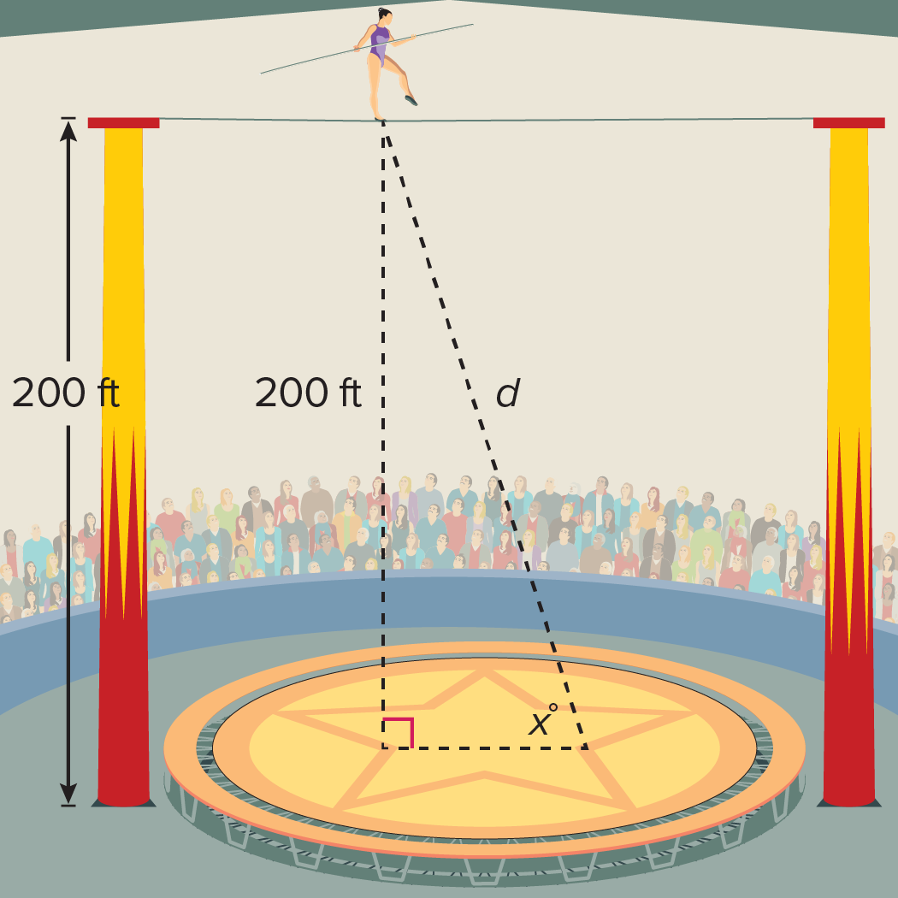
Example 5
16. ACROBATS Suppose an acrobat is walking from a high wire that is attached on its ends to two different towers at a height of 200 feet above the floor, as shown. The acrobat will eventually walk directly over the location of a camera in the floor. Let d be the distance in feet the acrobat is from the camera.
a. Write a function that relates the distance as a function of an angle x.
b. Graph the function.
c. Analyze the graph.

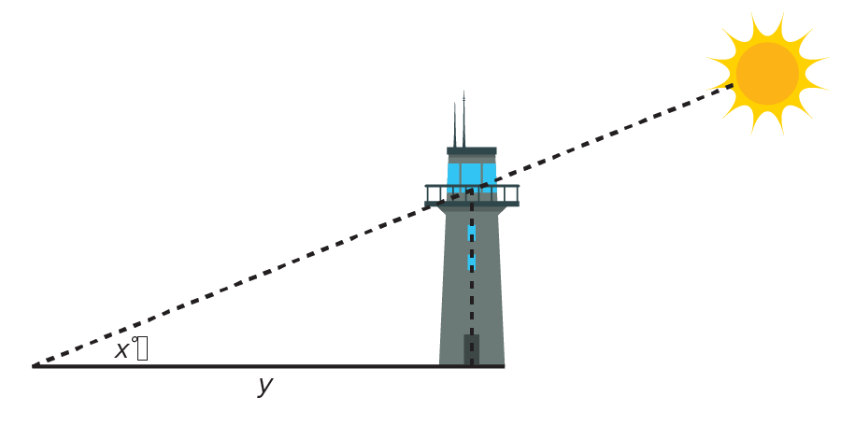
17. AIR TRAFFIC CONTROL Ground-based air traffic controllers direct aircraft on the ground and in controlled airspace from airport control towers. Let y be the length of the shadow of a 300-foot control tower as the Sun moves across the sky at angle x.
a. Write the function that relates the length of the shadow to the measure of the angle.
b. Graph the function.
c. Analyze the function.

Mixed Exercises
Find the period of each function. Then graph the function.
18. $y=2 tan\frac{1}{4}θ$ 19. $y=2 sec\frac{4}{5}θ$ 20. $y=5 csc 3θ$

21. $y=2 cot 6θ$ 22. y = sec 3$θ$ 23. y = 2 sec $θ$

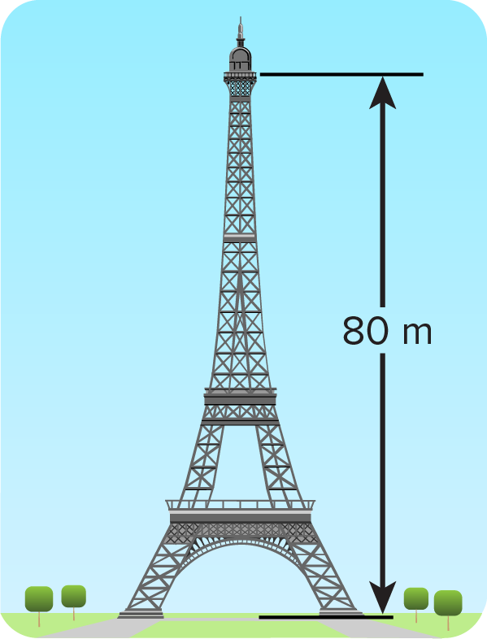
24. ATTRACTIONS A replica of the Eiffel Tower at an amusement park has an elevator that lifts riders vertically up the tower to an observation deck. Suppose Susana is waiting 20 meters away from the base of the tower while her sister Elva is on the elevator. Let d be the distance in meters from Susana to Elva as she is moving up the tower, and let x be the angle of elevation to Susana from Elva’s perspective. Write the function that relates the distance d as a function of an angle x.

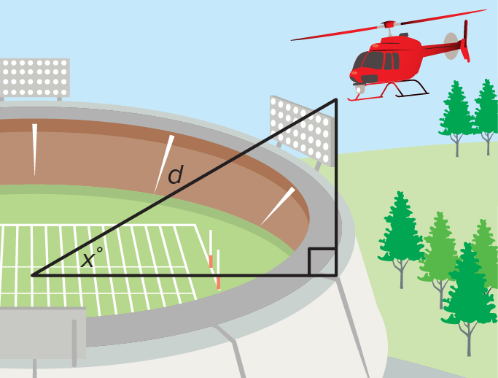
25. FOOTBALL As part of the pre-game celebration a military helicopter flies over the crowd of fans in the stadium. The helicopter will approach the stadium 2000 feet above field level and will eventually fly directly over the marching band located on the 50-yard line. Let d be the distance in feet the helicopter is from the 50-yard line, and let x be the angle of elevation to the helicopter from there. Write a function that relates the distance to the angle.

26. PERSEVERE Describe the domain and range of $y=a cos θ$ and $y=a sec θ$, where a is any positive real number.

27. FIND THE ERROR Tyler says the period of the function y = tan $\frac{1}{2}θ$ is 360°. Lacretia says it is 180°. Is either of them correct? Explain your reasoning.

28. CREATE Write a trigonometric function that has a domain of {$θ$|$θ$ ≠ 90° + 180n, n is an integer} and a range of {y|y ≤ ‒3 or y ≥ 3}.

29. WRITE How can you use the key features of a trigonometric function to sketch its graph?

