Translations of Trigonometric Graphs ⸱ Practice

Example 1
State the amplitude, period, and phase shift for each function. Then graph the function and state the domain and range.
1. y = sin ($θ$ + π) 2. y = tan $\left(θ – \frac{π}{2}\right)$ 3. y = sin ($θ$ + 90°)

4. y = cos ($θ$ – 45°) 5. y = tan $\left(θ+ \frac{π}{6}\right)$ 6. y = cos ($θ$ + 180°)

Example 2
State the amplitude, period, and phase shift for each function. Then graph the function and state the domain and range.
7. y = 3 cos ($θ$ – 45°) 8. y = 2 sin ($θ$ + 60°) 9. y = $\frac{1}{2}$ sin 3 $\left(θ – \frac{π}{3}\right)$

10. y = $\frac{1}{2}$ cos 3 $\left(θ – \frac{π}{2}\right)$ 11. y = 2 cos ($θ$ + 90°) 12. y = $\frac{1}{4}$ sin ($θ$ ‒ 30°)

Example 3
State the amplitude, period, phase shift, vertical shift, and midline equation of each function. Then graph the function and state the domain and range.
13. $y=\cos{θ}+3$ 14. $y=\tan{θ}-1$ 15. $y=\tan{θ}+\frac{1}{2}$

16. $y=2\cos{θ}-5$ 17. $y=2\sin{θ}-4$ 18. $y=\frac{1}{3}\sin{θ}+7$

Example 4
19. REASONING An office building has a large clock on its exterior. The center of the clock is located 79 feet above ground level, and the minute hand of the clock is 3 feet long. The function h(t) gives the height of the tip of the minute hand above ground level in feet at any time t minutes after 12:00 noon.
a. What is the amplitude of h(t)? What is the midline? What is the period?
b. Write the function h(t) as a cosine function.
c. Graph h(t).
d. On the interval t = 0 to t = 120, how many times does the function attain its minimum value? What does this represent in the real world-situation?

20. MODELING As the tide moves in and out of a bay, the depth of the water in the bay varies from a low of 15 meters to a high of 18 meters. It takes 6.2 hours for the tide to come in and 6.2 hours for the tide to go out. A marine biologist starts recording the depth of the water in the bay at high tide. She would like to develop a model that gives the depth of the water in the bay at any time t hours after she starts recording the data.
a. What are the maximum and minimum depths of the water in the bay?
b. Determine the amplitude and the midline of the function.
c. Choose a trigonometric function that can be used to represent the depth of the water in the bay at any time t hours after high tide when the marine biologist starts recording the data. Justify your choice. Then write a function to represent the situation.
d. Graph and analyze the function.
e. Use your graph to estimate the depth of the water 9 hours after high tide.

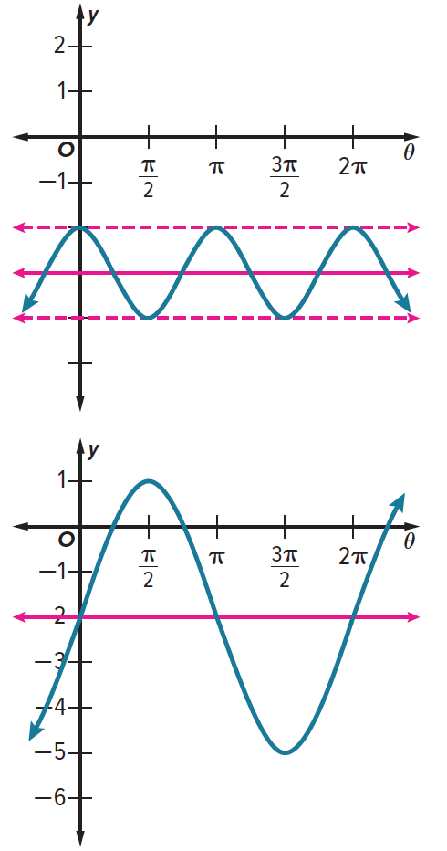
Example 5
21. Write a function for the cosine graph shown.
a. Find the vertical shift and amplitude.
b. Find the phase shift, if any.
c. Find the period.
d. Write the function.

22. Write a function for the sine graph shown.
a. Find the vertical shift and amplitude.
b. Find the phase shift.
c. Find the period.
d. Write the function.

Mixed Exercises
Write an equation for each translation.
23. y = sin x, translated 4 units to the right and 3 units up

24. y = cos x, translated 5 units to the left and 2 units down

25. y = tan x, translated π units to the right and 2.5 units up

State the amplitude, period, phase shift, and vertical shift for each function. Then graph
the function.
26. y = –3 + 2 sin 2 $\left(θ+\frac{π}{4}\right)$ 27. y = 3 cos 2($θ$ + 45°) + 1 28. y = –1 + 4 tan ($θ$ + π)

29. USE A MODEL What trigonometric function can best be used to represent the height of a cart on a Ferris wheel as a function of time? Explain.

30. ECOLOGY The population of an insect species in a stand of trees follows the growth cycle of a particular tree species. The insect population can be modeled by y = 40 + 30 sin 6t, where t is the number of years since November, 1920.
a. Evaluate the function in degrees to determine how often the insect population reaches its maximum level.
b. When did the population last reach its maximum?

31. POPULATION The population of predators and prey in a closed ecological system tends to vary periodically over time. In a certain system, the population of snakes P can be represented by
P = 100 + 20 sin $\left(\frac{π}{5}t\right)$, where t is the number of years since January 1, 2000. In that same system, the population of rats can be represented by R = 200 + 75 sin $\left(\frac{π}{5}t +\frac{π}{10}\right)$.
a. What is the maximum snake population? When is this population first reached?
b. What is the minimum rat population? When is this population first reached?

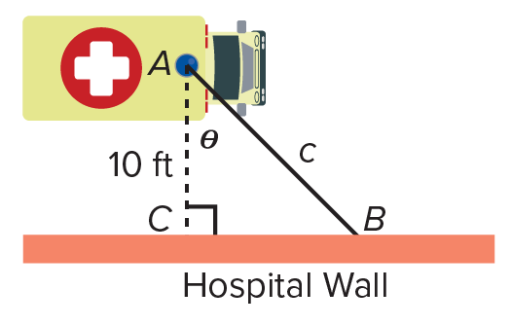
32. USE A MODEL An ambulance stops outside a hospital 10 feet from the outer wall. The rotating light at the top of the ambulance projects a beam of light $\overline{AB}$ on the wall. In the figure, c represents the length of the beam and $θ$ represents the measure of the angle in radians that the beam makes with the perpendicular segment to the wall. The light makes one complete rotation every second. What trigonometric function can best be used to represent the length c of the beam of light, in feet, as a function of time in x seconds? Explain.

Find the coordinates of a point that represents a maximum for each graph.
33. $y=-2\cos\left(x-\frac{π}{2}\right)$ 34. $y=4\sin\left(x+\frac{π}{3}\right)$

35. $y=3\tan\left(x+\frac{π}{2}\right)+2$ 36. $y=-3\sin\left(x-\frac{π}{4}\right)-4$

Compare each pair of graphs.
37. y = ‒cos 3$θ$ and y = sin 3($θ$ ‒ 90°)

38. y = 2 + 0.5 tan $θ$ and y = 2 + 0.5 tan ($θ$ + π)

39. $y=2\sin\left(θ-\frac{π}{6}\right)$ and $y=-2\sin\left(θ+\frac{5π}{6}\right)$

40. STRUCTURE Let f($θ$) = $2.7\cos{3\left(θ-π\right)+1}$. Write a sine function g($θ$) that has the same graph as f($θ$).

Identify the period of each function. Then write an equation for the graph using the given trigonometric function.
41. sine 42. cosine
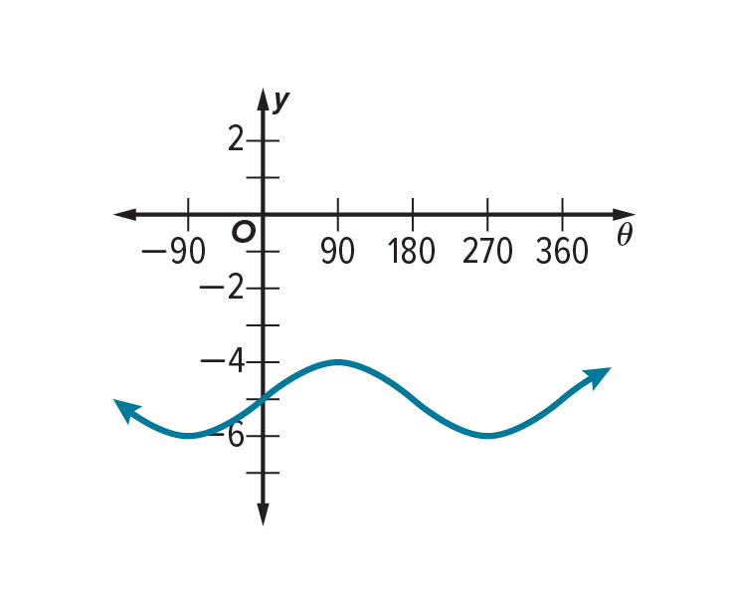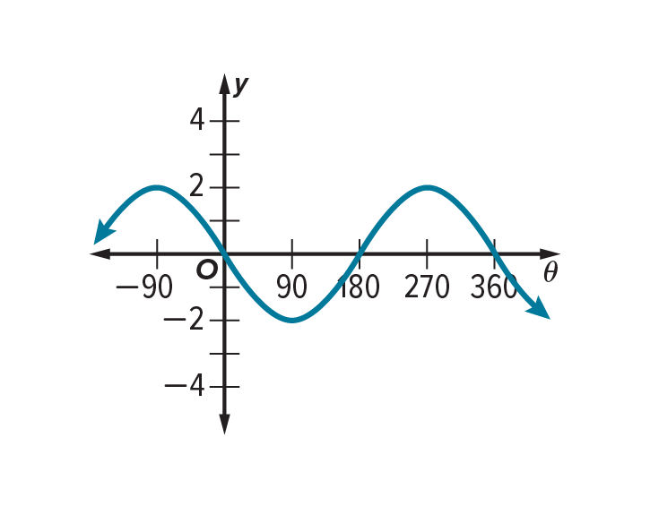
43. cosine 44. sine
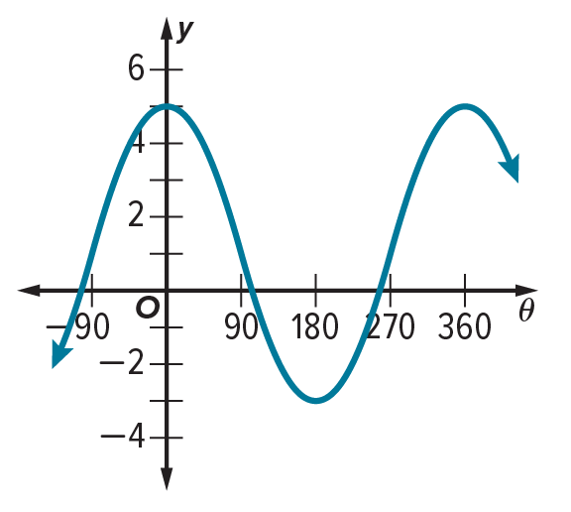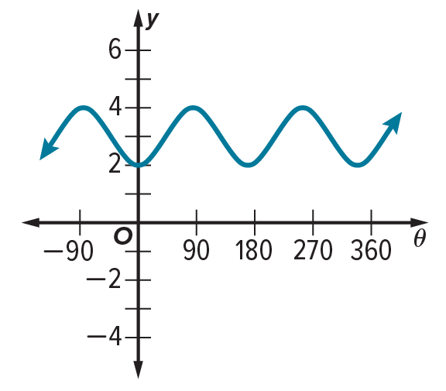

45. CREATE Write a cosine function h($θ$) with midline y = ‒2 and period π, that has no $θ$-intercepts.

46. ANALYZE If you are given the amplitude and period of a cosine function, is it sometimes, always, or never possible to find the maximum and minimum values of the function? Explain your reasoning.

47. PERSEVERE Describe how the graph of y = 3 sin 2$θ$ + 1 is different from y = sin $θ$.
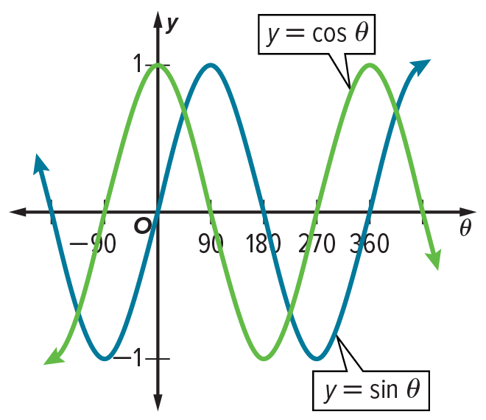
48. WRITE Describe two different phase shifts that will translate the sine curve onto the cosine curve shown at the right. Then write an equation for the new sine curve using each phase shift.

49. CREATE Write a periodic function that has an amplitude of 2 and midline at
y = ‒3. Then graph the function.

50. ARGUMENTS How many different sine graphs pass through the point (nπ, 0)? Justify your argument.

51. PERSEVERE Find a sine function equivalent to y = cos $θ$ – 3.

52. FIND THE ERROR Alex claimed that y = 4 sin $\frac{1}{4}θ$ and y = sin $θ$ are equivalent because$4⋅\frac{1}{4}=1$. Is Alex correct? Explain your reasoning.

