Inverse Trigonometric Functions ⸱ Practice

Example 1
Find each value. Write angle measures in degrees and radians.
1. ${Cos}^{-1}\left(\frac{\sqrt{3}}{2}\right)$ 2. ${Sin}^{-1}\left(-\frac{\sqrt{3}}{2}\right)$ 3. Arccos $\left(-\frac{1}{2}\right)$

4. Arctan $\sqrt{3}$ 5. Arccos $\left(-\frac{\sqrt{2}}{2}\right)$ 6. ${Tan}^{-1}\left(-1\right)$

7. ${Sin}^{-1}{\frac{\sqrt{2}}{2}}$ 8. ${Cos}^{-1}\left(-\frac{\sqrt{3}}{2}\right)$ 9. Arcsin 1

Example 2
USE TOOLS Find each value. Round to the nearest hundredth if necessary.
10. cos $\left[{Sin}^{-1}\left(-\frac{\sqrt{2}}{2}\right)\right]$ 11. tan $\left[Arcsin \left(-\frac{5}{7}\right)\right]$ 12. sin $\left({Tan}^{-1}{\frac{5}{12}}\right)$

13. Cos [Arcsin (–0.7)] 14. cos (Arctan 5) 15. sin $\left({Cos}^{-1}{0.3}\right)$

16. sin $\left({Cos}^{-1}{1}\right)$ 17. sin $\left({Sin}^{-1}{\frac{1}{2}}\right)$ 18. tan $\left(Arcsin \frac{\sqrt{3}}{2}\right)$

Example 3
USE TOOLS Find $θ$ in degrees. Round to the nearest hundredth if necessary.
19. Sin $θ$ = 0.8 20. Tan $θ$ = 4.5 21. Cos $θ$ = 0.5

22. Cos $θ$ = –0.95 23. Sin $θ$ = –0.1 24. Tan $θ$ = –1

25. Cos $θ$ = 0.52 26. Cos $θ$ = –0.2 27. Sin $θ$ = 0.35

28. Tan $θ$ = 8 29. Cos $θ$ = 0.25 30. Sin $θ$ = ‒0.57

Example 4
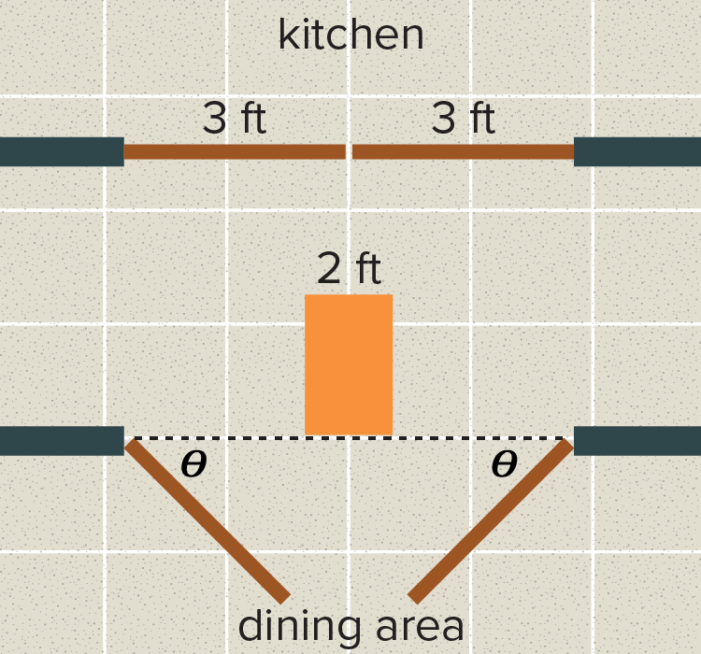
31. KITCHEN The exit from a restaurant kitchen has two pairs of swinging doors that meet in the middle of the doorway. Each door is three feet wide. A waiter needs to take a cart of plates into the dining area from the kitchen. The cart is two feet wide.
a. What is the minimum angle $θ$ through which the doors must each be opened to prevent the cart from hitting either door? Round to the nearest tenth.
b. What assumption did you make when solving for $θ$ in part a?

32. BIKING Compass directions are given as angles compared to North, South, East, or West. For example, northeast could be described as 45° east of north. Bong-Cha rides her bike two miles east and four miles south to get to her friend Marco’s house. If Bong-Cha could have traveled directly from her house to Marco’s, in what direction would she have traveled? Round to the nearest tenth.
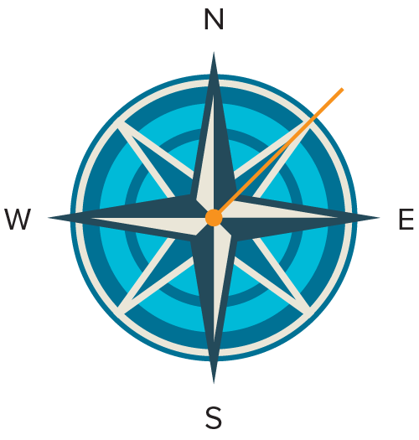
Mixed Exercises
Solve each equation for 0 ≤ $θ$ ≤ 2π.
33. csc $θ$ = 1 34. sec $θ$ = ‒1 35. sec $θ$ = 1

36. csc $θ$ = $\frac{1}{2}$ 37. cot $θ$ = 1 38. sec $θ$ = 2

39. SURVEYING In ancient times, it was known that a triangle with side lengths of 3, 4, and 5 units was a right triangle. Surveyors used ropes with knots at each unit of length to make sure that an angle was a right angle. Such a rope was placed on the ground so that one leg of the triangle had three knots and the other had four. This guaranteed that the triangle formed was a right triangle, meaning that the surveyor had formed a right angle. To the nearest degree, what are the angle measures of a triangle formed this way?

40. PERSEVERE Determine whether cos (Arccos x) = x for all values of x is true or false. If false, give a counterexample.

41. FIND THE ERROR Desiree and Oscar are solving cos $θ$ = 0.3 where 90° < $θ$ < 180°. Is either of them correct? Explain your reasoning.
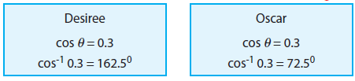
42. CREATE Write an equation with an Arcsine function and an equation with a Sine function that both involve the same angle measure.

43. WRITE Compare and contrast the relations y = tan^{‒1} x and y = Tan^{‒1} x. Include information about the domains and ranges.

44. ARGUMENTS Explain how Sin^{‒1} 8 and Cos^{‒1} 8 are undefined while Tan^{‒1} 8 is defined.

45. CREATE Write an inverse trigonometric function with domain {–2 ≤ $θ$ ≤ 2} and range {1 ≤ y ≤ π + 1}. Justify your answer and graph the function.

