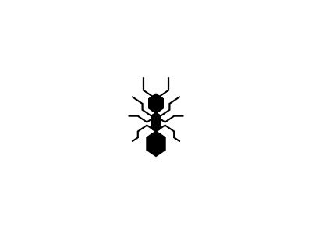

A



0

A

1



A



2

A

3



A



4

A

5



A



6

A

7



A



8

A

9



B



0

B

1



B



2

B

3



B



4

B

5



B



6

B

7



B



8

B

9



A



0

C

1



C



2

C

3



C



4

C

5



C



6

C

7



C



8

C

9

C



A



0

A

1



A



2

A

3



A



4

A

5



A



6

A

7



A



8

A

9



B



0

B

1



B



2

B

3



B



4

B

5



B



6

B

7



B



8

B

9



A



0

C

1



C



2

C

3



C



4

C

5



C



6

C

7



C



8

C

9

C



A



0

A

1



A



2

A

3



A



4

A

5



A



6

A

7



A



8

A

9



B



0

B

1



B



2

B

3



B



4

B

5



B



6

B

7



B



8

B

9



A



0

C

1



C



2

C

3



C



4

C

5



C



6

C

7



C



8

C

9

C



9

8

7

6

5

4

3

2

1

0

A

A

A

A

A

A

A

A

A

A

A





9

B

8

7

6

5

4

3

2

1

0

B

B

B

B

B

B

B

B

B



9

C

8

7

6

5

4

3

2

1

0

C

C

C

C

C

C

C

C

C





9

8

7

6

5

4

3

2

1

0

A

A

A

A

A

A

A

A

A

A

A





9

8

7

6

5

4

3

2

1

0

B

B

B

B

B

B

B

B

B

B





9

C

8

7

6

5

4

3

2

1

0

C

C

C

C

C

C

C

C

C





9

8

7

6

5

4

3

2

1

0

A

A

A

A

A

A

A

A

A

A

A





9

8

7

6

5

4

3

2

1

0

B

B

B

B

B

B

B

B

B

B





9

8

7

6

5

4

3

2

1

0

C

C

C

C

C

C

C

C

C

C