Course: | Full Stack Web Development
Course Code: | 23CM4121
Experiment No.: | 4
Student Name: | B.Venkata sai laxmi
Roll No.: | A24126552074
Date: | 05-10-2026
1. TITLE :
Design a Dynamic Budget Tracker Interface using HTML5 and CSS3.
2. AIM :
To design the interface of a budget tracker using HTML5 form elements and CSS3 styling, with a balance display, a transaction form and an area for the transaction history.
3. OBJECTIVE :
The objectives of this experiment are:
- To structure a web application using semantic and container elements.
- To create a form with text and number inputs and a submit button.
- To use built-in form validation (required and type="number").
- To style the page using an external CSS file with the box model, Flexbox, shadows and rounded corners.
- To add a hover effect to a button using the :hover pseudo-class.
- To prepare element ids and CSS classes that JavaScript can use to update the page dynamically.
4. THEORY :
A budget tracker records income and expenses and shows the remaining balance. Its interface is built with HTML for structure and CSS for presentation.
Form elements: The <form> element collects user input. <input type="text"> accepts text and <input type="number"> accepts only numeric values, including negative numbers. The required attribute stops submission when a field is empty, and placeholder shows a hint inside the field.
id and class: An id uniquely identifies one element (for example, total-balance) and lets JavaScript find and change it. A class (for example, transaction-item) lets the same style apply to many elements.
Box model: Every element is a box with content, padding, border and margin. These control the spacing and size of the card, inputs and buttons.
Flexbox: display: flex lays out items in a row or column. Here the body uses it to centre the card, and the form uses flex-direction: column with gap to stack the fields.
border-radius and box-shadow: border-radius rounds the corners of an element and box-shadow adds a soft shadow, giving a card-like appearance.
Pseudo-class :hover: Applies a style while the mouse pointer is over an element, used here to change the button colour.
Responsive width: Using width: 100% together with max-width: 400px lets the card shrink on small screens while not growing beyond 400px.
Flow of a Styled Web Page: Browser → Requests HTML → Server serves HTML → Browser requests linked CSS and JavaScript → Browser applies styles and renders → User interacts.
5. ALGORITHM / PROCESS :
- Start the HTML document with <!DOCTYPE html> and <html lang="en">.
- In <head>, add the charset and viewport meta tags, the title, and link style.css.
- Create a <div class="app-container"> to hold the whole tracker.
- Inside it, add a <header> with the heading and a balance card showing the Total Balance with the id total-balance.
- Create the form (id="tracker-form") with a required text input for the description, a required number input for the amount, and a submit button.
- Add the "Transaction History" heading and an empty <ul id="transaction-list">.
- Link script.js at the end of <body> and close the tags.
- Create style.css and style the body (font, background colour, flex centring, padding).
- Style the .app-container card (background, padding, rounded corners, shadow, maximum width).
- Style the .balance-card, the form layout, the inputs and the button with its :hover effect.
- Remove the list bullets and style the .transaction-item, .income, .expense and .delete-btn classes for the history list.
- Save the files, open index.html in a browser and verify the layout.
- Test the form validation and the hover effect.

6. PROGRAM :
index.html
<!DOCTYPE html>
<html lang="en">
<head>
<meta charset="UTF-8">
<meta name="viewport" content="width=device-width, initial-scale=1.0">
<title>Dynamic Budget Tracker</title>
<link rel="stylesheet" href="style.css">
</head>
<body>

<div class="app-container">
<header>
<h2>Dynamic Budget Tracker</h2>
<!-- This value updates dynamically using JavaScript -->
<div class="balance-card">
<span>Total Balance</span>
<h1 id="total-balance">₹0.00</h1>
</div>
</header>

<!-- Form for capturing dynamic user input -->
<form id="tracker-form">
<input type="text" id="reason-input" placeholder="What did you buy/earn?" required autocomplete="off">
<input type="number" id="amount-input" placeholder="Amount (e.g., 500, -200)" required>
<button type="submit">Add Transaction</button>
</form>

<h3>Transaction History</h3>
<!-- This list starts empty and is filled dynamically by JavaScript -->
<ul id="transaction-list"></ul>
</div>

<script src="script.js"></script>
</body>
</html>

style.css
body {
font-family: Arial, sans-serif;
background-color: #f7f9fa;
display: flex;
justify-content: center;
padding: 50px 20px;
margin: 0;
}

.app-container {
background: #ffffff;
padding: 25px;
border-radius: 10px;
box-shadow: 0 4px 15px rgba(0,0,0,0.05);
width: 100%;
max-width: 400px;
}

.balance-card {
background: #2c3e50;
color: white;
padding: 20px;
border-radius: 8px;
text-align: center;
margin: 15px 0;
}

form {
display: flex;
flex-direction: column;
gap: 10px;
margin-bottom: 25px;
}

input {
padding: 12px;
border: 1px solid #ddd;
border-radius: 5px;
font-size: 15px;
}

button {
padding: 12px;
background: #3498db;
color: white;
border: none;
border-radius: 5px;
font-size: 16px;
cursor: pointer;
}

button:hover { background: #2980b9; }

ul { list-style: none; padding: 0; margin: 0; }

/* Dynamic List Item Styles */
.transaction-item {
display: flex;
justify-content: space-between;
align-items: center;
padding: 12px;
background: #fdfdfd;
margin-bottom: 8px;
border-radius: 5px;
border-right: 5px solid #ccc;
box-shadow: 0 2px 5px rgba(0,0,0,0.02);
}

/* Appended dynamically if amount is positive */
.transaction-item.income { border-right-color: #2ecc71; }

/* Appended dynamically if amount is negative */
.transaction-item.expense { border-right-color: #e74c3c; }

.delete-btn {
background: none;
color: #e74c3c;
border: none;
padding: 0 5px;
font-size: 18px;
cursor: pointer;
}

7. CODE EXPLANATION :
Code | Explanation
<meta name="viewport"> | Sets the page width to the device width on mobile screens.
<link rel="stylesheet" href="style.css"> | Links the external CSS file to the HTML page.
<div class="app-container"> | Main card that holds the whole tracker.
<header>, <h2> | Header with the heading "Dynamic Budget Tracker".
<div class="balance-card"> | Box that displays the total balance.
<h1 id="total-balance"> | Shows the balance (initially ₹0.00); the id lets JavaScript update the value.
<form id="tracker-form"> | Form that collects the transaction details.
<input type="text" required> | Text field for the transaction description; required and autocomplete="off".
<input type="number" required> | Number field for the amount (positive for income, negative for expense); accepts only numbers.
<button type="submit"> | Button that submits the form ("Add Transaction").
<ul id="transaction-list"> | Empty list reserved for the transaction history.
<script src="script.js"> | Links the external JavaScript file.
body { display: flex; justify-content: center } | Centres the card horizontally on the page.
.app-container { max-width: 400px; width: 100% } | Card is at most 400px wide and shrinks on small screens.
border-radius, box-shadow | Rounded corners and a soft shadow for the card.
.balance-card | Dark background, white text, padding and centred text for the balance box.
form { display: flex; flex-direction: column; gap: 10px } | Stacks the inputs and button vertically with spacing.
input { padding; border; border-radius } | Styles the text and number fields.
button { background; color; cursor: pointer } | Styles the submit button with a pointer cursor.
button:hover | Changes the button colour when the mouse is over it.
ul { list-style: none } | Removes bullets and default spacing from the list.
.transaction-item, .income, .expense, .delete-btn | Styles for the list items and delete button that are added to the list; the income and expense classes set the colour of the item border.
8. TESTCASES AND EXECUTION DATA :
Test Case No. | Test Case Description | Input Data | Expected Output | Actual Output | Status
1 | Verify webpage loads successfully | Open HTML file in browser | Tracker card displays with all elements | Tracker card displays with all elements | PASS
2 | Verify CSS is linked | Open page with style.css | Centred white card on light background | Centred white card on light background | PASS
3 | Verify initial balance | View balance card | Total Balance shows ₹0.00 | Total Balance shows ₹0.00 | PASS
4 | Verify input fields | View form | Description and amount fields with placeholders | Description and amount fields with placeholders | PASS
5 | Verify empty form validation | Click Add Transaction with empty fields | Form prevents submission | Form shows validation error | PASS
6 | Verify amount field type | Type letters in amount field | Field does not accept letters | Field does not accept letters | PASS
7 | Verify button hover | Move mouse over button | Button colour changes | Button colour changes | PASS
8 | Verify transaction history | View history section | Heading shown with an empty list | Heading shown with an empty list | PASS
9 | Verify responsiveness | Resize browser window | Card shrinks to fit the screen | Card shrinks to fit the screen | PASS

9. OUTPUT :
Budget tracker interface:
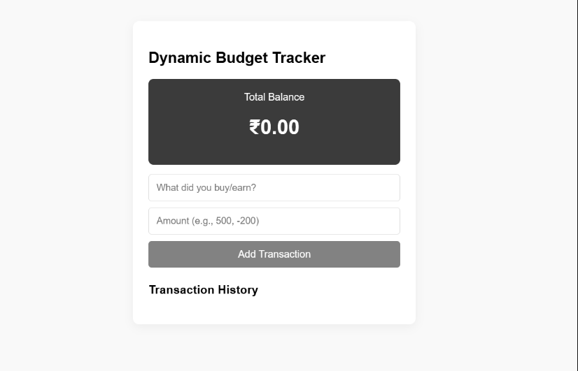
10. RESULT :
The interface of the Dynamic Budget Tracker was successfully designed using HTML5 and an external CSS3 stylesheet. The page displayed a centred card with the heading, a balance box showing ₹0.00, a form with description and amount fields and an Add Transaction button, and a Transaction History section. The form fields were validated using the required attribute and the number input type, and the button changed colour on hover. All test cases passed, confirming that HTML5 and CSS3 can be used to build a clean and responsive interface for a budget tracker.

