Course: Full Stack Web Development
Course Code: 23CM4121
Experiment No.: 2
Student Name: B.Venkata sai laxmi
Roll No.: A24126552074
Date: 05-10-2026

1. TITLE :
Design a College Information Portal using HTML Elements, Tables, Forms and HTML5 Features.
2. AIM :
To develop a multi-part static college information webpage using HTML text formatting, lists, hyperlinks, tables, images, forms and HTML5 multimedia and input elements.
3. OBJECTIVE :
The objectives of this experiment are:
- To display college information using headings, paragraphs and text-formatting tags such as <b>, <i>, <u> and <strong>.
- To use subscript (<sub>) and superscript (<sup>) tags for chemical and mathematical expressions.
- To create ordered and unordered lists and add hyperlinks to external websites.
- To present student details in a bordered HTML table and insert images with the <img> tag.
- To build a student registration form using text, email, password, radio, checkbox, select and textarea controls with submit and reset buttons.
- To demonstrate HTML5 semantic elements (<header>, <nav>, <section>, <article>, <footer>), audio, video and new input types (date, number, color, range).
4. THEORY :
Text Formatting: HTML provides heading tags <h1>–<h6> and the paragraph tag <p> for structuring text. Tags such as <b>, <strong>, <i> and <u> change the appearance or emphasis of text, while <sub> and <sup> lower or raise text for expressions like H₂O and x².
Lists: An ordered list (<ol>) numbers its items, whereas an unordered list (<ul>) marks them with bullets. Each item is written using <li>.
Hyperlinks: The anchor tag <a> with the href attribute links to other pages, external websites or sections inside the same page using #id.
Tables and Images: A <table> organises data into rows (<tr>), header cells (<th>) and data cells (<td>), with attributes like border, cellpadding and cellspacing. The <img> tag embeds pictures using src, width, height and alt attributes.
Forms: A <form> collects user input through <input> (text, email, password, radio, checkbox), <select>, <textarea> and <button> elements. <fieldset> and <legend> group related controls, and <label> associates text with a control for accessibility. Attributes such as required and placeholder support validation and hints.
HTML5 Semantic Elements: Elements such as <header>, <nav>, <section>, <article> and <footer> describe the meaning of the content, improving accessibility, SEO and readability.
HTML5 Multimedia and Input Types: The <audio> and <video> elements play media natively with the controls attribute, without plug-ins. HTML5 also adds input types such as email, date, number, color and range, which give built-in validation and user-friendly widgets.
Flow of a Static HTML Page: Browser → Requests HTML → Server Serves File → Browser Renders → User Interacts.
5. ALGORITHM / PROCESS :
- Start the document with <!DOCTYPE html> and the <html lang="en"> tag.
- Create the <head> with <meta charset="UTF-8">, the viewport meta tag and the <title>.
- Part A: Add the <h1> and <h2> headings and a paragraph about the college using <i>, <b>, <strong> and <u>.
- Add a subscript and superscript section (H₂O, E = mc², x² + y² = z², CO₂).
- Add an ordered list of departments and an unordered list of college facilities.
- Add hyperlinks to the ANITS official website and Google using <a href>, followed by <hr>.
- Part B: Create a table with border="1" containing S.NO, Roll Number, Name and Email for five students.
- Insert two images (college logo and library) using <img> with height, width and alt attributes.
- Part C: Create a <form> with a <fieldset> and <legend> titled "Student Registration form".
- Add text, email and password inputs with labels and placeholders.
- Add radio buttons for gender (with required), checkboxes for hobbies, a <select> for branch and a <textarea> for comments.
- Add Submit and Reset buttons and close the form.
- Part D: Add a <header> with the heading and a <nav> with internal anchor links.
- Add <section> and <article> elements describing ANITS and the student's education.
- Embed an <audio> and a <video> player using the controls attribute.
- Add a form using the HTML5 input types email, date, number, color and range, with Submit and Reset buttons.
- Add a <footer> with copyright text and close </body> and </html>.
- Save the file with the .html extension and open it in a web browser.
- Verify every part renders correctly, test the links, the form controls and the media players.

6. PROGRAM :
<!DOCTYPE html>
<html lang="en">
<head>
<meta charset="UTF-8">
<meta name="viewport" content="width=device-width, initial-scale=1.0">
<title>College information portal</title>
</head>
<body>
<!-- Task -1:Part A-->
<!--Displaying college information using headings and paragraphs-->
<h1>College Information Portal</h1>
<h2>Anil Neerukonda Institute Of Technology and Sciences</h2>
<p>
<i><b>ANITS (Anil Neerukonda Institute of Technology and Sciences)</b> is a premier autonomous engineering college
located in <strong>visakhapatnam,AndhraPradesh</strong>, established in 2001 by the <u>Anil Neerukonda Educational Society.</u>
It offers top undergraduate and postgraduate programs with NAAC A+ accreditation.</i></p>
<br>
<p>
<!--subscript ans superscript-->
<u><h3>Subscript & Superscript</h3></u>
• Water: H<sub>2</sub>O
<br>
• E = mc<sup>2</sup>
<br>
• Mathematical: x<sup>2</sup> + y<sup>2</sup> = z<sup>2</sup>
<br>
• Carbon Dioxide: CO<sub>2</sub>
</p>
<!--ordered & unordered list-->
<u><h3>Ordered &Unordered List</h3></u>
<p><b>Departments at ANITS</b></p>
<ol>
<li>Computer Science & Engineering(CSE)</li>
<li>Electronics & Communication (ECE)</li>
<li>Information Technology(IT)</li>
<li>Mechanical Engineering(Mech)</li>
<li>Chemical Engineering(chem)</li>
</ol>
<br>
<b>Facilites At Anits</b>
<ul>
<li><b>Spacious Campus :</b> having with modern infrastructure</li>
<li> <b>Digital Library :</b> books and computers</li>
<li> <b>Smart Classrooms :</b> IoT-enabled digital learning</li>
<li> <b>Computer Labs : </b>having in individual departments</li>
<li> <b>Hostel Facilities :</b> 2000+ capacity for boys and girls</li>
<li> <b>Hospital :</b> 24/7 on-campus health services</li>
<li><b>Canteen :</b> provides all types of food</li>
</ul>
<!--Adding hyperlinks-->
<h3><u>Adding Hyperlinks</u></h3>
<b>Anits Official Website</b>
<a href="https://anits.org/">Anits college</a>
<br>
<b>Google link</b>
<br>
<a href = "https://www.google.com/">Google</a>
<hr>
<!--PART-B-->
<h3>PART - B</h3>
<h4><u>TABLES & IMAGES</u></h4>
<!--Student details in the table-->
<table border="1" cellpadding="10" cellspacing="0">
<thead>
<tr>
<th>S.NO</th>
<th>Roll Number</th>
<th>Name</th>
<th>Email</th>
</tr>
</thead>
<tr>
<td>1</td>
<td>A24126552071</td>
<td>pranathi</td>
<td>pranathi@gmail.com</td>
</tr>
<tr>
<td>2</td>
<td>A24126552074</td>
<td>Sai laxmi</td>
<td>sai@gmail.com</td>
</tr>
<tr>
<td>3</td>
<td>A24126552087</td>
<td>Rama</td>
<td>rama@gmail.com</td>
</tr>
<tr>
<td>4</td>
<td>A24126552099</td>
<td>Samhavya</td>
<td>samhavya@gmail.com</td>
</tr>
<tr>
<td>5</td>
<td>A24126552125</td>
<td>Vanisree</td>
<td>vanisree@gmail.com</td>
</tr>
</table>
<br>
<b>Anits</b>
<br>
<img src="Anits.png" height = "100" width="300" alt = "Anits">
<br>
<img src="library.png" height = "100" width = "300" alt = "college library">
<hr>
<!--PART C-->
<h3>PART - C</h3>
<h4><u>Student Registration Form</u></h4>
<form action="#" method="post">
<fieldset>
<legend><b>Student Registration form</b></legend>
<p>
<label for ="Name">Fullname:</label>
<input type="text" id = "fullname" name = "fullname" placeholder="Enter the name">
</p>
<p><label for = "Email">Enter the Email:</label>
<input type = "email" placeholder = "sai@gmail.com">
</p>
<p>
<label for="password">Password :</label>
<input type ="password" id = "password" name ="password" placeholder ="enter the password">
</p>
<h3>Gender </h3>
<input type="radio" id="male" name="gender" value="Male" required>
<label for="male">Male</label><br>
<input type="radio" id="female" name="gender" value="Female">
<label for="female">Female</label><br>
<input type="radio" id="other" name="gender" value="Other">
<label for="other">Other</label><br>
<input type="radio" id="prefer-not" name="gender" value="Prefer not to say">
<label for="prefer-not">Prefer not to say</label>
<br>
<h3> Hobbies</h3>
<input type="checkbox" id="reading" name="hobbies[]" value="Reading">
<label for="reading"> Reading</label><br>
<input type="checkbox" id = "listening to music" name = "hobbies" value = "listening to music">
<label for = "listening to music">listening to music</label>
<br>
<input type="checkbox" id = "coding" name = "hobbies" value = "coding">
<label for = "coding">coding</label>
<br>
<input type="checkbox" id = "travelling" name = "hobbies" value = "travelling">
<label for = "travelling">travelling</label>
<br>
<label for="branch">select your branch :</label>
<select id="branch" name="branch" required>
<option value=""> Select Your Branch </option>
<option value="CSE">Computer Science & Engineering (CSE)</option>
<option value = "CSD">computerscience(DS)</option>
<option value ="CSM">Computer Science(AI & ML)</option>
<option value = "mech">mechanical Engineering</option>
<option value = "ECE">Electronics and communication engineering</option>
</select>
<br>
<label for = "comment">enter any comments</label>
<textarea id = "comments" name = "comments" rows = "5" cols="50" placeholder = "enter the comments" >
</textarea>
<br>
<!--submit & reset buttons-->
<button type = "submit">submit</button>
<br>
<button type = "Reset">Reset</button>
<br>
</fieldset>
</form>
<!--PART-D-->
<h3>PART-D </h3>
<header>
<h1>HTML5 Features Demo</h1>
</header>
<nav>
<a href="#semantic">Semantic Elements</a> &nbsp;|&nbsp;
<a href="#audio">Audio</a> &nbsp;|&nbsp;
<a href="#video">Video</a> &nbsp;|&nbsp;
<a href="#inputs">HTML5 Input Types</a>
<hr>
</nav>
<section id="semantic">
<h3>Anits:</h3>
<p>ANITS (Anil Neerukonda Institute of Technology and Sciences) is an autonomous private engineering college
located in Sangivalasa, Bheemunipatnam Mandal, Andhra Pradesh.
It was established in 2001 by the Anil Neerukonda Educational Society, is affiliated with Andhra University,
and is approved by AICTE.</p>
<article>
<h3>&lt;article</h3>
<p>Represents self-contained content like blog posts, news articles, or forum posts.</p>
</article>
</section>
<section>
<h3>Education :</h3>
<p>I am sailaxmi present pursing B.Tech 3rd in computer Science and Engineering
in the department of Artificial Intelligence and Machine Learning.My Journey started in technical field with C
later on i have improved my skills by learning java,python,DBMS etc</p>
</section>
<section id="audio">
<h3>Audio</h3>
<audio controls>
<source src="https://www.soundhelix.com/examples/mp3/SoundHelix-Song-1.mp3" type="audio/mpeg">
</audio>
</section>
<section id = "video">
<video controls width="560">
<source src="https://www.w3schools.com/html/mov_bbb.mp4" type="video/mp4">
</video>
<br>
</section>
<section id = "HTML inputs">
<form action="#">
<label for="demo-email">Email:</label><br>
<input type="email" id="demo-email" placeholder="your@email.com"><br><br>
<label for="demo-date">Date:</label><br>
<input type="date" id="demo-date"><br><br>
<label for="demo-number">Number (Age):</label><br>
<input type="number" id="demo-number" min="17" max="35"><br><br>
<label for="demo-color">Color:</label><br>
<input type="color" id="demo-color"><br><br>
<label for="demo-range">Range:</label><br>
<input type="range" id="demo-range" min="0" max="100"><br><br>
<button type="submit">Submit</button>
<button type="reset">Reset</button>
</form>
</section>
<footer>
<p>© 2026 <b>ANITS</b> - Anil Neerukonda Institute of Technology and Sciences</p>
</footer>
</body>
</html>

7. CODE EXPLANATION :
Code | Explanation
<!DOCTYPE html> | Declares the document type and HTML version.
<html lang="en"> | Root element with the language set to English.
<meta charset> / <meta viewport> | Sets the character encoding and makes the page scale on all screen sizes.
<title> | Sets the title shown on the browser tab.
<h1>, <h2>, <h3>, <h4> | Heading tags that create the page hierarchy.
<p>, <br>, <hr> | Paragraph, line break and horizontal rule.
<b>, <strong>, <i>, <u> | Bold, strong emphasis, italic and underlined text.
<sub>, <sup> | Subscript and superscript text (H₂O, mc²).
<ol>, <ul>, <li> | Ordered list, unordered list and list items.
<a href> | Creates hyperlinks to external sites and to page sections (#id).
<table>, <thead>, <tr>, <th>, <td> | Builds the student details table with header and data cells.
border, cellpadding, cellspacing | Table attributes controlling border, inner padding and cell gap.
<img src width height alt> | Inserts an image with size and alternative text.
<form action method> | Collects user input; action="#" and method="post".
<fieldset>, <legend> | Groups related form controls and gives the group a caption.
<label for> | Associates text with a form control for accessibility.
<input type="text | email | password"> | Single-line text, email and masked password fields.
<input type="radio"> | Select exactly one option (gender); required makes it mandatory.
<input type="checkbox"> | Select multiple options (hobbies).
<select>, <option> | Dropdown menu to choose a branch.
<textarea rows cols> | Multi-line text area for comments.
<button type="submit | reset"> | Submits the form or clears all its entries.
<header>, <nav>, <section>, <article>, <footer> | HTML5 semantic elements that structure the page.
<audio controls>, <video controls> | Native media players with play, pause and volume controls.
<source src type> | Specifies the media file and its format.
input type date, number, color, range | HTML5 input types: date picker, numeric field (min 17, max 35), colour picker and slider.
placeholder, required, id, name | Hint text, mandatory field, unique identifier and form data name.

8. TESTCASES AND EXECUTION DATA:
Test Case No. | Test Case Description | Input Data | Expected Output | Actual Output | Status
1 | Verify webpage loads successfully | Open HTML file in browser | Page displays all four parts | Page loads with all parts | PASS
2 | Verify text formatting | View Part A heading and paragraph | Bold, italic and underlined text appear | Formatting displayed correctly | PASS
3 | Verify subscript and superscript | View H2O, mc2, x2+y2=z2, CO2 | Digits lowered / raised correctly | Rendered correctly | PASS
4 | Verify lists | View department and facility lists | Numbered list and bulleted list display | Both lists displayed | PASS
5 | Verify hyperlinks | Click "Anits college" and "Google" | Opens the respective website | Links open correctly | PASS
6 | Verify student table | View Part B table | Table with 5 rows and 4 columns with borders | Table displayed correctly | PASS
7 | Verify images | View logo and library images | Both images display at 300 x 100 | Images displayed | PASS
8 | Verify registration form controls | Select gender, hobbies and branch | Radio, checkbox and dropdown work | All controls work | PASS
9 | Verify required validation | Submit without gender / branch | Form prevents submission | Validation message shown | PASS
10 | Verify reset button | Enter data and click Reset | All fields clear | All fields cleared | PASS
11 | Verify navigation links | Click "Audio" link in nav | Scrolls to audio section | Scrolls to audio section | PASS
12 | Verify audio and video | Click play on both players | Audio and video play | Both play correctly | PASS
13 | Verify HTML5 input types | Use date, number, colour, range | Date picker, number box, colour picker, slider display | All inputs displayed | PASS
14 | Verify footer | View footer | Copyright text displays | Copyright text displays | PASS

9. OUTPUT:
a) Part A – Text formatting, lists and hyperlinks:
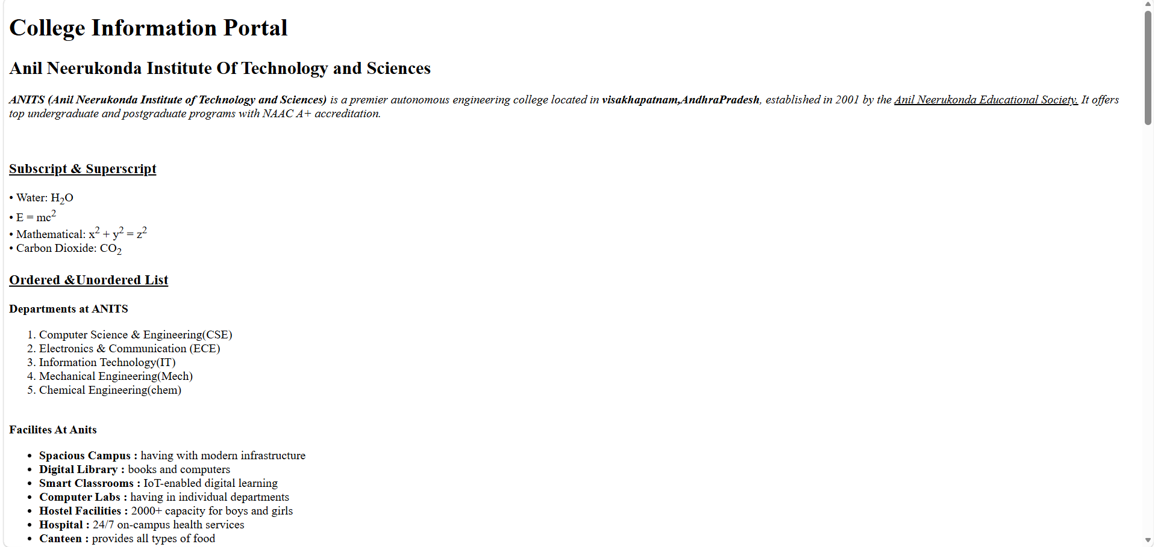
b) Part A (continued) and Part B – Hyperlinks, table and images:
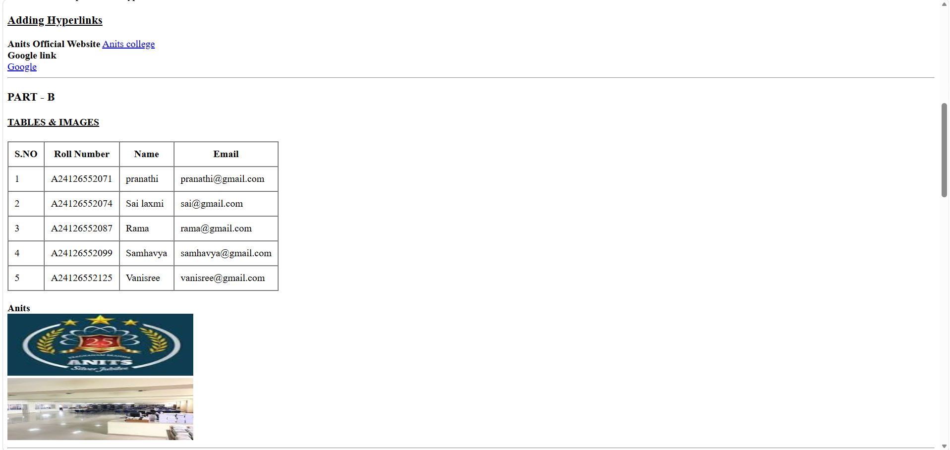
c) Part C – Student registration form:
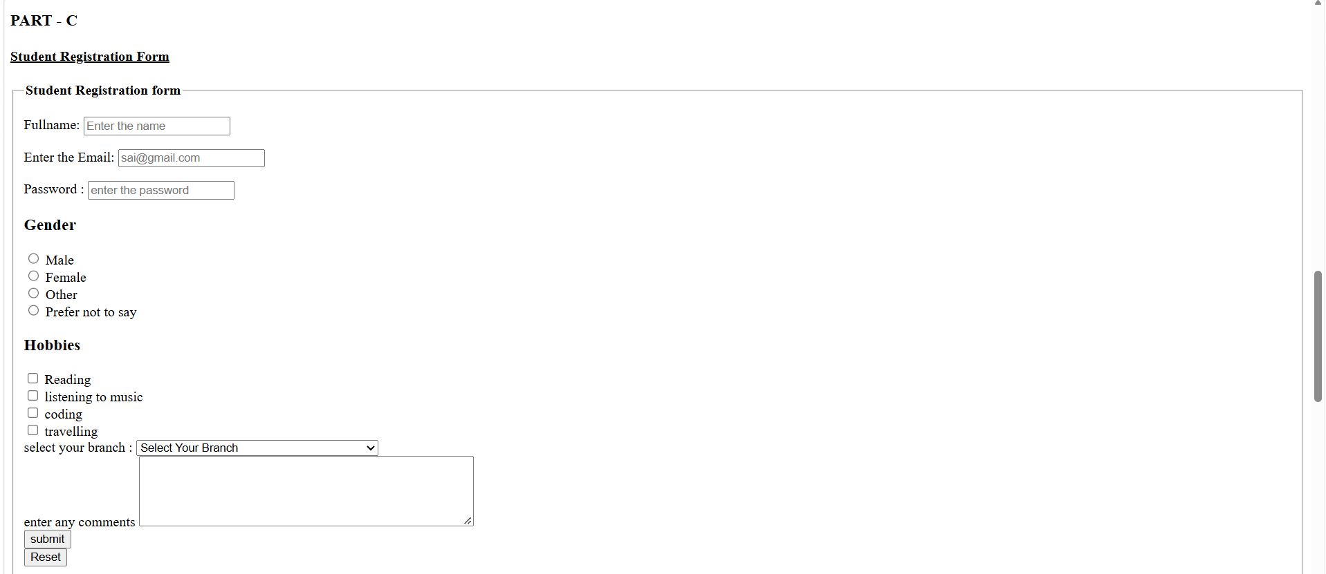
d) Part D – HTML5 semantic elements and audio:
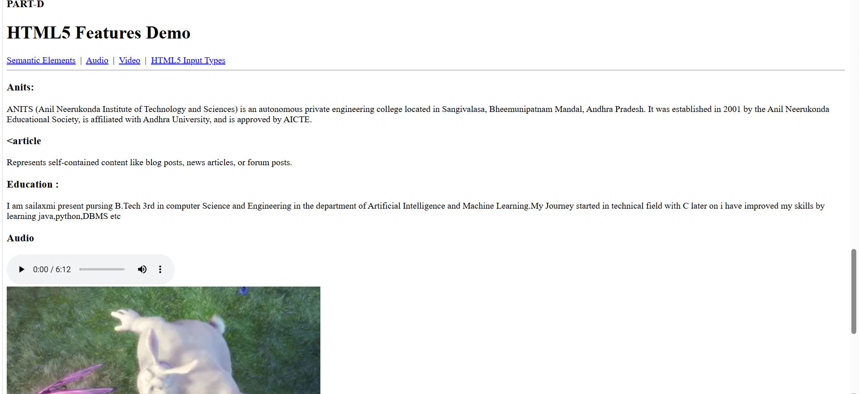
e) Part D (continued) – Video, HTML5 input types and footer:
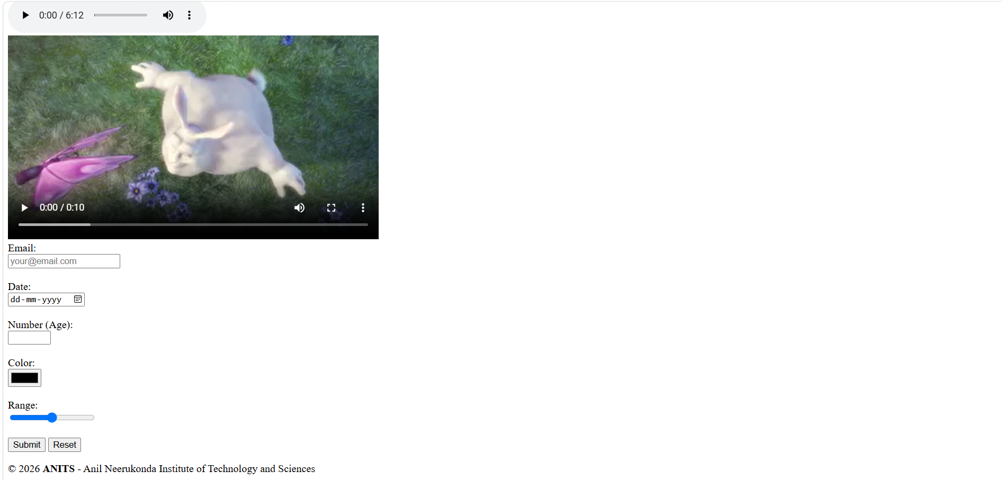
10. RESULT:
The college information portal was successfully designed using HTML components. Part A displayed the college details with text formatting, subscript/superscript, ordered and unordered lists and hyperlinks. Part B presented the student details in a bordered table along with images. Part C provided a student registration form with text, email, password, radio, checkbox, dropdown and textarea controls, and the required fields were validated. Part D demonstrated HTML5 semantic elements, internal navigation links, audio and video players and the new input types (email, date, number, color, range). All test cases passed, confirming that a well-structured, multi-featured static webpage can be created using HTML alone.

