Course: Full Stack Web Development
Course Code: 23CM4121
Experiment No.: 3
Student Name: B.Venkata sai laxmi
Roll No.: A24126552074
Date: 05-10-2026

1. TITLE :
Design a Styled Webpage using CSS.
2. AIM :
To style a webpage using internal CSS, applying the box model, gradients, Flexbox, CSS Grid and hover effects to build a responsive-looking card layout.
3. OBJECTIVE :
The objectives of this experiment are:
- To apply internal CSS using the <style> tag and element, class and descendant selectors.
- To reset default browser spacing using the universal selector and box-sizing: border-box.
- To use linear-gradient backgrounds, border-radius, box-shadow and text-shadow for visual effects.
- To create a horizontal navigation bar using Flexbox (display: flex, justify-content, gap).
- To arrange content cards in a three-column layout using CSS Grid (grid-template-columns).
- To add interactivity with :hover pseudo-classes on links, cards and buttons.
4. THEORY :
CSS (Cascading Style Sheets): CSS is the language used to control the presentation of HTML elements, including colours, fonts, spacing and layout. Styles can be applied inline, internally with the <style> tag, or externally through a linked .css file. This experiment uses internal CSS.
Selectors: Selectors choose which elements a rule applies to. Element selectors (header, nav), class selectors (.card, .btn), the universal selector (*), descendant selectors (nav ul li a) and pseudo-classes (:hover) are all used in this page.
Box Model: Every element is a box made of content, padding, border and margin. Setting box-sizing: border-box includes padding and border inside the declared width, which makes layouts easier to control.
Backgrounds and Effects: linear-gradient() creates a smooth transition between colours. border-radius rounds corners, box-shadow adds depth to boxes, and text-shadow adds depth to text.
Flexbox: display: flex arranges child items in a row. justify-content aligns them along the main axis (here, center) and gap sets the space between them. It is ideal for navigation bars.
CSS Grid: display: grid creates two-dimensional layouts. grid-template-columns: repeat(3, 1fr) divides the container into three equal columns, with gap defining the space between cards.
Pseudo-classes and Interaction: :hover applies a style when the pointer is over an element. Here it highlights navigation links, lifts cards using transform: translateY(-5px) and changes the button colour.
Flow of a Styled Page: Browser → Requests HTML → Parses HTML and CSS → Builds DOM and CSSOM → Renders styled page → User interacts.
5. ALGORITHM / PROCESS :
- Start the document with <!DOCTYPE html>, the <html> tag, and a <head> containing the <title>.
- Open a <style> tag inside <head> for internal CSS.
- Reset margin and padding for all elements using * and set box-sizing: border-box.
- Style the body with Arial font, a diagonal gradient background and 20px padding.
- Create a .container class: max-width 900px, centred using margin: auto, white background, padding, rounded corners and a shadow.
- Style the header with a dark-to-blue gradient, centred text, and a white heading with text-shadow.
- Style the nav bar with a dark background; make the <ul> a flex container with centred items and a 30px gap, and remove list bullets and link underlines.
- Add a hover rule for navigation links to change their background to blue.
- Create a .cards container using display: grid with three equal columns and a 20px gap.
- Style .card with a light grey background, padding, rounded corners and a coloured left border; add a hover effect that lifts the card and adds a shadow.
- Style the card heading, paragraph and the .btn button, with a hover colour change on the button.
- Style the footer with a dark background, centred white text and rounded corners.
- In <body>, build the HTML structure: .container → header, nav, .cards (three .card elements), footer.
- Override the left border colour of the second and third cards using inline style (red and green).
- Save the file with the .html extension, open it in a browser and test the hover effects.

6. PROGRAM :
<!DOCTYPE html>
<html>
<head>
<title>Task-2 part-B</title>
<style>
* {
margin: 0;
padding: 0;
box-sizing: border-box;
}

body {
font-family: Arial;
background: linear-gradient(135deg, #667eea, #764ba2);
padding: 20px;
}

.container {
max-width: 900px;
margin: auto;
background: white;
padding: 30px;
border-radius: 10px;
box-shadow: 0 10px 30px rgba(0,0,0,0.3);
}

header {
background: linear-gradient(135deg, #2c3e50, #3498db);
padding: 20px;
border-radius: 8px;
margin-bottom: 20px;
text-align: center;
}

header h1 {
color: white;
text-shadow: 2px 2px 4px rgba(0,0,0,0.3);
}

nav {
background: #2c3e50;
padding: 10px;
border-radius: 8px;
margin-bottom: 20px;
}

nav ul {
list-style: none;
display: flex;
justify-content: center;
gap: 30px;
}

nav ul li a {
color: white;
text-decoration: none;
padding: 5px 15px;
border-radius: 5px;
}

nav ul li a:hover {
background: #3498db;
}

.cards {
display: grid;
grid-template-columns: repeat(3, 1fr);
gap: 20px;
margin-bottom: 20px;
}

.card {
background: #ecf0f1;
padding: 20px;
border-radius: 8px;
border-left: 4px solid #3498db;
}

.card:hover {
transform: translateY(-5px);
box-shadow: 0 8px 20px rgba(0,0,0,0.15);
}

.card h3 {
color: #2c3e50;
margin-bottom: 10px;
}

.card p {
color: #555;
margin-bottom: 12px;
}

.btn {
padding: 8px 20px;
background: #3498db;
color: white;
border: none;
border-radius: 5px;
cursor: pointer;
}

.btn:hover {
background: #e74c3c;
}

footer {
background: #2c3e50;
padding: 15px;
border-radius: 8px;
text-align: center;
color: white;
}
</style>
</head>
<body>
<div class="container">
<header>
<h1>My Styled Web Page</h1>
</header>

<nav>
<ul>
<li><a href="#">Home</a></li>
<li><a href="#">About</a></li>
<li><a href="#">Services</a></li>
<li><a href="#">Contact</a></li>
</ul>
</nav>

<div class="cards">
<div class="card">
<h3>HTML</h3>
<p>HTML Structures Web Pages</p>
<button class="btn">Read More</button>
</div>
<div class="card" style="border-left-color: #e74c3c;">
<h3>CSS</h3>
<p>CSS Styles Web Page</p>
<button class="btn">Read More</button>
</div>
<div class="card" style="border-left-color: #27ae60;">
<h3>JavaScript</h3>
<p>JavaScript adds interactivity</p>
<button class="btn">Read More</button>
</div>
</div>

<footer>
<p>Copyright 2026</p>
</footer>
</div>
</body>
</html>

7. CODE EXPLANATION :
Code | Explanation
<style> | Holds the internal CSS rules for the page.
* { margin: 0; padding: 0; box-sizing: border-box; } | Universal reset that removes default spacing and includes padding and border in element width.
font-family: Arial | Sets the page font.
background: linear-gradient(135deg, #667eea, #764ba2) | Diagonal blue-to-purple gradient on the body.
.container | Centred white box (max-width 900px) with padding, rounded corners and shadow.
margin: auto | Centres the container horizontally.
border-radius | Rounds the corners of boxes and buttons.
box-shadow | Adds a soft shadow around an element for depth.
text-shadow | Adds a shadow to the header text.
header | Gradient banner with centred text.
nav ul { display: flex; justify-content: center; gap: 30px; } | Flexbox row with centred menu items spaced 30px apart.
list-style: none; text-decoration: none | Removes list bullets and link underlines.
nav ul li a:hover | Highlights a menu link in blue on mouse-over.
.cards { display: grid; grid-template-columns: repeat(3, 1fr); } | Three equal-width columns for the cards.
.card | Light grey card with padding, rounded corners and a blue left border.
.card:hover { transform: translateY(-5px); } | Moves the card up by 5px and adds a shadow on hover.
.btn / .btn:hover | Blue button that turns red when hovered; cursor changes to a pointer.
style="border-left-color: ..." | Inline style used to give the CSS and JavaScript cards red and green left borders.
footer | Dark footer bar with centred white copyright text.
<div class="container">, <header>, <nav>, <footer> | HTML structure that the CSS styles.

8. TESTCASES AND EXECUTION DATA:
Test Case No. | Test Case Description | Input Data | Expected Output | Actual Output | Status
1 | Verify webpage loads with styles | Open HTML file in browser | Gradient page with white container | Styled page displayed | PASS
2 | Verify header | View header | Gradient banner with white title | Displayed correctly | PASS
3 | Verify navigation bar | View nav bar | Four centred links in a dark bar | Displayed correctly | PASS
4 | Verify nav hover | Hover over a menu link | Link background turns blue | Link highlighted | PASS
5 | Verify grid layout | View cards section | Three equal columns with gaps | Three cards in one row | PASS
6 | Verify card borders | View the three cards | Blue, red and green left borders | Colours displayed correctly | PASS
7 | Verify card hover | Hover over a card | Card lifts with shadow | Card lifted with shadow | PASS
8 | Verify button hover | Hover over Read More | Button turns red | Button turned red | PASS
9 | Verify footer | View footer | Dark bar with "Copyright 2026" | Displayed correctly | PASS
10 | Verify centring | View on a wide screen | Container centred, max 900px | Container centred | PASS
9. OUTPUT:
Styled webpage with header, navigation bar, cards and footer:
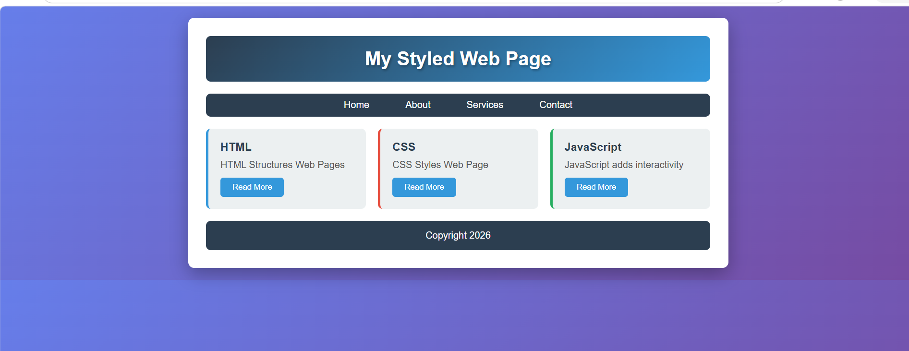
10. RESULT:
The webpage was successfully styled using internal CSS. The page displayed a gradient background, a centred container, a gradient header, a Flexbox navigation bar, a three-column card layout built with CSS Grid, and a styled footer. Hover effects on the navigation links, cards and buttons worked as expected. All test cases passed, confirming that CSS can be used to transform a plain HTML structure into an attractive, well-organised webpage.

