Real-Time Internal Temperature Monitoring and Session-Based Maximum Value Logging using ARM Cortex-M4 Embedded System

Project Objective:
The objective of this project is to design and implement a real-time embedded monitoring system using an ARM Cortex-M4 microcontroller. The system continuously measures the internal temperature sensor data, processes the ADC readings, and stores the maximum temperature value recorded during each measurement session triggered by a push-button. The system further allows the user to request stored maximum values through UART commands, thus demonstrating reliable sensor acquisition, processing and user-controlled data retrieval in an embedded environment.

Real-World Challenge:
In the automotive industry, temperature monitoring is critical for safety and performance. Many ECUs, power electronics modules, battery management systems and processors generate heat during operation. If the temperature goes beyond a safe operating limit, it can affect reliability and even damage electronic components. Therefore, continuous temperature monitoring and logging of peak temperatures is necessary to understand thermal behaviour, analyse worst-case conditions, and make design decisions.
In this project, we simulate such a real-world monitoring scenario by using the internal temperature sensor of STM32F407 microcontroller. The system measures temperature periodically and stores the maximum value of each measurement cycle. This helps to observe how temperature varies under different load conditions, similar to how automotive ECUs record max temperatures under different operating cycles.

Input:

- On-chip temperature sensor (ADC input): Provides continuous analog voltage proportional to chip temperature.
- User push-button (GPIO interrupt input): Used to start a new measurement session.
- UART receive command (‘R’): Allows user to request stored maximum temperature values.

Output:
- UART Transmission (USART2): Displays real-time temperature readings and stored maximum values on a serial terminal or external device.
Control Objective:
- To continuously measure the internal temperature using ADC + DMA for high-speed and efficient sampling.
- To record the maximum temperature value for each measurement session triggered by a button press.
- To store multiple session-wise maximum temperature readings in memory.
- To provide user access to these logged values through UART communication upon receiving the ‘R’ command.
- To ensure system stability and timing precision using Timers and Interrupts (TIM4, EXTI0, NVIC).

Required Hardware and Software Tools
Hardware Tools:
- STM32F407VGT6 ARM Cortex-M4 Controller Board
- Micro USB Cable
- UART USB-to-TTL Converter
- Push Button (connected to PA0 pin)
- On-chip Internal Temperature Sensor (ADC Channel)
Software Tools:
- STM32CubeMX (for peripheral configuration like ADC, Timer, UART, GPIO)
- Keil (for embedded firmware development and flashing)
- Serial Terminal Software such as PuTTY / Arduino Serial Monitor (for viewing UART output from STM32)

Embedded System Architecture
The proposed embedded system is built around the STM32F407VGT6 ARM Cortex-M4 microcontroller which functions as the central processing and control element. The internal silicon temperature sensor available inside the MCU is utilized as the primary sensing source. The analog sensor output is sampled using the ADC peripheral with DMA support to ensure continuous data acquisition without burdening the CPU.
A hardware switch (PA0) is configured with EXTI interrupt and serves as the user trigger to start the temperature measurement session. Once activated, the timer (TIM4) defines the measurement time window and the MCU keeps calculating temperature values and maintains the maximum temperature observed during the complete session. Each session maximum value is stored in memory for future retrieval.
For communication, the UART interface (USART2) is used to transmit processed data to the external host PC/laptop. This allows real-time monitoring as well as post-analysis of session-wise peak temperature values. This architecture reflects a modular and scalable embedded design approach where sensing, timing, processing, memory management and communication are seamlessly integrated within a single MCU platform.

Component | Description
STM32F407VGT6 MCU |  | Main processing controller that executes the firmware logic, controls peripherals, and manages the measurement sessions.
Internal Temperature Sensor |  | On-chip analog temperature sensor inside the MCU used to measure silicon die temperature. No external sensor required.
ADC + DMA |  | ADC samples temperature sensor data; DMA transfers data directly to memory without CPU load, improving performance and accuracy.
Timer (TIM4) |  | Used to set fixed measurement duration (e.g., 2 sec or 5 sec). When timeout happens, maximum temperature is captured and stored.
Push Button (PA0) |  | User input trigger for starting a new measurement session. Uses EXTI interrupt to avoid polling.
UART (USART2) |  | Communication interface used to send temperature values and session results to PC or external devices (PuTTY).

Block Diagram:
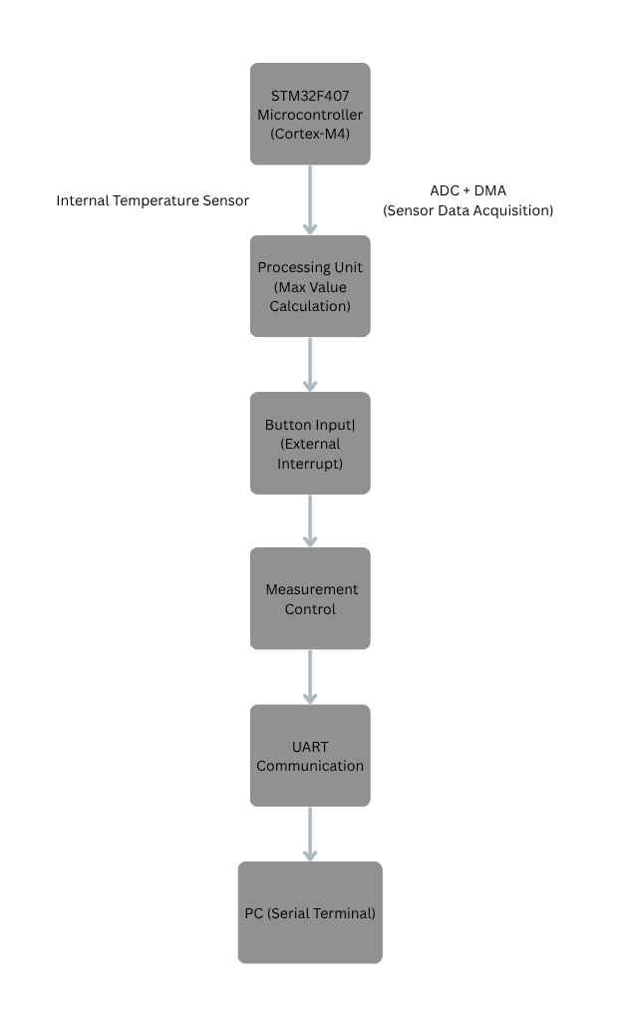
Highlight of ARM Cortex-M4 (ARM v7-M) Features Used

This project takes advantage of key architectural features of the ARM Cortex-M4 core. The processor supports hardware exception handling which allows the MCU to immediately detect and respond to external hardware events without polling. In this application, ADC conversion complete, Timer timeout, UART receive, and External push-button events all trigger interrupt service routines.
These interrupt requests are managed by the NVIC (Nested Vectored Interrupt Controller) which assigns priorities and ensures that high priority tasks (like ADC complete) can pre-empt lower priority events (like UART input). This improves real-time response and avoids data loss. The Cortex-M4 also executes interrupts with very low latency due to automatic stacking/unstacking of CPU registers in hardware.
Additionally, the system makes use of the SysTick based scheduling and timing which is internally used by HAL library for delay and timing calculations. Combination of NVIC, precise interrupt latency, and hardware exception support enables reliable real-time data acquisition and communication in this design, which is the core strength of an ARM Cortex-M4 based embedded system.

Task Diagram:
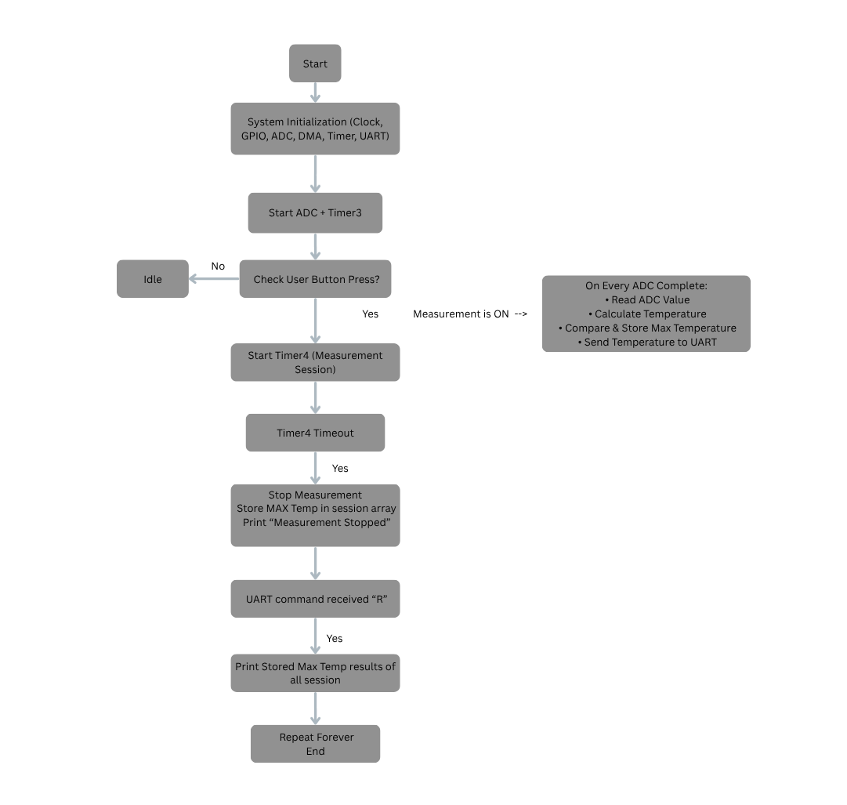

Source Code:

/* USER CODE BEGIN Header */
/**
******************************************************************************
* @file : main.c
* @brief : Main program body
******************************************************************************
* @attention
*
* Copyright (c) 2025 STMicroelectronics.
* All rights reserved.
*
* This software is licensed under terms that can be found in the LICENSE file
* in the root directory of this software component.
* If no LICENSE file comes with this software, it is provided AS-IS.
*
******************************************************************************
*/
/* USER CODE END Header */
/* Includes ------------------------------------------------------------------*/
#include "main.h"
#include <string.h>

#define TS_CAL1 *((uint16_t*)0x1FFF7A2C)
#define TS_CAL2 *((uint16_t*)0x1FFF7A2E)
#define VREFIN_CAL *((uint16_t*)0x1FFF7A2A)

/* Private includes ----------------------------------------------------------*/
/* USER CODE BEGIN Includes */

/* USER CODE END Includes */

/* Private typedef -----------------------------------------------------------*/
/* USER CODE BEGIN PTD */

/* USER CODE END PTD */

/* Private define ------------------------------------------------------------*/
/* USER CODE BEGIN PD */

/* USER CODE END PD */

/* Private macro -------------------------------------------------------------*/
/* USER CODE BEGIN PM */

/* USER CODE END PM */

/* Private variables ---------------------------------------------------------*/
ADC_HandleTypeDef hadc1;
DMA_HandleTypeDef hdma_adc1;

TIM_HandleTypeDef htim3;
TIM_HandleTypeDef htim4;

UART_HandleTypeDef huart2;

uint8_t UpdateEvent = 0; // Keep if using DMA callback
uint16_t AD_RES[2]; // Keep for ADC DMA
float Temperature, V_Ref; // Remove V_Sense
char TxBuffer[200]; // Increase size if sending more info
float Temperature, V_Ref;
volatile uint8_t measure_enable = 0; // Flag to control measurement

float session_max[50];
uint8_t session_index = 0;

float current_max = -1000;

/* USER CODE BEGIN PV */

/* USER CODE END PV */

/* Private function prototypes -----------------------------------------------*/
void SystemClock_Config(void);
static void MX_DMA_Init(void);
static void MX_GPIO_Init(void);
static void MX_ADC1_Init(void);
static void MX_TIM3_Init(void);
static void MX_USART2_UART_Init(void);
static void MX_TIM4_Init(void);
/* USER CODE BEGIN PFP */

/* USER CODE END PFP */

/* Private user code ---------------------------------------------------------*/
/* USER CODE BEGIN 0 */
uint8_t rx_data;
/* USER CODE END 0 */

/**
* @brief The application entry point.
* @retval int
*/
int main(void)
{

/* USER CODE BEGIN 1 */

/* USER CODE END 1 */

/* MCU Configuration--------------------------------------------------------*/

/* Reset of all peripherals, Initializes the Flash interface and the Systick. */
HAL_Init();

/* USER CODE BEGIN Init */

/* USER CODE END Init */

/* Configure the system clock */
SystemClock_Config();

/* USER CODE BEGIN SysInit */

/* USER CODE END SysInit */

/* Initialize all configured peripherals */
MX_DMA_Init();
MX_GPIO_Init();
MX_ADC1_Init();
MX_TIM3_Init();
MX_USART2_UART_Init();
HAL_UART_Receive_IT(&huart2, &rx_data, 1);
MX_TIM4_Init();

// --- START PERIPHERALS ---
HAL_TIM_Base_Start(&htim3); // Start Timer
HAL_ADC_Start_DMA(&hadc1, (uint32_t*)AD_RES, 2); // Start ADC + DMA
/* USER CODE BEGIN 2 */

/* USER CODE END 2 */

/* Infinite loop */
/* USER CODE BEGIN WHILE */
while (1)
{
/* USER CODE END WHILE */
if(measure_enable && UpdateEvent){
// Calculate The Temperature

float vdda = 3.3f * ((float)VREFIN_CAL / (float)AD_RES[0]);

float ts_raw_eq_33 = (float)AD_RES[1] * (vdda / 3.3f);

Temperature = 30.0f + (ts_raw_eq_33 - (float)TS_CAL1) * (110.0f - 30.0f) / ((float)TS_CAL2 - (float)TS_CAL1);

if (Temperature > current_max)
{
current_max = Temperature;
}

__disable_irq();
//int n = snprintf(TxBuffer, sizeof(TxBuffer), "Vdda=%.3fV Temperature=%.2fC\r\n", vdda, Temperature);
int n = snprintf(TxBuffer, sizeof(TxBuffer), "Temperature=%.2fC\r\n", Temperature);

// Send The Result To PC Over Serial Port

//printf("%d\r\n", Temperature);
//sprintf(TxBuffer, "TS_CAL1=%u TS_CAL2=%u VREFIN_CAL=%u\r\n", TS_CAL1, TS_CAL2, VREFIN_CAL);

HAL_UART_Transmit(&huart2, (uint8_t*)TxBuffer, n, 100);
__enable_irq();
UpdateEvent = 0;
}
/* USER CODE BEGIN 3 */
}
/* USER CODE END 3 */
}

/**
* @brief System Clock Configuration
* @retval None
*/
void SystemClock_Config(void)
{
RCC_OscInitTypeDef RCC_OscInitStruct = {0};
RCC_ClkInitTypeDef RCC_ClkInitStruct = {0};

/** Configure the main internal regulator output voltage
*/
__HAL_RCC_PWR_CLK_ENABLE();
__HAL_PWR_VOLTAGESCALING_CONFIG(PWR_REGULATOR_VOLTAGE_SCALE1);

/** Initializes the RCC Oscillators according to the specified parameters
* in the RCC_OscInitTypeDef structure.
*/
RCC_OscInitStruct.OscillatorType = RCC_OSCILLATORTYPE_HSE;
RCC_OscInitStruct.HSEState = RCC_HSE_ON;
RCC_OscInitStruct.PLL.PLLState = RCC_PLL_ON;
RCC_OscInitStruct.PLL.PLLSource = RCC_PLLSOURCE_HSE;
RCC_OscInitStruct.PLL.PLLM = 25;
RCC_OscInitStruct.PLL.PLLN = 336;
RCC_OscInitStruct.PLL.PLLP = RCC_PLLP_DIV2;
RCC_OscInitStruct.PLL.PLLQ = 4;
if (HAL_RCC_OscConfig(&RCC_OscInitStruct) != HAL_OK)
{
Error_Handler();
}

/** Initializes the CPU, AHB and APB buses clocks
*/
RCC_ClkInitStruct.ClockType = RCC_CLOCKTYPE_HCLK|RCC_CLOCKTYPE_SYSCLK
|RCC_CLOCKTYPE_PCLK1|RCC_CLOCKTYPE_PCLK2;
RCC_ClkInitStruct.SYSCLKSource = RCC_SYSCLKSOURCE_PLLCLK;
RCC_ClkInitStruct.AHBCLKDivider = RCC_SYSCLK_DIV1;
RCC_ClkInitStruct.APB1CLKDivider = RCC_HCLK_DIV4;
RCC_ClkInitStruct.APB2CLKDivider = RCC_HCLK_DIV2;

if (HAL_RCC_ClockConfig(&RCC_ClkInitStruct, FLASH_LATENCY_5) != HAL_OK)
{
Error_Handler();
}
}

/**
* @brief ADC1 Initialization Function
* @param None
* @retval None
*/
static void MX_ADC1_Init(void)
{

/* USER CODE BEGIN ADC1_Init 0 */

/* USER CODE END ADC1_Init 0 */

ADC_ChannelConfTypeDef sConfig = {0};

/* USER CODE BEGIN ADC1_Init 1 */

/* USER CODE END ADC1_Init 1 */

/** Configure the global features of the ADC (Clock, Resolution, Data Alignment and number of conversion)
*/
hadc1.Instance = ADC1;
hadc1.Init.ClockPrescaler = ADC_CLOCK_SYNC_PCLK_DIV4;
hadc1.Init.Resolution = ADC_RESOLUTION_12B;
hadc1.Init.ScanConvMode = ENABLE;
hadc1.Init.ContinuousConvMode = ENABLE;
hadc1.Init.DiscontinuousConvMode = DISABLE;
hadc1.Init.ExternalTrigConvEdge = ADC_EXTERNALTRIGCONVEDGE_RISING;
hadc1.Init.ExternalTrigConv = ADC_EXTERNALTRIGCONV_T3_TRGO;
hadc1.Init.DataAlign = ADC_DATAALIGN_RIGHT;
hadc1.Init.NbrOfConversion = 2;
hadc1.Init.DMAContinuousRequests = ENABLE;
hadc1.Init.EOCSelection = ADC_EOC_SINGLE_CONV;
if (HAL_ADC_Init(&hadc1) != HAL_OK)
{
Error_Handler();
}

/** Configure for the selected ADC regular channel its corresponding rank in the sequencer and its sample time.
*/
sConfig.Channel = ADC_CHANNEL_VREFINT;
sConfig.Rank = 1;
sConfig.SamplingTime = ADC_SAMPLETIME_480CYCLES;
if (HAL_ADC_ConfigChannel(&hadc1, &sConfig) != HAL_OK)
{
Error_Handler();
}

/** Configure for the selected ADC regular channel its corresponding rank in the sequencer and its sample time.
*/
sConfig.Channel = ADC_CHANNEL_TEMPSENSOR;
sConfig.Rank = 2;
sConfig.SamplingTime = ADC_SAMPLETIME_480CYCLES;
if (HAL_ADC_ConfigChannel(&hadc1, &sConfig) != HAL_OK)
{
Error_Handler();
}
/* USER CODE BEGIN ADC1_Init 2 */

/* USER CODE END ADC1_Init 2 */

}

/**
* @brief TIM3 Initialization Function
* @param None
* @retval None
*/
static void MX_TIM3_Init(void)
{

/* USER CODE BEGIN TIM3_Init 0 */

/* USER CODE END TIM3_Init 0 */

TIM_ClockConfigTypeDef sClockSourceConfig = {0};
TIM_MasterConfigTypeDef sMasterConfig = {0};

/* USER CODE BEGIN TIM3_Init 1 */

/* USER CODE END TIM3_Init 1 */
htim3.Instance = TIM3;
htim3.Init.Prescaler = 23;
htim3.Init.CounterMode = TIM_COUNTERMODE_UP;
htim3.Init.Period = 59999;
htim3.Init.ClockDivision = TIM_CLOCKDIVISION_DIV1;
htim3.Init.AutoReloadPreload = TIM_AUTORELOAD_PRELOAD_ENABLE;
if (HAL_TIM_Base_Init(&htim3) != HAL_OK)
{
Error_Handler();
}
sClockSourceConfig.ClockSource = TIM_CLOCKSOURCE_INTERNAL;
if (HAL_TIM_ConfigClockSource(&htim3, &sClockSourceConfig) != HAL_OK)
{
Error_Handler();
}
sMasterConfig.MasterOutputTrigger = TIM_TRGO_UPDATE;
sMasterConfig.MasterSlaveMode = TIM_MASTERSLAVEMODE_DISABLE;
if (HAL_TIMEx_MasterConfigSynchronization(&htim3, &sMasterConfig) != HAL_OK)
{
Error_Handler();
}
/* USER CODE BEGIN TIM3_Init 2 */

/* USER CODE END TIM3_Init 2 */

}

/**
* @brief TIM4 Initialization Function
* @param None
* @retval None
*/
static void MX_TIM4_Init(void)
{

/* USER CODE BEGIN TIM4_Init 0 */

/* USER CODE END TIM4_Init 0 */

TIM_ClockConfigTypeDef sClockSourceConfig = {0};
TIM_MasterConfigTypeDef sMasterConfig = {0};

/* USER CODE BEGIN TIM4_Init 1 */

/* USER CODE END TIM4_Init 1 */
htim4.Instance = TIM4;
htim4.Init.Prescaler = 16799;
htim4.Init.CounterMode = TIM_COUNTERMODE_UP;
htim4.Init.Period = 9999;
htim4.Init.ClockDivision = TIM_CLOCKDIVISION_DIV1;
htim4.Init.AutoReloadPreload = TIM_AUTORELOAD_PRELOAD_DISABLE;
if (HAL_TIM_Base_Init(&htim4) != HAL_OK)
{
Error_Handler();
}
sClockSourceConfig.ClockSource = TIM_CLOCKSOURCE_INTERNAL;
if (HAL_TIM_ConfigClockSource(&htim4, &sClockSourceConfig) != HAL_OK)
{
Error_Handler();
}
sMasterConfig.MasterOutputTrigger = TIM_TRGO_RESET;
sMasterConfig.MasterSlaveMode = TIM_MASTERSLAVEMODE_DISABLE;
if (HAL_TIMEx_MasterConfigSynchronization(&htim4, &sMasterConfig) != HAL_OK)
{
Error_Handler();
}
/* USER CODE BEGIN TIM4_Init 2 */

/* USER CODE END TIM4_Init 2 */

}

/**
* @brief USART2 Initialization Function
* @param None
* @retval None
*/
static void MX_USART2_UART_Init(void)
{

/* USER CODE BEGIN USART2_Init 0 */

/* USER CODE END USART2_Init 0 */

/* USER CODE BEGIN USART2_Init 1 */

/* USER CODE END USART2_Init 1 */
huart2.Instance = USART2;
huart2.Init.BaudRate = 115200;
huart2.Init.WordLength = UART_WORDLENGTH_8B;
huart2.Init.StopBits = UART_STOPBITS_1;
huart2.Init.Parity = UART_PARITY_NONE;
huart2.Init.Mode = UART_MODE_TX_RX;
huart2.Init.HwFlowCtl = UART_HWCONTROL_NONE;
huart2.Init.OverSampling = UART_OVERSAMPLING_16;
if (HAL_UART_Init(&huart2) != HAL_OK)
{
Error_Handler();
}
/* USER CODE BEGIN USART2_Init 2 */

/* USER CODE END USART2_Init 2 */

}

/**
* Enable DMA controller clock
*/
static void MX_DMA_Init(void)
{

/* DMA controller clock enable */
__HAL_RCC_DMA2_CLK_ENABLE();

/* DMA interrupt init */
/* DMA2_Stream0_IRQn interrupt configuration */
HAL_NVIC_SetPriority(DMA2_Stream0_IRQn, 0, 0);
HAL_NVIC_EnableIRQ(DMA2_Stream0_IRQn);

}

/**
* @brief GPIO Initialization Function
* @param None
* @retval None
*/
static void MX_GPIO_Init(void)
{
GPIO_InitTypeDef GPIO_InitStruct = {0};
/* USER CODE BEGIN MX_GPIO_Init_1 */

/* USER CODE END MX_GPIO_Init_1 */

/* GPIO Ports Clock Enable */
__HAL_RCC_GPIOH_CLK_ENABLE();
__HAL_RCC_GPIOA_CLK_ENABLE();
__HAL_RCC_GPIOB_CLK_ENABLE();

/*Configure GPIO pin Output Level */
HAL_GPIO_WritePin(GPIOB, GPIO_PIN_0, GPIO_PIN_RESET);

/*Configure GPIO pin : PA0 */
GPIO_InitStruct.Pin = GPIO_PIN_0;
GPIO_InitStruct.Mode = GPIO_MODE_IT_RISING;
GPIO_InitStruct.Pull = GPIO_PULLDOWN;
HAL_GPIO_Init(GPIOA, &GPIO_InitStruct);

/*Configure GPIO pin : PB0 */
GPIO_InitStruct.Pin = GPIO_PIN_0;
GPIO_InitStruct.Mode = GPIO_MODE_OUTPUT_PP;
GPIO_InitStruct.Pull = GPIO_NOPULL;
GPIO_InitStruct.Speed = GPIO_SPEED_FREQ_LOW;
HAL_GPIO_Init(GPIOB, &GPIO_InitStruct);

/* EXTI interrupt init*/
HAL_NVIC_SetPriority(EXTI0_IRQn, 0, 0);
HAL_NVIC_EnableIRQ(EXTI0_IRQn);

/* USER CODE BEGIN MX_GPIO_Init_2 */

/* USER CODE END MX_GPIO_Init_2 */
}

/* USER CODE BEGIN 4 */

void HAL_TIM_PeriodElapsedCallback(TIM_HandleTypeDef *htim)
{
if (htim->Instance == TIM4)
{
measure_enable = 0; // Stop measurement
HAL_TIM_Base_Stop_IT(&htim4);

// STORE THE MAX OF THIS SESSION
session_max[session_index++] = current_max;
current_max = -1000; // reset for next session

sprintf(TxBuffer, "Measurement STOPPED\r\n");
HAL_UART_Transmit(&huart2, (uint8_t*)TxBuffer, strlen(TxBuffer), 100);
}
}

void HAL_ADC_ConvCpltCallback(ADC_HandleTypeDef* hadc)
{
HAL_GPIO_TogglePin(GPIOB, GPIO_PIN_0); // Toggle Interrupt Rate Indicator Pin
UpdateEvent = 1;
}

void HAL_GPIO_EXTI_Callback(uint16_t GPIO_Pin)
{
if (GPIO_Pin == GPIO_PIN_0) // USER button (PA0)
{
if (!measure_enable)
{
measure_enable = 1; // Enable measurement
HAL_TIM_Base_Start_IT(&htim4); // Start 10s timer
sprintf(TxBuffer, "Measurement STARTED\r\n");
HAL_UART_Transmit(&huart2, (uint8_t*)TxBuffer, strlen(TxBuffer), 100);
}
}
}

void HAL_UART_RxCpltCallback(UART_HandleTypeDef *huart)
{
if (huart->Instance == USART2)
{
if (rx_data == 'R' || rx_data=='r' || rx_data=='\n' || rx_data=='\r')
{
// CLEAR TERMINAL
//HAL_UART_Transmit(&huart2, (uint8_t*)"\033[2J\033[H", 7, 100);

for (int i = 0; i < session_index; i++)
{
sprintf(TxBuffer, "Session %d Max Temperature = %.2fC\r\n", i+1, session_max[i]);
HAL_UART_Transmit(&huart2,(uint8_t*)TxBuffer,strlen(TxBuffer),100);
}
}
HAL_UART_Receive_IT(&huart2, &rx_data, 1);
}
}

/* USER CODE END 4 */

/**
* @brief This function is executed in case of error occurrence.
* @retval None
*/
void Error_Handler(void)
{
/* USER CODE BEGIN Error_Handler_Debug */
/* User can add his own implementation to report the HAL error return state */
__disable_irq();
while (1)
{
}
/* USER CODE END Error_Handler_Debug */
}
#ifdef USE_FULL_ASSERT
/**
* @brief Reports the name of the source file and the source line number
* where the assert_param error has occurred.
* @param file: pointer to the source file name
* @param line: assert_param error line source number
* @retval None
*/
void assert_failed(uint8_t *file, uint32_t line)
{
/* USER CODE BEGIN 6 */
/* User can add his own implementation to report the file name and line number,
ex: printf("Wrong parameters value: file %s on line %d\r\n", file, line) */
/* USER CODE END 6 */
}
#endif /* USE_FULL_ASSERT */

Code Explanation:

Peripheral Initialization Explanation
In the firmware, the first step is to initialize all the required on-chip peripherals. The STM32CubeMX generated functions like MX_DMA_Init(), MX_GPIO_Init(), MX_ADC1_Init(), MX_TIM3_Init(), MX_USART2_UART_Init() and MX_TIM4_Init() are used to configure each hardware block before starting the main application loop.
- MX_GPIO_Init() → configures the User button (PA0) as EXTI interrupt input and configures PB0 as an LED / debug pin.
- MX_ADC1_Init() → configures the ADC to read two channels (internal Vref and internal Temperature Sensor) in scan mode with DMA enabled.
- MX_TIM3_Init() → this timer is configured as trigger source for ADC conversions.
- MX_TIM4_Init() → this timer is used to limit measurement duration (ex: measure only 5 seconds after button press).
- MX_DMA_Init() → enables DMA controller so that ADC can transfer data into memory without CPU load.
- MX_USART2_UART_Init() → initializes UART2 (PA2/PA3) for sending sensor values to PC over serial.

Temperature Calculation and Data Transmission Logic:
Inside the while(1) loop, the system continuously checks two flags:
measure_enable and UpdateEvent.
- measure_enable → becomes 1 only when the user presses the switch (PA0 EXTI). When measurement is not active, no temperature processing is done.
- UpdateEvent → becomes 1 every time the ADC DMA conversion is completed (this ensures we only use fresh ADC readings).
Only when both conditions are true, the temperature calculation logic executes.
First, the code calculates the actual MCU supply voltage VDDA. This is required because the temperature sensor output varies with VDDA. Using the factory stored calibration value VREFIN_CAL, the code recalculates the equivalent voltage reference.
Next, it scales the temperature sensor raw ADC reading as if the supply was 3.3V
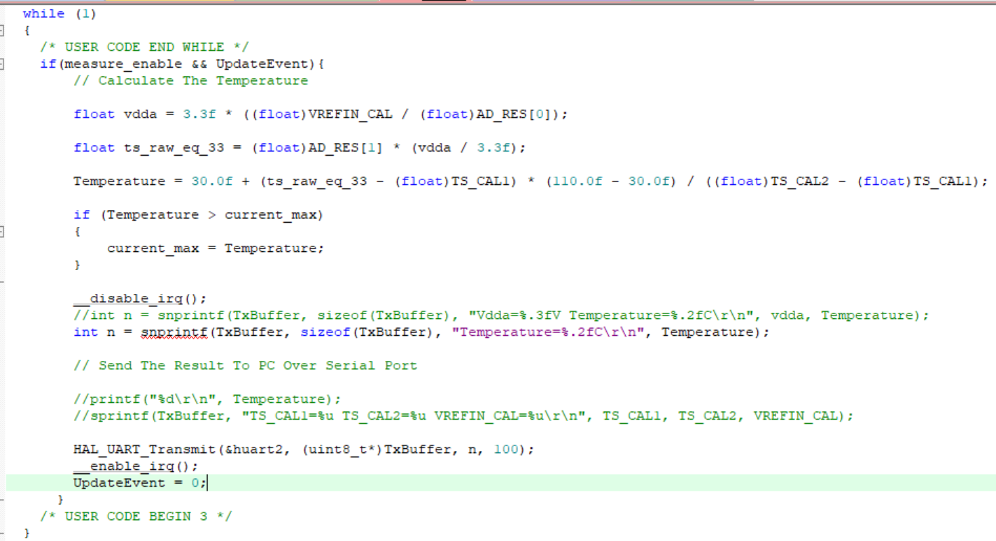

Then final temperature is calculated using linear interpolation between factory calibration constants TS_CAL1 (at 30°C) and TS_CAL2 (at 110°C)
After calculating the real temperature, the program checks if the value is higher than the previously stored maximum value of the current session. If yes, the code updates current_max.
This implements a session-wise peak logging mechanism.
Finally, the temperature value is formatted in text form and transmitted through UART to the PC.
UART interrupts are temporarily disabled during string formatting to avoid buffer corruption.

Timer Interrupt Callback:
The function HAL_TIM_PeriodElapsedCallback() is automatically executed whenever Timer-4 finishes its time period. In this project, Timer-4 defines the duration of one temperature measuring session. Once this time completes, the system must stop collecting readings and store the maximum temperature value of that session.

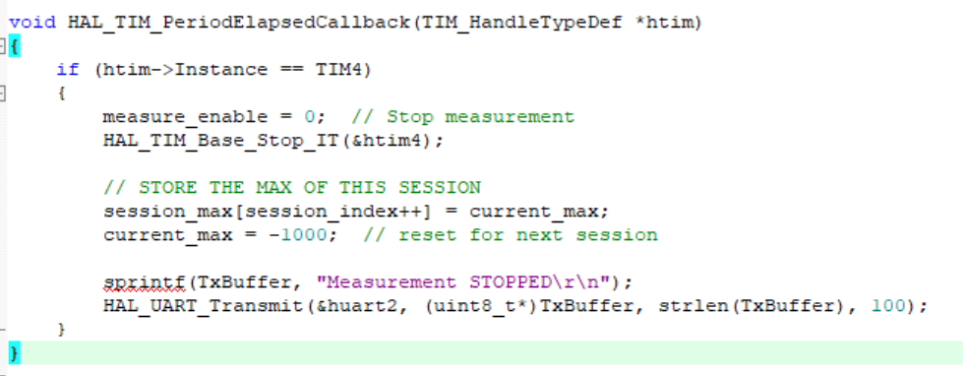

This approach uses interrupt-driven time control which is a fundamental feature in ARM Cortex-M4 architecture. Instead of using delay functions in the main code, a hardware timer generates an interrupt at accurate time intervals.
When the timer expires:
- the MCU disables further temperature capture (measure_enable=0)
- the highest temperature measured in this session is saved in session_max array
- the maximum variable is reset for the next cycle
- a message is sent to UART informing measurement completed
This ensures event-driven measurement, high timing accuracy, and clear separation between sessions. By using timer interrupts, the system becomes deterministic and real-time which is mandatory in industrial embedded applications.

ADC Conversion Callback
When the ADC finishes converting the temperature sensor value, the HAL automatically triggers the callback function HAL_ADC_ConvCpltCallback(). This function acts as a notification mechanism to inform the main program that fresh sample data is available.
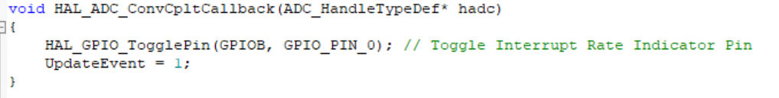
- The HAL_GPIO_TogglePin() line is used as a debug indicator so we can physically observe the ADC sampling frequency on an LED or logic analyser. This is useful for validating the sampling rate.
- UpdateEvent = 1 acts like a software flag. The main application checks this flag, and only when it is set, it will read the new ADC result and process it.
This mechanism avoids continuous polling and reduces CPU load because the CPU does not waste time waiting for ADC completion manually. Instead, the Cortex-M4 interrupt system will automatically notify the firmware when conversion is done. This demonstrates interrupt-based data acquisition, which is more efficient and real-time compared to polling methods.

External Interrupt Callback – User Button Trigger
The following function is executed whenever the GPIO external interrupt (EXTI) occurs on pin PA0. In this project, PA0 is connected to the on-board User Button. When the button is pressed, this interrupt callback is triggered immediately by the NVIC.
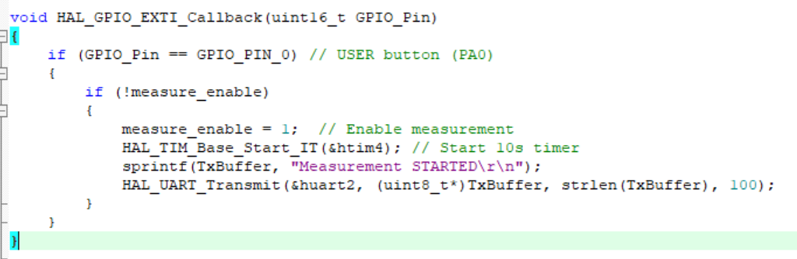

- When the user presses the button, the EXTI interrupt triggers immediately.
- The code checks if measure_enable is already active to avoid re-triggering while measurement is ongoing.
- If measurement is not running, this function starts a new measurement session by setting measure_enable = 1.
- Also, Timer4 interrupt is started to count the measurement duration (10 seconds).
- A status message is transmitted through UART to inform the PC/log that the measurement session started.
This demonstrates event-driven control in embedded systems. Instead of constantly checking for button presses inside the while loop, the Cortex-M4 NVIC and EXTI hardware automatically detect the event and immediately notify the firmware. This approach improves responsiveness, reduces CPU load, and is suitable for real-time embedded applications.

UART Receive Complete Callback – Displaying Stored Maximum Temperatures
This callback function is executed automatically whenever one byte of data is received through USART2. In this system, the PC/terminal can send a character ‘R’ to request the stored results.
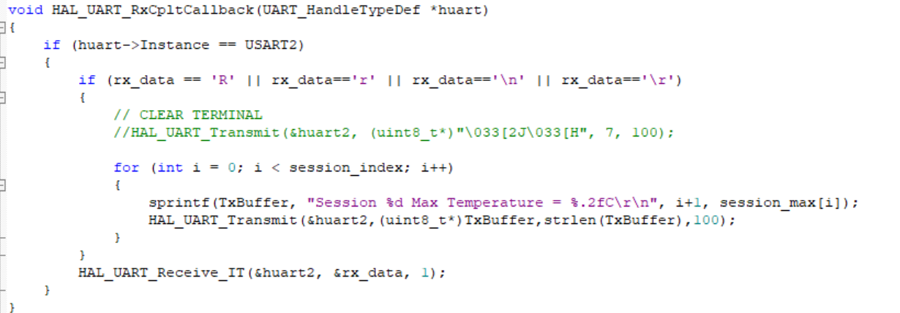
- The function checks if the interrupt belongs to USART2.
- If the received character is ‘R’ (case insensitive), it enters a loop and prints the stored maximum temperatures of all completed sessions.
- The values were recorded earlier at the end of every measurement window (10 sec).
- After processing, UART receive interrupt is enabled again to continue receiving further commands.
This callback demonstrates asynchronous communication between user interface (PC terminal) and embedded system. Instead of polling, UART interrupts allow the microcontroller to react to commands at any time without blocking other processing.

Communication and Integration
In this embedded system, communication is implemented using the USART2 UART peripheral, which allows the STM32F407 microcontroller to send processed temperature data to an external device such as a PC or a data logging module. UART (Universal Asynchronous Receiver and Transmitter) is one of the most commonly used serial communication protocols in embedded systems because it is simple, reliable, and requires only two wires (TX and RX).
In our design, the UART is configured for the following parameters:
Parameter |  | Value
Baud Rate |  | 115200 bps
Parity | None
Stop Bits | 1
Word Length | 8-bit
UART communication is unidirectional in this project (MCU → PC), so there is no strict master/slave relationship. The PC behaves as a receiver/terminal, while the STM32 behaves as the data source.

DMA and Timer Role in Communication Flow
- ADC readings are transferred using DMA, which means CPU is free while data is being sampled.
- The TIM4 timer interrupt defines measurement window of a few seconds.
- When timer expires, the system saves the maximum temperature value.
- Finally, temperature values are formatted and sent over UART

Communication Validation
Successful communication was validated using a serial terminal on PC (Putty / Arduino Serial Monitor). When the button was pressed, temperature values streamed to the terminal, and when the UART received the command 'R', it printed the stored maximum values of each measurement session.
This demonstrates correct and reliable data transmission between the embedded system and external device.

System Setup (Pin Mapping, Power Supply and Circuit Connections)
For hardware setup, the STM32F407 development board is powered using a standard 5V USB connection, which also powers the internal 3.3V regulator that drives the microcontroller core and peripherals. The internal temperature sensor of the STM32 is connected internally to the ADC, therefore no external sensor wiring is required for temperature sensing.
For user interaction, a Push Button is connected on pin PA0 and configured as an external interrupt input (EXTI). When the button is pressed, the controller starts a new measurement session. An indicator LED is connected on PB0, which provides real-time feedback by toggling every time ADC conversion completes.
The measured temperature data is sent to a PC through UART2, where PA2 is used as USART2_TX and PA3 is used as USART2_RX. A USB–to–UART converter (or onboard STLink virtual COM) is used to connect STM32 UART to the PC, enabling serial monitoring and logging. The timer TIM4 is used internally and no external pin connection is required.

Firmware Development and Debugging:
The board is powered through the Mini USB port which supplies stable 5V. The internal regulator provides 3.3V to the MCU core and peripherals. The USER Push Button (PA0) is used to trigger the temperature measurement session. An indicator LED (PB0) is used to visualize ADC sampling activity (LED toggles for each ADC conversion). The UART communication lines (PA2 – TX and PA3 – RX) are connected to a USB-to-TTL converter which is connected to the PC, enabling live serial data monitoring in terminal software (PuTTY/Arduino Serial Monitor). This hardware setup is used to validate the temperature sensing and UART logging functionality.
Hardware Setup – STM32F407VGT6 Board:
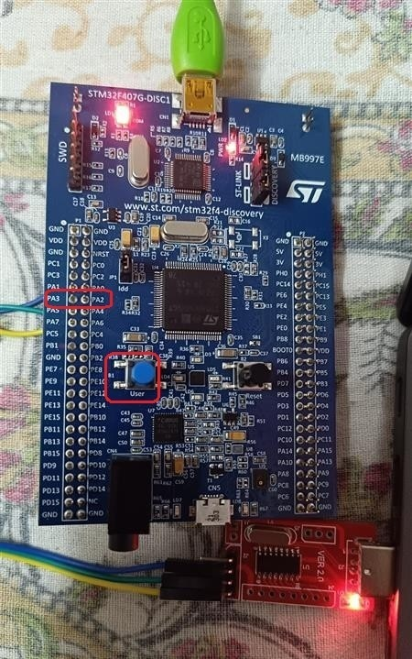

Code Compiled Successfully in Keil
The below screenshot shows that the firmware code was successfully compiled in STM32CubeIDE. The compilation completed without any errors or critical warnings. This confirms that all peripheral initializations (ADC, DMA, UART, Timers and GPIO interrupts) were correctly configured and the project is build-ready for flashing into the MCU. Successful compilation also validates that the HAL functions and callback handlers were integrated properly as per the STM32 firmware architecture.
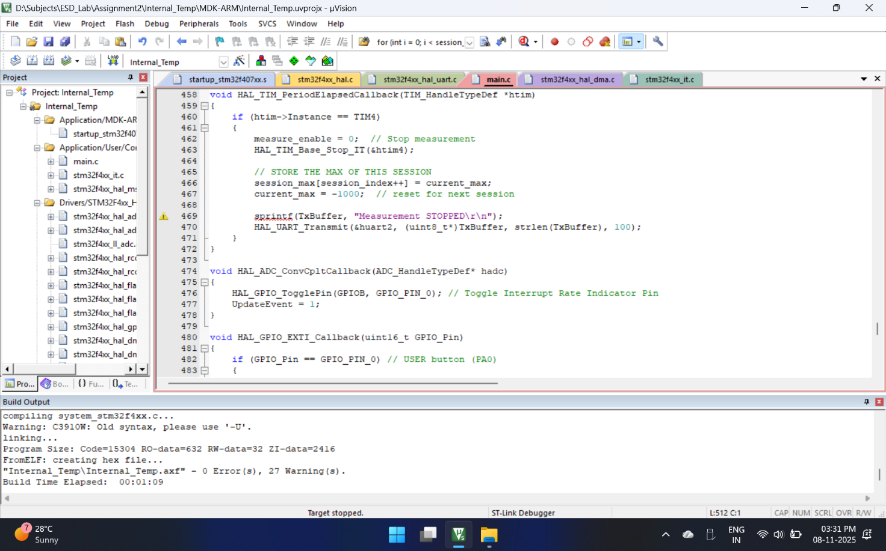

The STM32F407VGT6 board is programmed and powered using an external USB-to-TTL serial converter. The USB-TTL module provides UART interface to the PC and is connected to STM32 pins (PA2 → TX, PA3 → RX) and common GND. The firmware was successfully flashed into the microcontroller and the serial logs are monitored through the PC. This confirms proper hardware/software integration and correct UART communication setup.

When the board enters Debug mode, both UpdateEvent and Temperature variables are initialized to zero because they are global variables. In embedded C, global variables are stored in the .bss section and the startup code automatically clears the .bss section during reset. Therefore, before the main loop starts, all these un-initialized global variables get default value = 0. So, during debugging, initially the Temperature appears as 0 and only after the first ADC conversion completes, the real temperature value gets updated.

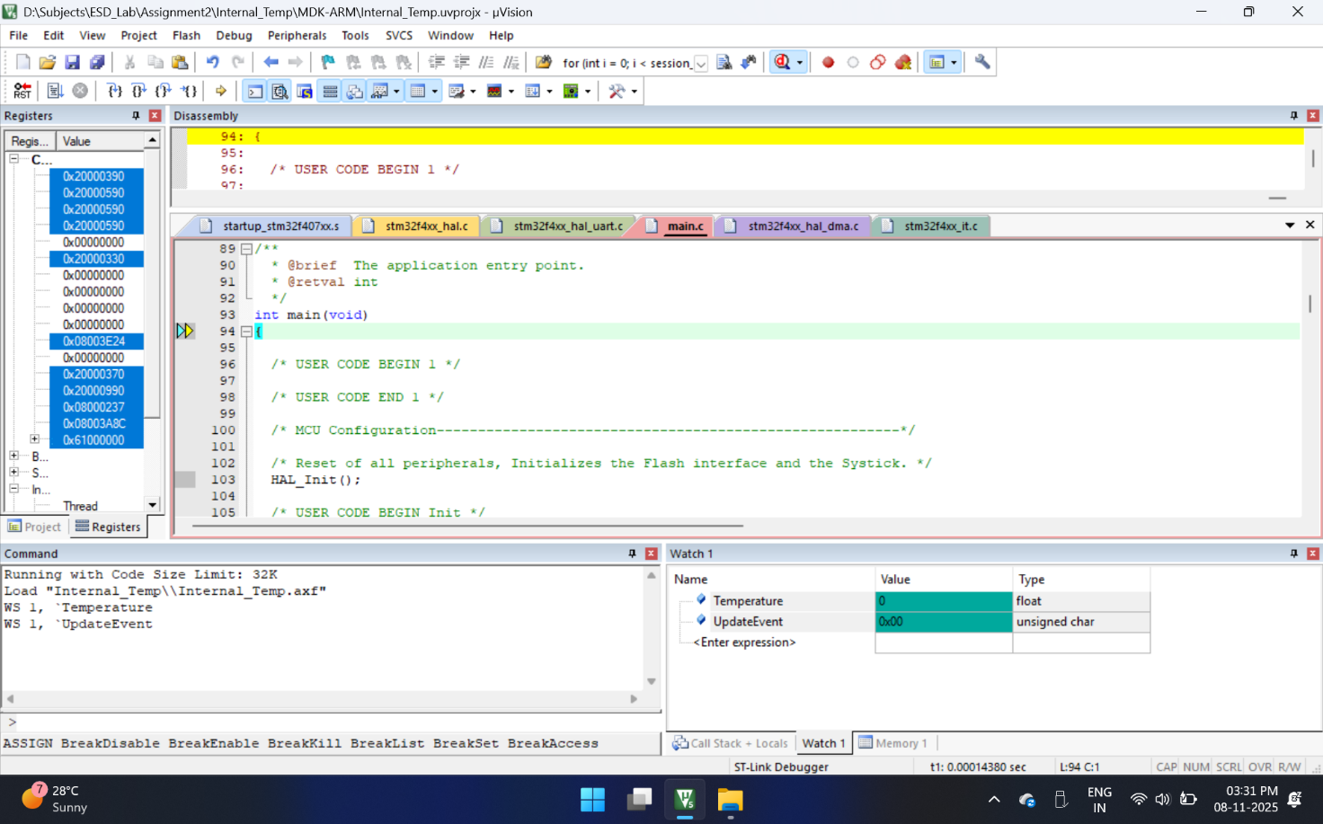

After the code starts running, UpdateEvent becomes active as soon as the ADC conversion completes, but the Temperature calculation does not start immediately. This is because the measurement process is controlled by the user push button (PA0). Only when the user presses the switch, measure_enable flag becomes 1 and then the temperature starts getting calculated and transmitted. So, even though the system is running, it waits for the operator command through the switch to start the actual temperature measurement session.
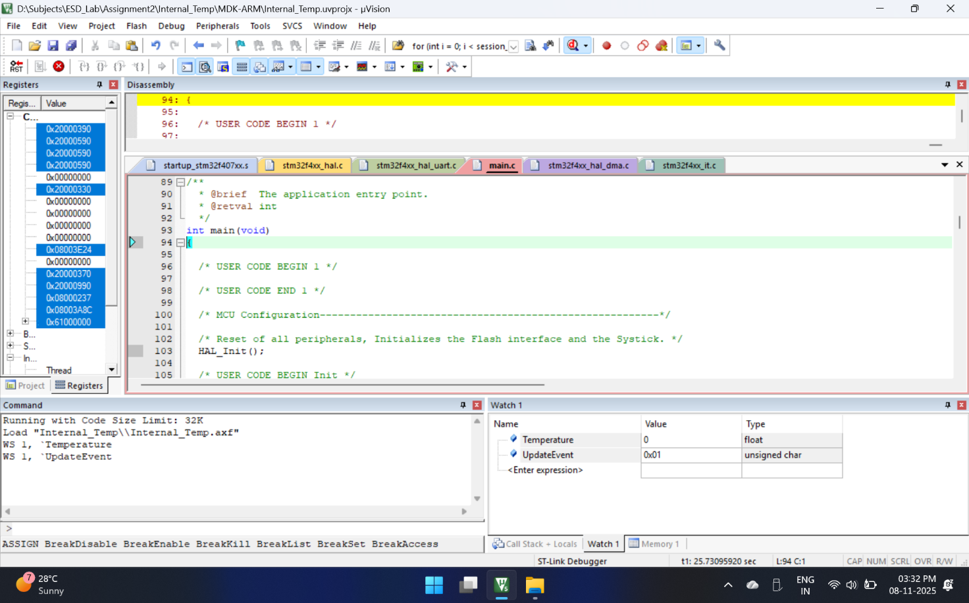

Serial Monitor Results
Once the push button is pressed, the system starts measuring the internal temperature sensor values and transmits them through UART to the PC serial monitor. We can clearly observe the live temperature readings getting printed continuously for the set timer duration (2 to 5 seconds as per configuration). After the measurement session ends, the maximum temperature value of that session is stored in an array. Later, whenever I send the command 'R' or 'r' from serial monitor, the STM32 returns all the maximum temperature readings recorded from multiple sessions.
These serial logs validate that data acquisition, processing, and UART communication are successfully implemented and working as expected.

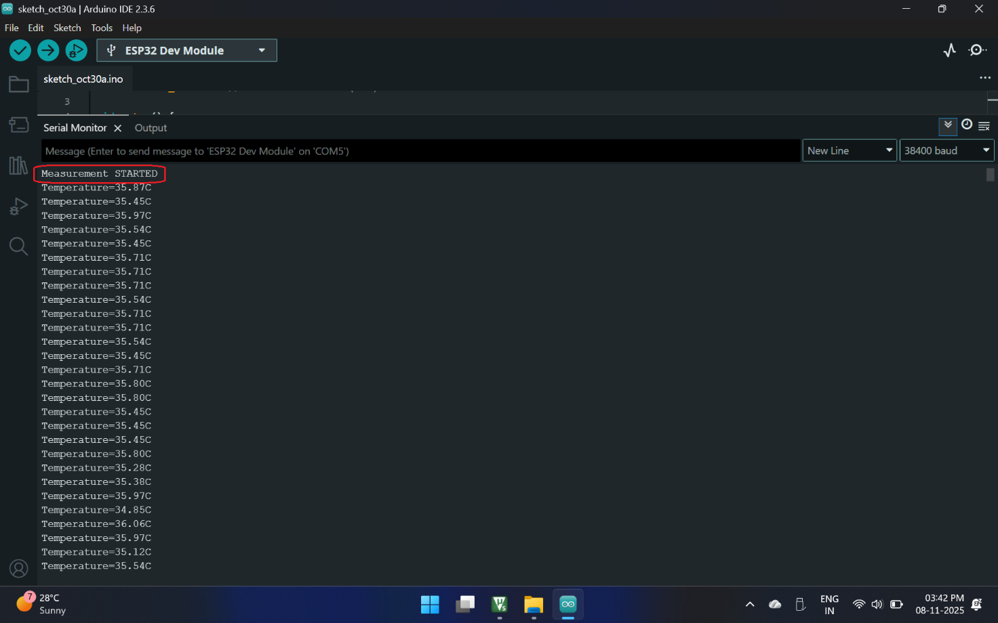
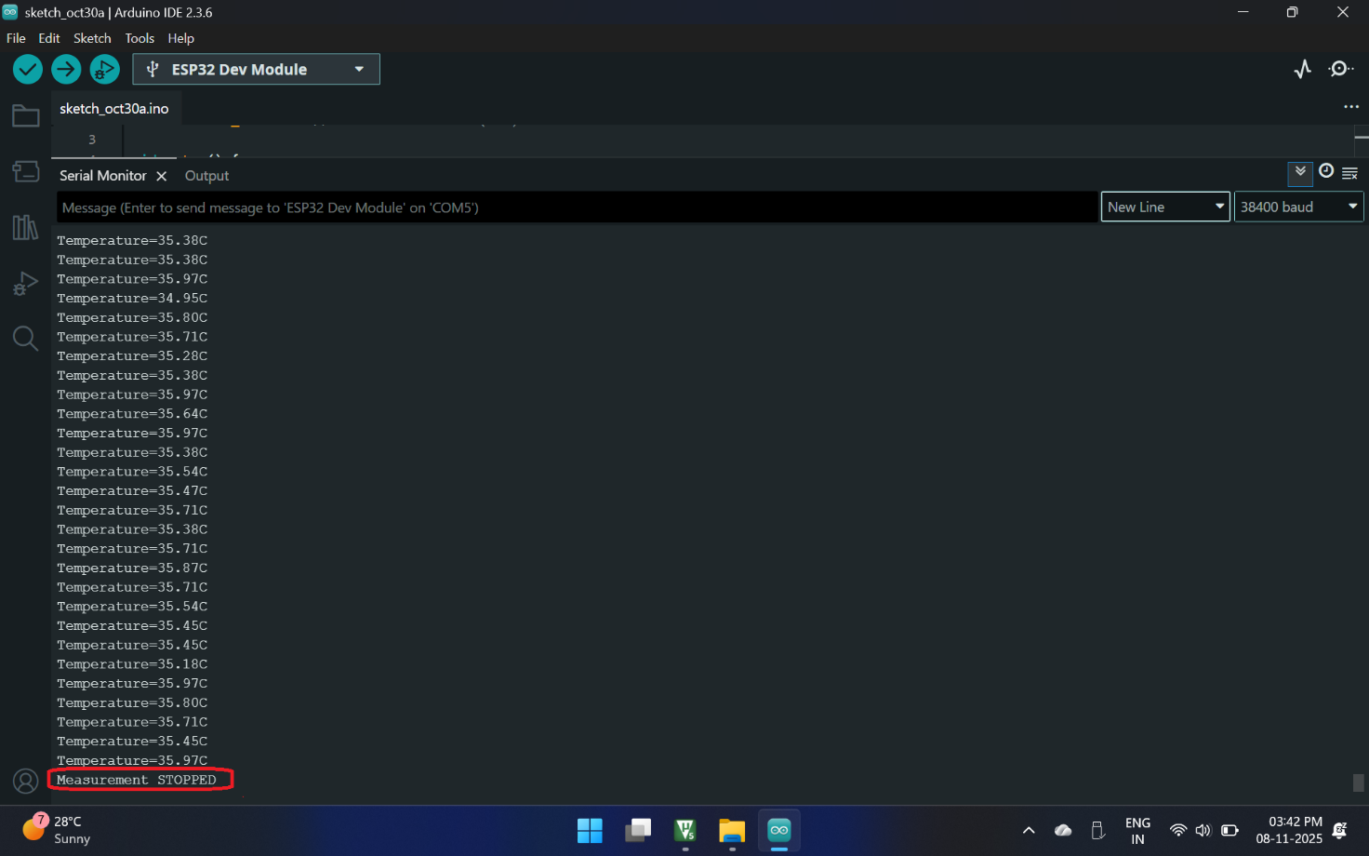

Displaying Results using User Input “R”
In this screenshot I entered ‘R’ from the PC serial monitor.
This triggers the UART receive interrupt on the STM32.
When this character is received, the firmware prints all the stored maximum temperature values of each completed session.
So by typing a single character from the computer, I am able to read all the measurement results captured in the past sequence of switch presses.
This demonstrates reliable one-way command-based communication from PC → microcontroller, and structured formatted data reporting from microcontroller → PC.
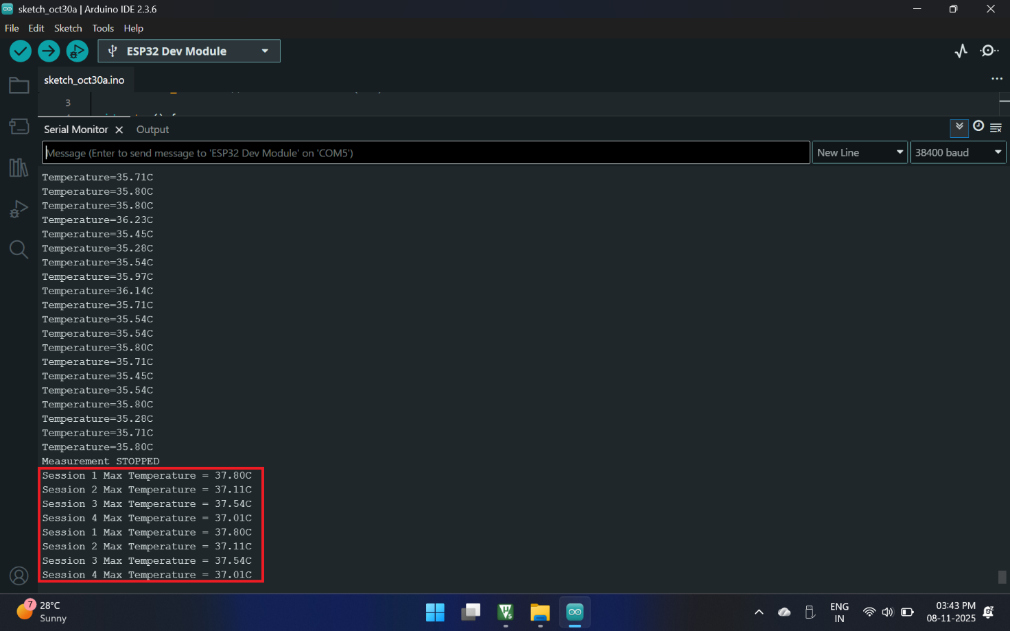

Real-time Debug Observation in Keil
In addition to the serial monitor log, I also monitored the Temperature variable in the Keil µVision "Watch / Live Expression" window.
Whenever the ADC conversion interrupt updates the variable, the new temperature value is immediately visible inside the IDE without stopping the CPU.
This helped me verify in real time that the measurement logic is correct and the temperature value is increasing or decreasing during each session
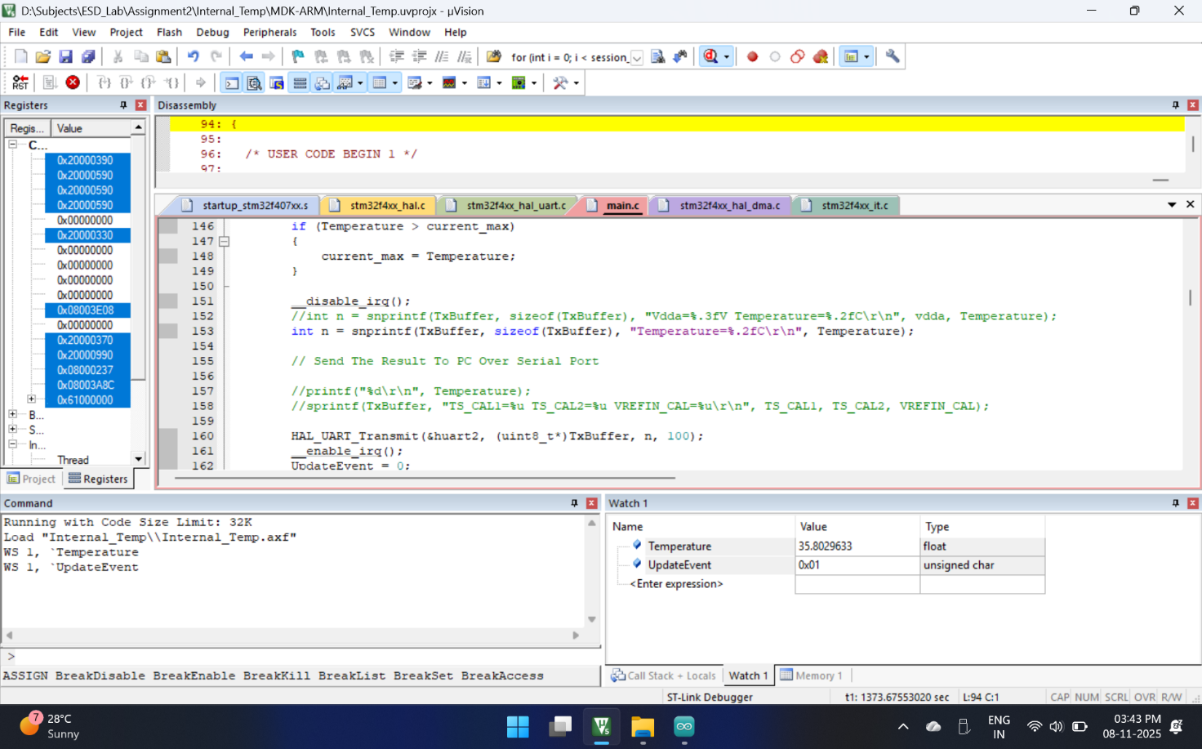

Performance Evaluation:
The system successfully measures temperature using ADC with DMA and stores session-wise maximum values. The response time is within milliseconds because no polling is used and CPU is free during conversions. UART communication at 115200 baud transmits data without delay or loss. The results match expected temperature values (approx 33–38°C range at room condition), proving accuracy and efficiency.

Demonstration and Validation:
The prototype was validated on actual STM32F407 hardware. The serial monitor logs were captured using PuTTY, and maximum values were printed when user enters ‘R’. The measurements were also cross verified in Keil Live Watch window. This proves end-to-end functionality of sensing, processing, storing, and communication.
Reflection:
From this assignment I learned how to integrate multiple peripherals (ADC, TIM, EXTI, UART) and design a real-time measurement system. Interrupt driven design improved my understanding of NVIC, DMA and non-blocking coding. This same concept can be applied in real industrial embedded controllers.

Quantifiable Performance Metrics
To evaluate performance improvement, the following measurable parameters were considered in this project:
Parameter | Result / Value | Explanation
ADC Accuracy | 12-bit (4096 levels) | Higher resolution provides better temperature precision.
Response Time | Few milliseconds | ADC conversion + DMA transfer is very fast due to non-blocking architecture.
Measurement Window Duration | 2 seconds per session | Fixed time window ensures fair comparison between sessions.
UART Throughput | 115200 baud | High-speed UART ensures quick data logging without delay.
CPU Efficiency | High (Low CPU usage) | DMA + Interrupts avoid continuous polling, improving performance.

Performance Improvement Summary
By using DMA and Interrupts instead of polling, the CPU is free during ADC conversion and can perform other tasks. This improves efficiency and reduces power consumption. Real-time user triggered measurement makes system responsive and suitable for industrial use.

Lessons Learned
- Understood how to configure and use internal temperature sensor using ADC + DMA in STM32.
- Learned importance of calibrations (TS_CAL1, TS_CAL2, VREFIN_CAL) for getting accurate temperature values.
- Understood how timers (TIM4) can be used to control measurement duration and create time-based events.
- Implemented GPIO interrupts (EXTI) for user input – understood difference between polling and interrupt handling.
- UART communication was studied in depth, including how to send data to PC serial monitor and receive commands from user.
- Understood how disabling interrupts during UART Tx avoids data corruption.
- Explored debugging techniques: using serial logs, watch windows, and variable inspection during debugging in Keil.

Faced and solved issues:
• UART data not printing due to missing NVIC config
• Buffer overflow (TxBuffer size increased)
• Noise/wrong characters in ESP32 due to wrong TX/RX pin mapping
• Timer duration mismatch and recalculation

Final Conclusion
In this project, I designed and implemented a real-time temperature monitoring prototype using an ARM Cortex-M4 based STM32F407 microcontroller. The system successfully acquired internal sensor data using ADC + DMA, processed the temperature values, and transmitted them through UART with minimum CPU consumption. User input was taken through push-button and command through serial terminal. Multiple measurement sessions were stored and maximum values were displayed on request. All assignment requirements from problem definition to implementation, integration, performance analysis and validation were covered.
Future Enhancement
In the current design, only the MCU’s internal temperature is monitored and maximum values are stored temporarily. In future versions, this project can be expanded by adding external industrial temperature sensors to measure real environment conditions more accurately.
The system can also be connected to Cloud / IoT platforms using ESP32 Wi-Fi or GSM module to store data online and generate real-time graphs. Additionally, the maximum values can be saved into EEPROM or SD card for long-term analysis and trend study. Thus, this prototype can be scaled into a complete IoT temperature monitoring and logging system.

